Lesson 14: More on the Angles of a Triangle

Classwork
Exercises 1–4
Use the diagram below to complete Exercises 1–4.
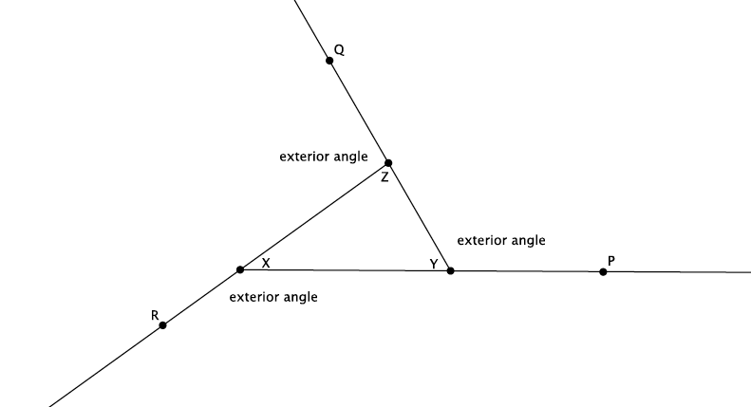
- Name an exterior angle and the related remote interior angles.

- Name a second exterior angle and the related remote interior angles.

- Name a third exterior angle and the related remote interior angles.

- Show that the measure of an exterior angle is equal to the sum of the related remote interior angles.

Example 1
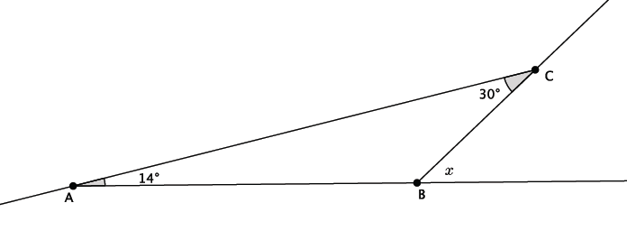
Find the measure of angle $x$.

Example 2
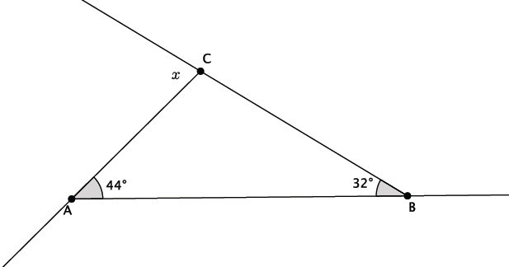
Find the measure of angle $x$.

Example 3
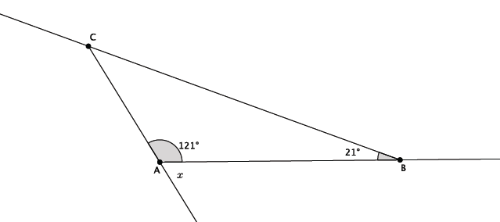
Find the measure of angle $x$

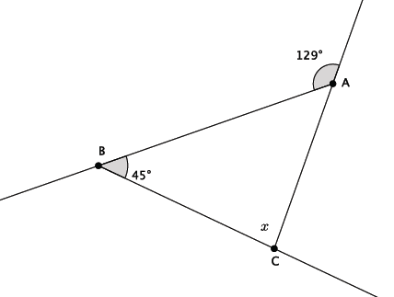
Example 4
Find the measure of angle $x$.

Exercises 5–10
- Find the measure of angle $x$. Present an informal argument showing that your answer is correct.
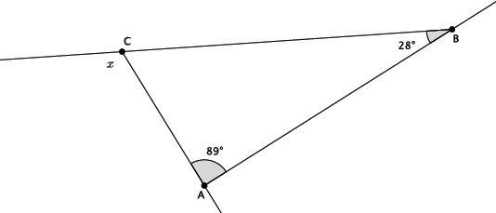

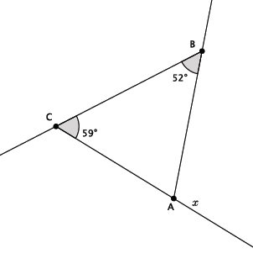
- Find the measure of angle $x$. Present an informal argument showing that your answer is correct.

- Find the measure of angle $x$. Present an informal argument showing that your answer is correct.
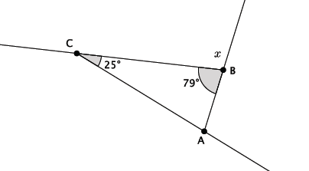

- Find the measure of angle $x$. Present an informal argument showing that your answer is correct.

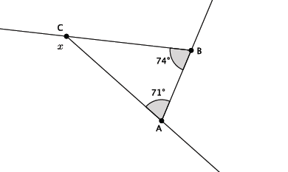

- Find the measure of angle $x$. Present an informal argument showing that your answer is correct.

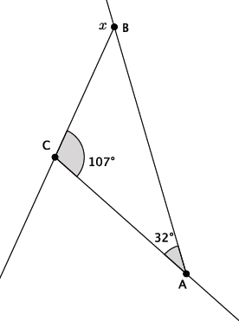

- Find the measure of angle $x$. Present an informal argument showing that your answer is correct.
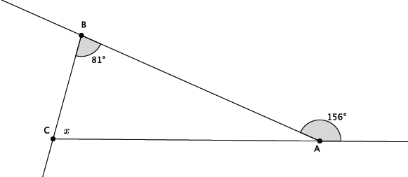

Lesson Summary
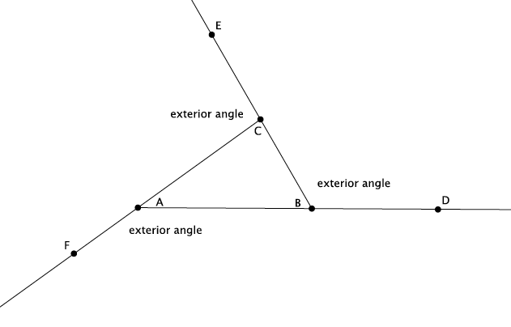
The sum of the remote interior angles of a triangle is equal to the measure of the related exterior angle. For example, $∠CAB+∠ABC=∠ACE.$

Problem Set

For each of the problems below, use the diagram to find the missing angle measure. Show your work.
- Find the measure of angle $x$. Present an informal argument showing that your answer is correct.

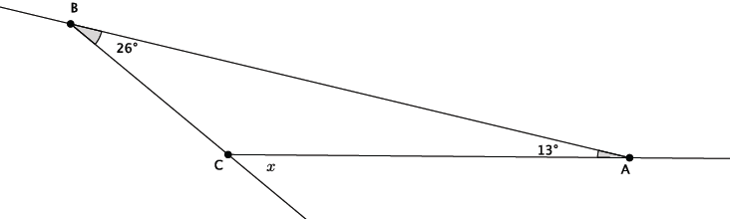

- Find the measure of angle $x$.
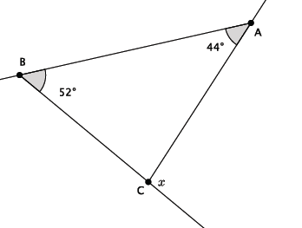

- Find the measure of angle $x$. Present an informal argument showing that your answer is correct.
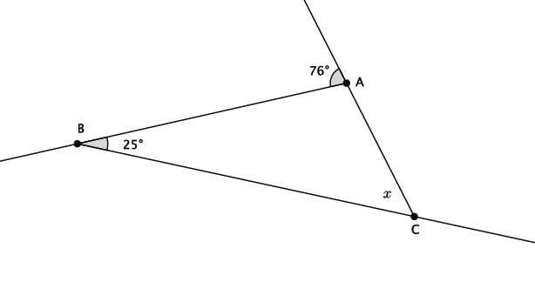

- Find the measure of angle $x$.
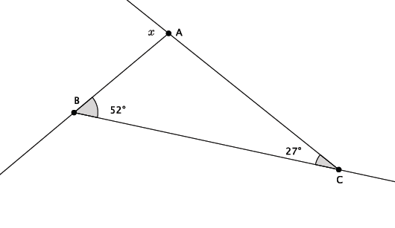

- Find the measure of angle $x$.
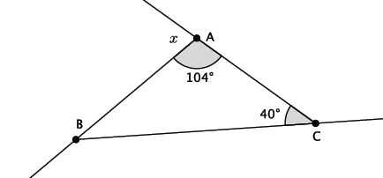

- Find the measure of angle $x$.
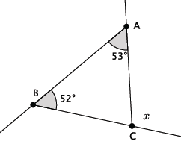

- Find the measure of angle $x$.
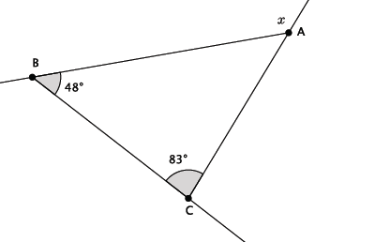

- Find the measure of angle $x$.
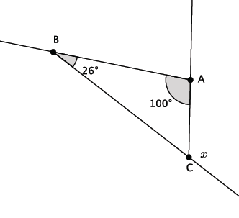
- Find the measure of angle $x$.
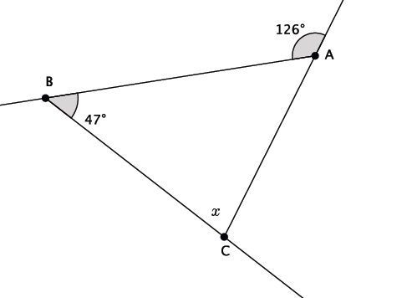

- Write an equation that would allow you to find the measure of angle $x$. Present an informal argument showing that your answer is correct.
