Lesson 14: More on the Angles of a Triangle

Student Outcomes
- Students know a third informal proof of the angle sum theorem.
- Students know how to find missing interior and exterior angle measures of triangles and present informal arguments to prove their answer is correct.

Lesson Notes
Students will see one final informal proof of the angle sum of a triangle before moving on to working with exterior angles of triangles.

Classwork
Discussion (7 minutes)
Let’s look at one final proof that the sum of the degrees of the interior angles of a triangle is $180$.
- Start with a rectangle. What properties do rectangles have?
  - All four angles are right angles; opposite sides are equal in length.
- If we draw a diagonal that connects $A$ to $C$ (or we could choose to connect $B$ to $D$), what shapes are formed?
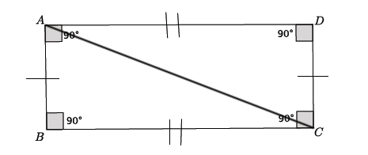
  - We get two triangles.
- What do we know about these triangles, and how do we know it?
  - The triangles are congruent. We can trace one of the triangles and, through a sequence of basic rigid motions, map it onto the other triangle.
- Our goal is to show that the angle sum of a triangle is $180°$. We know that when we draw a diagonal through a rectangle, we get two congruent triangles. How can we put this information together to show that the sum of angles in a triangle is $180°$?
  - The rectangle has four right angles which means that the sum of the angles of the rectangle is $4(90°)=360°$. Since the diagonal divides the rectangle into two congruent triangles, each triangle will have exactly half the total degrees of the rectangle. Since $360°÷2=180°$, then each triangle has a sum of angles equal to $180°$.

Discussion (7 minutes)
Now let’s look at what is called the exterior angle of a triangle. An exterior angle is formed when one of the sides of the triangle is extended. The interior angles are inside the triangle, so the exterior angle is outside of the triangle along the extended side. In triangle $ABC$, the exterior angles are $∠CBD$, $∠ECA$, and $∠BAF$.
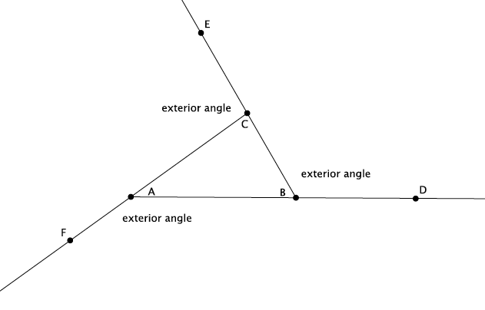
- What do we know about the sum of interior angles of a triangle? Name the angles.
  - The sum of the interior angles $∠ABC$,$∠BCA$, and $∠CAB$ of the triangle is $180°$.
- What do we know about the degree of a straight angle?
  - A straight angle has a measure of $180°$.
- Let’s look specifically at straight angle $∠ABD$. Name the angles that make up this straight angle.
  - $∠ABC$and$∠CBD$

- Because the triangle and the straight angle both have measures of $180°$, we can write them as equal to one another. That is, since
$$∠ABC+∠BCA+∠CAB=180,$$and
$$∠ABC+∠CBD=180,$$then,
$$∠ABC+∠BCA+∠CAB=∠ABC+∠CBD.$$
- Which angle is common to both the triangle and the straight angle?
  - $∠ABC$
- If we subtract the measure of $∠ABC$ from both the triangle and the straight angle, we get
$$\begin{aligned}∠ABC-∠ABC+∠BCA+∠CAB=∠ABC-∠ABC+∠CBD \\ ∠BCA+∠CAB=∠CBD.\end{aligned}$$
- What kind of angle is $∠CBD$?
  - It is the exterior angle of the triangle.
- We call angles $∠BCA$ and $∠CAB$ the remote interior angles because they are the farthest, “remotest” from the exterior angle $∠CBD$. Each of the remote angles share one side with the angle adjacent to the exterior angle. The equation $∠BCA+∠CAB=∠CBD$ means that the sum of the remote interior angles are equal to the exterior angle of the triangle.

Exercises 1–4 (8 minutes)
Scaffolding:
Keep the work of Example 1 visible while students work on Exercises 1–4.
Students work in pairs to identify the remote interior angles and corresponding exterior angle of the triangle in Exercises 1–3. After most of the students have finished Exercises 1–3, provide the correct answers before they move on to the next exercise. In Exercise 4, students recreate the reasoning of Example 1 for another exterior angle of the triangle.
Exercises 1–4
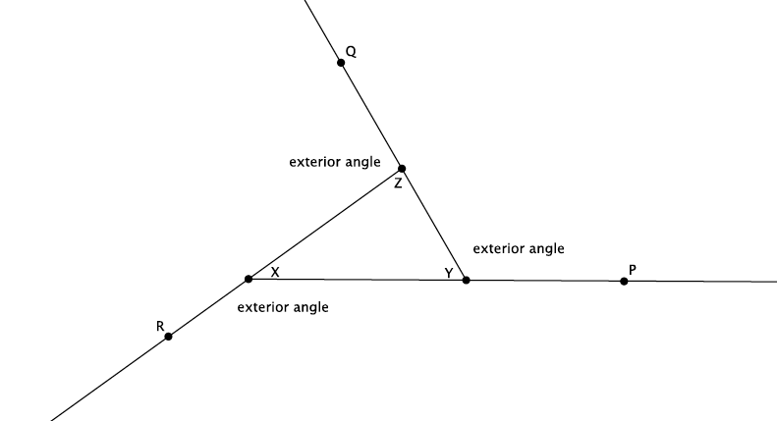
Use the diagram below to complete Exercises 1–4.

- Name an exterior angle and the related remote interior angles.
The exterior angle is $∠ZYP$, and the related remote interior angles are $∠YZX$ and $∠ZXY$.

- Name a second exterior angle and the related remote interior angles.
The exterior angle is $∠XZQ$, and the related remote interior angles are $∠ZYX$ and $∠ZXY$.

- Name a third exterior angle and the related remote interior angles.
The exterior angle is $∠RXY$, and the related remote interior angles are $∠ZYX$ and $∠XZY$.

- Show that the measure of an exterior angle is equal to the sum of the related remote interior angles.
Triangle $XYZ$ has interior angles $∠XYZ$,$∠YZX$, and $∠ZXY$. The sum of those angles is $180°$. The straight angle $∠XYP$ also has a measure of $180°$ and is made up of angles $∠XYZ$ and $∠ZYP$. Since the triangle and the straight angle have the same number of degrees, we can write the sum of their respective angles as an equality:
$$∠XYZ+∠YZX+∠ZXY=∠XYZ+ZYP.$$
Both the triangle and the straight angle share $∠XYZ$. We can subtract the measure of that angle from the triangle and the straight angle. Then, we have
$$∠YZX+∠ZXY=∠ZYP,$$
where the angle $∠ZYP$ is the exterior angle, and the angles $∠YZX$ and $∠ZXY$ are the related remote interior angles of the triangle. Therefore, the sum of the remote interior angles of a triangle are equal to the exterior angle.

Example 1 (2 minutes)
- Ask students what we need to do to find the measure of angle $x$. Then, have them work on white boards and show you their answer.
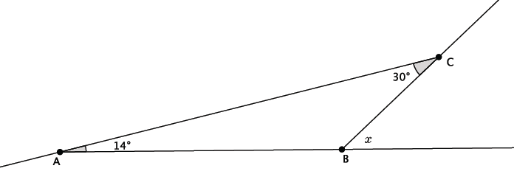
Example 1
Find the measure of angle $x$.

We need to find the sum of the remote interior angles to find the measure of the exterior angle $x$:
$14+30=44$. Therefore, the measure of angle $x=44°$.

- Present an informal argument that proves you are correct.
  - We know that triangles have a sum of interior angles that is equal to $180°$. We also know that straight angles are $180°$. Angle $∠ABC$ must be $136°$, which means that $∠x=44°$.

Example 2 (2 minutes)
Ask students what we need to do to find the measure of angle $x$. Then, have them work on white boards and show you their answer.

Example 2
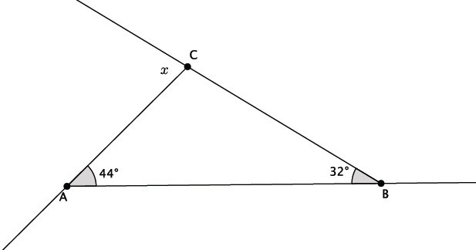
Find the measure of angle $x$.
We need to find the sum of the remote interior angles to find the measure of the exterior angle $x$: $44+32=76$. Therefore, the measure of angle $x=76°$.

- Present an informal argument that proves you are correct.
  - We know that triangles have a sum of interior angles that is equal to $180°$. We also know that straight angles are $180°$. Angle $∠ACB$ must be $104°$, which means that $∠x=76°$.

Example 3 (2 minutes)
Ask students what we need to do to find the measure of angle $x$. Then, have them work on white boards and show you their answers. Make sure students see that this is not like the last two examples. They must pay attention to the information that is provided and not expect to always do the same procedure.
Example 3
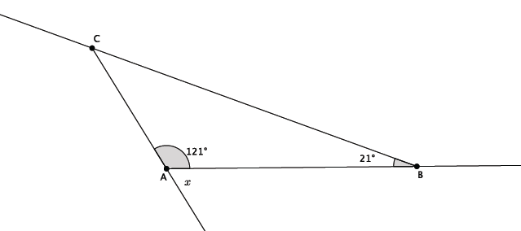
Find the measure of angle $x$.

$180-121=59$. Therefore, the measure of angle $=59°$.

Students should notice that we are not given the two remote interior angles associated with the exterior angle $x$. For that reason, we must use what we know about straight angles (or supplementary angles) to find the measure of angle $x$.

Example 4 (2 minutes)
Ask students what we need to do to find the measure of angle $x$. Then, have them work on white boards and show you their answers. Make sure students see that this is not like the last three examples. They must pay attention to the information that is provided and not expect to always do the same procedure.
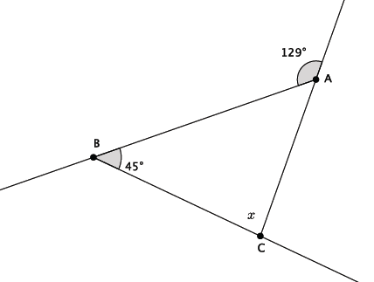
Example 4
Find the measure of angle $x$.

$129-45=84$. Therefore, the measure of angle $x=84°$.

Students should notice that we are given just one of the remote interior angle measures and the exterior angle measure. For that reason, we will need to subtract $45$ from the exterior angle to find the measure of angle $x$.

Exercises 5–10 (6 minutes)
Students complete Exercises 5–10 independently. Check solutions once most students have finished.
Exercise 5–10
- Find the measure of angle $x$. Present an informal argument showing that your answer is correct.
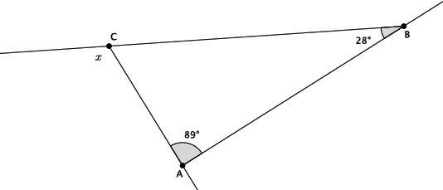
Since$89 + 28 = 117$, the measure of angle $x$ is $117°$. We know that triangles have a sum of interior angles that is equal to $180°$. We also know that straight angles are$180°$. Angle $∠ACB$ must be $63°$, which means that $∠x=117°$.

- Find the measure of angle $x$. Present an informal argument showing that your answer is correct.
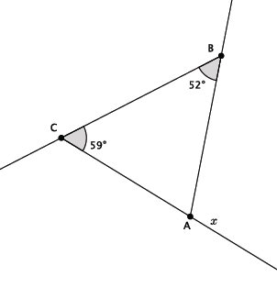

Since $59+52=111$, the measure of angle $x$ is $111°$. We know that triangles have a sum of interior angles that is equal to $180°$. We also know that straight angles are $180°$. Angle $∠CAB$ must be $69°$, which means that $∠x=111°$.

- Find the measure of angle $x$. Present an informal argument showing that your answer is correct.
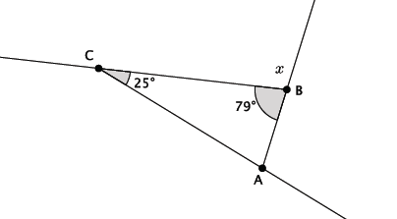
Since$180-79=101$, the measure of angle $x$ is $101°$. We know that straight angles are $180°$, and the straight angle in the diagram is made up of angle $∠ABC$ and angle $∠x$. Angle $∠ABC$ is $79°$, which means that $∠x=101°$.

- Find the measure of angle $x$. Present an informal argument showing that your answer is correct.
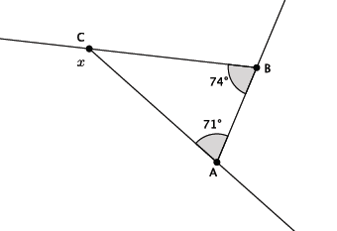

Since $71+74=145$, the measure of angle $x$ is $145°$. We know that triangles have a sum of interior angles that is equal to $180°$. We also know that straight angles are $180°$. Angle $∠ACB$ must be $35°$, which means that $∠x=145°$.

- Find the measure of angle $x$. Present an informal argument showing that your answer is correct.
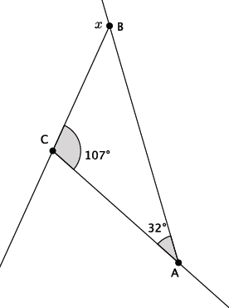

Since $107+32=139$, the measure of angle $x$ is $139°$. We know that triangles have a sum of interior angles that is equal to $180°$. We also know that straight angles are $180°$. Angle $∠CBA$ must be $41°$, which means that $∠139°$.

- Find the measure of angle $x$. Present an informal argument showing that your answer is correct.
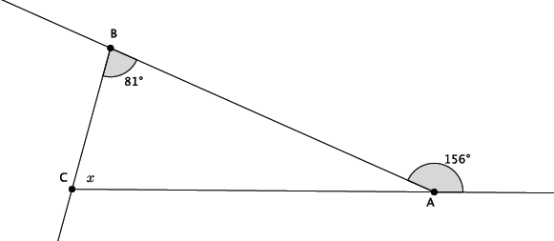

Since $156 - 81 = 75$, the measure of angle $x$ is $75˚$. We know that triangles have a sum of interior angles that is equal to $180˚$. We also know that straight angles are $180˚$. Angle $∠BAC$ must be $24˚$ because it is part of the straight angle. Then, $∠x=180°-\left(81°+24°\right)=75°$.

Closing (4 minutes)
Summarize, or have students summarize, the lesson.
- We learned another proof as to why the interior angles of a triangle are equal to $180°$ with respect to a triangle being exactly half of a rectangle.
- We learned the definitions of exterior angles and remote interior angles.
- The sum of the remote interior angles of a triangle is equal to the measure of the related exterior angle.
Lesson Summary
The sum of the remote interior angles of a triangle is equal to the measure of the related exterior angle. For example, $∠CAB+∠ABC=∠ACE$.

Exit Ticket (5 minutes)

Name Date
Lesson 14: More on the Angles of a Triangle

Exit Ticket

- Find the measure of angle $p$. Present an informal argument showing that your answer is correct.

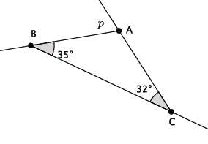

- Find the measure of angle $q$. Present an informal argument showing that your answer is correct.

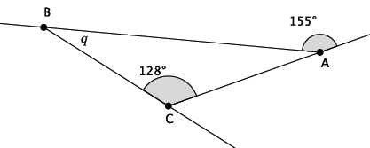

- Find the measure of angle $r$. Present an informal argument showing that your answer is correct.
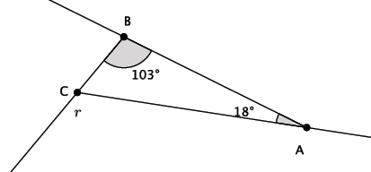
Exit Ticket Sample Solutions

- Find the measure of angle $p$. Present an informal argument showing that your answer is correct.
The measure of angle $p$ is $67°$. We know that triangles have a sum of interior angles that is equal to $180°$. We also know that straight angles are $180°$. Angle $∠BAC$ must be $113°$, which means that $∠p=67°$.

- Find the measure of angle $q$. Present an informal argument showing that your answer is correct.
The measure of angle $q$ is $27°$. We know that triangles have a sum of interior angles that is equal to $180°$. We also know that straight angles are $180°$. Angle $∠CAB$ must be $25°$, which means that $∠q=27°$.

- Find the measure of angle $r$. Present an informal argument showing that your answer is correct.
The measure of angle $r$ is $121°$. We know that triangles have a sum of interior angles that is equal to $180°$. We also know that straight angles are $180°$. Angle $∠BCA$ must be$59°$, which means that $∠r=121°$.

Problem Set Sample Solutions
Students practice finding missing angle measures of triangles.
For each of the problems below, use the diagram to find the missing angle measure. Show your work.
- Find the measure of angle $x$. Present an informal argument showing that your answer is correct.
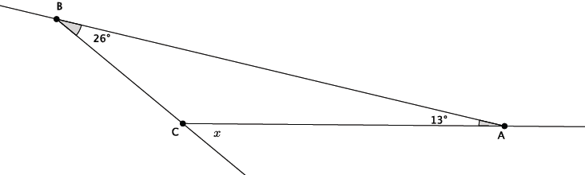
Since $26+13=39$, the measure of angle $x$ is $39°$. We know that triangles have a sum of interior angles that is equal to $180°$. We also know that straight angles are $180°$. Angle $∠BCA$ must be $141°$, which means that
$∠x=39°$.
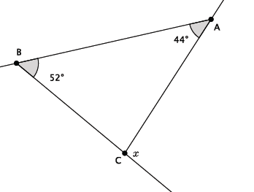
- Find the measure of angle $x$.

Since $52+44=96$, the measure of angle $x$ is $96°$.

- Find the measure of angle $x$. Present an informal argument showing that your answer is correct.
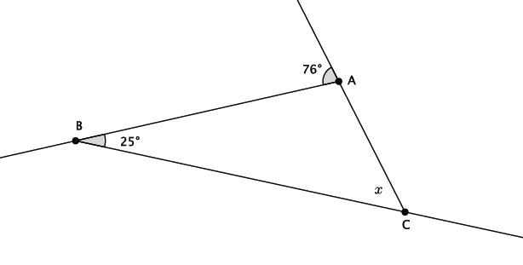
Since $76-25=51$, the measure of angle $x$ is $51°$. We know that triangles have a sum of interior angles that is equal to $180°$. We also know that straight angles are $180°$. Angle $∠BAC$ must be $104°$ because it is part of the straight angle. Then, $x=180°-\left(104°+25°\right)=51°$.

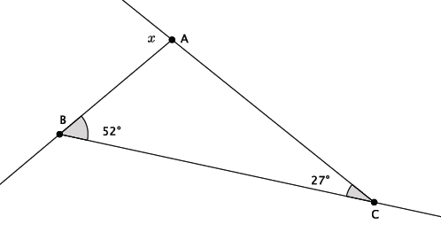
- Find the measure of angle $x$.

Since $27 + 52 = 79$, the measure of angle $x$ is $79°$.

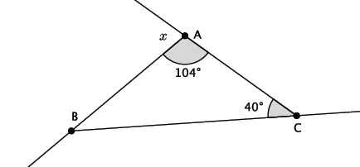
- Find the measure of angle $x$.

Since$180-104=76$, the measure of angle$x$ is $76°$.

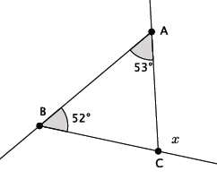
- Find the measure of angle $x$.

Since $52+53=105$, the measure of angle $x$ is $105°$.

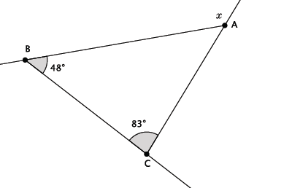
- Find the measure of angle $x$.

Since $48+83=131$, the measure of angle $x$ is $131°$.

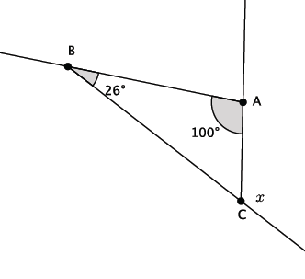
- Find the measure of angle $x$.

Since$100+26=126$, the measure of angle $x$ is $126°$.

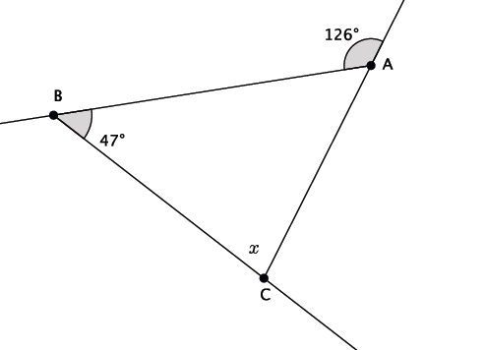
- Find the measure of angle $x$.

Since$126-47=79$, the measure of angle $x$ is $79°$.

- Write an equation that would allow you to find the measure of angle $x$. Present an informal argument showing that your answer is correct.
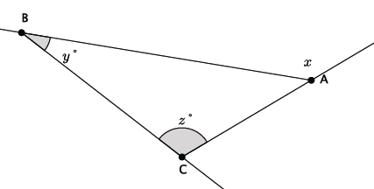
Since $y+z=x$, the measure of angle $x$ is $(y+z)°$. We know that triangles have a sum of interior angles that is equal to $180°$. We also know that straight angles are $180°$. Then, $∠y+∠z+∠BAC=180°$, and $∠x+∠BAC=180°$. Since both equations are equal to $180°$, then $∠y+∠z+∠BAC=∠x+∠BAC$. Subtract $∠BAC$ from each side of the equation, and you get $∠y+∠z=∠x$.

