Lesson 13: Angle Sum of a Triangle

Classwork
Concept Development
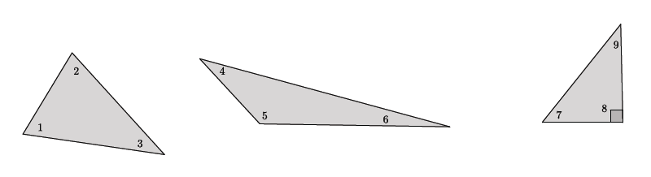

$$∠1+∠2+∠3=∠4+∠5+∠6=∠7+∠8+∠9=180$$
Note that the sum of angles $7$ and $9$ must equal $90°$ because of the known right angle in the right triangle.

Exploratory Challenge 1
Let triangle $ABC$ be given. On the ray from $B$ to $C$, take a point $D$ so that $C$ is between $B$ and $D$. Through point $C$, draw a line parallel to $AB$, as shown. Extend the parallel lines $AB$ and $CE$. Line $AC$ is the transversal that intersects the parallel lines.
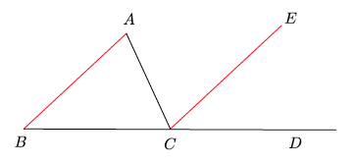

  - Name the three interior angles of triangle $ABC$.

  - Name the straight angle.

  - What kinds of angles are $∠ABC$ and $∠ECD$? What does that mean about their measures?

  - What kinds of angles are $∠BAC$ and $∠ECA$? What does that mean about their measures?

  - We know that $∠BCD=∠BCA+∠ECA+∠ECD=180°$. Use substitution to show that the three interior angles of the triangle have a sum of $180°$.

Exploratory Challenge 2
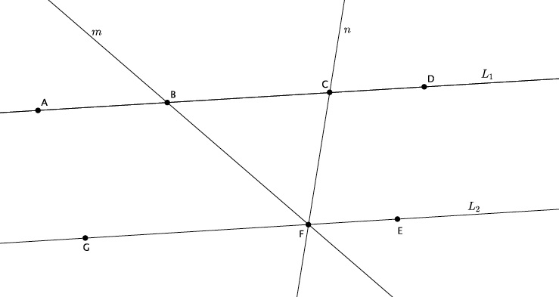
The figure below shows parallel lines $L_{1}$ and $L_{2}$. Let $m$ and $n$ be transversals that intersect $L_{1}$ at points $B$ and $C$, respectively, and $L_{2}$ at point $F$, as shown. Let $A$ be a point on $L_{1}$ to the left of $B$, $D$ be a point on $L_{1}$ to the right of $C$, $G$ be a point on $L_{2}$ to the left of $F,$ and $E$ be a point on $L_{2}$ to the right of $F$.

  - Name the triangle in the figure.

  - Name a straight angle that will be useful in proving that the sum of the interior angles of the triangle is $180°$.

  - Write your proof below.

Lesson Summary
All triangles have a sum of interior angles equal to $180°$.
The proof that a triangle has a sum of interior angles equal to $180°$ is dependent upon the knowledge of straight angles and angle relationships of parallel lines cut by a transversal.

Problem Set

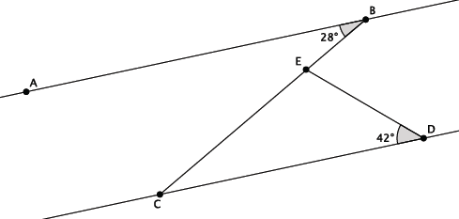
- In the diagram below, line $AB$ is parallel to line $CD$, i.e., $L_{AB}∥L_{CD}$. The measure of angle $∠ABC=28°$, and the measure of angle $∠EDC=42°$. Find the measure of angle $∠CED$. Explain why you are correct by presenting an informal argument that uses the angle sum of a triangle.

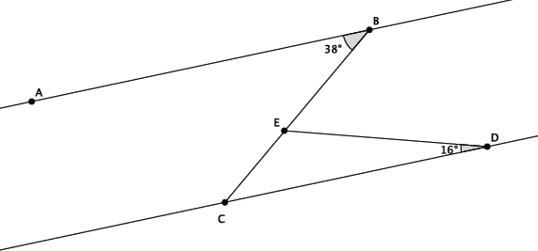
- In the diagram below, line $AB$ is parallel to line $CD$, i.e., $L_{AB}∥L_{CD}$. The measure of angle $∠ABE=38°,$ and the measure of angle $∠EDC=16°$. Find the measure of angle $∠BED$. Explain why you are correct by presenting an informal argument that uses the angle sum of a triangle. (Hint: Find the measure of angle $∠CED$ first, and then use that measure to find the measure of angle $∠BED$.)

- In the diagram below, line $AB$ is parallel to line $CD$, i.e., $L_{AB}∥L_{CD}$. The measure of angle $∠ABE=56°$, and the measure of angle $∠EDC=22°$. Find the measure of angle $∠BED$. Explain why you are correct by presenting an informal argument that uses the angle sum of a triangle. (Hint: Extend the segment $BE$ so that it intersects line $CD$.)
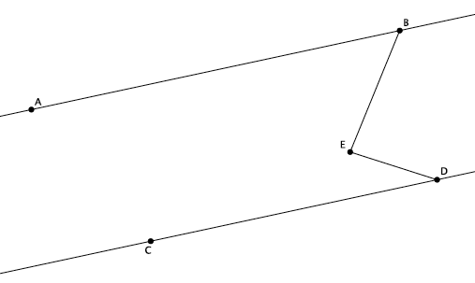

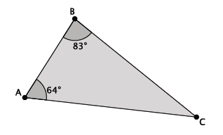
- What is the measure of $∠ACB$?

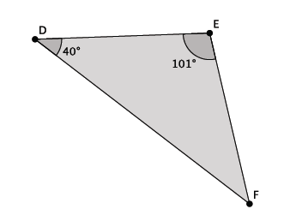
- What is the measure of $∠EFD$?
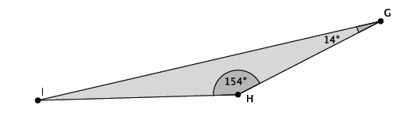
- What is the measure of $∠HIG$?

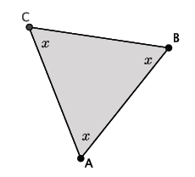
- What is the measure of $∠ABC$?

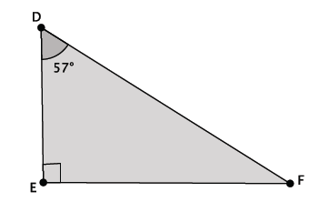
- Triangle $DEF$ is a right triangle. What is the measure of $∠EFD$?

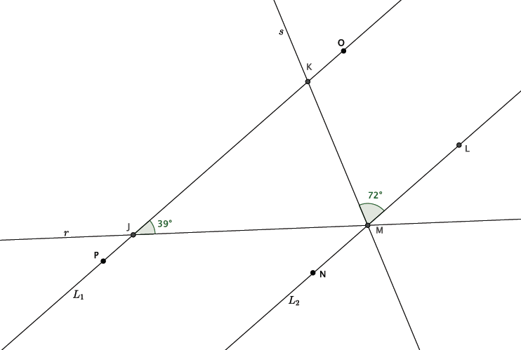
- In the diagram below, lines $L_{1}$ and $L_{2}$ are parallel. Transversals $r$ and $s$ intersect both lines at the points shown below. Determine the measure of $∠JMK$. Explain how you know you are correct.

