Lesson 13: Angle Sum of a Triangle

Student Outcomes
- Students know the angle sum theorem for triangles; the sum of the interior angles of a triangle is always $180°$.
- Students present informal arguments to draw conclusions about the angle sum of a triangle.

Classwork
Concept Development (3 minutes)
- The angle sum theorem for triangles states that the sum of the interior angles of a triangle is always $180°$
($∠$ sum of $△$).
- It does not matter what kind of triangle it is (i.e., acute, obtuse, right); when you add the measure of the three angles, you always get a sum of $180°$.
Concept Development
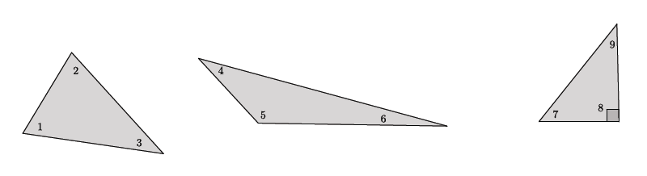
$$∠1+∠2+∠3=∠4+∠5+∠6=∠7+∠8+∠9=180$$
Note that the sum of angles $7$ and $9$ must equal $90°$ because of the known right angle in the right triangle.

We want to prove that the angle sum of any triangle is $180°$. To do so, we will use some facts that we already know about geometry:
- A straight angle is $180°$ in measure.
- Corresponding angles of parallel lines are equal in measure (corr. $∠s$, $\overline{AB}∥\overline{CD}$).
- Alternate interior angles of parallel lines are equal in measure (alt. $∠s$, $\overline{AB}∥\overline{CD}$).

Exploratory Challenge 1 (13 minutes)
Provide students 10 minutes of work time. Once the 10 minutes have passed, review the solutions with the students before moving on to Exploratory Challenge 2.
Exploratory Challenge 1
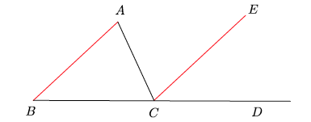
Let triangle $ABC$ be given. On the ray from $B$ to $C$, take a point $D$ so that $C$ is between $B$ and $D$. Through point $C$, draw a line parallel to $AB$, as shown. Extend the parallel lines $AB$ and $CE$. Line $AC$ is the transversal that intersects the parallel lines.

  - Name the three interior angles of triangle $ABC$.
$∠ABC$,$∠BAC$,$∠BCA$

  - Name the straight angle.
$$∠BCD$$
Our goal is to show that the three interior angles of triangle $ABC$ are equal to the angles that make up the straight angle. We already know that a straight angle is $180°$ in measure. If we can show that the interior angles of the triangle are the same as the angles of the straight angle, then we will have proven that the interior angles of the triangle have a sum of $180°$.

  - What kinds of angles are $∠ABC$ and $∠ECD$? What does that mean about their measures?
MP.3
$∠ABC$ and $∠ECD$ are corresponding angles. Corresponding angles of parallel lines are equal in measure (corr. $∠s$, $\overline{AB}∥\overline{CE}$).

  - What kinds of angles are $∠BAC$ and $∠ECA$? What does that mean about their measures?
$∠BAC$ and $∠ECA$ are alternate interior angles. Alternate interior angles of parallel lines are equal in measure (alt. $∠s$, $\overline{AB}$ $||$ $\overline{CE}$).

  - We know that $∠BCD=∠BCA+∠ECA+∠ECD=180°$. Use substitution to show that the three interior angles of the triangle have a sum of $180°$.
$∠BCD=∠BCA+∠BAC+∠ABC=180°$ ($∠$ sum of $△$).

Exploratory Challenge 2 (20 minutes)
Provide students 15 minutes of work time. Once the 15 minutes have passed, review the solutions with the students.
Exploratory Challenge $2$
The figure below shows parallel lines $L_{1}$ and $L_{2}$. Let $m$ and $n$ be transversals that intersect $L_{1}$ at points $B$ and $C$, respectively, and $L_{2}$ at point $F$, as shown. Let $A$ be a point on $L_{1}$ to the left of $B$, $D$ be a point on $L_{1}$ to the right of $C$, $G$ be a point on $L_{2}$ to the left of $F$, and $E$ be a point on $L_{2}$ to the right of $F$.
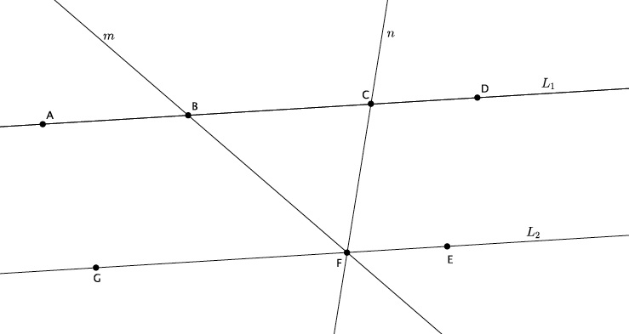

  - Name the triangle in the figure.
$$∆BCF$$

  - Name a straight angle that will be useful in proving that the sum of the interior angles of the triangle is $180°$.
$$∠GFE$$
As before, our goal is to show that the interior angles of the triangle are equal to the straight angle. Use what you learned from Exploratory Challenge 1 to show that interior angles of a triangle have a sum of $180°$.

  - Write your proof below.
The straight angle $∠GFE$ is comprised of angles $∠GFB$, $∠BFC$, and $∠EFC$. Alternate interior angles of parallel lines are equal in measure (alt. $∠s$, $\overline{AD}∥\overline{CE}$). For that reason, $∠BCF=∠EFC$and$∠CBF=∠GFB$. Since $∠GFE$ is a straight angle, it is equal to $180°$. Then, $∠GFE=∠GFB+∠BFC+∠EFC=180°$. By substitution, $∠GFE=∠CBF+∠BFC+∠BCF=180°$. Therefore, the sum of the interior angles of a triangle is $180°$ ($∠$sum of $△$).
MP.3

Closing (4 minutes)
Summarize, or have students summarize, the lesson.
- All triangles have a sum of interior angles equal to $180°$.
- We can prove that a triangle has a sum of interior angles equal to that of a straight angle using what we know about alternate interior angles and corresponding angles of parallel lines.

Lesson Summary
All triangles have a sum of interior angles equal to $180°$.
The proof that a triangle has a sum of interior angles equal to $180°$ is dependent upon the knowledge of straight angles and angle relationships of parallel lines cut by a transversal.
Exit Ticket (5 minutes)

Name Date
Lesson 13: Angle Sum of a Triangle

Exit Ticket

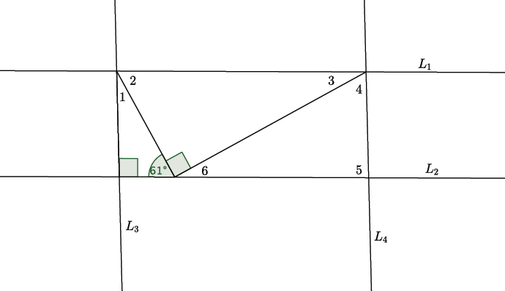
- If $L_{1}∥L_{2}$, and $L_{3}∥L_{4}$, what is the measure of $∠1$? Explain how you arrived at your answer.

- Given Line $AB$ is parallel to Line $CE$, present an informal argument to prove that the interior angles of triangle $ABC$ have a sum of $180°$.
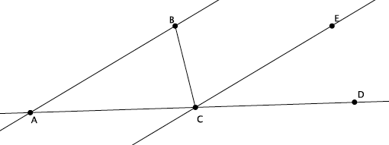
Exit Ticket Sample Solutions

- If $L_{1}∥L_{2}$, and $L_{3}∥L_{4}$, what is the measure of $∠1$? Explain how you arrived at your answer.
The measure of angle $1$ is $29°$. I know that the angle sum of triangles is $180°$. I already know that two of the angles of the triangle are $90°$ and $61°$.

- Given Line $AB$ is parallel to Line $CE$, present an informal argument to prove that the interior angles of triangle $ABC$ have a sum of $180°$.

Since $AB$ is parallel to $CE$, then the corresponding angles $∠BAC$ and $∠ECD$ are equal in measure. Similarly, angles $∠ABC$ and $∠ECB$ are equal in measure because they are alternate interior angles. Since $∠ACD$ is a straight angle, i.e., equal to $180°$ in measure, substitution shows that triangle $ABC$ has a sum of $180°$. Specifically, the straight angle is made up of angles $∠ACB$, $∠ECB$, and $∠ECD$. $∠ACB$ is one of the interior angles of the triangle and one of the angles of the straight angle. We know that angle $∠ABC$ has the same measure as angle $∠ECB$ and that angle $∠BAC$ has the same measure as $∠ECD$. Therefore, the sum of the interior angles will be the same as the angles of the straight angle, which is $180°$.

Problem Set Sample Solutions
Students practice presenting informal arguments about the sum of the angles of a triangle using the theorem to find the measures of missing angles.

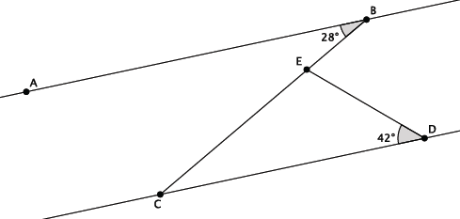
- In the diagram below, line $AB$ is parallel to line $CD$, i.e., $L_{AB}∥L_{CD}$. The measure of angle $∠ABC=28°$, and the measure of angle $∠EDC=42°$. Find the measure of angle $∠CED$. Explain why you are correct by presenting an informal argument that uses the angle sum of a triangle.

The measure of angle $∠CED=110°$. This is the correct measure for the angle because $∠ABC$ and $∠DCE$ are alternate interior angles of parallel lines. That means that the angles are congruent and have the same measure. Since the angle sum of a triangle is $180°$, then the measure of $∠CED=180°-\left(28°+42°\right)=110°$.

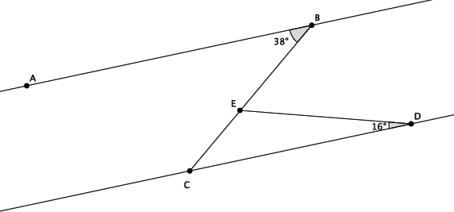
- In the diagram below, line $AB$ is parallel to line $CD$, i.e., $L_{AB}∥L_{CD}$. The measure of angle $∠ABE=38°$, and the measure of angle $∠EDC=16°$. Find the measure of angle $∠BED$. Explain why you are correct by presenting an informal argument that uses the angle sum of a triangle. (Hint: Find the measure of angle $∠CED$ first, and then use that measure to find the measure of angle $∠BED$.)

The measure of angle $∠BED=54°$. This is the correct measure for the angle because $∠ABC$ and $∠DCE$ are alternate interior angles of parallel lines. That means that the angles are congruent and have the same measure. Since the angle sum of a triangle is $180°$, then the measure of $∠CED=180°-\left(38°+16°\right)=126°$. The straight angle $∠BEC$ is made up of $∠CED$ and $∠BED$. Since we know straight angles are $180°$ in measure, and angle $∠CED=126°$, then $∠BED=54°$.

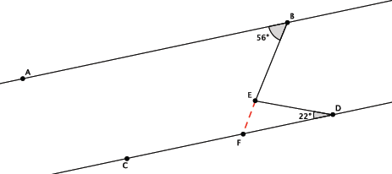
- In the diagram below, line $AB$ is parallel to line $CD$, i.e., $L_{AB}∥L_{CD}$. The measure of angle $∠ABE=56°$, and the measure of angle $∠EDC=22°$. Find the measure of angle $∠BED$. Explain why you are correct by presenting an informal argument that uses the angle sum of a triangle. (Hint: Extend the segment $BE$ so that it intersects line $CD$.)

The measure of angle $∠BED=78°$. This is the correct measure for the angle because $∠ABE$ and $∠DFE$ are alternate interior angles of parallel lines. That means that the angles are congruent and have the same measure. Since the angle sum of a triangle is $180°$, then the measure of $∠FED=180°-\left(56°+22°\right)=102°$. The straight angle $∠BEF$ is made up of $∠FED$ and $∠BED$. Since straight angles are $180°$in measure, and angle $∠FED=102°$, then $∠BED=78°$.

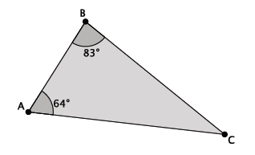
- What is the measure of $∠ACB$?
The measure of $∠ACB$ is $180°-\left(83°+64°\right)=33°$.

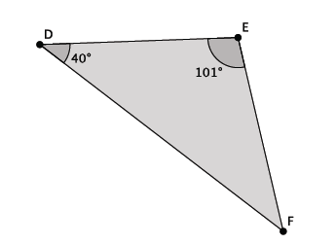
- What is the measure of $∠EFD$?
The measure of $∠EFD$ is $180°-(101°+40°)=39°$.

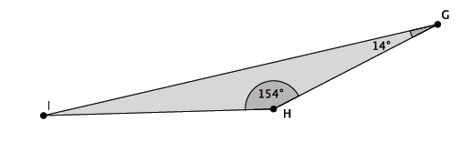
- What is the measure of $∠HIG$?
The measure of $∠HIG$ is $180°-(154°+14°)=12°$.

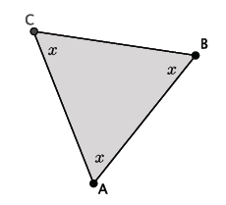
- What is the measure of $∠ABC$?
The measure of $∠ABC$ is $60°$ because $60+60+60=180$.

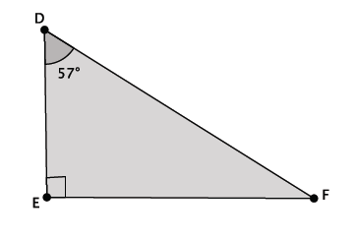
- Triangle $DEF$ is a right triangle. What is the measure of $∠EFD$?
The measure of $∠EFD$ is $90°-57°=33°$.

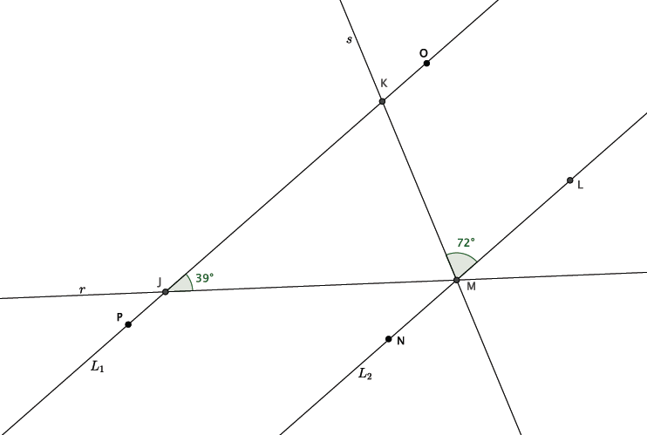
- In the diagram below, lines $L_{1}$ and $L_{2}$ are parallel. Transversals $r$ and $s$ intersect both lines at the points shown below. Determine the measure of $∠JMK$. Explain how you know you are correct.

The lines $L_{1}$ and $L_{2}$ are parallel, which means that the alternate interior angles formed by the transversals are equal. Specifically, $∠LMK=∠JKM=72°$. Since triangle $∆JKM$ has a sum of interior angles equal to $180°$, then $∠KJM+∠JMK+∠JKM=180°$. By substitution, we have $39+∠JMK+72=180$; therefore, $∠JMK=69°$.

