Lesson 12: Angles Associated with Parallel Lines

Classwork
Exploratory Challenge 1
In the figure below, $L_{1}$ is not parallel to $L_{2}$, and $m$ is a transversal. Use a protractor to measure angles 1–8. Which, if any, are equal? Explain why. (Use your transparency if needed.)
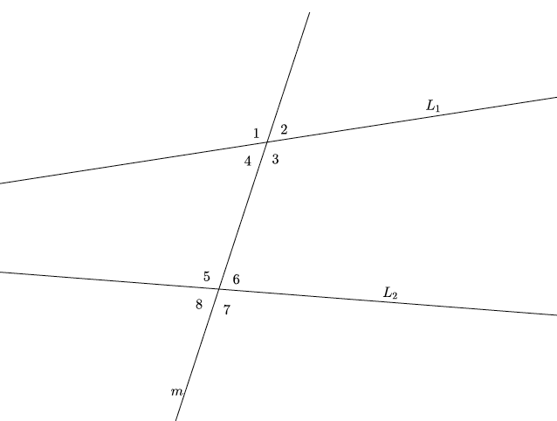

Exploratory Challenge 2
In the figure below, $L_{1}∥L_{2}$, and $m$ is a transversal. Use a protractor to measure angles 1–8. List the angles that are equal in measure.
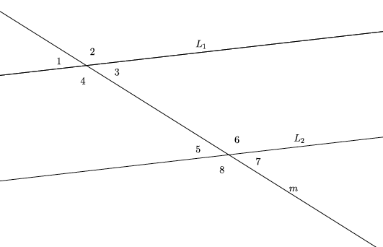
  - What did you notice about the measures of $∠1$ and $∠5$? Why do you think this is so? (Use your transparency if needed.)

  - What did you notice about the measures of $∠3$ and $∠7$? Why do you think this is so? (Use your transparency if needed.) Are there any other pairs of angles with this same relationship? If so, list them.

  - What did you notice about the measures of $∠4$ and $∠6$? Why do you think this is so? (Use your transparency if needed.) Is there another pair of angles with this same relationship?

Lesson Summary
Angles that are on the same side of the transversal in corresponding positions (above each of $L_{1}$ and $L_{2}$ or below each of $L_{1}$ and $L_{2}$) are called corresponding angles. For example, $∠2$ and $∠4$ are corresponding angles.  When angles are on opposite sides of the transversal and between (inside) the lines $L_{1}$ and $L_{2}$, they are called alternate interior angles. For example, $∠3$ and $∠7$ are alternate interior angles.  When angles are on opposite sides of the transversal and outside of the parallel lines (above $L_{1}$ and below $L_{2}$), they are called alternate exterior angles. For example, $∠1$ and $∠5$ are alternate exterior angles. | 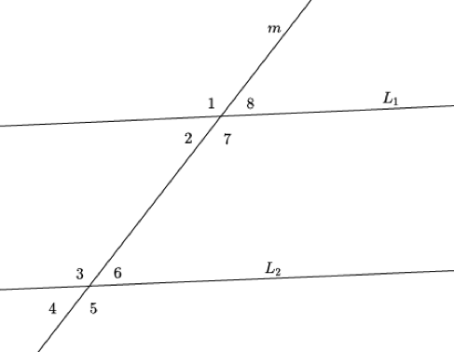
When parallel lines are cut by a transversal, any corresponding angles, any alternate interior angles, and any alternate exterior angles are equal in measure. If the lines are not parallel, then the angles are not equal in measure.

Problem Set

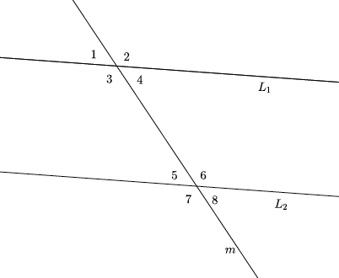
Use the diagram below to do Problems 1–6.
- Identify all pairs of corresponding angles. Are the pairs of corresponding angles equal in measure? How do you know?

- Identify all pairs of alternate interior angles. Are the pairs of alternate interior angles equal in measure? How do you know?

- Use an informal argument to describe why $∠1$ and $∠8$ are equal in measure if $L_{1}∥L_{2}.$

- Assuming $L_{1}∥L_{2}$ if the measure of $∠4$ is $73°$, what is the measure of $∠8$? How do you know?

- Assuming $L_{1}∥L_{2}$, if the measure of $∠3$ is $107°$ degrees, what is the measure of $∠6$? How do you know?

- Assuming $L_{1}∥L_{2},$ if the measure of $∠2$ is $107°$, what is the measure of $∠7$? How do you know?

- Would your answers to Problems 4–6 be the same if you had not been informed that $L_{1}∥L_{2}$? Why, or why not?

- Use an informal argument to describe why $∠1$ and $∠5$ are equal in measure if $L_{1}∥L_{2}$.

- Use an informal argument to describe why $∠4$ and $∠5$ are equal in measure if $L_{1}∥L_{2}$.

- Assume that $L_{1}$ is not parallel to $L_{2}$. Explain why $∠3≠∠7$.

