Lesson 11: Definition of Congruence and Some Basic Properties

Classwork

Exercise 1

* 1. Describe the sequence of basic rigid motions that shows .

Macintosh HD:Users:shassan:Desktop:ex1.pdf

* 1. Describe the sequence of basic rigid motions that shows

Macintosh HD:Users:shassan:Desktop:ex1.pdf

* 1. Describe a sequence of basic rigid motions that shows .

Macintosh HD:Users:shassan:Desktop:ex1.pdf

Exercise 2

Perform the sequence of a translation followed by a rotation of Figure , where is a translation along a vector , and is a rotation of degrees (you choose ) around a center . Label the transformed figure . Will ?

Macintosh HD:Users:shassan:Desktop:ex2.pdf

Lesson Summary

Given that sequences enjoy the same basic properties of basic rigid motions, we can state three basic properties of congruences:

(Congruence 1) A congruence maps a line to a line, a ray to a ray, a segment to a segment, and an angle to an angle.

(Congruence 2) A congruence preserves lengths of segments.

(Congruence 3) A congruence preserves measures of angles.

The notation used for congruence is

Problem Set

1. 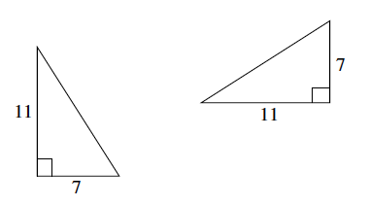Given two right triangles with lengths shown below, is there one basic rigid motion that maps one to the other? Explain.
2. Are the two right triangles shown below congruent? If so, describe a congruence that would map one triangle onto the other.
3. Given two rays, and :

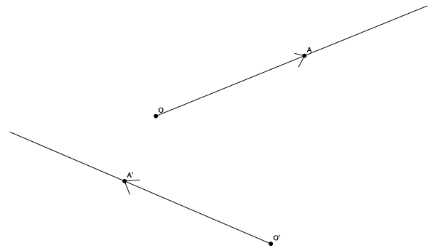

* 1. Describe a congruence that maps to .
  2. Describe a congruence that maps to .