Lesson 11: Definition of Congruence and Some Basic Properties

Student Outcomes
- Students know the definition of congruence and related notation, i.e., $≅$. Students know that to prove two figures are congruent, there must be a sequence of rigid motions that maps one figure onto the other.
- Students know that the basic properties of congruence are similar to the properties for all three rigid motions (translations, rotations, and reflections).

Classwork
Example 1 (5 minutes)
- Sequencing basic rigid motions has been practiced throughout the lessons of Topic B in this module because, in general, the sequence of (a finite number of) basic rigid motions is called a congruence. A geometric figure $S$ is said to be congruent to another geometric figure $S^{'}$ if there is a sequence of rigid motions that maps $S$ to $S^{'}$, i.e., $Congruence(S)= S^{'}$. The notation related to congruence is the symbol $≅$. When two figures are congruent, like $S$ and $S'$, we can write: $S≅S^{'}.$
MP.6
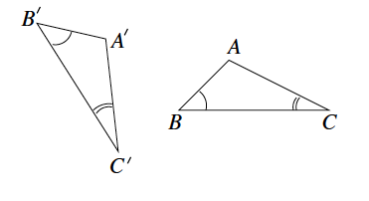
- We want to describe the sequence of rigid motions that demonstrates the two triangles shown below are congruent, i.e., $△ABC≅ △A^{'}B^{'}C^{'}$.
Note to Teacher:
Demonstrate, or have students demonstrate, the rigid motions as they work through the sequence.
- What rigid motion will bring the two triangles together? That is, which motion would bring together at least one pair of corresponding points (vertices)? Be specific.
  - Translate $△A^{'}B^{'}C^{'}$ along vector $\vec{A'A}.$
- What rigid motion would bring together one pair of sides? Be specific.
  - Rotate $d$ degrees around center $A$.
- After these two rigid motions, we have shown that $△ABC≅ △A^{'}B^{'}C^{'}$ through the sequence of a translation followed by a rotation. Notice that only two rigid motions were needed for this sequence. A sequence to demonstrate congruence can be made up of any combination of the basic rigid motions using all three or even just one.
- The concept of congruence between two geometric figures is one of the cornerstones of geometry. Congruence is now realized as “a sequence of basic rigid motions that maps one figure onto another.”
Note to Teacher:
The preceding definition of congruence is meant to replace the existing “same size and same shape” definition.
- Recall the first question raised in this module, “Why move things around?” Now, a complete answer can be given in terms of congruence.

Example 2 (10 minutes)
- It is said that $S$ is congruent to $S^{'}$ if there is a congruence so that $Congruence(S)=S^{'}$. This leaves open the possibility that, although $S$ is congruent to $S^{'}$, the figure $S^{'}$ may not be congruent to $S$.
Ask students:
- If there is a $Congruence_{1}$ so that $Congruence_{1}(S)=S^{'}$, do we know that there will also be a $Congruence_{2}$ so that $Congruence_{2}(S^{'})=S$?
Make sure students understand the question.
- Can you say for certain that if they begin by mapping figure 1 onto figure 2$,$ they can also map figure 2 onto figure 1?
  - Students will likely say yes, but without proof, further work is necessary.
- Assume that the congruence is a sequence of a translation followed by a reflection where there is a translation along a given vector $\vec{MN}$, and there is the reflection across line $L$. Let $S$ be the figure on the left below, and let $S^{'}$ be the figure on the right below. Then, the equation
$Congruence\left(S\right)=Translation \left(S\right) followed by the Reflection=S^{'}$ (7)
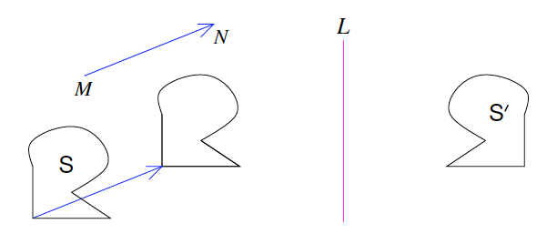
says that if we trace S in red on a transparency, then translate the transparency along $\vec{MN}$ and flip it across $L$, we get the figure to coincide completely with $S^{'}$.

- Now keeping in mind what we know about how to undo transformations in general, it is obvious how to get a congruence to map $S^{'}$ to $S$. Namely, tracing the figure $S^{'}$ in red, flip the transparency across $L$ so the red figure arrives at the figure in the middle, and then translate the figure along vector $\vec{NM}$. (Note the change in direction of the vector from $\vec{MN}$.) The red figure now coincides completely with $S$. The sequence of the reflection across $L$ followed by the translation along vector $\vec{NM}$ achieves the congruence.

- The general argument is that if there is a $Congruence_{1}$ so that $Congruence_{1}(S)=S^{'}$, then there will also be a $Congruence_{2}$ so that $Congruence_{2}(S^{'})=S$ is similar. The only additional comment to complete the picture is that, in addition to
- The sequence required to show that $Congruence_{2}$followed by $Congruence_{1}$ is equal to $Congruence_{1}$followed by $Congruence_{2}$,
- A reflection is undone by a reflection across the same line.
We also have to draw upon the sequence of rotations that maps a figure onto itself to be certain that each of the three basic rigid motions can be undone by another basic rigid motion.
- In summary, if a figure $S$ is congruent to another figure $S^{'}$, then $S^{'}$ is also congruent to $S$. In symbols $S≅S^{'}$. It does not matter whether $S$ or $S^{'}$comes first.

Exercise 1 (10 minutes)
Students work on Exercise 1 in pairs. Students will likely need some guidance with part (a) of Exercise 1. Provide support, and then allow them to work with a partner to complete parts (b) and (c).
Exercise 1
  - Describe the sequence of basic rigid motions that shows $S_{1}≅ S_{2}$.
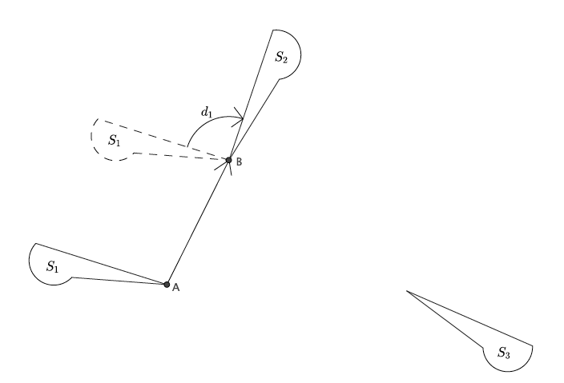
Let there be the translation along vector $\vec{AB}$. Let there be a rotation around point $B$, $d_{1}$ degrees. Let there be a reflection across the longest side of the figure so that $S_{1}$ maps onto $S_{2}$. Then, the $Translation\left(S_{1}\right)$ followed by the rotation followed by the reflection $=S_{2}.$

  - Describe the sequence of basic rigid motions that shows $S_{2}≅ S_{3}.$
Let there be a translation along vector $\vec{BC}$. Let there be a rotation around point $C$, $d_{2}$ degrees so that $S_{2}$ maps onto $S_{3}$. Then, the $Translation(S_{2})$ followed by the rotation $=S_{3}$.
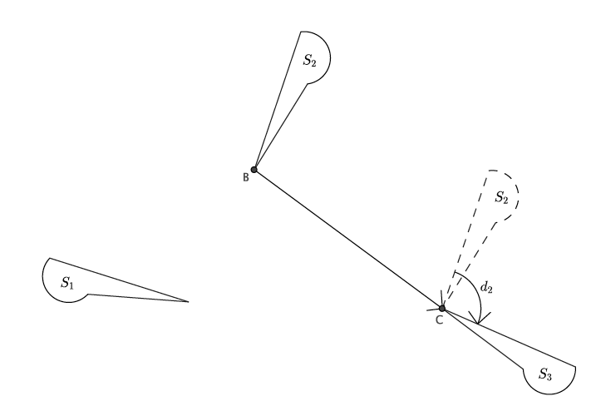
  - Describe a sequence of basic rigid motions that shows $S_{1}≅ S_{3}$.
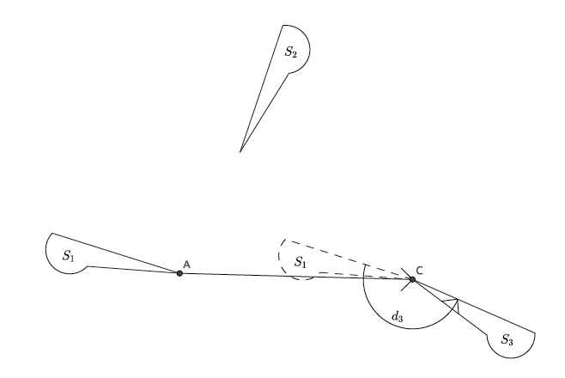
Sample student response: Let there be a translation along vector $\vec{AC}$. Let there be a rotation around point $C$, $d_{3}$ degrees. Let there be the reflection across the longest side of the figure so that $S_{1}$ maps onto $S_{3}$. Then, the $Translation (S_{1})$ followed by the $Rotation$ followed by the $Reflection=S_{3}.$ Because we found a congruence that maps $S_{1}$ to $S_{2}$; that is, $S_{1}≅S_{2}$, and another congruence that maps $S_{2}$ to $S_{3}$; that is, $S_{2}≅S_{3}$, then we know for certain that $S_{1}≅S_{3}$.

Discussion and Exercise 2 (10 minutes)
Ask the students if they really need to do all of the work they did in part (c) of Exercise 1.
Students should say no. The reason we do not need to do all of that work is because we already know that translations, rotations, and reflections preserve angle measures and lengths of segments. For that reason, if we know that $S_{1}≅S_{2}$ and $S_{2}≅S_{3}$, then $S_{1}≅S_{3}$.
Ask students to help summarize the basic properties of all three basic rigid motions.
Elicit from students the following three statements:
  - A basic rigid motion maps a line to a line, a ray to a ray, a segment to a segment, and an angle to an angle.
MP.8
  - A basic rigid motion preserves lengths of segments.
  - A basic rigid motion preserves measures of angles.
Ask students if they believe these same facts are true for sequences of basic rigid motions.
- Specifically, under a sequence of a translation followed by a rotation: If there is a translation along a vector $\vec{AB,}$ and there is a rotation of $d$ degrees around a center $O$, will a figure that is sequenced remain rigid? That is, will lengths and angles be preserved? Will lines remain lines, segments remain segments, etc.?
  - Students should say that yes, sequences of rigid motions also have the same basic properties of rigid motions in general.
If students are unconvinced, have them complete Exercise 2; then, discuss again.
- Given that sequences enjoy the same basic properties of basic rigid motions, we can state three basic properties of congruences:
(Congruence 1) A congruence maps a line to a line, a ray to a ray, a segment to a segment, and an angle to an angle.
MP.8
(Congruence 2) A congruence preserves lengths of segments.
(Congruence 3) A congruence preserves measures of angles.
Exercise 2
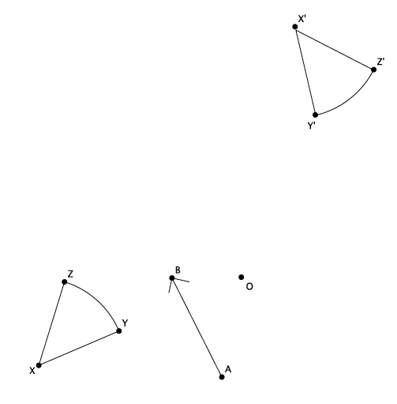
Perform the sequence of a translation followed by a rotation of Figure $XYZ$, where $T$ is a translation along a vector $\vec{AB}$, and $R$ is a rotation of $d$ degrees (you choose $d$) around a center $O$. Label the transformed figure $X^{'}Y^{'}Z^{'}$. Will $XYZ≅X^{'}Y^{'}Z^{'}$?

After this exercise, students should be convinced that a sequence of rigid motions maintains the basic properties of individual basic rigid motions. They should clearly see that the figure $XYZ$ that they traced in red is exactly the same, i.e., congruent, to the transformed figure $X^{'}Y^{'}Z^{'}$.

Closing (5 minutes)
Summarize, or have students summarize, the lesson.
- We now have a definition for congruence, i.e., a sequence of basic rigid motions.
- We now have new notation for congruence, $≅$.
- The properties that apply to the individual basic rigid motions also apply to congruences.
Lesson Summary
Given that sequences enjoy the same basic properties of basic rigid motions, we can state three basic properties of congruences:
(Congruence 1) A congruence maps a line to a line, a ray to a ray, a segment to a segment, and an angle to an angle.
(Congruence 2) A congruence preserves lengths of segments.
(Congruence 3) A congruence preserves measures of angles.
The notation used for congruence is $≅$.

Exit Ticket (5 minutes)

Name Date
Lesson 11: Definition of Congruence and Some Basic Properties

Exit Ticket

- Is $△ABC≅ △A^{'}B^{'}C^{'}$? If so, describe a sequence of rigid motions that proves they are congruent. If not, explain how you know.
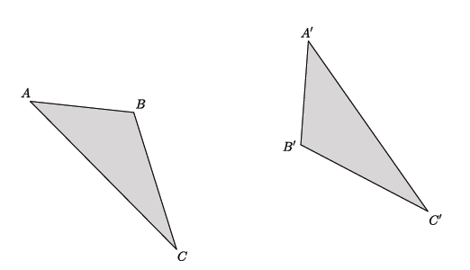

- Is $△ABC≅ △A^{'}B^{'}C^{'}$? If so, describe a sequence of rigid motions that proves they are congruent. If not, explain how you know.
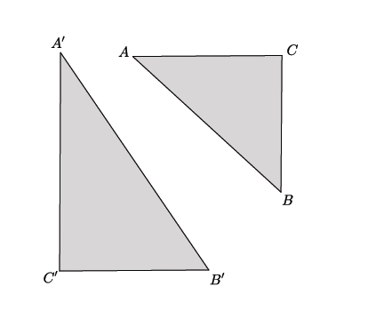
Exit Ticket Sample Solutions

- Is $△ABC≅△A^{'}B^{'}C^{'}$? If so, describe a sequence of rigid motions that proves they are congruent. If not, explain how you know.
Sample student response: Yes, $△ABC≅△A^{'}B^{'}C^{'}$. Translate $△A^{'}B^{'}C^{'}$ along vector $\vec{A'A}$. Rotate
$△A^{'}B^{'}C^{'}$ around center $A$, $d$ degrees until side $A^{'}C^{'}$ coincides with side $AC$. Then, reflect across line $AC$.

- Is $△ABC≅△A^{'}B^{'}C^{'}$? If so, describe a sequence of rigid motions that proves they are congruent. If not, explain how you know.
Sample student response: No, $△ABC$is not congruent to$△A^{'}B^{'}C^{'}$. Though I could translate and rotate to get some of the parts from each triangle to coincide, there is no rigid motion that would map side $A^{'}C^{'}$ to $AC$ or side $A^{'}B^{'}$ to side $AB$, because they are different lengths. Basic rigid motions preserve length, so no sequence would map $△A^{'}B^{'}C^{'}$ onto $△ABC$.

Problem Set Sample Solutions
Students practice describing sequences of rigid motions that produce a congruence.

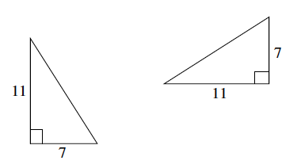
- Given two right triangles with lengths shown below, is there one basic rigid motion that maps one to the other? Explain.
Yes, a rotation of $d$ degrees around some center would map one triangle onto the other. The rotation would map the right angle to the right angle; the sides of length $7$ and length $11$ would then coincide.

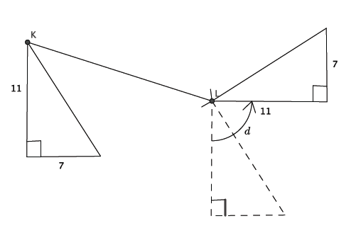
- Are the two right triangles shown below congruent? If so, describe a congruence that would map one triangle onto the other.
Sample student response: Yes, they are congruent. Let there be the translation along vector $\vec{KL}$. Let there be the rotation around point $L$, $d$ degrees. Then, the translation followed by the rotation will map the triangle on the left to the triangle on the right.

- Given two rays, $\vec{OA}$ and $\vec{O'A'}$:
  - Describe a congruence that maps $\vec{OA}$ to $\vec{O'A'}$.
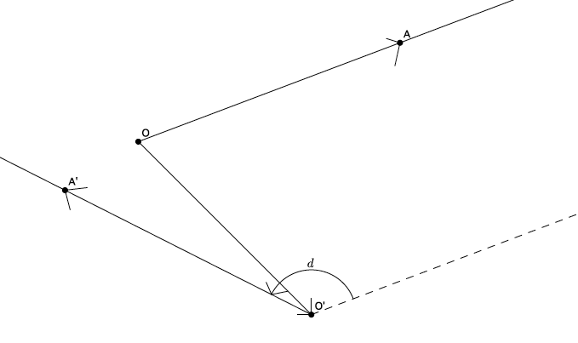
Sample student response: Let there be the translation along vector $\vec{OO'}$. Let there be the rotation around point $O^{'}$, $d$ degrees. Then, the $Translation(\vec{OA})$ followed by the $Rotation=\vec{O'A'}$.

  - Describe a congruence that maps $\vec{O'A'}$ to $\vec{OA}$.
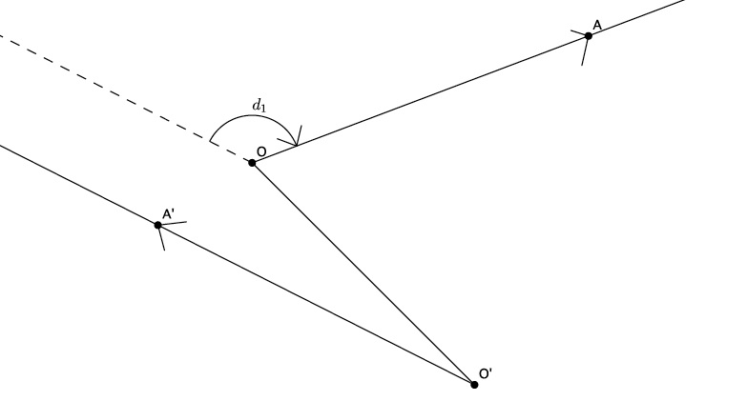
Sample student response: Let there be the translation along vector $\vec{O'O}$. Let there be the rotation around point $O$, $d_{1}$ degrees. Then, the $Translation (\vec{O^{'}A^{'}})$ followed by the $Rotation=\vec{OA}$.

