Lesson 10: Sequences of Rigid Motions

Classwork

Exercises

1. In the following picture, triangle can be traced onto a transparency and mapped onto triangle .

Which basic rigid motion, or sequence of, would map one triangle onto the other?

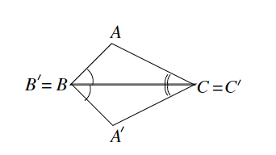

1. In the following picture, triangle can be traced onto a transparency and mapped onto triangle .

Which basic rigid motion, or sequence of, would map one triangle onto the other?

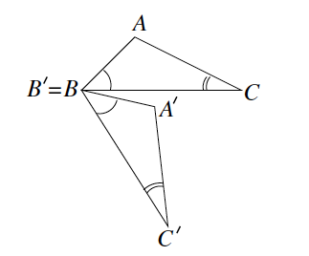.

1. In the following picture, triangle can be traced onto a transparency and mapped onto triangle .

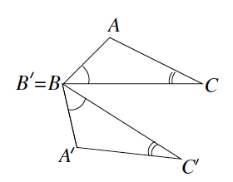Which basic rigid motion, or sequence of, would map one triangle onto the other?

1. In the following picture, we have two pairs of triangles. In each pair, triangle can be traced onto a transparency and mapped onto triangle .

Which basic rigid motion, or sequence of, would map one triangle onto the other?

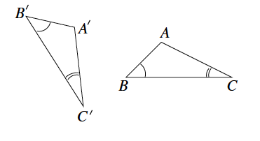Scenario 1:

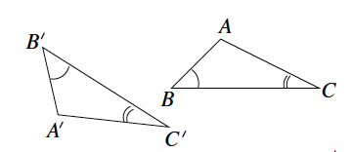Scenario 2:

1. Let two figures and be given so that the length of curved segment equals the length of curved segment , , and . With clarity and precision, describe a sequence of rigid motions that would map figure onto figure *.*

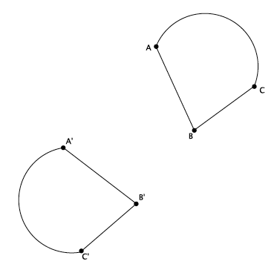

Problem Set

1. Let therebe the translation along vector , let there be the rotation around point *,* degrees (clockwise), and let there be the reflection across line . Let be the figure as shown below. Show the location of after performing the following sequence: a translation followed by a rotation followed by a reflection.

Macintosh HD:Users:shassan:Dropbox:Module 2:Images:Sequence Rigid Motions:ps 1 s.pdf

1. Would the location of the image of in the previous problem be the same if the translation was performed last instead of first, i.e., does the sequence: translation followed by a rotation followed by a reflection equal a rotation followed by a reflection followed by a translation? Explain.
2. Use the same coordinate grid to complete parts (a)–(c).

Macintosh HD:Users:shassan:Desktop:ps 2b.pdf

* 1. Reflect triangle across the vertical line, parallel to the -axis, going through point . Label the transformed points *, ,*  as ,,, respectively.
  2. Reflect triangle across the horizontal line, parallel to the -axis going through point . Label the transformed points of , , as , , , respectively.
  3. Is there a single rigid motion that would map triangle to triangle ?