Lesson 10: Sequences of Rigid Motions

Student Outcomes
- Students describe a sequence of rigid motions that maps one figure onto another.

Classwork
Example 1 (8 minutes)
So far, we have seen how to sequence translations, sequence reflections, sequence translations and reflections, and sequence translations and rotations. Now that we know about rotation, we can move geometric figures around the plane by sequencing a combination of translations, reflections, and rotations.
Let’s examine the following sequence:
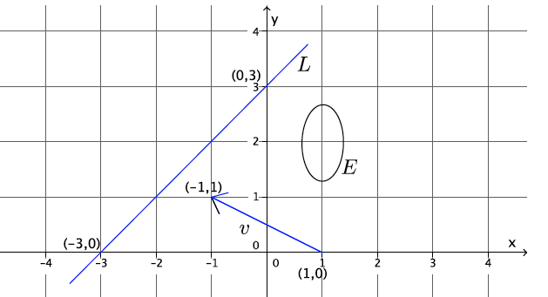
- Let $E$ denote the ellipse in the coordinate plane as shown.

- Let ${Translation}_{1}$ be the translation along the vector $\vec{v}$ from $(1,0)$ to $(-1,1)$, let ${Rotation}_{2}$ be the $90$degree rotation around $(-1,1)$, and let ${Reflection}_{3}$ be the reflection across line $L$ joining $(-3,0)$ and $(0,3)$. What is the $Translation_{1}\left(E\right)$ followed by the $Rotation_{2}(E)$ followed by the $Reflection_{3}(E)$?

- Which transformation do we perform first, the translation, the reflection, or the rotation? How do you know? Does it make a difference?
  - The order in which transformations are performed makes a difference. Therefore, we perform the translation first. So now, we let $E_{1}$ be ${Translation}_{1}\left(E\right)$.
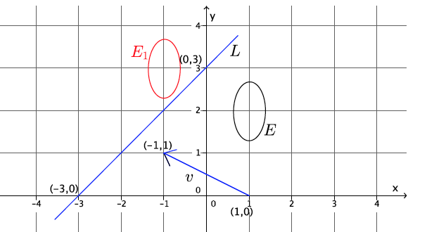

- Which transformation do we perform next?
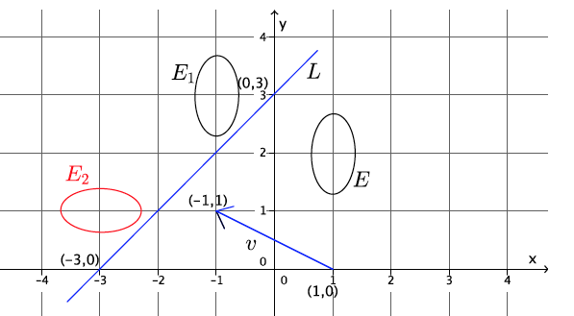
  - The rotation. So now, we let $E_{2}$ be the image of $E$ after the $Translation_{1}(E)$ followed by the $Rotation_{2}(E)$.

- Now, the only transformation left is ${Reflection}_{3}$. So now, we let $E_{3}$ be the image of$E$ after the $Translation_{1}(E)$ followed by the $Rotation_{2}(E)$ followed by the $Reflection_{3}\left(E\right).$
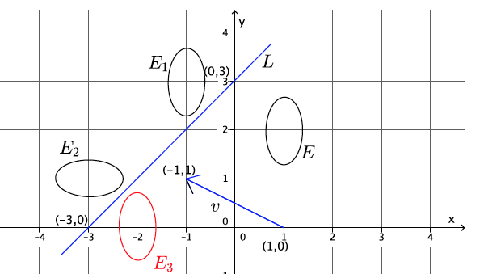
Video Presentation (2 minutes)
Students have seen this video in an earlier lesson, but now that they know about rotation, it is worthwhile to watch it again.
www.youtube.com/watch?v=O2XPy3ZLU7Y

Exercises 1–5 (25 minutes)
Give students one minute or less to work independently on Exercise 1, then have the discussion with them that follows the likely student response. Repeat this process for Exercises 2 and 3. For Exercise 4, have students work in pairs. One student can work on Scenario 1 and the other on Scenario 2, or each student can do both scenarios and then compare with their partner.

Exercises
- In the following picture, triangle $ABC$ can be traced onto a transparency and mapped onto triangle $A^{'}B^{'}C^{'}$.
Which basic rigid motion, or sequence of, would map one triangle onto the other?
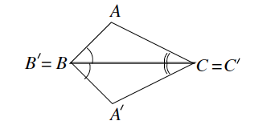
Solution provided below with likely student responses.
Yes, reflection.

Elicit more information from students by asking the following:
- Reflection requires some information about which line to reflect over; can you provide a clearer answer?
  - Reflect over line $L_{BC}$.

Expand on their answer: Let there be a reflection across the line $L_{BC}$. We claim that the reflection maps $△ABC$ onto $△A^{'}B^{'}C^{'}.$ We can trace $△A^{'}B^{'}C^{'}$ on the transparency and see that when we reflect across line $L_{BC}$, $△A^{'}B^{'}C^{'}$ maps onto $△ABC.$ The reason is because $∠B$ and $∠B^{'}$ are equal, and the ray $\vec{B^{'}A^{'}}$ on the transparency falls on the ray $\vec{BA}$. Similarly, the ray $\vec{C^{'}A^{'}}$ falls on the ray $\vec{CA}$. By the picture, it is obvious that $A^{'}$ on the transparency falls exactly on $A$, so the reflection of $△A^{'}B^{'}C^{'}$ across $L_{BC}$ is exactly $△ABC.$
Note to Teacher: Here is the precise reasoning without appealing to a transparency. Since a reflection does not move any point on $L_{BC}$, we already know that $Reflection\left(B^{'}\right)=B$ and $Reflection\left(C^{'}\right)=C.$ It remains to show the reflection maps $A^{'}$ to $A$. The hypothesis says $∠A^{'}BC=∠ABC$; therefore, the ray $\vec{BC}$ is the angle bisector [$∠$ bisector] of $∠ABA^{'}$. The reflection maps the ray$\vec{BA'}$ to the ray $\vec{BA}.$ Similarly, the reflection maps the ray $\vec{CA'}$ to the ray $\vec{CA}$. Therefore, the reflection maps the intersection of the rays $\vec{BA'}$ and $\vec{CA'}$, which is of course just $A^{'}$, to the intersection of rays $\vec{BA}$and $\vec{CA}$, which is, of course, just $A$. So, $Reflection\left(A^{'}\right)=A$; therefore, $Reflection\left(△A^{'}B^{'}C^{'}\right)=△ABC$.

- In the following picture, triangle $ABC$ can be traced onto a transparency and mapped onto triangle $A^{'}B^{'}C^{'}$.
Which basic rigid motion, or sequence of, would map one triangle onto the other?
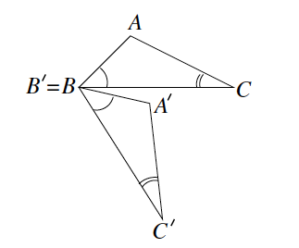
Rotation

Elicit more information from students by asking:
- Rotation requires some information about what point to rotate around (the center) and how many degrees. If we say we need to rotate $d$ degrees, can you provide a clearer answer?
  - Rotate around point $B$ as the center, $d$ degrees.

Expand on their answer: Let there be the (counterclockwise) rotation of d degrees around $B$, where $d$ is the (positive) degree of the $∠CBC^{'}$. We claim that the rotation maps $△A^{'}B^{'}C^{'}$ to $△ABC$. We can trace $△A^{'}B^{'}C^{'}$ on the transparency and see that when we pin the transparency at $B^{'}$ (same point as $B$) and perform a counterclockwise rotation of $d$ degrees, the segment $B^{'}C^{'}$ on the transparency maps onto segment $BC$ (both are equal in length because we can trace one on the transparency and show it is the same length as the other). The point $A^{'}$ on the transparency and $A$ are on the same side (half-plane) of line $L_{BC}$. Now, we are at the same point we were in the end of Exercise 1; therefore, $△A^{'}B^{'}C^{'}$ and $△ABC$ completely coincide.
Note to Teacher: Here is the precise reasoning without appealing to a transparency. By definition of rotation, rotation maps the ray $\vec{BC'}$ to the ray $\vec{BC}$. However, by hypothesis, $BC=BC^{'}$, so $Rotation\left(C^{'}\right)=C$. Now, the picture implies that after the rotation, $A$ and $Rotation(A)$ lie on the same side of line $L_{BC}$. If we compare the triangles $ABC$ and $Rotation\left(A^{'}B^{'}C^{'}\right)$, we are back to the situation at the end of Exercise 1; therefore, the reasoning given here shows that the two triangles coincide.

- In the following picture, triangle $ABC$ can be traced onto a transparency and mapped onto triangle $A^{'}B^{'}C^{'}$.
Which basic rigid motion, or sequence of, would map one triangle onto the other?
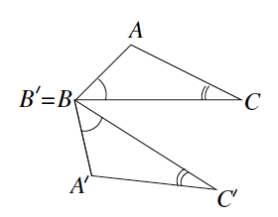
Rotation and reflection

Elicit more information from students. Prompt students to think back to what was needed in the last two examples.
- What additional information do we need to provide?
  - Rotate around point $B$ as the center $d$ degrees; then, reflect across line $L_{BC}$.
Expand on their answer: We need a sequence this time. Let there be the (counterclockwise) rotation of $d$ degrees around $B$, where $d$ is the (positive) degree of the $∠CBC^{'}$, and let there be the reflection across the line $L_{BC}$. We claim that the sequence rotation then reflection maps $△A^{'}B^{'}C^{'}$ to $△ABC$. We can trace $△A^{'}B^{'}C^{'}$ on the transparency and see that when we pin the transparency at $B^{'}$ (same point as $B$) and perform a counterclockwise rotation of $d$degrees, that the segment $B^{'}C^{'}$ on the transparency maps onto segment $BC$. Now, $△ABC$ and $△A^{'}B^{'}C^{'}$ are in the exact position as they were in the beginning of Example 2 (Exercise 1); therefore, the reflection across $L_{BC}$ would map $△A^{'}B^{'}C^{'}$on the transparency to $△ABC.$
Students may say that they want to reflect first, then rotate. The sequence can be completed in that order, but point out that we need to state which line to reflect across. In that case, we would have to find the appropriate line of reflection. For that reason, it makes more sense to bring a pair of sides together first, i.e., $BC$ and $BC^{'}$, by a rotation, then reflect across the common side of the two triangles. When the rotation is performed first, we can use what we know about Exercise 1.
Note to Teacher: Without appealing to a transparency, the reasoning is as follows. By definition of rotation, rotation maps the ray $\vec{BC'}$ to the ray $\vec{BC}$. However, by hypothesis, $BC=BC^{'}$, so $Rotation\left(C^{'}\right)=C$. Now, when comparing the triangles $ABC$ and $Rotation\left(A^{'}B^{'}C^{'}\right)$, we see that we are back to the situation in Exercise 1; therefore, the reflection maps the triangle $Rotation \left(△A^{'}B^{'}C^{'}\right)$ to triangle $△ABC$. This means that rotation then reflection maps $△A^{'}B^{'}C^{'}$ to
$$△ABC.$$

- In the following picture, we have two pairs of triangles. In each pair, triangle $ABC$ can be traced onto a transparency and mapped onto triangle $A^{'}B^{'}C^{'}$.
Which basic rigid motion, or sequence of, would map one triangle onto the other?
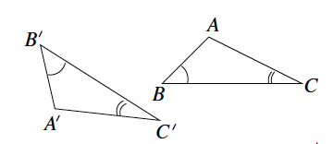
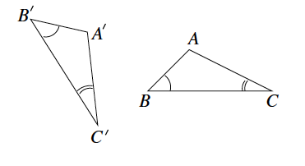
Scenario 1:
Scenario 2:

In Scenario 1, a translation and a rotation; in Scenario 2, a translation, a reflection, then a rotation

Elicit more information from students by asking the following:
- What additional information is needed for a translation?
  - We need to translate along a vector.
- Since there is no obvious vector in our picture, which vector should we draw and then use to translate along?
When they do not respond, prompt them to select a vector that would map a point from $△A^{'}B^{'}C^{'}$ to a corresponding point in $△ABC$. Students will likely respond,
  - Draw vector $\vec{B^{'}B}$ (or $\vec{A^{'}A}$ or $\vec{C^{'}C}$).
Make it clear to students that we can use any of the vectors they just stated, but using $\vec{B^{'}B}$ makes the most sense because we can use the reasoning given in the previous exercises rather than constructing the reasoning from the beginning (For example, in Exercises 1–3, $B=B'$).
Expand on their answer: Let there be the translation along vector $\vec{B^{'}B}$. In Scenario 1, the triangles $ABC$ and $Translation(A^{'}B^{'}C^{'})$ would be similar to the situation of Exercise 2. In Scenario 2, the triangles $ABC$ and $Translation(A^{'}B^{'}C^{'})$ would be similar to the situation of Exercise 3. Based on the work done in Exercises 2 and 3, we can conclude the following: In Scenario 1, the sequence of a translation along $\vec{B^{'}B}$ followed by a rotation around $B$ would map $△A^{'}B^{'}C^{'}$ to $△ABC$, and in Scenario 2, the sequence of a translation along $\vec{B^{'}B}$ followed by a rotation around $B$ and finally followed by the reflection across line $L_{BC}$ would map $△A^{'}B^{'}C^{'}$ to $△ABC$.
Students complete Exercise $5$ independently or in pairs.

- Let two figures $ABC$ and $A^{'}B^{'}C^{'}$ be given so that the length of curved segment $AC$ equals the length of curved segment $A^{'}C^{'}$, $\left|∠B\right|=\left|∠B^{'}\right|=80°$, and $\left|AB\right|=\left|A^{'}B^{'}\right|=5$. With clarity and precision, describe a sequence of rigid motions that would map figure $ABC$ onto figure $A^{'}B^{'}C^{'}$.
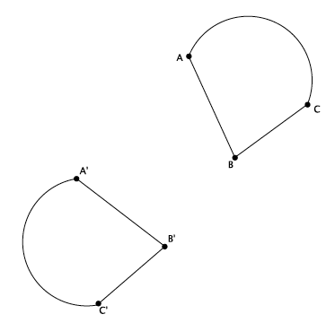
Let there be the translation along vector $\vec{AA^{'}}$, let there be the rotation around point $A$ $d$ degrees, and let there be the reflection across line $L_{AB}$. Translate so that $Translation(A^{'})=A$. Rotate so that $Rotation(B^{'})=B$ and $Rotation(A^{'}B^{'})$ coincides with $AB$ (by hypothesis, they are the same length, so we know they will coincide). Reflect across $L_{AB}$ so that $Reflection\left(C^{'}\right)=C$ and $Reflection\left(C^{'}B^{'}\right)=CB$ (by hypothesis, $\left|∠B\right|=\left|∠B^{'}\right|=80°$, so we know that segment $C^{'}B^{'}$ will coincide with $CB$). By hypothesis, the length of the curved segment $A^{'}C^{'}$ is the same as the length of the curved segment $AC$, so they will coincide. Therefore, a sequence of translation, then rotation, and then reflection will map figure $A^{'}B^{'}C^{'}$ onto figure $ABC$.

Closing (5 minutes)
Summarize, or have students summarize, the lesson and what they know of rigid motions to this point:
- We can now describe, using precise language, how to sequence rigid motions so that one figure maps onto another.

Exit Ticket (5 minutes)

Name Date
Lesson 10: Sequences of Rigid Motions

Exit Ticket

Triangle $ABC$ has been moved according to the following sequence: a translation followed by a rotation followed by a reflection. With precision, describe each rigid motion that would map $△ABC$ onto $△A^{'}B^{'}C^{'}$. Use your transparency and add to the diagram if needed.
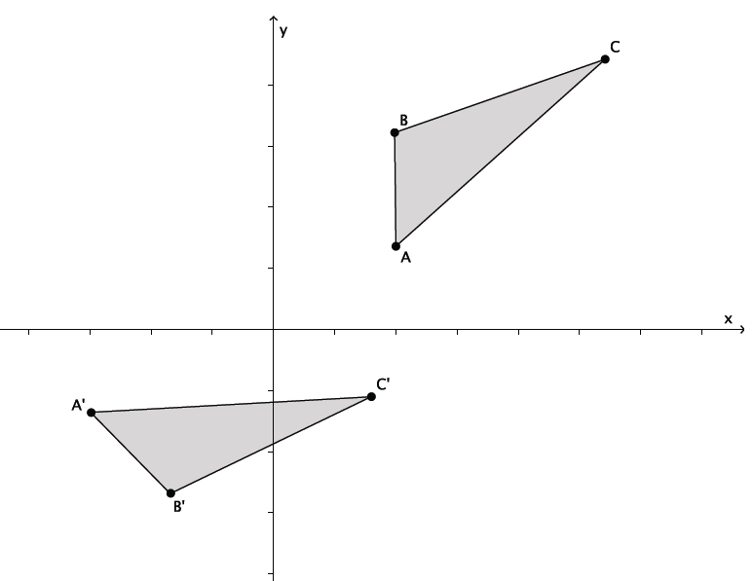

Exit Ticket Sample Solutions

Triangle $ABC$ has been moved according to the following sequence: a translation followed by a rotation followed by a reflection. With precision, describe each rigid motion that would map $△ABC$ onto $△A^{'}B^{'}C^{'}$. Use your transparency and add to the diagram if needed.
Let there be the translation along vector $\vec{AA^{'}}$ so that $A=A^{'}$. Let there be the clockwise rotation by $d$ degrees around point $A^{'}$ so that $C=C^{'}$ and $AC=A^{'}C^{'}$. Let there be the reflection across $L_{A^{'}C^{'}}$ so that $B=B^{'}$.

Problem Set Sample Solutions

- Let there be the translation along vector $\vec{v}$, let there be the rotation around point $A$, $-90$ degrees (clockwise), and let there be the reflection across line $L$. Let $S$ be the figure as shown below. Show the location of $S$ after performing the following sequence: a translation followed by a rotation followed by a reflection.
Solution is shown in red.
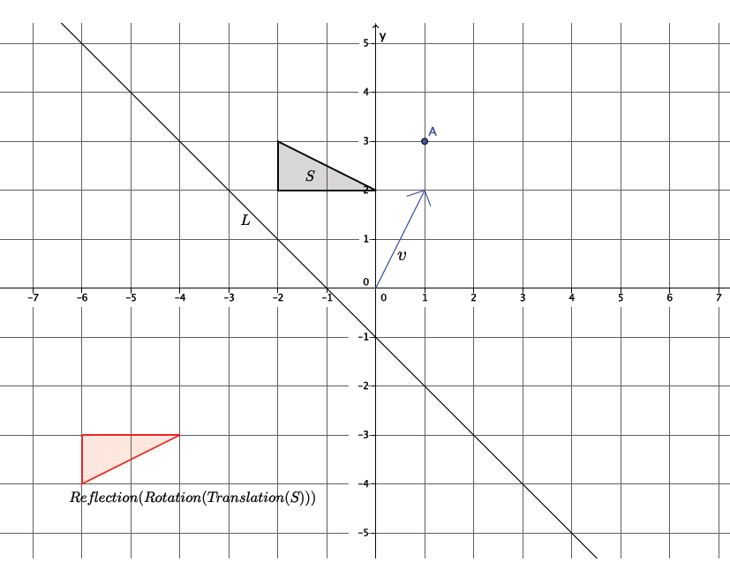

- Would the location of the image of $S$ in the previous problem be the same if the translation was performed last instead of first, i.e., does the sequence: translation followed by a rotation followed by a reflection equal a rotation followed by a reflection followed by a translation? Explain.
No, the order of the transformation matters. If the translation was performed last, the location of the image of $S$, after the sequence, would be in a different location than if the translation was performed first.

- Use the same coordinate grid to complete parts (a)–(c).
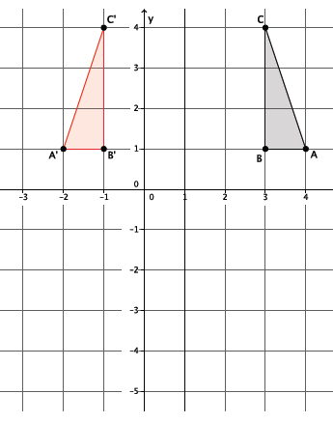
  - Reflect triangle $ABC$ across the vertical line, parallel to the $y$-axis, going through point $(1, 0)$. Label the transformed points $A$, $B$, $C$ as $A'$,$B'$,$C'$, respectively.

  - Reflect triangle $A'B'C'$ across the horizontal line, parallel to the $x$-axis going through point $(0, -1)$. Label the transformed points of $A'$, $B'$, $C'$ as $A^{''}$, $B^{''}$, $C''$, respectively.
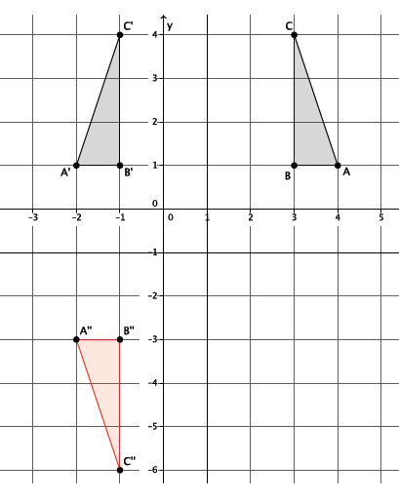

  - Is there a single rigid motion that would map triangle $ABC$ to triangle $A^{''}B^{''}C^{''}$?
Yes, a $180°$ rotation around center $(1, -1)$. The coordinate $(1, -1)$ happens to be the intersection of the two lines of reflection.

The video was developed by Larry Francis.

