|  |
| --- |
|  |

Lesson 9: Sequencing Rotations

Student Outcomes

* Students learn that sequences of rotations preserve lengths of segments as well as degrees of measures of angles.
* Students describe a sequence of rigid motions that would map a triangle back to its original position after being rotated around two different centers.

Classwork

Exploratory Challenge (35 minutes)

Exploratory Challenge

*Scaffolding:*

It may be beneficial to check student work periodically throughout the exploratory challenge. As necessary, provide teacher modeling.

1. Macintosh HD:Users:Stefanie:Desktop:ex chall 1 teacher.pdf
   1. Rotate degrees around center . Label the rotated image as .

Sample student work shown in blue.

* 1. Rotate degrees around center . Label the rotated image as .

Sample student work shown in red.

* 1. Measure and label the angles and side lengths of . How do they compare with the images and ?

Measures of corresponding sides and measures of corresponding angles of three triangles are equal.

* 1. How can you explain what you observed in part (c)? What statement can you make about properties of sequences of rotations as they relate to a single rotation?

We already knew that a single rotation would preserve the lengths of segments and degrees of angles. Performing one rotation after the other will not change the lengths of segments or degrees of angles. That means that sequences of rotations enjoy the same properties as a single rotation.

1. Macintosh HD:Users:shassan:Desktop:exploratory 2teachr.pdf
   1. Rotate degrees around center ,and then rotate again degrees around center . Label the image as after you have completed both rotations.

Possible student solution shown in diagram as .

* 1. Can a single rotation around center map onto ?

No, a single rotation around center will not map onto .

* 1. Can a single rotation around center map onto ?

No, a single rotation around center will not map onto .

* 1. Can you find a center that would map onto in one rotation? If so, label the center .

Yes, a-degree rotation around center will map onto .

Note: Students can only find the center through trial and error at this point. Finding the center of rotation for two congruent figures is a skill that will be formalized in high school Geometry.

Macintosh HD:Users:shassan:Desktop:exploratory 3teacher.pdf

1. Rotate (counterclockwise) around center , and then rotate the image another (counterclockwise) around center. Label the image .

Sample student work shown in blue.

1. Rotate (counterclockwise) around center , and then rotate the image another (counterclockwise) around center . Label the image .

Sample student work shown in red.

1. What do you notice about the locations of and ? Does the order in which you rotate a figure around different centers have an impact on the final location of the figure’s image?

The triangles are in two different locations. Yes, the order in which we rotate a figure around two different centers must matter because the triangles are not in the same location after rotating around centerand then center, compared to center and then center .

1. Macintosh HD:Users:shassan:Desktop:exploratory 4teacher.pdf
2. Rotate (counterclockwise) around center , and then rotate the image another (counterclockwise) around center . Label the.

Rotated triangle shown above.

1. Rotate (counterclockwise) around center , and then rotate the image another (counterclockwise) around center . Label the.

Rotated triangle shown above.

1. What do you notice about the locations of and ? Does the order in which you rotate a figure around the same center have an impact on the final location of the figure’s image?

The triangles are in the same location. This indicates that when a figure is rotated twice around the same center, it does not matter in which order you perform the rotations.

1. has been rotated around two different centers, and its image is . Describe a sequence of rigid motions that would map onto .

Macintosh HD:Users:shassan:Desktop:ex challenge 5.pdf

Translate along vector . Then, rotate around point until maps onto .

Closing (5 minutes)

Summarize, or have students summarize, the lesson.

* Sequences of rotations enjoy the same properties as single rotations. That is, a sequence of rotations preserves lengths of segments and degrees of measures of angles.
* The order in which a sequence of rotations around two different centers is performed matters. The order in which a sequence of rotations around the same center is performed does not matter.
* When a figure is rotated around two different centers, we can describe a sequence of rigid motions that would map the original figure onto the resulting image.

Lesson Summary

* **Sequences of rotations have the same properties as a single rotation:** 
  + **A sequence of rotations preserves degrees of measures of angles.**
  + **A sequence of rotations preserves lengths of segments.**
* **The order in which a sequence of rotations around different centers is performed matters with respect to the final location of the image of the figure that is rotated.**
* **The order in which a sequence of rotations around the same center is performed does not matter. The image of the figure will be in the same location.**

Exit Ticket (5 minutes)

Name Date

Lesson 9: Sequencing Rotations

Exit Ticket

1. Let be the rotation of a figure degrees around center . Let be the rotation of the same figure degrees around center . Does the of the figure followed by the equal a of the figure followed by the ? Draw a picture if necessary.
2. Angle underwent a sequence of rotations. The original size of . What was the size of the angle after the sequence of rotations? Explain.
3. Triangle underwent a sequence of rotations around two different centers. Its image is Describe a sequence of rigid motions that would map onto

Macintosh HD:Users:shassan:Desktop:etl93.pdf

Exit Ticket Sample Solutions

1. Let be the rotation of a figure degrees around center . Let be the rotation of the same figure degrees around center . Does the of the figure followed by the equal a of the figure followed by the ? Draw a picture if necessary.

No. If the sequence of rotations were around the same center, then it would be true. However, when the sequence involves two different centers, the order in which they are performed matters because the images will not be in the same location in the plane.

1. Angle underwent a sequence of rotations. The original size of . What was the size of the angle after the sequence of rotations? Explain.

Since sequences of rotations enjoy the same properties as a single rotation, then the measure of any image of under any sequence of rotations will remain . Rotations and sequences of rotations preserve the measure of degrees of angles.

1. Triangle underwent a sequence of rotations around two different centers. Its image is . Describe a sequence of rigid motions that would map onto .

Macintosh HD:Users:shassan:Desktop:etl93.pdf

Translate along vector . Then, rotate degrees around point until maps onto .

Problem Set Sample Solutions

1. Refer to the figure below.

Macintosh HD:Users:shassan:Desktop:ps1.pdf

* 1. Rotate and segment degrees around center , then degrees around center . Label the final location of the images as and *.*
  2. What is the size of , and how does it compare to the size of ? Explain.

The measure of . The measure of . The angles are equal in measure because a sequence of rotations will preserve the degrees of an angle.

* 1. What is the length of segment , and how does it compare to the length of segment ? Explain.

The length of segment is cm. The length of segment is also cm. The segments are equal in length because a sequence of rotations will preserve the length of segments.

1. Refer to the figure given below.

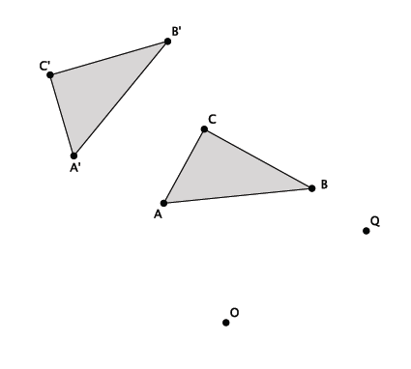

* 1. Let be a counterclockwise rotation of around the center . Let be a clockwise rotation of around the center . Determine the approximate location of followed by Label the image of triangle as *.*
  2. Describe the sequence of rigid motions that would map onto .

The image of is shown above. Translate along vector . Rotate degrees around center . Then, will map onto .

1. Refer to the figure given below.

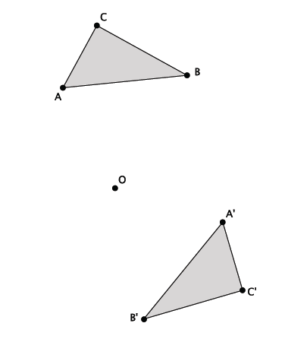

Let be a rotation of around the center . Let be a rotation of around the same center . Determine the approximate location of followed by Label the image of triangle as *.*

The image of is shown above.