Lesson 8: Sequencing Reflections and Translations

Classwork

Exercises 1–3

Use the figure below to answer Exercises 1–3.

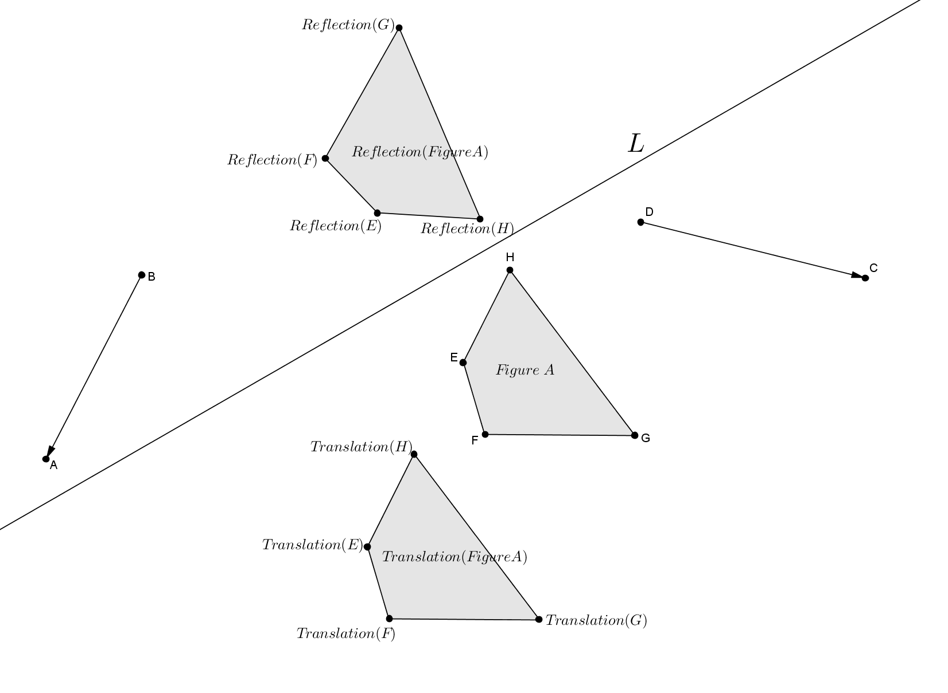

1. Figure A was translated along vector resulting in . Describe a sequence of translations that would map Figure A back onto its original position.
2. Figure A was reflected across line resulting in . Describe a sequence of reflections that would map Figure A back onto its original position.

1. Can of Figure A undo the transformation of of Figure A? Why or why not?

Exercises 4–7

Let be the black figure.

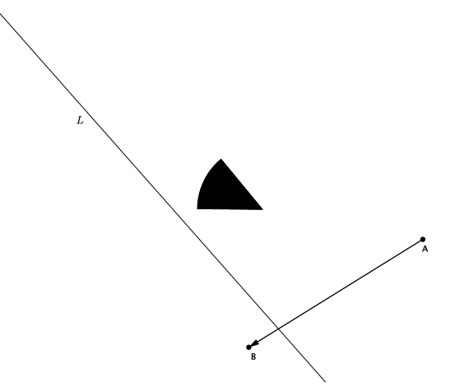

1. Let there be the translation along vector and a reflection across line .

Use a transparency to perform the following sequence: Translate figure ;then, reflect figure *.* Label the image .

1. Let there be the translation along vector and a reflection across line .

Use a transparency to perform the following sequence: Reflect figure ;then, translate figure *.* Label the image *.*

1. Using your transparency, show that under a sequence of any two translations, and (along different vectors), that the sequence of the followed by the is equal to the sequence of the followed by the *.* That is, draw a figure, , and two vectors. Show that the translation along the first vector, followed by a translation along the second vector, places the figure in the same location as when you perform the translations in the reverse order. (This fact will be proven in high school). Label the transformed image . Now, draw two new vectors and translate along them just as before. This time, label the transformed image . Compare your work with a partner. Was the statement “the sequence of the followed by the is equal to the sequence of the followed by the ” true in all cases? Do you think it will always be true?
2. Does the same relationship you noticed in Exercise 6 hold true when you replace one of the translations with a reflection. That is, is the following statement true: A translation followed by a reflection is equal to a reflection followed by a translation?

Lesson Summary

* A reflection across a line followed by a reflection across the same line places all figures in the plane back onto their original position.
* A reflection followed by a translation does not place a figure in the same location in the plane as a translation followed by a reflection. The order in which we perform a sequence of rigid motions matters.

Problem Set

1. 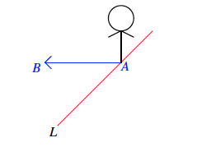Let there be a reflection across line , and let there be a translation along vector , as shown. If denotes the black figure, compare the translation of followed by the reflection of with the reflection of followed by the translation of *.*
2. Let and be parallel lines, and let and be the reflections across and , respectively (in that order). Show that a followed by is not equal to a followed by . (Hint: Take a point on and see what each of the sequences does to it.)

Macintosh HD:Users:shassan:Desktop:ps 2b.pdf

1. Let and be parallel lines, and let and be the reflections across and , respectively (in that order). Can you guess what followed by is? Give as persuasive an argument as you can. (Hint: Examine the work you just finished for the last problem.)