Lesson 8: Sequencing Reflections and Translations

Student Outcomes
- Students learn that the reflection is its own inverse transformation.
- Students understand that a sequence of a reflection followed by a translation is not necessarily equal to a translation followed by a reflection.

Classwork
Discussion (10 minutes)
- Lesson 7 was an introduction to sequences of translations. It was clear that when a figure was translated along a vector, we could undo the move by translating along the same vector, but in the opposite direction, creating an inverse transformation.
- Note that not all transformations can be undone. For that reason, we will investigate sequences of reflections.
- Let there be a reflection across line $L$. What would undo this action? What is the inverse of this transformation?
  - A reflection is always its own inverse.
- Consider the picture below of a reflection across a vertical line $L$.
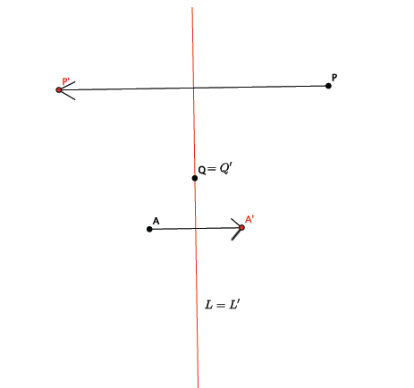
- Trace this picture of the line $L$and the points $P$, $A$, and $Q$ as shown. Create a reflection across line $L$followed by another reflection across line $L.$ Is the transformation corresponding to flipping the transparency once across $L$, and then flipping it once more across$L$? Obviously, the red figure on the transparency would be right back on top of the original black figure. Everything stays the same.
Let us take this opportunity to reason through the preceding fact without a transparency.
- For a point $P$ not on line$L$, what would the refletion of the reflection of point $P$ be?
- The picture shows $Reflection(P)=P'$ is a point to the left of $L$, and if we reflect the point $P'$ across$L$, clearly we get back to $P$ itself. Thus the reflection of the reflection of point $P$ is $P$ itself. The same holds true for $A$: the reflection of the reflection of point $A$is $A$.
- For point $Q$on the line $L$, what would the reflection of the reflection of point $Q$ be?
- The lesson on reflection showed us that a point on the line of reflection is equal to itself, i.e., $Reflection(Q)=Q$. Then, the reflection of the reflection of point $Q$ is $Q$. No matter how many times a point on the line of reflection is reflected, it will be equal to itself.
- Based on the last two statements, we can say that the reflection of the reflection of $P$ is $P$ for any point $P$in the plane. Further,
reflection of $P$followed by the reflection of $P=I$, (4)
where$I$ denotes the identity transformation (Lesson 1). In terms of transparencies, equation (4) says that if we flip the transparency (on which we have traced a given figure in red) across the line of reflection $L$, then flipping it once more across $L$ brings the red figure to coincide completely with the original figure. In this light, equation (4) is hardly surprising!

Exercises 1–3 (3 minutes)
Students complete Exercises 1–3 independently.
Exercises 1–3
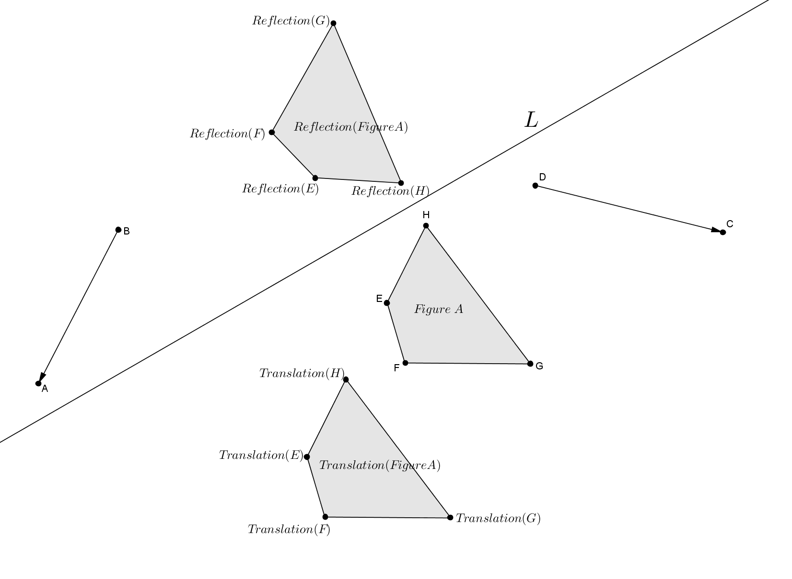
Use the figure below to answer Exercises 1–3.

- Figure A was translated along vector $\vec{BA}$ resulting in $Translation\left(Figure A\right)$. Describe a sequence of translations that would map Figure A back onto its original position.
Translate Figure A along vector $\vec{BA}$; then, translate the image of Figure A along vector $\vec{AB}$.

- Figure A was reflected across line $L$ resulting in $Reflection(Figure A)$. Describe a sequence of reflections that would map Figure A back onto its original position.
Reflect Figure A across line$L$; then, reflect Figure A across line $L$ again.

- Can ${Translation}_{\vec{BA}}$ of Figure A undo the transformation of ${Translation}_{\vec{DC}}$of Figure A? Why or why not?
No. To undo the transformation, you would need to move the image of Figure A after the translations back to Figure A. The listed translations do not do that.

Discussion (10 minutes)
- Does the order in which we sequence rigid motions really matter?
- Consider a reflection followed by a translation. Would a figure be in the same final location if the translation was done first then followed by the reflection?
- Let there be a reflection across line $L$ and let $T$be the translation along vector $\vec{AB}$. Let $E$represent the ellipse. The following picture shows the reflection of $E$ followed by the translation of $E$.
- Before showing the picture, ask students which transformation happens first: the reflection or the translation?
  - Reflection
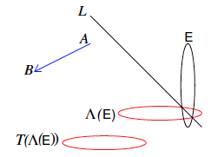
$$Reflection(E)$$
$$Reflection, then translation of (E)$$

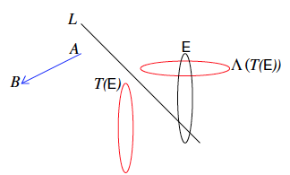
- Ask students again if they think the image of the ellipse will be in the same place if we translate first and then reflect. The following picture shows a translation of $E$ followed by the reflection of $E$.
$$Translation, then reflection of (E)$$
$$Translation(E)$$

- It must be clear now that the order in which the rigid motions are performed matters. In the above example, we saw that the reflection followed by the translation of $E$ is not the same as the translation followed by the reflection of $E$; therefore, a translation followed by a reflection and a reflection followed by a translation are not equal.

Video Presentation (2 minutes)
Show the video on the sequence of basic rigid motions located at http://youtu.be/O2XPy3ZLU7Y. Note that this video makes use of rotation, which will not be defined until Lesson 9. The video, however, does clearly convey the general idea of sequencing.

Exercises 4–7 (10 minutes)
Students complete Exercises 4, 5, and 7 independently. Students complete Exercise 6 in pairs.
Exercises 4–7
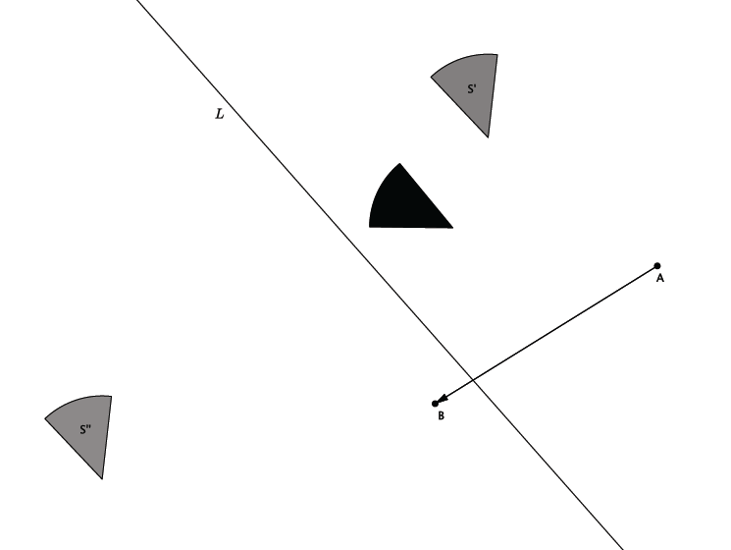
Let $S$ be the black figure.

- Let there be the translation along vector $\vec{AB}$ and a reflection across line $L$.
Use a transparency to perform the following sequence: Translate figure $S$; then, reflect figure $S$. Label the image $S'$.
Solution on the diagram above.

- Let there be the translation along vector $\vec{AB}$ and a reflection across line $L$.
Use a transparency to perform the following sequence: Reflect figure $S$; then, translate figure $S$. Label the image $S''$.
Solution on the diagram above.

- Using your transparency, show that under a sequence of any two translations, $Translation$ and ${Translation}_{0}$ (along different vectors), that the sequence of the $Translation$ followed by the ${Translation}_{0}$ is equal to the sequence of the ${Translation}_{0}$ followed by the $Translation$. That is, draw a figure, $A$, and two vectors. Show that the translation along the first vector, followed by a translation along the second vector, places the figure in the same location as when you perform the translations in the reverse order. (This fact will be proven in high school). Label the transformed image $A'$. Now, draw two new vectors and translate along them just as before. This time, label the transformed image $A''$. Compare your work with a partner. Was the statement “the sequence of the $Translation$ followed by the ${Translation}_{0}$ is equal to the sequence of the ${Translation}_{0}$ followed by the $Translation$” true in all cases? Do you think it will always be true?
Sample Student Work:
First, let $T$ be the translation along vector $\vec{AB}$, and let $T_{0}$ be the translation along vector $\vec{CD}$.
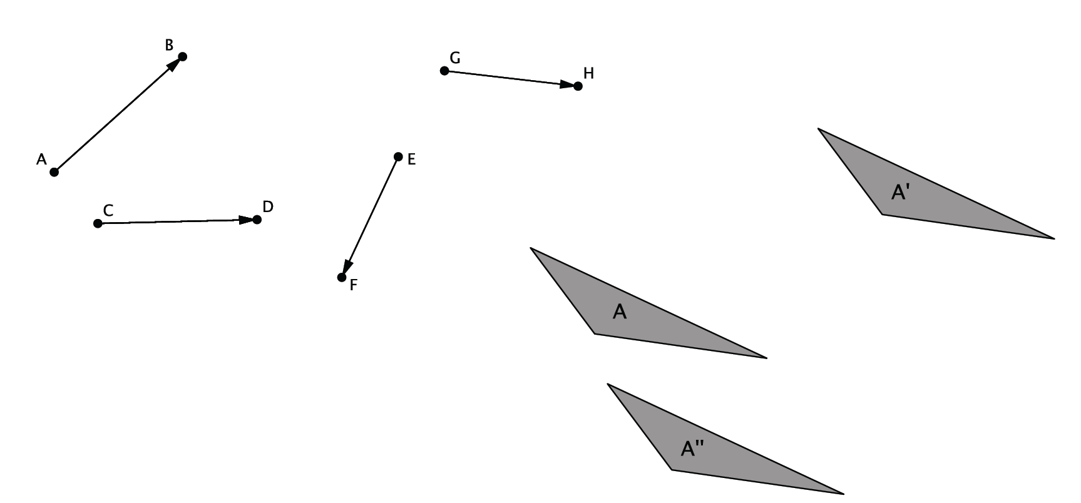
Then, let $T$ be the translation along vector $\vec{EF}$, and let $T_{0}$ be the translation along vector $\vec{GH}$.

- Does the same relationship you noticed in Exercise 6 hold true when you replace one of the translations with a reflection. That is, is the following statement true: A translation followed by a reflection is equal to a reflection followed by a translation?
No. The translation followed by a reflection would put a figure in a different location in the plane when compared to the same reflection followed by the same translation.

Closing (5 minutes)
Summarize, or have students summarize, the lesson.
- We can sequence rigid motions.
- We have notation related to sequences of rigid motions.
- The sequence of a reflection followed by the same reflection is the identity transformation, and the order in which we sequence rigid motions matters.

Lesson Summary
- A reflection across a line followed by a reflection across the same line places all figures in the plane back onto their original position.
- A reflection followed by a translation does not place a figure in the same location in the plane as a translation followed by a reflection. The order in which we perform a sequence of rigid motions matters.

Exit Ticket (5 minutes)
Name Date
Lesson 8: Sequencing Reflections and Translations

Exit Ticket

Draw a figure, $A$, a line of reflection, $L$, and a vector $\vec{FG}$ in the space below. Show that under a sequence of a translation and a reflection that the sequence of the reflection followed by the translation is not equal to the translation followed by the reflection. Label the figure as $A'$ after finding the location according to the sequence reflection followed by the translation, and label the figure$A''$ after finding the location according to the composition translation followed by the reflection. If $A'$ is not equal to $A''$, then we have shown that the sequence of the reflection followed by a translation is not equal to the sequence of the translation followed by the reflection. (This will be proven in high school.)

Exit Ticket Sample Solutions

Draw a figure, $A$, a line of reflection, $L$, and a vector $\vec{FG}$ in the space below. Show that under a sequence of a translation and a reflection, that the sequence of the reflection followed by the translation is not equal to the translation followed by the reflection. Label the figure as $A'$ after finding the location according to the sequence reflection followed by the translation, and label the figure$A''$after finding the location according to the composition translation followed by the reflection. If $A'$ is not equal to $A''$, then we have shown that the sequence of the reflection followed by a translation is not equal to the sequence of the translation followed by the reflection. (This will be proven in high school.)
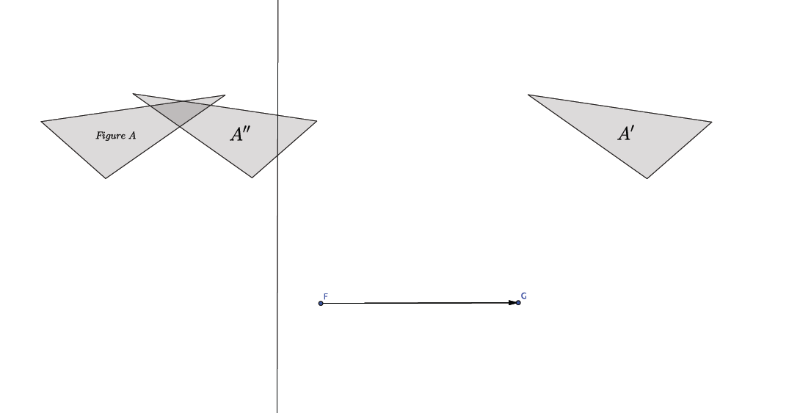
Sample student drawing:

Problem Set Sample Solutions

- Let there be a reflection across line $L$, and let there be a translation along vector $\vec{AB}$, as shown. If $S$denotes the black figure, compare the translation of $S$followed by the reflection of $S$with the reflection of $S$ followed by the translation of $S$.
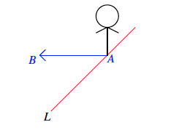
Students should notice that the two sequences place figure $S$ in different locations in the plane.

- Let $L_{1}$ and $L_{2}$ be parallel lines, and let ${Reflection}_{1}$ and ${Reflection}_{2}$ be the reflections across $L_{1}$ and $L_{2}$, respectively (in that order). Show that a ${Reflection}_{2}$followed by $Reflection_{1}$ is not equal to a $Reflection_{1}$followed by $Reflection_{2}$. (Hint: Take a point on $L_{1}$ and see what each of the sequences does to it.)
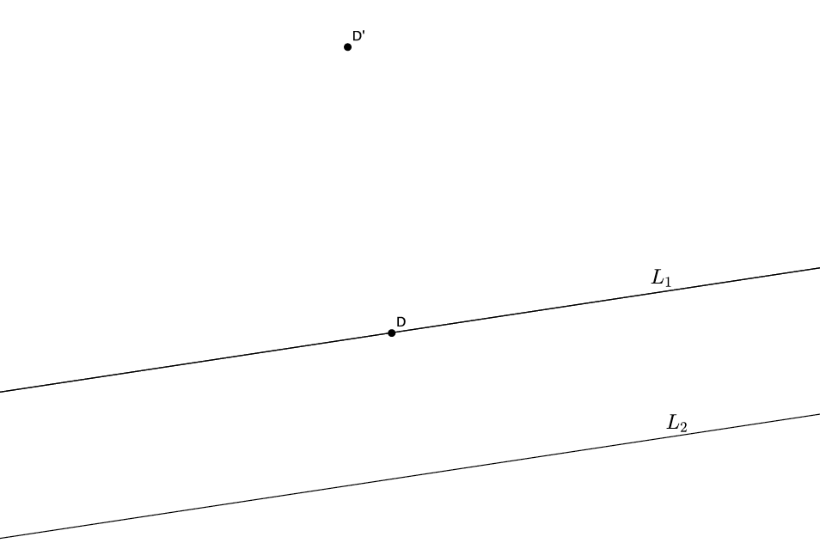
Let $D$ be a point on $L_{1}$, as shown, and let $D'={Reflection}_{2}$ followed by ${Reflection}_{1}$. Notice where $D'$ is.
$$D'$$
$$D$$

Let $D''={Reflection}_{1}$ followed by ${Reflection}_{2}$. Notice where the $D''$ is.
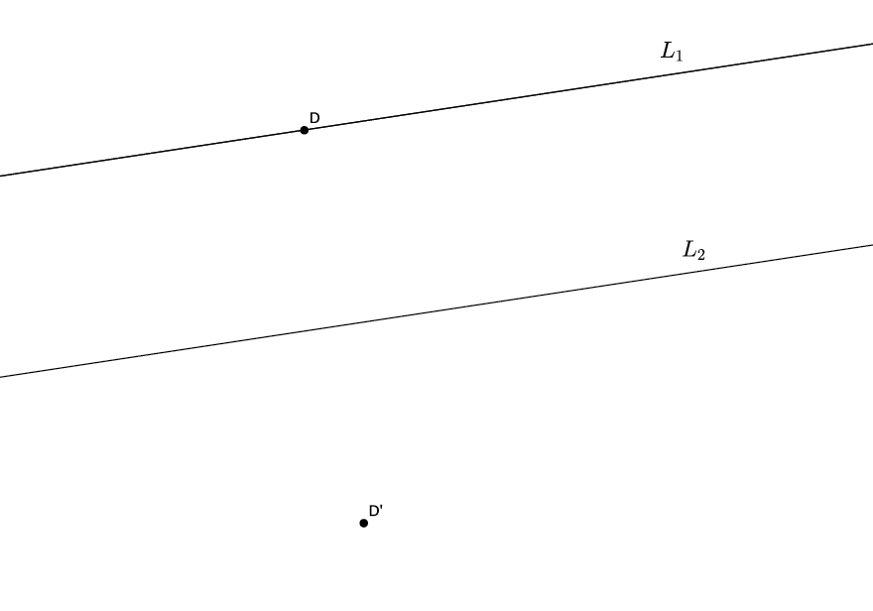
$$D''$$
$$D$$

Since $D'≠D''$, the sequences are not equal.

- Let $L_{1}$ and $L_{2}$ be parallel lines, and let ${Reflection}_{1}$ and ${Reflection}_{2}$ be the reflections across $L_{1}$ and $L_{2}$, respectively (in that order). Can you guess what ${Reflection}_{1}$ followed by ${Reflection}_{2}$ is? Give as persuasive an argument as you can. (Hint: Examine the work you just finished for the last problem.)
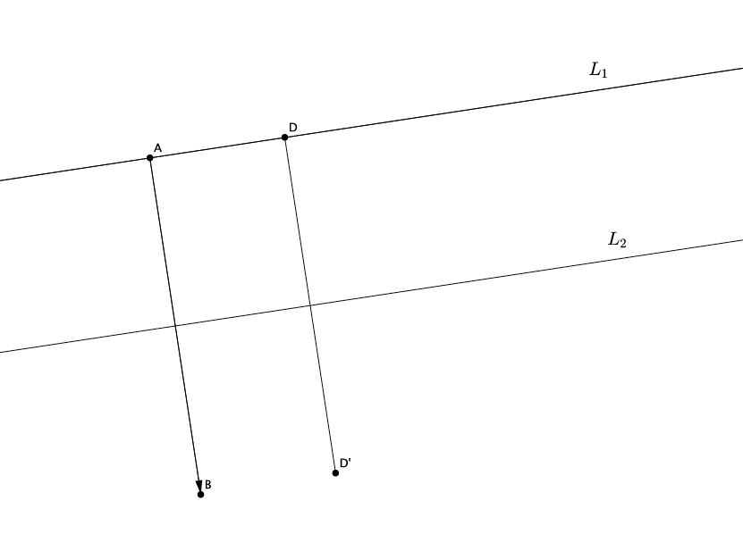
The sequence${Reflection}_{1}$ followed by ${Reflection}_{2}$ is just like the translation along a vector$\vec{AB}$, as shown below, where $AB⊥L_{1}$. The length of $AB$ is equal to twice the distance between $L_{1}$ and $L_{2}$.

