Lesson 7: Sequencing Translations

Classwork

Exploratory Challenge

1. Macintosh HD:Users:shassan:Dropbox:Module 2:Images:New Sequence Trans Lesson Images:exploratory challenge 1.pdf
   1. Translate and segment along vector Label the translated images appropriately, i.e., and .
   2. Translate and segment along vector Label the translated images appropriately, i.e., and
   3. How does the size of compare to the size of ?
   4. How does the length of segment compare to the length of the segment ?
   5. Why do you think what you observed in parts (d) and (e) were true?
2. Translate along vector and then translate its image along vector . Be sure to label the images appropriately.

Macintosh HD:Users:shassan:Dropbox:Module 2:Images:Sequence Translations:translate along FGS.pdf

1. Translate figure along vector . Then translate its image along vector . Label each image appropriately.

**Macintosh HD:Users:shassan:Desktop:compose T.pdf**

Macintosh HD:Users:shassan:Dropbox:Module 2:Images:New Sequence Trans Lesson Images:exploratory challenge 4.pdf

* 1. Translate Circle and Ellipse along vector . Label the images appropriately.
  2. Translate Circle and Ellipse along vector . Label each image appropriately.
  3. Did the size or shape of either figure change after performing the sequence of translations? Explain.

1. 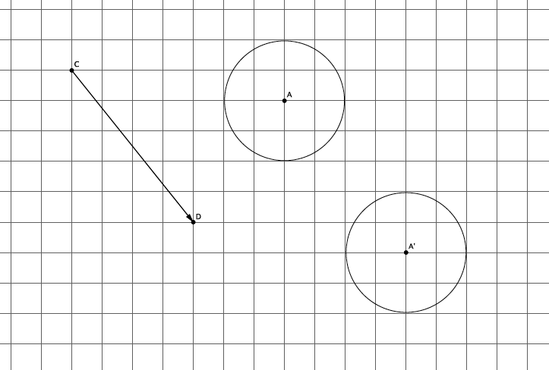The picture below shows the translation of Circle along vector . Name the vector that will map the image of Circle *A* back to its original position.
2. If a figure is translated along vector , what translation takes the figure back to its original location?

Lesson Summary

* Translating a figure along one vector then translating its image along another vector is an example of a sequence of transformations.
* A sequence of translations enjoys the same properties as a single translation. Specifically, the figures’ lengths and degrees of angles are preserved.
* If a figure undergoes two transformations, and , and is in the same place it was originally, then the figure has been mapped onto itself.

Problem Set

1. Sequence translations of parallelogram (a quadrilateral in which both pairs of opposite sides are parallel) along vectors and . Label the translated images.

Macintosh HD:Users:shassan:Dropbox:Module 2:Images:New Sequence Trans Lesson Images:Sequence Translations:compose parallelogram S.pdf

1. What do you know about and compared with and ? Explain.
2. Are and equal in length? How do you know?
3. Translate the curved shape along the given vector. Label the image.

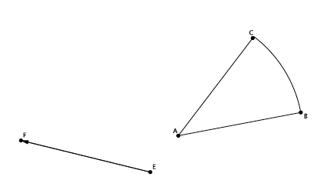

1. What vector would map the shape back onto *?*