|  |
| --- |
|  |

Lesson 7: Sequencing Translations

Student Outcomes

* Students learn about the sequence of transformations (one move on the plane followed by another) and that a sequence of translations enjoy the same properties as a single translation with respect to lengths of segments and degrees of angles.
* Students learn that a translation along a vector followed by another translation along a vector of the same length in the opposite direction can move all points of a plane back to its original position.

Classwork

Discussion (5 minutes)

* Is it possible to translate a figure more than one time? That is, translating a figure along one vector, then taking that figure and translating it along another vector?
  + *The simple answer is yes. It is called a* ***sequence of transformations*** *or, more specifically, a sequence of translations.*

MP.6

* Suppose we have two transformations of the plane, and . A point , under transformation , will be assigned to a new location, *Transformation*  denoted by . Transformation will assign to a new location, *Transformation*  denoted by . This is true for every point in the plane.
* 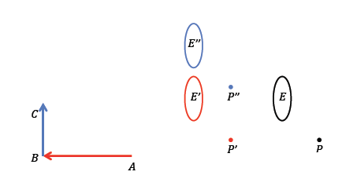In the picture below, the point and ellipse in black have undergone a sequence of transformations, first along the red vector where images are shown in red, and then along the blue vector where images are shown in blue.

Exploratory Challenge

Exercises 1–4 (22 minutes)

Students complete Exercises 1–4 individually or in pairs.

Exploratory Challenge

1. Macintosh HD:Users:shassan:Desktop:exploratory challenge 1teacher.pdf
   1. Translate and segment along vector . Label the translated images appropriately, i.e., and *.*

Images shown above in blue.

* 1. Translate and segment along vector . Label the translated images appropriately, i.e., and .

Images shown above in red.

* 1. How does the size of compare to the size of ?

The measure of is equal to the size of .

* 1. How does the length of segment compare to the length of the segment ?

The length of is equal to the length of .

* 1. Why do you think what you observed in parts (d) and (e) were true?

One translation of the plane moved the angle and the segment to a new location. We know that translations preserve lengths of segments and degrees of measures of angles. The second translation moved the images to another new location, also preserving the length of the segment and the measure of the angle. Therefore, performing two translations, or a sequence of translations, keeps lengths of segments and size of angles rigid.

1. 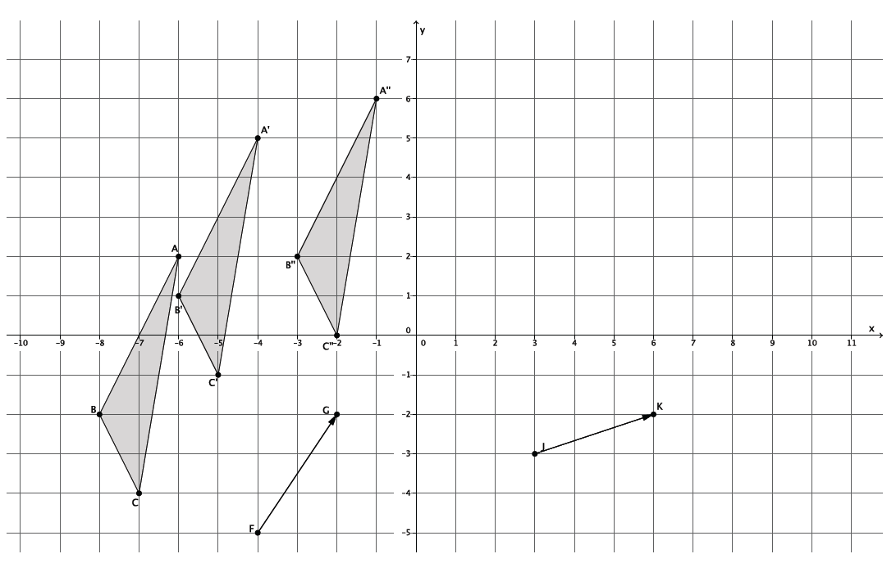Translate along vector and then translate its image along vector . Be sure to label the images appropriately.
2. Translate figure along vector . Then translate its image along vector . Label each image appropriately.

**Macintosh HD:Users:Stefanie:Desktop:compose T.pdf**

Macintosh HD:Users:shassan:Desktop:exploratory challenge 4teacher.pdf

* 1. Translate Circle and Ellipse along vector . Label the images appropriately.

Images shown above in blue.

* 1. Translate Circle and Ellipse along vector . Label each image appropriately.

Images shown above in red.

* 1. Did the size or shape of either figure change after performing the sequence of translations? Explain.

The circle and the ellipse remained the same in size and shape after the sequence of translations. Since translations are a basic rigid motion, a sequence of translations will maintain the shape and size of the figures rigid and unchanged.

Discussion (5 minutes)

* What need is there for sequencing transformations?
* Imagine life without an undo button on your computer or smartphone. If we move something in the plane, it would be nice to know we can move it back to its original position.
* Specifically, if a figure undergoes two transformations and , and ends up in the same place as it was originally, then the figure has been mapped onto itself.
* 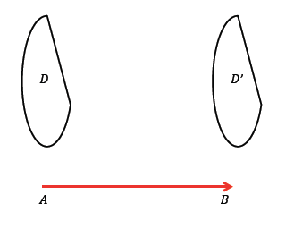Suppose we translate figure along vector .
* How do we undo this move? That is, what translation of figure along vector that would bring back to its original position?
  + 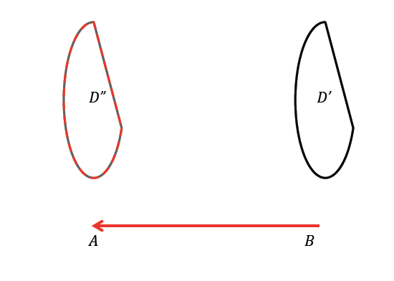*We translate (the image of ) along the vector .*
* All of the points in were translated to , and then translated again to . Because all of the points in (shown in grey under the dashed red lines of ) are also in (shown as the figure with the dashed red lines), we can be sure that we have performed a sequence of translations that map the figure back onto itself.
* The ability to undo something or put it back in its original place is obviously very desirable. We will see in the next few lessons that every basic rigid motion can be undone. That is one of the reasons we want to learn about basic rigid motions and their properties.

Exercises 5–6 (3 minutes)

Students continue with the Exploratory Challenge to complete Exercises 5 and 6 independently.

1. The picture below shows the translation of Circle along vector . Name the vector that will map the image of Circle *A* back to its original position.

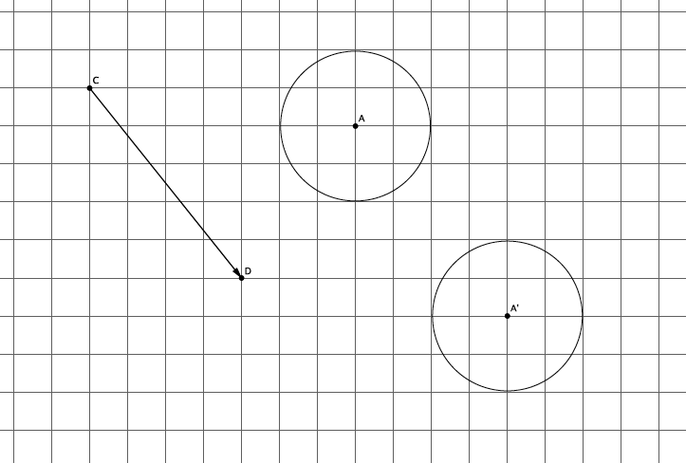

1. If a figure is translated along vector , what translation takes the figure back to its original location?

A translation along vector would take the figure back to its original location.

Closing (5 minutes)

Summarize, or have students summarize, the lesson.

* We know that we can sequence translations and the figure remains rigid, i.e., lengths of segments and degrees of measures of angles are preserved.
* Any translation of the plane can be undone, and figures can be mapped onto themselves.

Lesson Summary

* **Translating a figure along one vector then translating its image along another vector is an example of a sequence of transformations.**
* **A sequence of translations enjoys the same properties as a single translation. Specifically, the figures’ lengths and degrees of angles are preserved.**
* **If a figure undergoes two transformations, and , and is in the same place it was originally, then the figure has been mapped onto itself.**

Exit Ticket (5 minutes)

Name Date

Lesson 7: Sequencing Translations

Exit Ticket

Use the picture below to answer Problems 1 and 2.

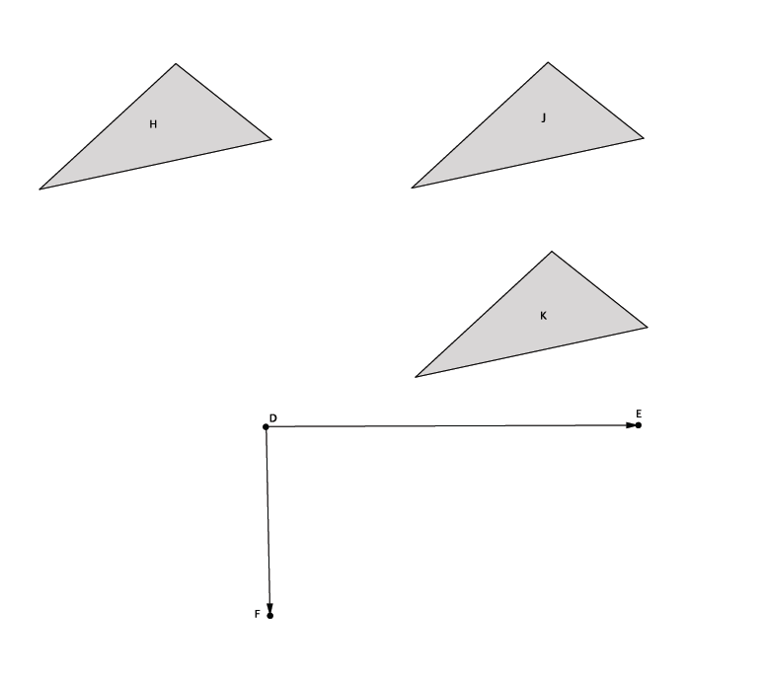

1. Describe a sequence of translations that would map Figure H onto Figure K.
2. Describe a sequence of translations that would map Figure J onto itself.

Exit Ticket Sample Solutions

Use the picture below to answer Problems 1 and 2.

1. Describe a sequence of translations that would map Figure H onto Figure K.

Translate Figure H along vector , and then translate the image along vector .

1. Describe a sequence of translations that would map Figure J onto itself.

Translate Figure J along vector , and then translate the image along vector .

Translate Figure J along vector , and then translate the image along vector .

Problem Set Sample Solutions

1. 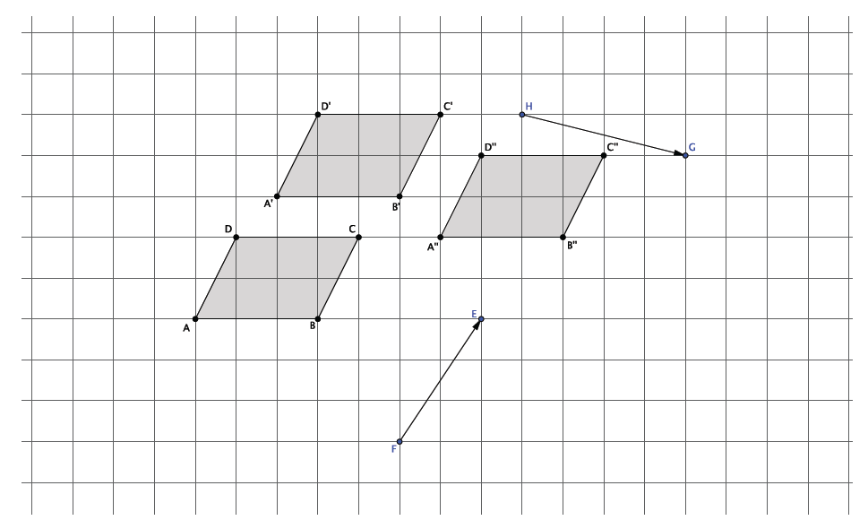Sequence translations of parallelogram (a quadrilateral in which both pairs of opposite sides are parallel) along vectors and . Label the translated images.
2. What do you know about and compared with and ? Explain.

By the definition of a parallelogram, . Since translations map parallel lines to parallel lines, I know that .

1. Are and equal in length? How do you know?

Yes, . Translations preserve lengths of segments.

1. 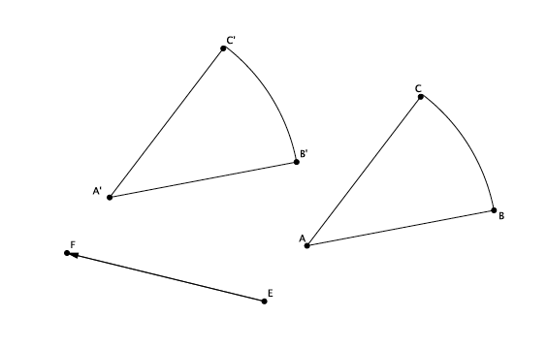Translate the curved shape along the given vector. Label the image.
2. What vector would map the shape back onto *?*

Translating the image along vector would map the image back onto its original position.