Lesson 6: Rotations of 180 Degrees

Classwork

**Example 1**

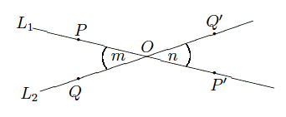 The picture below shows what happens when there is a rotation of around center

**Example 2**

The picture below shows what happens when there is a rotation of around center , the origin of the coordinate plane.

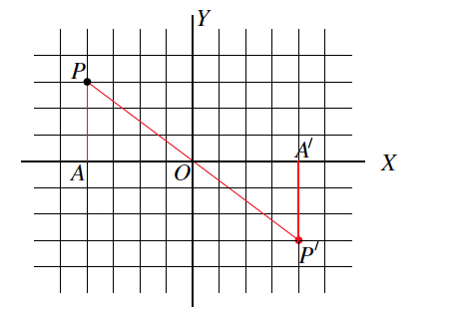

Exercises 1–9

1. Macintosh HD:Users:shassan:Desktop:ex 1t copy.pdfUsing your transparency, rotate the plane degrees, about the origin. Let this rotation be. What are the coordinates of ?
2. Macintosh HD:Users:shassan:Desktop:ex 1t copy.pdfLet be the rotation of the plane by degrees, about the origin. Without using your transparency, find .
3. Let be the rotation of degrees around the origin. Let be the line passing through parallel to the *-*axis. Find . Use your transparency if needed.

**Macintosh HD:Users:shassan:Desktop:ex 1t.pdf**

1. Let be the rotation of degrees around the origin. Let be the line passing through parallel to the -axis. Find . Use your transparency if needed.

Macintosh HD:Users:shassan:Desktop:ex 1t.pdf

1. Let be the rotation of degrees around the origin. Let be the line passing through parallel to the *-*axis. Is parallel to ?

**Macintosh HD:Users:shassan:Dropbox:Module 2:Images:Rotations of 180˚:ex 3s.pdf**

1. Let be the rotation of degrees around the origin. Let be the line passing through parallel to the *-*axis. Is parallel to ?

Macintosh HD:Users:shassan:Dropbox:Module 2:Images:Rotations of 180˚:ex 4s.pdf

1. Let be the rotation of degrees around the origin. Let be the line passing through parallel to the *-*axis. Is parallel to ?

Macintosh HD:Users:shassan:Dropbox:Module 2:Images:Rotations of 180˚:ex 5s.pdf

1. Let be the rotation of degrees around the origin. Is parallel to ? Use your transparency if needed.

Macintosh HD:Users:shassan:Dropbox:Module 2:Images:Rotations of 180˚:ex 6s.pdf

1. Let be the rotation of degrees around the origin. Is parallel to ? Use your transparency if needed.

Macintosh HD:Users:shassan:Dropbox:Module 2:Images:Rotations of 180˚:ex7s.pdf

Lesson Summary

* A rotation of degrees around is the rigid motion so that if is any point in the plane, , , and are *collinear* (i.e., lie on the same line).
* Given a -degree rotation, around the origin of a coordinate system, and a point with coordinates , it is generally said that is the point with coordinates .

Theorem: Let be a point not lying on a given line . Then, the -degree rotation around maps to a line parallel to .

Problem Set

Use the following diagram for Problems 1–5. Use your transparency as needed.

Macintosh HD:Users:shassan:Dropbox:Module 2:Images:Rotations of 180˚:ps1sv2.pdf

1. Looking only at segment , is it possible that a rotation would map onto ? Why or why not?
2. Looking only at segment , is it possible that a rotation would map onto ? Why or why not?
3. Looking only at segment , is it possible that a rotation would map onto ? Why or why not?
4. Connect point to point , point to point , and point to point . What do you notice? What do you think that point is?
5. Would a rotation map triangle onto triangle ? If so, define the rotation (i.e., degree and center). If not, explain why not.
6. The picture below shows right triangles  and , where the right angles are at and *.* Given that , and , and that is not parallel to , is there a rotation that would map onto ? Explain.

