Lesson 6: Rotations of 180 Degrees

Student Outcomes
- Students learn that a rotation of $180$ degrees moves a point on the coordinate plane $(a,b)$ to $(-a,-b)$.
- Students learn that a rotation of $180$ degrees around a point, not on the line, produces a line parallel to the given line.

Classwork
Example 1 (5 minutes)
- Rotations of $180$ degrees are special. Recall, a rotation of $180$ degrees around $O$ is a rigid motion so that if $P$ is any point in the plane, $P$, $O$, and $Rotation(P)$ are collinear (i.e., they lie on the same line).
- Rotations of $180$ degrees occur in many situations. For example, the frequently cited fact that vertical angles [vert. $∠s$] at the intersection of two lines are equal, follows immediately from the fact that $180$-degree rotations are angle-preserving. More precisely, let two lines $L_{1}$ and $L_{2}$ intersect at $O$, as shown:
Example 1
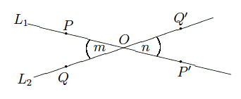
The picture below shows what happens when there is a rotation of $180°$around center $O$.

- We want to show that the vertical angles [vert. $∠s$], $∠m$ and $∠n$, are equal (i.e., $∠m=∠n$). If we let $R{otation}_{0}$ be the $180$-degree rotation around $O$, then $R{otation}_{0}$ maps $∠m$ to $∠n.$ More precisely, if $P$ and $Q$ are points on $L_{1}$ and $L_{2}$, respectively (as shown above), let ${Rotation}_{0}\left(P\right)=P'$ and ${Rotation}_{0}\left(Q\right)=Q^{'}$. Then, ${Rotation}_{0}$ maps $∠POQ$ ($∠m$) to $∠Q^{'}OP'$ ($∠n$), and since ${Rotation}_{0}$ is angle-preserving, we have $∠m=∠n$.

Example 2 (5 minutes)
- Let’s look at a $180$-degree rotation, ${Rotation}_{0}$ around the origin $O$ of a coordinate system. If a point $P$ has coordinates $(a,b)$, it is generally said that ${Rotation}_{0}\left(P\right)$ is the point with coordinates $(-a,-b)$.
- Suppose the point $P$ has coordinates $\left(-4, 3\right)$; we will show that the coordinates of ${Rotation}_{0}\left(P\right)$ are $(4, -3)$.

Example 2
The picture below shows what happens when there is a rotation of $180°$ around center $O$, the origin of the coordinate plane.
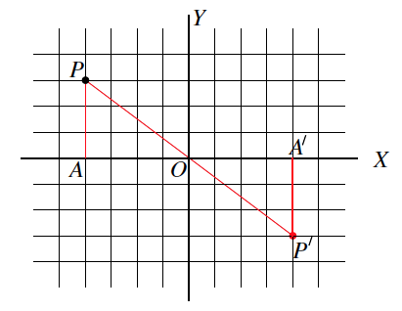

- Let $P^{'}={Rotation}_{0}\left(P\right).$ Let the vertical line (i.e., the line parallel to the $y$-axis) through $P$ meet the $x$-axis at a point $A$. Because the coordinates of $P$ are $(-4, 3)$, the point $A$ has coordinates $(-4, 0)$ by the way coordinates are defined. In particular, $A$is of distance $4$ from $O$, and since ${Rotation}_{0}$ is length-preserving, the point $A^{'}={Rotation}_{0}\left(A\right)$ is also of distance $4$ from $O$. However, ${Rotation}_{0}$ is a $180$-degree rotation around $O$, so $A'$ also lies on the $x$-axis but on the opposite side of the $x$-axis from $A$. Therefore, the coordinates of $A'$ are $(4,0).$ Now, $∠PAO$ is a right angle and—since ${Rotation}_{0}$ maps it to $∠P^{'}A^{'}O,$ and also preserves degrees—we see that $∠P'A'O$ is also a right angle. This means that $A'$ is the point of intersection of the vertical line through $P'$ and the $x$-axis. Since we already know that $A'$ has coordinates of $(4, 0)$, then the $x$-coordinate of $P'$ is $4$, by definition.
- Similarly, the $y$-coordinate of $P$ being $3$ implies that the $y$-coordinate of $P'$ is $–3$. Altogether, we have proved that the $180$-degree rotation of a point of coordinates $\left(-4, 3\right)$ is a point with coordinates $(4, -3).$
The reasoning is perfectly general: The same logic shows that the $180$-degree rotation around the origin of a point of coordinates $\left(a, b\right)$ is the point with coordinates $(-a,-b)$, as desired.

Exercises 1–9 (16 minutes)
Students complete Exercises 1–2 independently. Check solutions. Then, let students work in pairs on Exercises 3–4. Students complete Exercises 5–9 independently in preparation for the example that follows.

Exercises 1–9
- Using your transparency, rotate the plane $180$degrees, about the origin. Let this rotation be${Rotation}_{0}$. What are the coordinates of ${Rotation}_{0}\left(2, -4\right)$?
${Rotation}_{0}\left(2, -4\right)=\left(-2, 4\right)$.
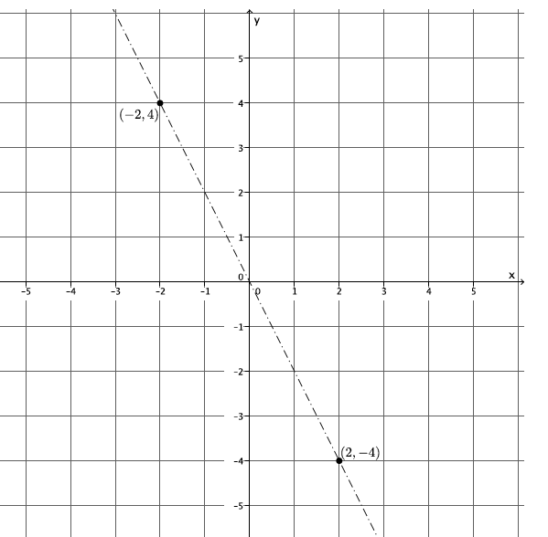
- Let ${Rotation}_{0}$ be the rotation of the plane by $180$ degrees, about the origin. Without using your transparency, find ${Rotation}_{0}\left(-3, 5\right)$.
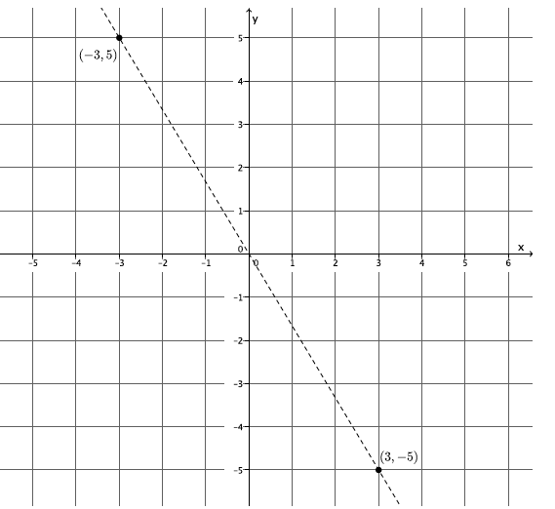
${Rotation}_{0}\left(-3, 5\right)=\left(3, -5\right)$.

- Let ${Rotation}_{0}$ be the rotation of $180$ degrees around the origin. Let $L$ be the line passing through $(-6,6)$ parallel to the $x$-axis. Find ${Rotation}_{0}\left(L\right)$. Use your transparency if needed.

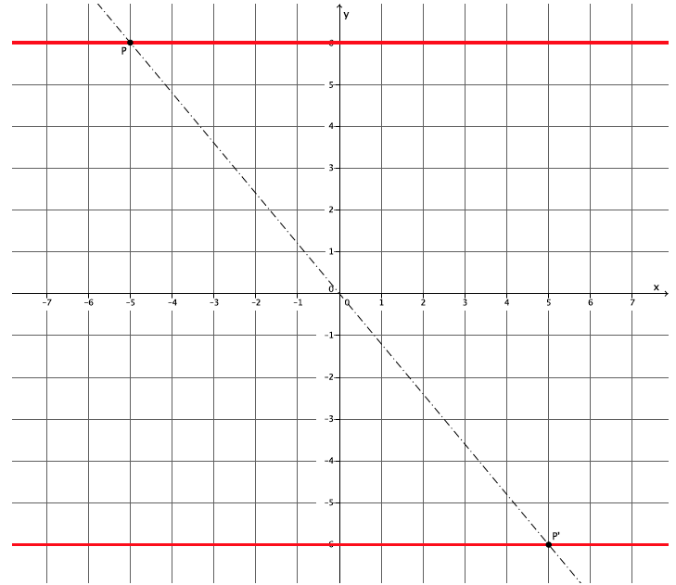

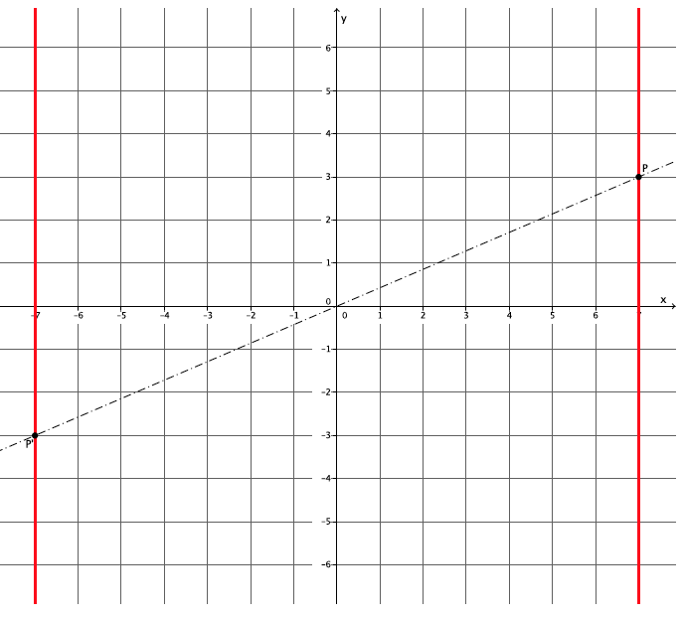
- Let ${Rotation}_{0}$ be the rotation of $180$ degrees around the origin. Let $L$ be the line passing through $(7,0)$ parallel to the $y$-axis. Find ${Rotation}_{0}\left(L\right)$. Use your transparency if needed.
- Let ${Rotation}_{0}$ be the rotation of $180$ degrees around the origin. Let $L$ be the line passing through $(0,2)$ parallel to the $x$-axis. Is $L$ parallel to ${Rotation}_{0}\left(L\right)$?
Yes, $L∥{Rotation}_{0}\left(L\right)$.
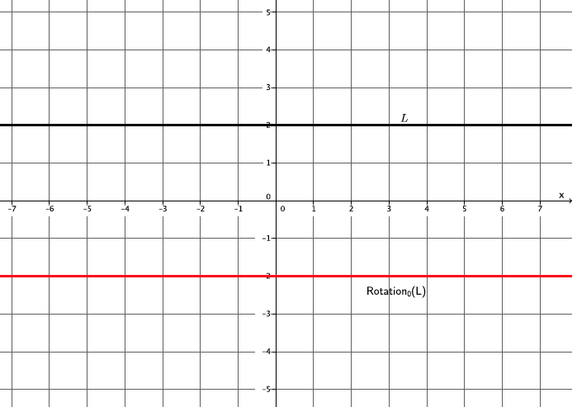

- Let ${Rotation}_{0}$ be the rotation of $180$degrees around the origin. Let $L$ be the line passing through $(4,0)$ parallel to the $y$-axis. Is $L$ parallel to ${Rotation}_{0}\left(L\right)$?
Yes, $L∥{Rotation}_{0}\left(L\right)$.

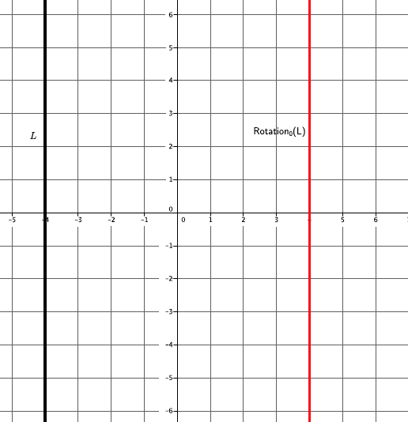

- Let ${Rotation}_{0}$ be the rotation of $180$ degrees around the origin. Let $L$ be the line passing through $(0,-1)$ parallel to the $x$-axis. Is $L$ parallel to ${Rotation}_{0}\left(L\right)$?
Yes, $L∥{Rotation}_{0}\left(L\right)$.

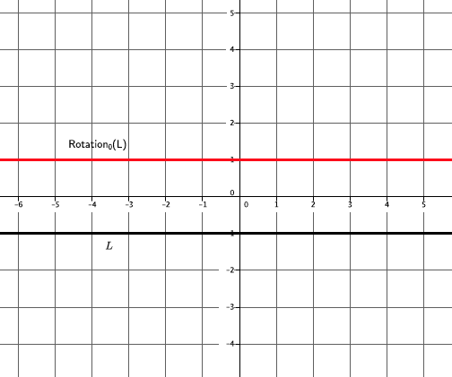

- Let ${Rotation}_{0}$ be the rotation of $180$ degrees around the origin. Is $L$ parallel to ${Rotation}_{0}\left(L\right)$? Use your transparency if needed.
Yes, $L∥{Rotation}_{0}\left(L\right)$.

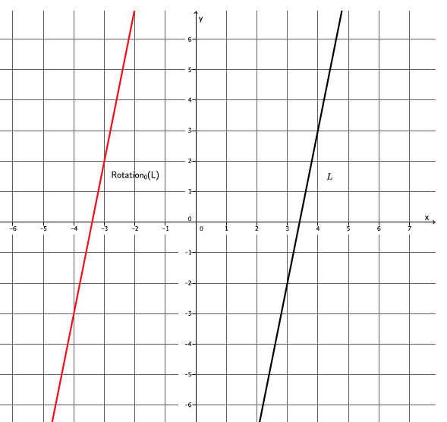

- Let ${Rotation}_{0}$ be the rotation of $180$degrees around the origin. Is $L$ parallel to ${Rotation}_{0}\left(L\right)$? Use your transparency if needed.
Yes, $L∥{Rotation}_{0}\left(L\right)$.
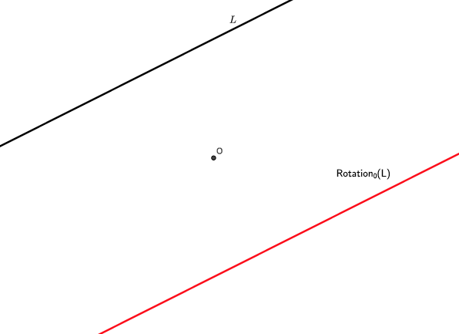

Example 3 (5 minutes)
MP.2
Scaffolding:
After completing Exercises 5–9, students should be convinced that the theorem is true. Make it clear that their observations can be proven (by contradiction) if we assume something different will happen (e.g., the lines will intersect).
Theorem. Let $O$ be a point not lying on a given line $L$. Then, the $180$-degree rotation around $O$maps $L$ to a line parallel to$L$.
Proof: Let ${Rotation}_{0}$ be the $180$-degree rotation around $O,$ and let $P$ be a point on $L$. As usual, denote ${Rotation}_{0}\left(P\right)$ by $P’$. Since ${Rotation}_{0}$ is a $180$-degree rotation, $P$,$O$, $P'$ lie on the same line (denoted by $l$).
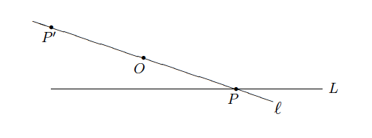
We want to investigate whether $P'$ lies on $L$ or not. Keep in mind that we want to show that the $180$-degree rotation maps $L$ to a line parallel to $L$. If the point $P'$ lies on $L$, then at some point, the line $L$ and ${Rotation}_{0}\left(L\right)$ intersect, meaning they are not parallel. If we can eliminate the possibility that $P'$ lies on $L$, then we have to conclude that $P'$ does not lie on $L$ (rotations of $180$ degrees make points that are collinear). If $P'$ lies on $L$, then $l$ is a line that joins two points, $P'$ and $P$, on $L$. However $L$ is already a line that joins $P'$ and $P$, so $l$ and $L$ must be the same line (i.e., $l=L$). This is trouble because we know $O$ lies on $l$, so $l=L$ implies that $O$ lies on $L$. Look at the hypothesis of the theorem: “Let $O$ be a point not lying on a given line $L$.” We have a contradiction. So, the possibility that $P'$ lies on $L$ is nonexistent. As we said, this means that $P'$ does not lie on $L$.
What we have proved is that no matter which point $P$ we take from $L$, we know ${Rotation}_{0}\left(P\right)$ does not lie on $L$. But ${Rotation}_{0}\left(L\right)$ consists of all the points of the form ${Rotation}_{0}\left(P\right)$ where $P$ lies on $L$, so what we have proved is that no point of ${Rotation}_{0}\left(L\right)$lies on $L$. In other words, $L$ and ${Rotation}_{0}\left(L\right)$ have no point in common (i.e., $L∥{Rotation}_{0}\left(L\right)$). The theorem is proved.

Closing (5 minutes)
Summarize, or have students summarize, the lesson.
- Rotations of $180$degrees are special:
  - A point, $P$, that is rotated $180$ degrees around a center $O$, produces a point $P'$ so that $P$, $O$,$P'$ are collinear.
  - When we rotate around the origin of a coordinate system, we see that the point with coordinates $(a, b)$ is moved to the point $(-a, -b)$.
- We now know that when a line is rotated $180$ degrees around a point not on the line, it maps to a line parallel to the given line.
Lesson Summary
- A rotation of $180$ degrees around $O$ is the rigid motion so that if $P$ is any point in the plane, $P$, $O$, and $Rotation(P)$ are collinear (i.e., lie on the same line).
- Given a $180$-degree rotation, $R_{0}$ around the origin $O$ of a coordinate system, and a point $P$ with coordinates $(a, b)$, it is generally said that $R_{0}\left(P\right)$ is the point with coordinates $(-a, -b)$.
Theorem: Let $O$ be a point not lying on a given line $L$. Then, the $180$-degree rotation around $O$ maps $L$ to a line parallel to $L$.

Exit Ticket (5 minutes)

Name Date
Lesson 6: Rotations of 180 Degrees

Exit Ticket

Let there be a rotation of $180$ degrees about the origin. Point $A$ has coordinates $\left(-2,-4\right),$ and point $B$ has coordinates $(-3, 1)$, as shown below.
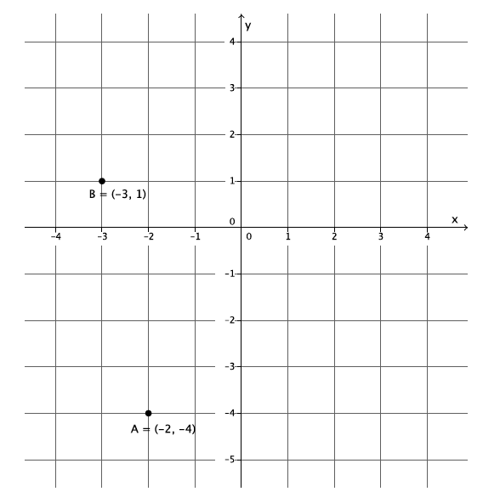
- What are the coordinates of $Rotation(A)$? Mark that point on the graph so that $Rotation(A)=A'$. What are the coordinates of $Rotation(B)$? Mark that point on the graph so that $Rotation(B)=B'$.

- What can you say about the points $A$, $A^{'}$, and $O$? What can you say about the points $B$,$B^{'}$, and $O$?

- Connect point $A$ to point $B$ to make the line $L_{AB}$. Connect point $A'$ to point $B'$ to make the line $L_{A^{'}B^{'}}$. What is the relationship between $L_{AB}$ and $L_{A^{'}B^{'}}$?

Exit Ticket Sample Solutions

Let there be a rotation of $180$ degrees about the origin. Point $A$ has coordinates $\left(-2, -4\right)$, and point $B$ has coordinates $(-3, 1)$, as shown below.
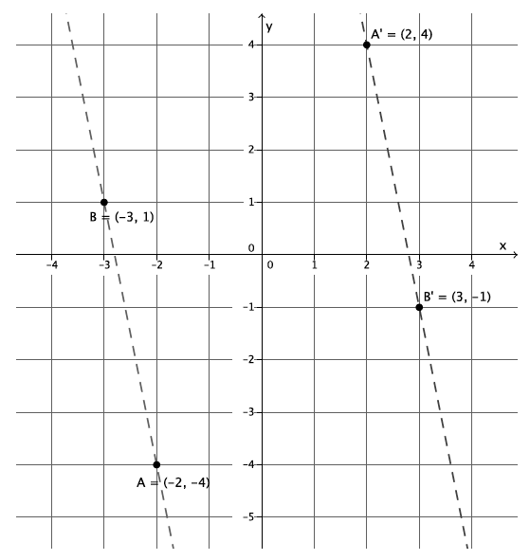
- What are the coordinates of $Rotation(A)$? Mark that point on the graph so that $Rotation(A)=A'$. What are the coordinates of $Rotation(B)$? Mark that point on the graph so that $Rotation(B)=B’$.
$A^{'}=\left(2,4\right)$,$B'=(3,-1)$

- What can you say about the points $A$,$A^{'}$, and $O$? What can you say about the points $B$, $B'$, and $O$?
The points $A$,$A'$, and $O$ are collinear. The points $B$,$B'$, and $O$ are collinear.

- Connect point $A$ to point $B$ to make the line $L_{AB}$. Connect point $A'$ to point $B'$ to make the line $L_{A^{'}B^{'}}$. What is the relationship between $L_{AB}$ and $L_{A^{'}B^{'}}$?
$L_{AB}∥L_{A^{'}B^{'}}$.

Problem Set Sample Solutions

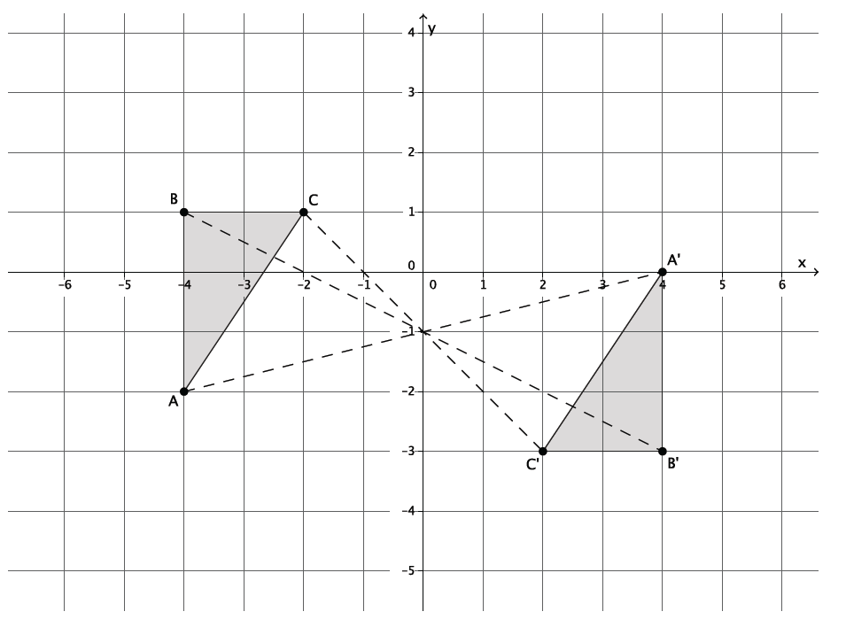
Use the following diagram for Problems 1–5. Use your transparency as needed.

- Looking only at segment $BC$, is it possible that a $180°$ rotation would map $BC$ onto $B'C'$? Why or why not?
It is possible because the segments are parallel.

- Looking only at segment $AB$, is it possible that a $180°$rotation would map $AB$ onto $A'B'$? Why or why not?
It is possible because the segments are parallel.

- Looking only at segment $AC$, is it possible that a $180°$rotation would map $AC$ onto $A'C'$? Why or why not?
It is possible because the segments are parallel.

- Connect point $B$ to point $B'$, point $C$ to point $C'$, and point $A$ to point $A'$. What do you notice? What do you think that point is?
All of the lines intersect at one point. The point is the center of rotation, I checked by using my transparency.

- Would a rotation map triangle $ABC$ onto triangle $A'B'C'$ ? If so, define the rotation (i.e., degree and center). If not, explain why not.
Let there be a rotation $180°$ around point $(0, -1)$. Then, $Rotation\left(∆ABC\right)=∆A'B'C'$.

- The picture below shows right triangles $ABC$ and $A'B'C'$, where the right angles are at $B$ and $B'$. Given that $AB=A^{'}B^{'}=1$, and $BC=B^{'}C^{'}=2$, and that $AB$ is not parallel to $A'B'$, is there a $180°$ rotation that would map $∆ABC$ onto $△A'B'C'$ ? Explain.
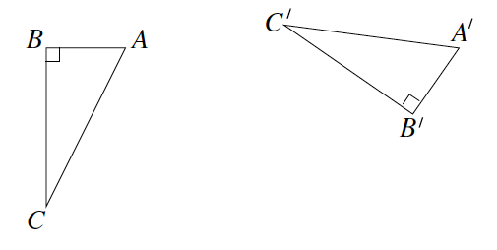
No, because a $180°$ rotation of a segment will map to a segment that is parallel to the given one. It is given that $AB$ is not parallel to $A^{'}B'$; therefore, a rotation of$180°$ will not map $△ABC$ onto $△A'B'C'$.

