Lesson 5: Definition of Rotation and Basic Properties

Classwork
Exercises
- Let there be a rotation of $d$ degrees around center $O$. Let $P$ be a point other than $O$. Select $d$ so that $d≥0$. Find $P'$ (i.e., the rotation of point $P$) using a transparency.

- Let there be a rotation of $d$ degrees around center $O$. Let $P$ be a point other than $O$. Select $d$ so that $d<0$. Find $P'$ (i.e., the rotation of point $P$) using a transparency.

- Which direction did the point $P$ rotate when $d≥0$?

- Which direction did the point $P$ rotate when $d<0$?

- Let $L$be a line, $\vec{AB}$ be a ray, $CD$ be a segment, and $∠EFG$ be an angle, as shown. Let there be a rotation of $d$ degrees around point $O$. Find the images of all figures when $d≥0$.
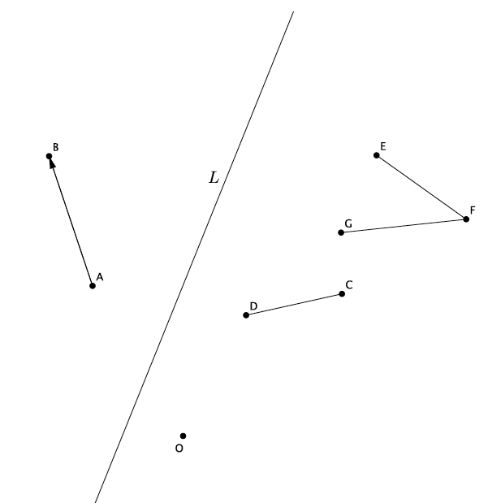
- Let $\overline{AB}$ be a segment of length $4$ units and $∠CDE$ be an angle of size $45°$. Let there be a rotation by $d$ degrees, where $d<0$, about $O$. Find the images of the given figures. Answer the questions that follow.

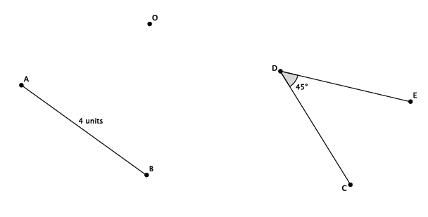

  - What is the length of the rotated segment $Rotation(AB)$?

  - What is the degree of the rotated angle $Rotation\left(∠CDE\right)$?

- Let $L_{1}$ and$L_{2}$ be parallel lines. Let there be a rotation by $d$ degrees, where $-360<d<360$, about $O$.
Is ${\left(L_{1}\right)}^{'}∥\left(L_{2}\right)'$?
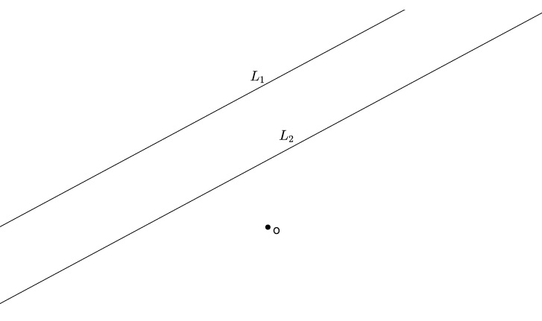

- Let $L$ be a line and $O$ be the center of rotation. Let there be a rotation by $d$ degrees, where $d≠180$ about $O$. Are the lines $L$ and $L'$ parallel?

Lesson Summary
Rotations require information about the center of rotation and the degree in which to rotate. Positive degrees of rotation move the figure in a counterclockwise direction. Negative degrees of rotation move the figure in a clockwise direction.
Basic Properties of Rotations:
- (Rotation 1) A rotation maps a line to a line, a ray to a ray, a segment to a segment, and an angle to an angle.
- (Rotation 2) A rotation preserves lengths of segments.
- (Rotation 3) A rotation preserves measures of angles.
When parallel lines are rotated, their images are also parallel. A line is only parallel to itself when rotated exactly $180°$.

Problem Set

- Let there be a rotation by $-90°$ around the center $O$.
- Explain why a rotation of $90$ degrees around any point $O$ never maps a line to a line parallel to itself.

- A segment of length $94$ cm has been rotated $d$ degrees around a center $O$. What is the length of the rotated segment? How do you know?

- An angle of size $124°$ has been rotated $d$ degrees around a center $O$. What is the size of the rotated angle? How do you know?

