Lesson 5: Definition of Rotation and Basic Properties

Student Outcomes
- Students know how to rotate a figure a given degree around a given center.
- Students know that rotations move lines to lines, rays to rays, segments to segments, and angles to angles. Students know that rotations preserve lengths of segments and degrees of measures of angles. Students know that rotations move parallel lines to parallel lines.

Lesson Notes
In general, students are not required to rotate a certain degree nor identify the degree of rotation. The only exceptions are when the rotations are multiples of $90°$. For this reason, it is recommended in the discussion following the video presentation that you show students how to use the transparency to rotate in multiples of $90°$, i.e., turn transparency one quarter turn for each $90°$ rotation.

Classwork
Discussion (8 minutes)
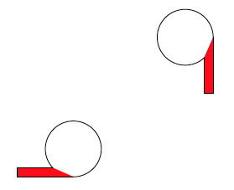
- What is the simplest transformation that would map one of the following figures to the other?

- Would a translation work? Would a reflection work?
  - Because there seems to be no known simple transformation that would do the job, we will learn about a new transformation called rotation. Rotation is the transformation needed to map one of the figures onto the other.
Let $O$ be a point in the plane and let $d$ be a number between –$360$ and $360$, or, in the usual notation, $-360<d<360$.
- Why do you think the numbers –$360$ and $360$ are used in reference to rotation?
  - Rotating means that we are moving in a circular pattern, and circles have$360°$.
The rotation of $d$ degrees with center $O$ is defined by using transparencies. On a piece of paper, fix a point $O$ as the center of rotation, let $P$ be a point in the plane, and let the ray $\vec{OP}$ be drawn. Let $d$ be a number between $-360$ and $360$.
MP.6
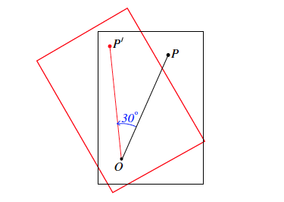
Definition. If there is a rotation of $d$ degrees with center $O$, the image $Rotation(P)$ is the point described as follows. On a piece of transparency, trace $O$, $P$, and $\vec{OP}$ in red. Now, use a pointed object (e.g., the leg-with-spike of a compass) to pin the transparency at the point $O$. First, suppose $d≥0$. Then, holding the paper in place, rotate the transparency counterclockwise so that if we denote the final position of the rotated red point (that was $P$) by $P'$, then the $∠P'OP$ is $d$ degrees. For example, if $d=30$, we have the following picture:
As before, the red rectangle represents the border of the rotated transparency. Then, by definition, $Rotation(P)$ is the point $P'$.
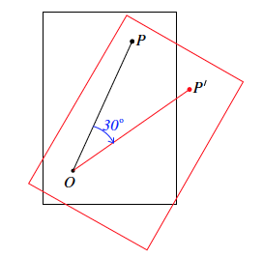
If, however, $d<0$, then holding the paper in place, we would now rotate the transparency clockwise so that if we denote the position of the red point (that was $P$) by $P'$, then the angle $∠POP'$ is $d$ degrees. For example, if $d=-30$, we have the following picture:

Again, we define $Rotation(P)$ to be $P’$ in this case. Notice that the rotation moves the center of rotation $O$ to itself, i.e., $Rotation(O)=O$.

Exercises 1–4 (4 minutes)
Students complete Exercises 1–4 independently.
Exercises
- Let there be a rotation of $d$ degrees around center $O$. Let $P$ be a point other than $O$. Select $d$ so that $d≥0$. Find $P'$ (i.e., the rotation of point $P$) using a transparency.
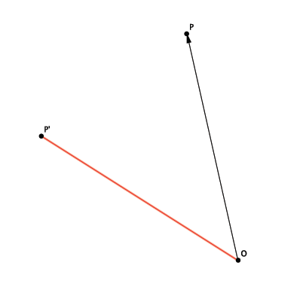
Verify that students have rotated around center $O$ in the counterclockwise direction.

- Let there be a rotation of $d$ degrees around center $O$. Let $P$ be a point other than $O$. Select $d$ so that $d<0$. Find $P'$ (i.e., the rotation of point $P$) using a transparency.
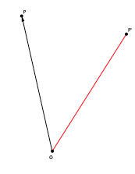
Verify that students have rotated around center $O$ in the clockwise direction.

- Which direction did the point $P$ rotate when $d≥0$?
It rotated counterclockwise, or to the left of the original point.

- Which direction did the point $P$ rotate when $d<0$?
It rotated clockwise, or to the right of the original point.

Discussion (5 minutes)
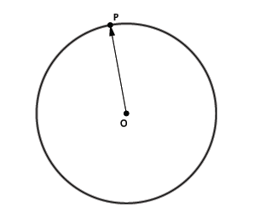
Observe that, with $O$ as the center of rotation, the points $P$ and $Rotation(P)$ lie on a circle whose center is $O$ and whose radius is $\vec{OP}$.
- Assume we rotate the plane $d$ degrees around center $O$. Let $P$ be a point other than $O$. Where do you think $P'$ will be located?
  - The point $P$ and $P'$ will be equidistant from $O;$ that is, $P'$ is on the circumference of the circle with center $O$ and radius $OP$. The point $P'$ would be clockwise from $P$ if the degree of rotation is negative. The point $P'$ would be counterclockwise from $P$ if the degree of rotation is positive.
- If we rotated $P$, $d$ degrees around center $O$ several times, where would all of the images of $P$ be located?
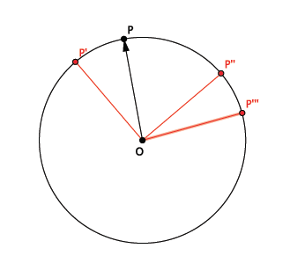
  - All images of $P$ will be on the circumference of the circle with radius $OP$.
- Why do you think this happens?
  - Because, like translations and reflections, rotations preserve lengths of segments. The segments of importance here are the segments that join the center $O$ to the images of $P$. Each segment is the radius of the circle. We will discuss this more, later in the lesson.
- Consider a rotation of point $P$, around center $O$, $180$ degrees and $-180$ degrees. Where do you think the images of $P$ will be located?
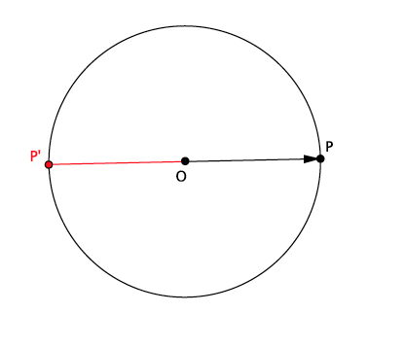
  - Both rotations, although they are in opposite directions, will move the point $P$ to the same location, $P'$. Further, the points $P$, $O$, and $P'$ will always be collinear (i.e., they will lie on one line, for any point $P)$. This concept will be discussed in more detail in Lesson 6.
Concept Development (3 minutes)
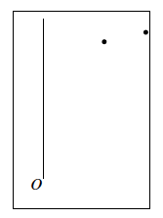
- Now that we know how a point gets moved under a rotation, let us look at how a geometric figure gets moved under a rotation. Let $S$ be the figure consisting of a vertical segment (not a line) and two points. Let the center of rotation be $O$, the lower endpoint of the segment, as shown.
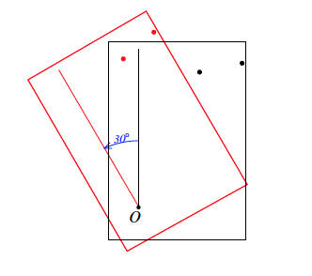
- Then, the rotation of $30$ degrees with center $O$ moves the point represented by the left black dot to the lower red dot, the point represented by the right black dot to the upper red dot, and the vertical black segment to the red segment to the left at an angle of $30$ degrees, as shown.

Video Presentation (2 minutes)
The following two videos show how a rotation of $35$ degrees and $-35$ degrees with center $B$, respectively, rotates a geometric figure consisting of three points and two line segments.
http://www.harpercollege.edu/~skoswatt/RigidMotions/rotateccw.html
http://www.harpercollege.edu/~skoswatt/RigidMotions/rotatecw.html

Discussion (2 minutes)
Revisit the question posed at the beginning of the lesson and ask students:
- What is the simplest transformation that would map one of the following figures to the other?

  - We now know that the answer is a rotation.

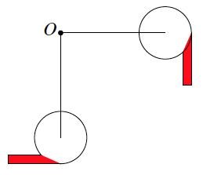
Show students how a rotation of approximately $90$ degrees around a point $O$, chosen on the perpendicular bisector [$⊥$ bisector] of the segment joining the centers of the two circles in the figures, would map the figure on the left to the figure on the right. Similarly, a rotation of $-90$ degrees would map the figure on the right to the figure on the left.
Note to Teacher:
Continue to remind students that a positive degree of rotation moves the figure counterclockwise, and a negative degree of rotation moves the figure clockwise.

Exercises 5–6 (4 minutes)
Students complete Exercises 5 and 6 independently.

- Let $L$be a line, $\vec{AB}$ be a ray, $CD$ be a segment, and $∠EFG$ be an angle, as shown. Let there be a rotation of $d$ degrees around point $O$. Find the images of all figures when $d≥0$.
Verify that students have rotated around center $O$ in the counterclockwise direction.

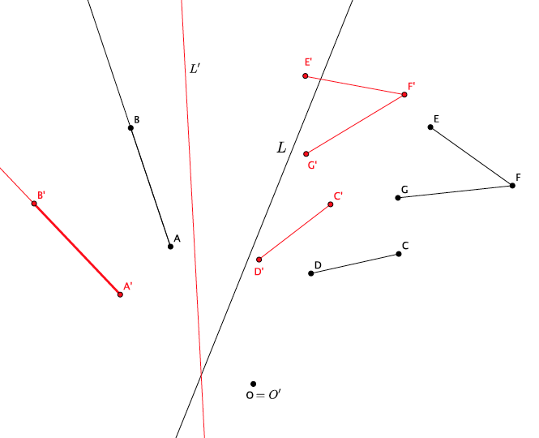

- Let $\overline{AB}$ be a segment of length $4$ units and $∠CDE$ be an angle of size $45°$. Let there be a rotation by $d$ degrees, where $d<0$, about $O$. Find the images of the given figures. Answer the questions that follow.
Verify that students have rotated around center $O$ in the clockwise direction.
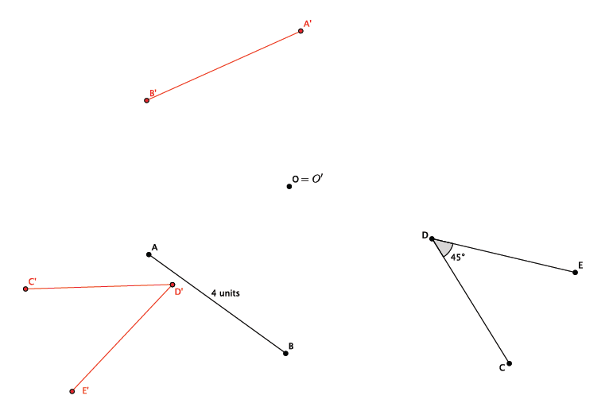

  - What is the length of the rotated segment $Rotation(AB)$?
The length of the rotated segment is $4$ units.

  - What is the degree of the rotated angle $Rotation \left(∠CDE\right)$?
The degree of the rotated angle is $45°$.

Concept Development (4 minutes)
Based on the work completed during the lesson, and especially in Exercises 5 and 6, we can now states that rotations have properties similar to translations with respect to (Translation 1)–(Translation 3) of Lesson 2 and reflections with respect to (Reflection 1)–(Reflection 3) of Lesson 4:
(Rotation 1) A rotation maps a line to a line, a ray to a ray, a segment to a segment, and an angle to an angle.
(Rotation 2) A rotation preserves lengths of segments.
(Rotation 3) A rotation preserves measures of angles.
Also, as with translations and reflections, if $L_{1}$ and $L_{2}$ are parallel lines and if there is a rotation, then the lines $Rotation\left(L_{1}\right)$ and $Rotation\left(L_{2}\right)$ are also parallel. However, if there is a rotation of degree $d≠180$ and $L$ is a line, $L$ and $Rotation(L)$ are not parallel. (Note to teacher: Exercises 7 and 8 will illustrate these two points.)
Exercises 7–8 (4 minutes)
Students complete Exercises 7 and 8 independently.

- Let $L_{1}$ and$L_{2}$ be parallel lines. Let there be a rotation by $d$ degrees, where $-360<d<360$, about $O$.
Is ${\left(L_{1}\right)}^{'}∥\left(L_{2}\right)'$?
Verify that students have rotated around center $O$ in either direction. Students should respond that ${\left(L_{1}\right)}^{'}∥\left(L_{2}\right)'$.
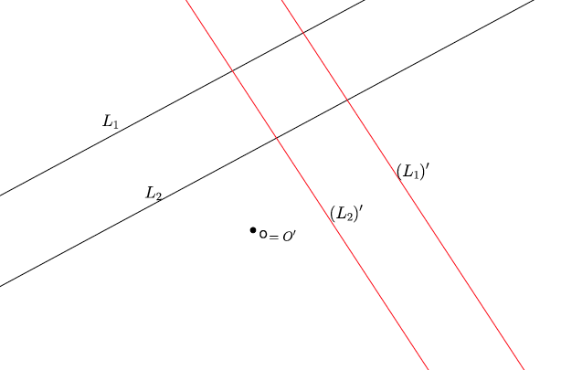

- Let $L$ be a line and $O$ be the center of rotation. Let there be a rotation by $d$ degrees, where $d≠180$ about $O$. Are the lines $L$ and $L'$ parallel?
Verify that students have rotated around center $O$ in either direction any degree other than $180$. Students should respond that $L$ and $L’$ are not parallel.
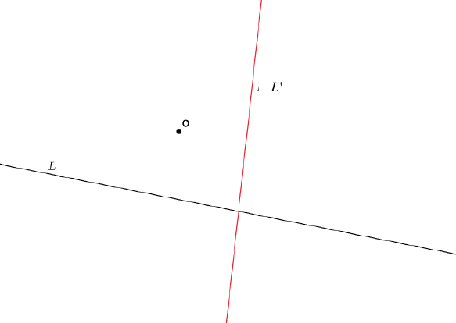

Closing (3 minutes)
Summarize, or have students summarize, what we know of rigid motions to this point:
- We now have definitions for all three rigid motions: translations, reflections, and rotations.
- Rotations move lines to lines, rays to rays, segments to segments, angles to angles, and parallel lines to parallel lines, similar to translations and reflections.
- Rotations preserve lengths of segments and degrees of measures of angles similar to translations and reflections.
- Rotations require information about the center and degree of rotation, whereas translations require only a vector, and reflections require only a line of reflection.
Lesson Summary
Rotations require information about the center of rotation and the degree in which to rotate. Positive degrees of rotation move the figure in a counterclockwise direction. Negative degrees of rotation move the figure in a clockwise direction.
Basic Properties of Rotations:
- (Rotation 1) A rotation maps a line to a line, a ray to a ray, a segment to a segment, and an angle to an angle.
- (Rotation 2) A rotation preserves lengths of segments.
- (Rotation 3) A rotation preserves measures of angles.
When parallel lines are rotated, their images are also parallel. A line is only parallel to itself when rotated exactly $180°$.

Exit Ticket (5 minutes)

Name Date
Lesson 5: Definition of Rotation and Basic Properties

Exit Ticket

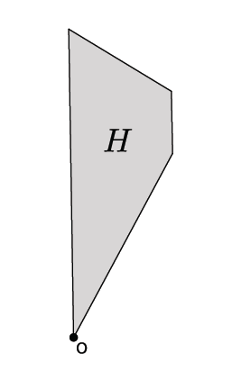
- Given the figure $H$, let there be a rotation by $d$ degrees, where $d≥0$, about $O$. Let $Rotation(H)$ be $H'$.

- Using the drawing above, let $Rotation_{1}$ be the rotation $d$ degrees with $d<0$, about $O$. Let $Rotation_{1}(H)$ be $H''$.

Exit Ticket Sample Solutions

- Given the figure $H$, let there be a rotation by $d$ degrees, where $d≥0$, about $O$. Let $Rotation(H)$ be $H'$.
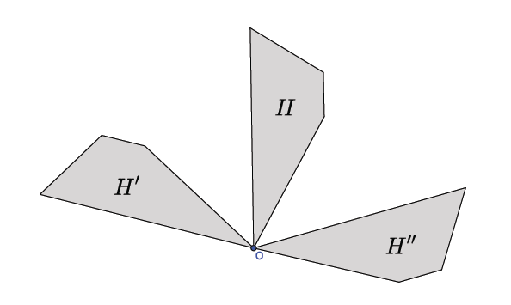
Sample rotation shown below. Verify that the figure $H’$ has been rotated counterclockwise with center $O$.

- Using the drawing above, let $Rotation_{1}$ be the rotation $d$degrees with $d<0$, about $O$. Let $Rotation_{1}(H)$ be $H''$.
Sample rotation shown above. Verify that the figure $H''$ has been rotated clockwise with center $O$.

Problem Set Sample Solutions

- Let there be a rotation by $-90°$ around the center $O$.
Rotated figures are shown in red.

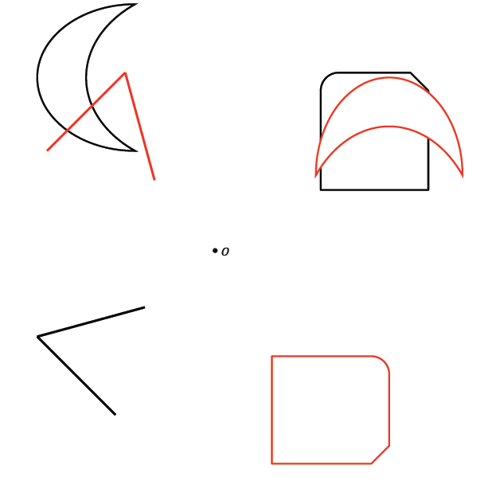
- Explain why a rotation of $90$ degrees around any point $O$ never maps a line to a line parallel to itself.
A $90$ degree rotation around point $O$ will move a given line $L$ to $L'$. Parallel lines never intersect, so it is obvious that a$90$ degree rotation in either direction does not make lines $L$ and $L'$ parallel. Additionally, we know that there exists just one line parallel to the given line $L$ that goes through a point not on $L$. If we let $P$ be a point not on $L$, the line $L'$ must go through it in order to be parallel to $L$. $L'$ does not go through point $P$; therefore, $L$and $L'$ are not parallel lines. Assume we rotate line $L$ first and then place a point $P$ on line $L'$ to get the desired effect (a line through $P$). This contradicts our definition of parallel (i.e., parallel lines never intersect); so, again, we know that line $L$ is not parallel to $L'$.
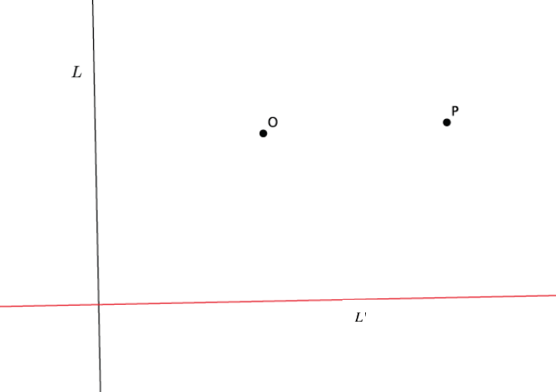

- A segment of length $94$ cm has been rotated $d$ degrees around a center $O$. What is the length of the rotated segment? How do you know?
The rotated segment will be $94$ cm in length. (Rotation 2) states that rotations preserve lengths of segments, so the length of the rotated segment will remain the same as the original.

- An angle of size $124°$ has been rotated $d$ degrees around a center $O$. What is the size of the rotated angle? How do you know?
The rotated angle will be $124°$. (Rotation 3) states that rotations preserve the degrees of angles, so the rotated angle will be the same size as the original.

The videos were developed by Sunil Koswatta.

