Lesson 4: Definition of Reflection and Basic Properties

Classwork

**Exercises**

1. Reflect and Figure across line . Label the reflected images.

Macintosh HD:Users:shassan:Dropbox:Module 2:Images:Def of Reflection:ex 1s.pdf

1. Which figure(s) were not moved to a new location on the plane under this transformation?
2. Reflect the images across line . Label the reflected images.

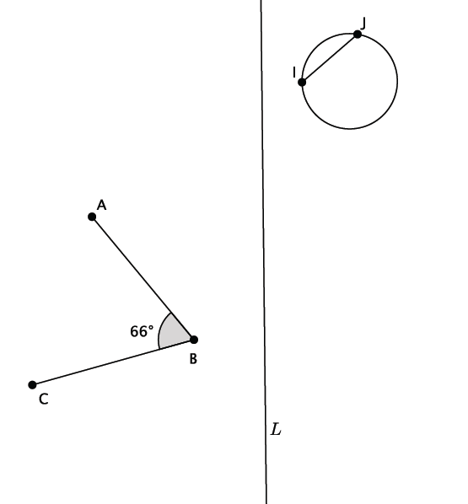

1. Answer the questions about the image above.
   1. Use a protractor to measure the reflected . What do you notice?
   2. Use a ruler to measure the length of and the length of the image of after the reflection. What do you notice?
2. Reflect Figure and across line . Label the reflected images.

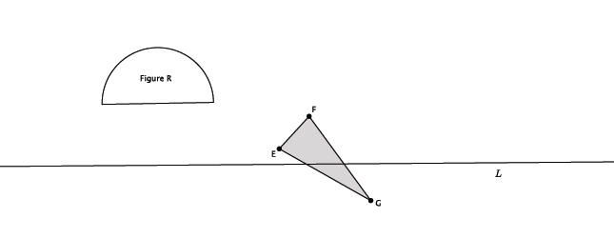

Basic Properties of Reflections:

(Reflection 1) A reflection maps a line to a line, a ray to a ray, a segment to a segment, and an angle to an angle.

(Reflection 2) A reflection preserves lengths of segments.

(Reflection 3) A reflection preserves measures of angles.

If the reflection is across a line and is a point not on, then bisects the segment , joining to its reflected image . That is, the lengths of andare equal.

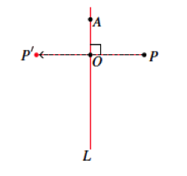

Use the picture below for Exercises 6–9.

Macintosh HD:Users:shassan:Desktop:ex 6s.pdf

1. Use the picture to label the unnamed points.
2. What is the measure of ? ? ? How do you know?
3. What is the length of segment ? ? How do you know?
4. What is the location of ? Explain.

Lesson Summary

* A reflection is another type of basic rigid motion.
* Reflections occur across lines. The line that you reflect across is called the line of reflection.
* When a point, , is joined to its reflection, , the line of reflection bisects the segment,

Problem Set

1. In the picture below, , , units, units, point is on line and point is off of line . Let there be a reflection across line . Reflect and label each of the figures, and answer the questions that follow.

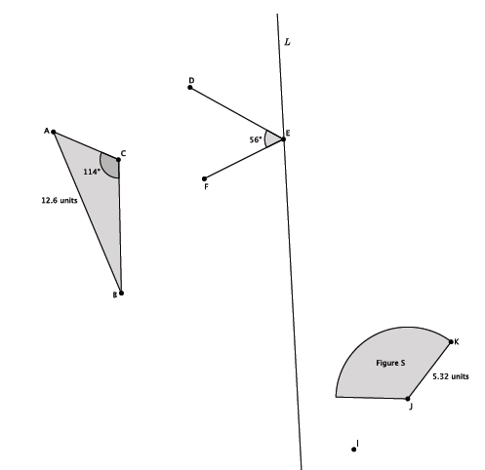

1. What is the measure of ? Explain.
2. What is the length of ? Explain.
3. What is the measure of ?
4. What is the length of ?
5. Two figures in the picture were not moved under the reflection. Name the two figures and explain why they were not moved.
6. Connect points and . Name the point of intersection of the segment with the line of reflection point . What do you know about the lengths of segments and ?