Lesson 4: Definition of Reflection and Basic Properties

Student Outcomes
- Students know the definition of reflection and perform reflections across a line using a transparency.
- Students show that reflections share some of the same fundamental properties with translations (e.g., lines map to lines, angle- and distance-preserving motion, etc.). Students know that reflections map parallel lines to parallel lines.
- Students know that for the reflection across a line $L$, then every point $P$, not on $L$, $L$ is the bisector of the segment joining $P$ to its reflected image $P'$.

Classwork
Example 1 (5 minutes)
The reflection across a line $L$ is defined by using the following example.
MP.6
- Let $L$ be a vertical line, and let $P$ and $A$ be two points not on $L$, as shown below. Also, let $Q$ be a point on $L$. (The black rectangle indicates the border of the paper.)
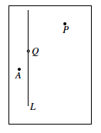
- The following is a description of how the reflection moves the points $P$, $Q$, and $A$ by making use of the transparency.
- Trace the line $L$and three points onto the transparency exactly, using red. (Be sure to use a transparency that is the same size as the paper.)
- Keeping the paper fixed, flip the transparency across the vertical line (interchanging left and right) while keeping the vertical line and point $Q$ on top of their black images.
- The position of the red figures on the transparency now represents the reflection of the original figure. $Reflection(P)$ is the point represented by the red dot to the left of $L$, $Reflection(A)$is the red dot to the right of $L$, and point $Reflection(Q)$ is point $Q$ itself.
Scaffolding:
- There are manipulatives, such as MIRA and Georeflector, which facilitate the learning of reflections by producing a reflected image.
- Note that point $Q$ is unchanged by the reflection.
- The red rectangle in the picture on the next page represents the border of the transparency.
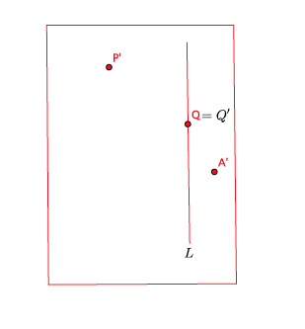
- In the picture above, you see that the reflected image of the points is noted similar to how we represented translated images in Lesson 2. That is, the reflected point $P$ is $P'$. More importantly, note that the line $L$ and point $Q$ have reflected images in exactly the same location as the original; hence, $Reflection\left(L\right)=L$ and $Reflection(Q)=Q$, respectively.

- The figure and its reflected image are shown together, below.
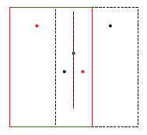
- Pictorially, reflection moves all of the points in the plane by reflecting them across $L$ as if $L$ were a mirror. The line $L$ is called the line of reflection. A reflection across line $L$ may also be noted as ${Reflection}_{L}$.

Video Presentation (2 minutes)
The following animation of a reflection will be helpful to beginners.
http://www.harpercollege.edu/~skoswatt/RigidMotions/reflection.html

Exercises 1–2 (3 minutes)
Students complete Exercises 1 and 2 independently.
Exercises
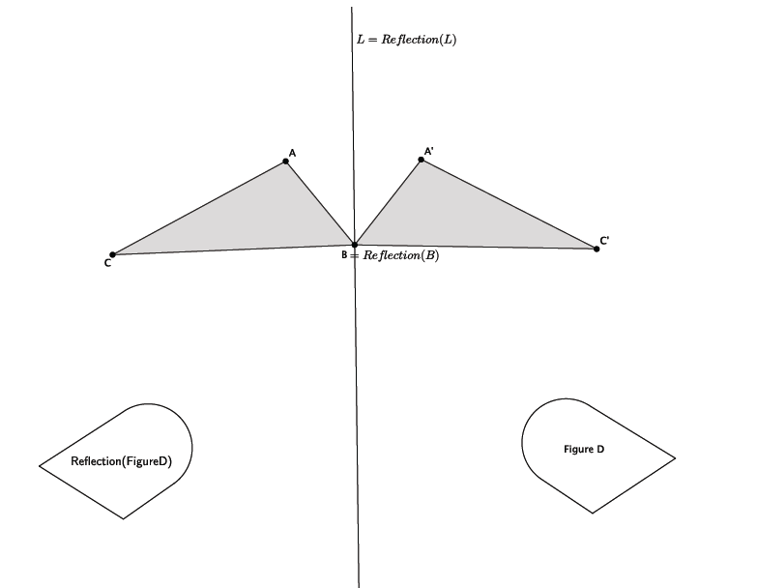
- Reflect $△ABC$ and Figure $D$ across line $L$. Label the reflected images.

- Which figure(s) were not moved to a new location on the plane under this transformation?
Point $B$and line$L$ were not moved to a new location on the plane under this reflection.

Example 2 (3 minutes)
Now we look at some features of reflected geometric figures in the plane.
- If we reflect across a vertical line $l$, then the reflected image of right-pointing figures, such as $T$ below, will be left-pointing. Similarly, the reflected image of a right-leaning figure, such as $S$ below, will become left-leaning.
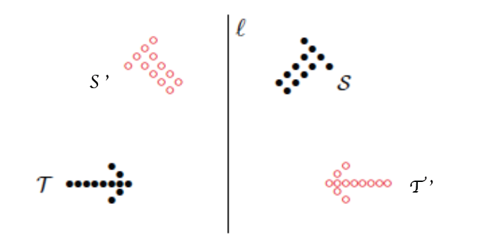

- Observe that up and down do not change in the reflection across a vertical line. Also observe that the horizontal figure $T$ remains horizontal. This is similar to what a real mirror does.

Example 3 (2 minutes)
A line of reflection can be any line in the plane. In this example, we look at a horizontal line of reflection.
- Let $l$ be the horizontal line of reflection, $P$ be a point off of line $l$, and $T$ be the figure above the line of reflection.
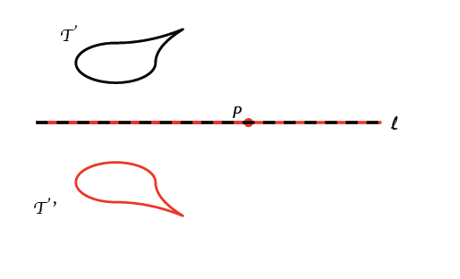
- Just as before, if we trace everything in red on the transparency and reflect across the horizontal line of reflection, we see the reflected images in red, as shown below.

Exercises 3–5 (5 minutes)
Students complete Exercises 3–5 independently.

- Reflect the images across line $L$. Label the reflected images.
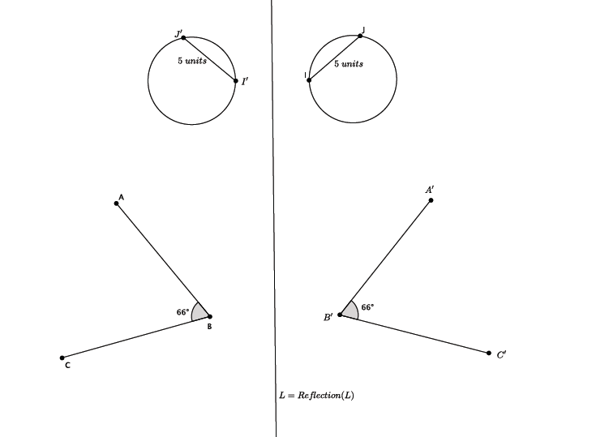
- Answer the questions about the previous image.
  - Use a protractor to measure the reflected $∠ABC$. What do you notice?
The measure of the reflected image of $∠ABC$ is $66°$.

  - Use a ruler to measure the length $IJ$and the length of the image of $IJ$ after the reflection. What do you notice?
The length of the reflected segment is the same as the original segment, $5$ units.
Note: This is not something students are expected to know, but it is a preview for what is to come later in this lesson.

- Reflect Figure $R$ and $△EFG$ across line $L$. Label the reflected images.
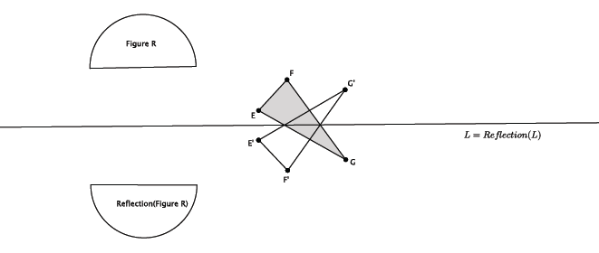
Discussion (3 minutes)
As with translation, a reflection has the same properties as (Translation 1)–(Translation 3) of Lesson 2. Precisely, lines, segments, angles, etc., are moved by a reflection by moving their exact replicas (on the transparency) to another part of the plane. Therefore, distances and degrees are preserved.
(Reflection 1) A reflection maps a line to a line, a ray to a ray, a segment to a segment, and an angle to an angle.
(Reflection 2) A reflection preserves lengths of segments.
(Reflection 3) A reflection preserves degrees of angles.
These basic properties of reflections will be taken for granted in all subsequent discussions of geometry.
Basic Properties of Reflections:
(Reflection 1) A reflection maps a line to a line, a ray to a ray, a segment to a segment, and an angle to an angle.
(Reflection 2) A reflection preserves lengths of segments.
(Reflection 3) A reflection preserves measures of angles.
If the reflection is across a line $L$ and $P$ is a point not on$L$, then $L$ bisects the segment $PP'$, joining $P$ to its reflected image $P'$. That is, the lengths of $OP$ and$OP'$are equal.
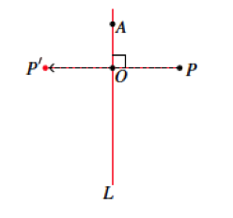

Example 4 (7 minutes)
A simple consequence of (Reflection 2) is that it gives a more precise description of the position of the reflected image of a point.
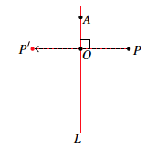
- Let there be a reflection across line $L$, let $P$ be a point not on line $L$, and let $P'$represent $Reflection\left(P\right).$ Let the line $PP'$intersect $L$at $O$, and let $A$ be a point on $L$distinct from $O$, as shown.
- What can we say about segments $PO$ and $OP^{'}$?
  - Because $Reflection\left(PO\right)=P'O$, (Reflection 2) guarantees that segments $PO$ and $P'O$ have the same length.
- In other words, $O$ is the midpoint (i.e., the point equidistant from both endpoints) of $PP'$.
- In general, the line passing through the midpoint of a segment is said to bisect the segment.
- What happens to point $A$ under the reflection?
  - Because the line of reflection maps to itself, then point A remains unmoved, i.e., $A=A^{'}.$
- As with translations, reflections map parallel lines to parallel lines. (i.e., If $L_{1}∥L_{2}$ , and there is a reflection across a line, then $Reflection(L_{1})∥Reflection(L_{2})$.)
- Let there be a reflection across line $m$. Given $L_{1}∥L_{2}$, then $Reflection(L_{1})∥Reflection(L_{2})$. The reason is that any point $A$ on line $L_{1}$ will be reflected across $m$ to a point $A'$ on $Reflection(L_{1})$. Similarly, any point$B$ on line $L_{2}$ will be reflected across $m$ to a point $B'$on $Reflection(L_{2})$. Since $L_{1}∥L_{2}$, no point $A$ on line $L_{1}$ will ever be on $L_{2}$, and no point $B$on $L_{2}$ will ever be on $L_{1}$. The same can be said for the reflections of those points. Then, since $Reflection(L_{1})$ shares no points with $Reflection(L_{2})$, $Reflection(L_{1})∥Reflection(L_{2})$.

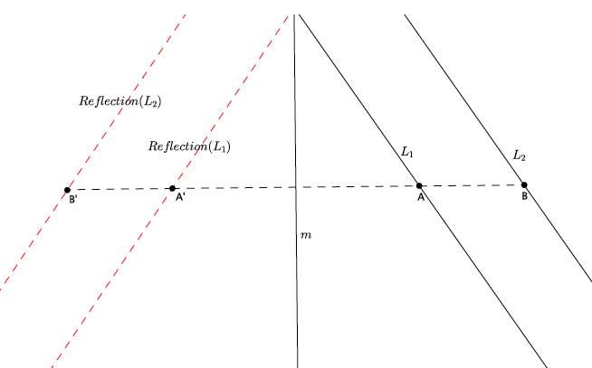

Exercises 6–9 (7 minutes)
Students complete Exercises 6–9 independently.
Use the picture below for Exercises 6–9.
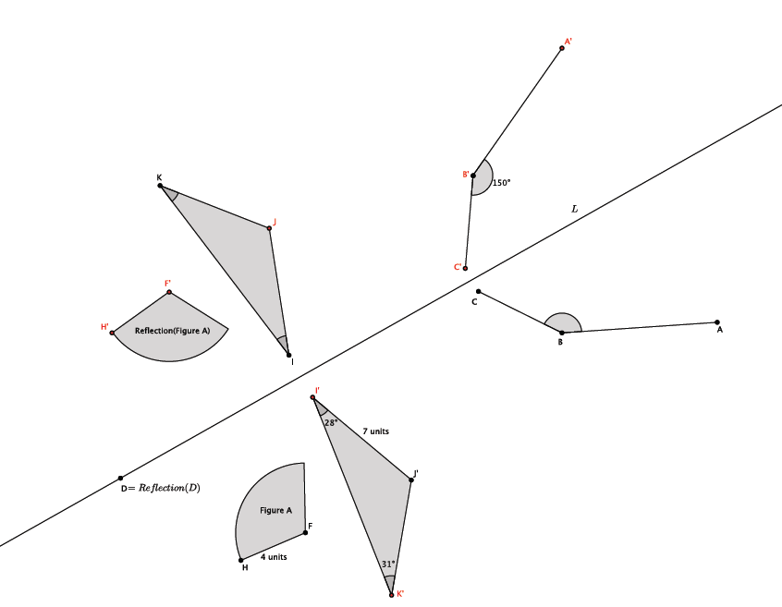
- Use the picture to label the unnamed points.
Points labeled in red, above.

- What is the measure of $∠JKI$? $∠KIJ$? $∠ABC$? How do you know?
$m∠JKI=31°$, $m∠KIJ=28°$, and $m∠ABC=150°$. Reflections preserve angle measures.

- What is the length of segment $Reflection(FH)$? $IJ$? How do you know?
$\left|Reflection(FH)\right|=4$units, and $IJ=7$ units. Reflections preserve lengths of segments.

- What is the location of $Reflection(D)$? Explain.
Point $D$ and its image are in the same location on the plane. Point$D$ was not moved to another part of the plane because it is on the line of reflection. The image of any point on the line of reflection will remain in the same location as the original point.

Closing (4 minutes)
Summarize, or have students summarize, the lesson.
- We know that a reflection across a line is a basic rigid motion.
- Reflections have the same basic properties as translations; reflections map lines to lines, rays to rays, segments to segments and angles to angles.
- Reflections have the same basic properties as translations because they, too, are distance- and angle-preserving.
- The line of reflection $L$ is the bisector of the segment that joins a point not on $L$ to its image.
Lesson Summary
- A reflection is another type of basic rigid motion.
- Reflections occur across lines. The line that you reflect across is called the line of reflection.
- When a point, $P$, is joined to its reflection, $P'$, the line of reflection bisects the segment, $PP^{'}.$

Exit Ticket (4 minutes)

Name Date
Lesson 4: Definition of Reflection and Basic Properties

Exit Ticket

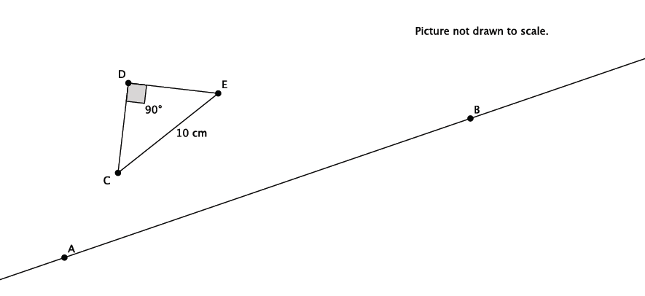
- Let there be a reflection across line $L_{AB}$. Reflect $△CDE$ and label the reflected image.

- Use the diagram above to state the measure of $Reflection(∠CDE)$. Explain.

- Use the diagram above to state the length of segment $Reflection(CE)$. Explain.

- Connect point $C$ to its image in the diagram above. What is the relationship between line $L_{AB}$ and the segment that connects point $C$ to its image?

Exit Ticket Sample Solutions

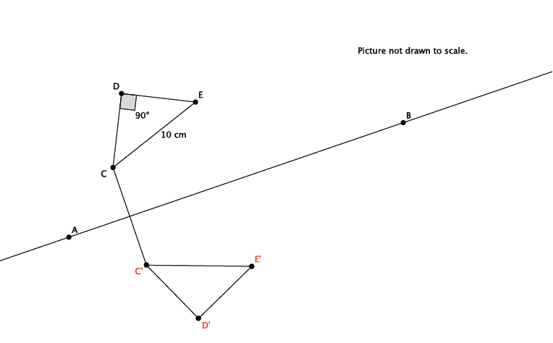
- Let there be a reflection across line $L_{AB}$. Reflect $△CDE$ across line $L_{AB}$. Label the reflected image.

- Use the diagram above to state the measure of $Reflection(∠CDE)$. Explain.
The measure of $Reflection\left(∠CDE\right)=90°$ because reflections preserve degrees of measures of angles.

- Use the diagram above to state the length of segment $Reflection(CE)$. Explain.
The length of $Reflection\left(CE\right)$ is $10$ cm because reflections preserve segment lengths.

- Connect point $C$ to its image in the diagram above. What is the relationship between line $L_{AB}$ and the segment that connects point $C$ to its image?
The line of reflection bisects the segment that connects$C$ to its image.

Problem Set Sample Solutions

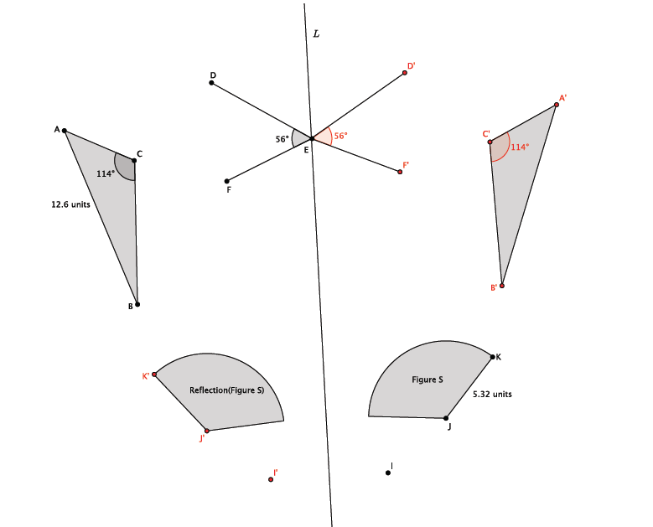
- In the picture below, $∠DEF=56°$, $∠ACB=114°$, $AB=12.6$units, $JK=5.32$units, point $E$is on line $L$, and point $I$ is off of line $L$. Let there be a reflection across line $L$. Reflect and label each of the figures, and answer the questions that follow.

- What is the measure of $Reflection(∠DEF)$? Explain.
The measure of $Reflection\left(∠DEF\right)=56°$. Reflections preserve degrees of angles.

- What is the length of $Reflection(JK)$? Explain.
The length of $Reflection \left(JK\right)=5.32$ units. Reflections preserve lengths of segments.

- What is the measure of $Reflection(∠ACB)$?
The measure of $Reflection\left(∠ACB\right)=114°$.

- What is the length of $Reflection(AB)$?
The length of $Reflection\left(AB\right)=12.6$ units.
- Two figures in the picture were not moved under the reflection. Name the two figures and explain why they were not moved.
Point $E$ and line $L$were not moved. All of the points that make up the line of reflection remain in the same location when reflected. Since point $E$ is on the line of reflection, it is not moved.

- Connect points $I$and $I'$. Name the point of intersection of the segment with the line of reflection point $Q$. What do you know about the lengths of segments$IQ$ and $QI'$?
Segments$IQ$ and $QI'$ are equal in length. The segment $II'$ connects point $I$ to its image,$I'$. The line of reflection will go through the midpoint, or bisect, the segment created when you connect a point to its image.

Animation developed by Sunil Koswatta.

