Lesson 2: Definition of Translation and Three Basic Properties

Classwork
Exercise 1
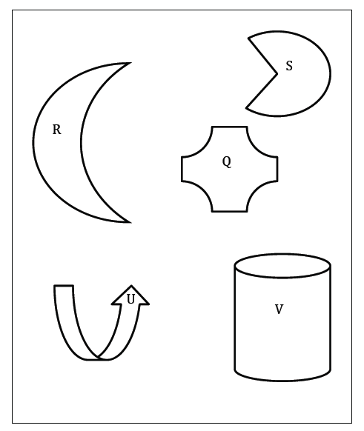
Draw at least three different vectors, and show what a translation of the plane along each vector will look like. Describe what happens to the following figures under each translation using appropriate vocabulary and notation as needed.

Exercise 2
The diagram below shows figures and their images under a translation along $\vec{HI}$. Use the original figures and the translated images to fill in missing labels for points and measures.
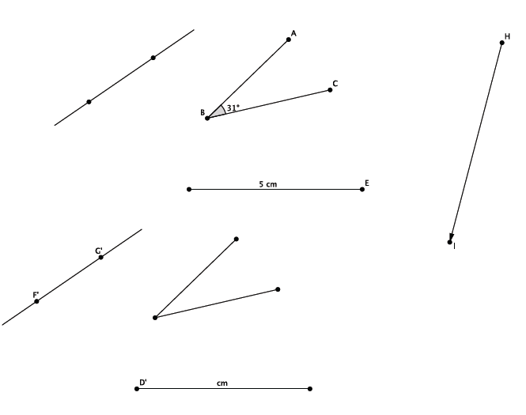

Lesson Summary
Translation occurs along a given vector:
- A vector is a segment in the plane with direction. One of its two endpoints is known as a starting point; while the other is known simply as the endpoint.
- The length of a vector is, by definition, the length of its underlying segment.
- Pictorially note the starting and endpoints:
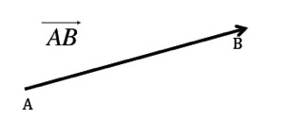
A translation of a plane along a given vector is a basic rigid motion of a plane.
The three basic properties of translation are as follows:
(Translation 1) A translation maps a line to a line, a ray to a ray, a segment to a segment, and an angle to an angle.
(Translation 2) A translation preserves lengths of segments.
(Translation 3) A translation preserves measures of angles.

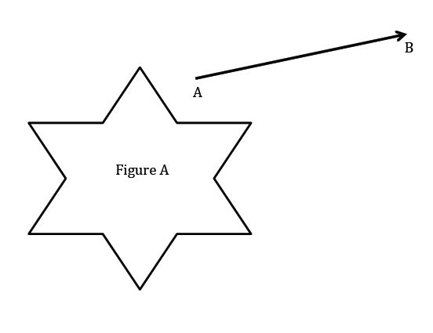
Problem Set

- Translate the plane containing Figure $A$ along $\vec{AB}$. Use your transparency to sketch the image of Figure $A$by this translation. Mark points on Figure $A$and label the image of Figure $A$accordingly.

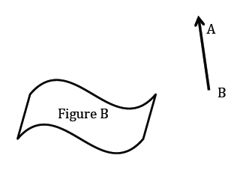

- Translate the plane containing Figure $B$ along $\vec{BA}$. Use your transparency to sketch the image of Figure $B$by this translation. Mark points on Figure $B$ and label the image of Figure $B$ accordingly.

- Draw an acute angle (your choice of degree), a segment with length $3$ cm, a point, a circle with radius $1$ in., and a vector (your choice of length, i.e., starting point and ending point). Label points and measures (measurements do not need to be precise, but your figure must be labeled correctly). Use your transparency to translate all of the figures you have drawn along the vector. Sketch the images of the translated figures and label them.

- What is the length of the translated segment? How does this length compare to the length of the original segment? Explain.

- What is the length of the radius in the translated circle? How does this radius length compare to the radius of the original circle? Explain.

- What is the degree of the translated angle? How does this degree compare to the degree of the original angle? Explain.

- Translate point $D$ along vector $\vec{AB}$ and label the image $D'$. What do you notice about the line containing vector $\vec{AB}$ and the line containing points$D$ and $D'$? (Hint: Will the lines ever intersect?)
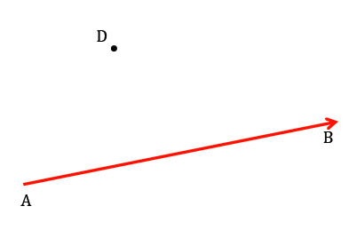

- Translate point $E$along vector $\vec{AB}$ and label the image $E'$. What do you notice about the line containing vector $\vec{AB}$ and the line containing points $E$and $E'$?
