Lesson 1: Why Move Things Around?

Classwork
Exploratory Challenge
- Describe, intuitively, what kind of transformation will be required to move the figure on the left to each of the figures (1)–(3) on the right. To help with this exercise, use a transparency to copy the figure on the left. Note: Begin by moving the left figure to each of the locations in (1), (2), and (3).

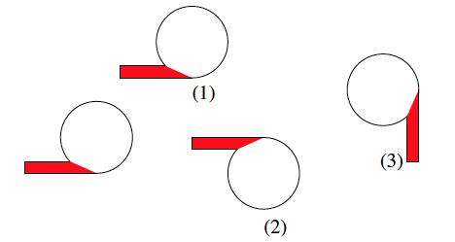

- Given two segments $AB$ and $CD$, which could be very far apart, how can we find out if they have the same length without measuring them individually? Do you think they have the same length? How do you check? In other words, why do you think we need to move things around on the plane?

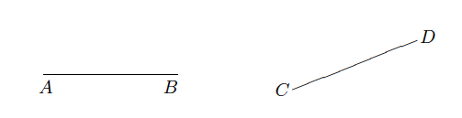
Lesson Summary
A transformation of the plane, to be denoted by $F$, is a rule that assigns to each point $P$ of the plane one and only one (unique) point which will be denoted by $F(P)$.
- So, by definition, the symbol $F(P)$ denotes a specific single point.
- The symbol $F(P)$ shows clearly that $F$ moves $P$ to$F(P)$.
- The point $F(P)$ will be called the image of $P$ by $F$.
- We also say $F$ maps $P$ to $F(P)$.
If given any two points $P$ and $Q$, the distance between the images $F(P)$ and $F(Q)$ is the same as the distance between the original points $P$ and $Q$, then the transformation $F$ preserves distance, or is distance-preserving.
- A distance-preserving transformation is called a rigid motion (or an isometry), and the name suggests that it moves the points of the plane around in a rigid fashion.

Problem Set

- Using as much of the new vocabulary as you can, try to describe what you see in the diagram below.
$$A$$
$$B$$
$$F(A)$$
$$F(B)$$

- Describe, intuitively, what kind of transformation will be required to move Figure A on the left to its image on the right.
Figure A
Image of A

