Lesson 1: Why Move Things Around?

Student Outcomes
- Students are introduced to vocabulary and notation related to rigid motions (e.g., transformation, image, and map).
- Students are introduced to transformations of the plane and learn that a rigid motion is a transformation that is distance-preserving.
- Students use transparencies to imitate a rigid motion that moves or maps one figure to another figure in the plane.

Materials (needed for this and subsequent lessons)
- Overhead projector transparencies (one per student)
- Fine point dry-erase markers (one per student)
- Felt cloth or other eraser (one per student, or per pair)

Lesson Notes
The goal of this module is to arrive at a clear understanding of the concept of congruence. (i.e., What does it mean for two geometric figures to have the same size and shape?) We introduce the basic rigid motions (i.e., translations, reflections, and rotations) using overhead projector transparencies. We then explain congruence in terms of a sequence of these basic rigid motions. It may be worth pointing out that we are studying the basic rigid motions for a definite mathematical purpose, not for artistic reasons or for the purpose of studying “transformational geometry,” per se.
The traditional way of dealing with congruence in Euclidian geometry is to write a set of axioms that abstractly guarantees that two figures are “the same” (i.e., congruent). This method can be confusing to students. Today, we take a more direct approach so that the concept of congruence ceases to be abstract and intangible, becoming instead, susceptible to concrete realizations through hands-on activities using an overhead projector transparency. It will be important not only that teachers use transparencies for demonstration purposes, but also that students have access to them for hands-on experience.
The two basic references for this module are “Teaching Geometry According to the Common Core Standards,” and “Pre-Algebra,” both by Hung-Hsi Wu. Incidentally, the latter is identical to the document cited on page 92 of the Common Core State Standards for Mathematics, which is “Lecture Notes for the 2009 Pre-Algebra Institute” by Hung-Hsi Wu, September 15, 2009.

Classwork
Concept Development (20 minutes)
- Given two segments $AB$ and $CD$, which could be very far apart, how can we find out if they have the same length without measuring them individually? Do you think they have the same length? How do you check? (We will revisit this question later.)

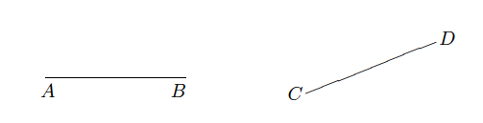
- For example, given a quadrilateral $ABCD$ where all four angles at $A$, $B$, $C$, $D$ are right angles, are the opposite sides $AD$, $BC$ of equal length?
Later, we will prove that they have the same length.
- Similarly, given angles $∠AOB$ and $∠A^{'}O^{'}B^{'}$, how can we tell whether they have the same degree without having to measure each angle individually?
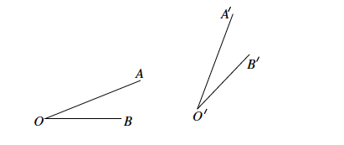
- For example, if two lines $L$ and $L'$ are parallel and they are intersected by another line, how can we tell if the angles $∠a$ and $∠b$ (as shown) have the same degree when measured?
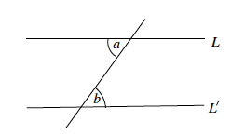

- We are, therefore, confronted with having two geometric figures (two segments, two angles, two triangles, etc.) in different parts of the plane, and we have to find out if they are, in some sense, the same (e.g., same length, same degree, same shape).
- To this end, there are three standard moves we can use to bring one figure on top of another to see if they coincide.
- So, the key question is how do we move things around in a plane, keeping in mind that lines are still lines after being moved, and that the lengths of segments and degrees of the measures of angles remain unchanged in the process.
- “Moving things around in a plane” is exactly where the concept of transformation comes in.
  - A transformation of the plane, to be denoted by $F,$ is a rule that associates (or assigns) to each point $P$ of the plane a unique point which will be denoted by $F(P)$.
MP.2
&
MP.4
    - So, by definition, the symbol $F(P)$ denotes a single point, unambiguously.
    - The symbol $F(P)$ indicates clearly that $F$ moves $P$ to $F(P)$.
    - The point $F(P)$ will be called the image of $P$ by $F$.
    - We also say $F$ maps $P$ to $F(P)$.
  - The reason for the image terminology is that one can, intuitively, think of the plane as a sheet of overhead projector transparency, or as a sheet of paper. A transformation $F$ of the plane is a projection (literally, using a light source) from one sheet of the transparency to a sheet of paper with the two sheets identified as being the same plane. Then, the point $F(P)$ is the image on the sheet of paper when the light source projects the point $P$ from the transparency.

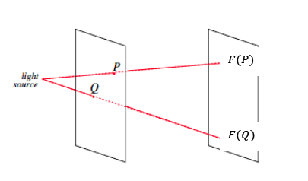

- As to the “map” terminology, think of how you would draw a street map. Drawing a map is a complicated process, but the most mathematically accurate description for the purpose of school mathematics may be that one starts with an aerial view of a particular portion of a city. In the picture below we look at the area surrounding the Empire State Building (E.S.B.) in New York City. The picture reduces the $3$-dimensional information into two dimensions and then “maps” each point on the street to a point on your paper (the map).
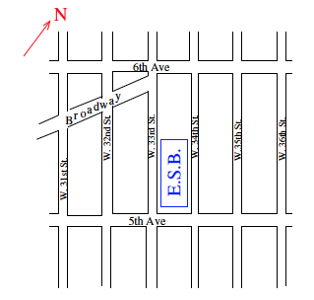
  - A point on the street becomes a point on your paper (the map). So, you are mapping each point on the street to your paper.

- Transformations can be defined on spaces of any dimension, but for now we are only concerned with transformations in the plane, in the sense that transformations are those that assign a point of the plane to another point of the plane.
- Transformations can be complicated (i.e., the rule in question can be quite convoluted), but for now we will concentrate on only the simplest transformations, namely those that preserve distance.
- A transformation $F$ preserves distance, or is distance-preserving, if given any two points $P$ and $Q$, the distance between the images $F(P)$ and $F(Q)$ is the same as the distance between the original points $P$ and $Q$.
MP.6
- An obvious example of this kind of transformation is the identity transformation, which assigns each point $P$ of the plane to $P$ itself.
- A main purpose of this module is to introduce many other distance-preserving transformations and show why they are important in geometry.
- A distance-preserving transformation is called a rigid motion (or an isometry) that, as the name suggests, moves the points of the plane around in a rigid fashion.
Exploratory Challenge (15 minutes)
Have students complete Exercise 1 independently and Exercise 2 in small groups. Have students share their responses.
Exploratory Challenge
- Describe, intuitively, what kind of transformation will be required to move the figure on the left to each of the figures (1)–(3) on the right. To help with this exercise, use a transparency to copy the figure on the left. Note: Begin by moving the left figure to each of the locations in (1), (2), and (3).
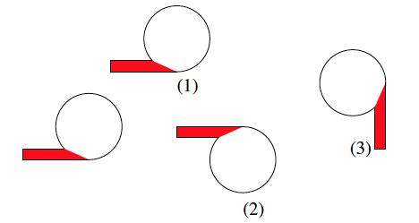
Slide the original figure to the image (1) until they coincide. Slide the original figure to (2), then flip it so they coincide. Slide the original figure to (3); then, turn it until they coincide.

- Given two segments $AB$ and $CD$, which could be very far apart, how can we find out if they have the same length without measuring them individually? Do you think they have the same length? How do you check? In other words, why do you think we need to move things around on the plane?
We can trace one of the segments on the transparency and slide it to see if it coincides with the other segment. We move things around in the plane to see if they are exactly the same. This way, we don’t have to do any measuring.

Closing (5 minutes)
Summarize, or have students summarize, the lesson.
- We can use a transparency to represent the plane and move figures around.
- We can check to see if one figure is the same as another by mapping one figure onto another and checking to see if they coincide.
- A transformation that preserves distance is known as a rigid motion (the distance between any two corresponding points is the same after the transformation is performed).
Lesson Summary
A transformation of the plane, to be denoted by $F$, is a rule that assigns to each point $P$ of the plane one and only one (unique) point which will be denoted by $F(P)$.
- So, by definition, the symbol $F(P)$ denotes a specific single point.
- The symbol $F(P)$ shows clearly that $F$ moves $P$ to$F(P)$.
- The point $F(P)$ will be called the image of $P$ by $F$.
- We also say $F$ maps $P$ to $F(P)$.
If given any two points $P$ and $Q$, the distance between the images $F(P)$ and $F(Q)$ is the same as the distance between the original points $P$ and $Q$, then the transformation $F$ preserves distance, or is distance-preserving.
- A distance-preserving transformation is called a rigid motion (or an isometry), and the name suggests that it moves the points of the plane around in a rigid fashion.

Exit Ticket (5 minutes)

Name Date
Lesson 1: Why Move Things Around?

Exit Ticket

First, draw a simple figure and name it “Figure W.” Next, draw its image under some transformation, (i.e., trace your “Figure W” on the transparency), and then move it. Finally, draw its image somewhere else on the paper.
Describe, intuitively, how you moved the figure. Use complete sentences.

Exit Ticket Sample Solutions

First, draw a simple figure and name it “Figure W.” Next, draw its image under some transformation, (i.e., trace your “Figure W” on the transparency), and then move it. Finally, draw its image somewhere else on the paper.
Describe, intuitively, how you moved the figure. Use complete sentences.
Accept any figure and transformation that is correct. Check for same size and shape. Students should describe the movement of the figure as “sliding” to the left or right, “turning” to the left or right, or “flipping,” similar to how they described the movement of figures in the exercises of the lesson.

Problem Set Sample Solutions

- Using as much of the new vocabulary as you can, try to describe what you see in the diagram below.
$$A$$
$$B$$
$$F(A)$$
$$F(B)$$
There was a transformation, $F$, that moved point $A$ to its image $F(A)$ and point $B$ to its image $F(B)$. Since a transformation preserves distance, the distance between points $A$ and $B$ is the same as the distance between the points $F(A)$ and $F(B)$.

- Describe, intuitively, what kind of transformation will be required to move Figure A on the left to its image on the right.
Figure A
Image of A

First, I have to slide Figure A so that the point containing two dots maps onto the Image of A in the same location; next, I have to turn (rotate) it so that Figure A maps onto Image of A; finally, I have to flip the figure over so the part of the star with the single dot maps onto the image.

This is done in a way that intuitively preserves the shape. The correct terminology here is similar, as shown in Module 3.

