Lesson 16: Understanding Box Plots

Classwork
Exercise 1: Supreme Court Chief Justices
The Supreme Court is the highest court of law in the United States, and it makes decisions that affect the whole country. The Chief Justice is appointed to the Court and will be a justice the rest of his or her life unless he or she resigns or becomes ill. Some people think that this gives the Chief Justice a very long time to be on the Supreme Court. The first Chief Justice was appointed in 1789.
The table shows the years in office for each of the Chief Justices of the Supreme Court as of 2013:
Name | Years | Appointed in
John Jay | $$6$$ | $$1789$$
John Rutledge | $$1$$ | $$1795$$
Oliver Ellsworth | $$4$$ | $$1796$$
John Marshall | $$34$$ | $$1801$$
Roger Brooke Taney | $$28$$ | $$1836$$
Salmon P. Chase | $$9$$ | $$1864$$
Morrison R. Waite | $$14$$ | $$1874$$
Melville W. Fuller | $$22$$ | $$1888$$
Edward D. White | $$11$$ | $$1910$$
William Howard Taft | $$9$$ | $$1921$$
Charles Evens Hughes | $$11$$ | $$1930$$
Harlan Fiske Stone | $$5$$ | $$1941$$
Fred M. Vinson | $$7$$ | $$1946$$
Earl Warren | $$16$$ | $$1953$$
Warren E. Burger | $$17$$ | $$1969$$
William H. Rehnquist | $$19$$ | $$1986$$
John G. Roberts | $$8$$ | $$2005$$
Data Source: http://en.wikipedia.org/wiki/List_of_Justices_of_the_Supreme_Court_of_the_United_States

- Use the table to answer the following:
  - Which Chief Justice served the longest term and which served the shortest term? How many years did each of these Chief Justices serve?

  - What is the median number of years these Chief Justices have served on the Supreme Court? Explain how you found the median and what it means in terms of the data.

  - Make a box plot of the years the justices served. Describe the shape of the distribution and how the median and IQR relate to the box plot.

  - Is the median half way between the least and the most number of years served? Why or why not?

Exercises 2–3: Downloading Songs
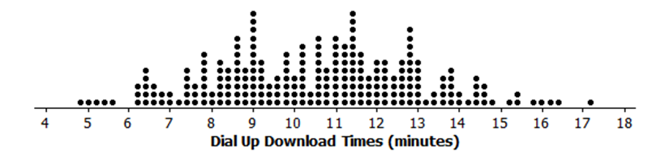
- A broadband company timed how long it took to download $232$ four-minute songs on a dial up connection. The dot plot below shows their results.

  - What can you observe about the download times from the dot plot?

  - Is it easy to tell whether or not $12.5$ minutes is in the top quarter of the download times?

  - The box plot of the data is shown below. Now answer parts (a) and (b) above using the box plot.
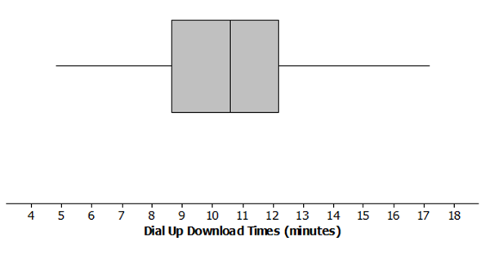

  - What are the advantages of using a box plot to display a large set of data? What are the disadvantages?

- Molly presented the plots below to argue that using a dial up connection would be better than using a broadband connection. She argued that the dial up connection seems to have less variability around the median even though the overall range seems to be about the same for the download times using broadband. What would you say?

Exercises 4–5: Rainfall
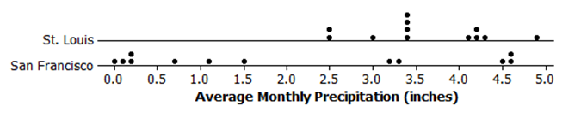
- Data on average rainfall for each of the twelve months of the year were used to construct the two dot plots below.

  - How many data points are in each dot plot? What does each data point represent?

  - Make a conjecture about which city has the most variability in the average monthly amount of precipitation and how this would be reflected in the IQRs for the data from both cities.

  - Based on the dot plots, what are the approximate values of the interquartile ranges (IQR) of the amount of average monthly precipitation in inches for each city? Use each IQR to compare the cities.

  - In an earlier lesson, the average monthly temperatures were rounded to the nearest degree Fahrenheit. Would it make sense to round the amount of precipitation to the nearest inch? Why or why not?

- Use the data from Exercise 4 to answer the following.
  - Make a box plot of the amount of precipitation for each city.

0.0 0.5 1.0 1.5 2.0 2.5 3.0 3.5 4.0 4.5 5.0
Average Monthly Precipitation in St. Louis (inches)

0.0 0.5 1.0 1.5 2.0 2.5 3.0 3.5 4.0 4.5 5.0
Average Monthly Precipitation in San Francisco (inches)

  - Compare the percent of months that have above $2$ inches of precipitation for the two cities. Explain your thinking.

  - How do the top fourths of the average monthly precipitation in the two cities compare?

  - Describe the intervals that contain the smallest $25\%$ of the average monthly precipitation amounts for each city.

  - Think about the dot plots and the box plots. Which representation do you think helps you the most in understanding how the data vary?

Lesson Summary
In this lesson, you reviewed what you know about box plots, the $5$-number summary of the data used to construct a box plot, and the IQR. Box plots are very useful for comparing data sets and for working with large amounts of data. When you compare two or more data sets using box plots; however, you have to be sure that the scales and units are the same.

Problem Set

- The box plots below summarize the ages at the time of the award for leading actress and leading actor Academy Award winners.
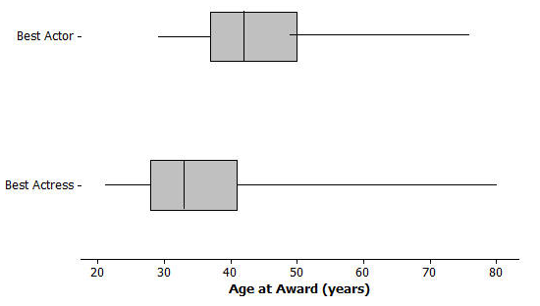
Data Source: http://en.wikipedia.org/wiki/List_of_Best_Actor_winners_by_age_at_win http://en.wikipedia.org/wiki/List_of_Best_Actress_winners_by_age_at_win

  - Do you think it is harder for an older woman to win an academy award for best actress than it is for an older man to win a best actor award? Why or why not?
  - The oldest female to win an academy award was Jessica Tandy in 1990 for Driving Miss Daisy. The oldest actor was Henry Fonda for On Golden Pond in 1982. How old were they when they won the award? How can you tell? Were they a lot older than most of the other winners?
  - The 2013 winning actor was Daniel Day-Lewis for Lincoln. He was $55$ years old at that time. What can you say about the percent of male award winners who were older than Daniel Day-Lewis when they won their Oscar?
  - Use the information you can see in the box plots to write a paragraph supporting or refuting the claim that fewer older actresses than actors win academy awards.

- The scores of sixth and seventh graders on a test about polygons and their characteristics are summarized in the box plots below.
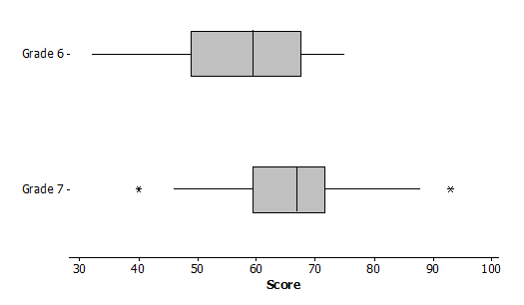

  - In which grade did the students do the best? Explain how you can tell.
  - Why do you think two of the data values in grade seven are not part of the line segments?
  - How do the median scores for the two grades compare? Is this surprising? Why or why not?
  - How do the IQRs compare for the two grades?

- A formula for IQR could be written as $Q3-Q1=IQR$. Suppose you knew the IQR and the Q1. How could you find the Q3?

- Consider the statement, “Historically, the average length of service as Chief Justice on the Supreme Court has been less than $15$ years; however, since 1970 the average length of service has increased.” Use the data given in Exercise 1 to answer the following questions.
  - Do you agree or disagree with the statement? Explain your thinking.
  - Would your answer change if you used the median number of years rather than the mean?

