Lesson 14: Summarizing a Distribution Using a Box Plot

A box plot is a graph that is used to summarize a data distribution. What does the box plot tell us about the data distribution? How does the box plot indicate the variability of the data distribution?

Classwork
Example 1: Time to Get to School
What is the typical amount of time it takes for a person in your class to get to school? The amount of time it takes to get to school in the morning varies for each person in your class. Take a minute to answer the following questions. Your class will use this information to create a dot plot.
Write your name and an estimate of the number of minutes it took you to get to school today on a post-it note.

What were some of the things you had to think about when you made your estimate?

Exercises 1–4
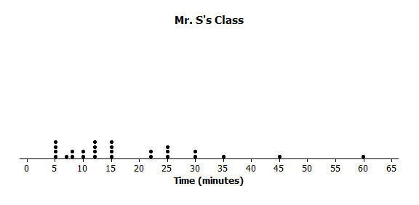
Here is a dot plot of the estimates of the times it took students in Mr. S’s class to get to school one morning.
- Put a line in the dot plot that seems to separate the shortest times and the longest times.

- Put another line in the plot that separates those who seem to live really close to school and one that marks off those who took a long time to get to school.

- Your plot should be divided into four sections. Record the number of times in each of the four sections.

- Share your marked up dot plot with some of your classmates. Compare how each of you divided the plot into four sections.

Exercises 5–7: Time to Get to School
The teacher asked the class to make a representation that would summarize the times it took students in Mr. S’s class to get to school and how they are spread out. Tim decided to get rid of the dots and just use a picture of the divisions he made of the shortest times and the longest times. He put a box around the two middle sections.
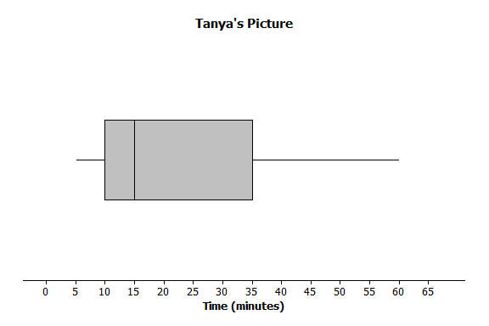
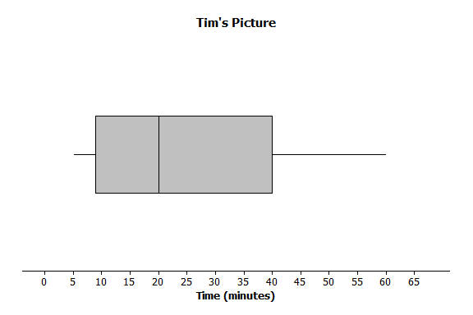
Tanya thought that was a good idea and made a picture of the way she had divided the times. Here are their pictures.

- What do the pictures tell you about the length of time it takes the students to get to school?

- What don’t the pictures tell you about the length of time it takes the students to get to school?

- How do the two pictures compare?

Example 2: Making a Box Plot
Mr. S suggested that to be sure everyone had the same picture, statisticians developed a standard procedure for making the cut marks for the sections.
Mr. S. wrote the following on the board:
To make a box plot
- Find the median of all of the data
- Find Q1, the median of the bottom half of the data, and Q3, the median of the top half of the data.
- Draw a box that goes from Q1 to Q3, the two middle sections.
- Draw a line segment connecting the minimum value to the box and one that connects the maximum value to the box.

Now use the given number line to make a box plot of the data below.
$20$, $21$,$25$,$31$,$35$,$38$,$40$,$42$,$44$
The $5$-number summary is as follows:
Min = $20$
Q1 = $23$
Median = $35$
Q3 = $41$
Max = $44$

$15$ $20$ $25$ $30$ $35$ $40$ $45$

Exercises 8–11: A Human Box Plot
Consider again your post-it note that you used to write down the number of minutes it takes you to get to school. If possible, you and your classmates will form a human box plot of the number of minutes it takes your class to get to school.
- Find the median of the group. Does someone represent the median? If not, who is the closest to the median?

- Find the maximum and minimum of the group. Who are they?

- Find Q1 and Q3 of the group. Does anyone represent Q1 or Q3? If not, who is the closest to Q1? Who is closest to Q3?

- Sketch the box plot for this data set below.

Lesson Summary
The focus of this lesson is moving from a plot that shows all of the data values (dot plot) to one that summarizes the data with five points (box plot).
You learned how to make a box plot by doing the following:
- Finding the median of all of the data
- Finding Q1, the median of the bottom half of the data, and Q3, the median of the top half of the data.
- Drawing a box that goes from Q1 to Q3, the two middle sections.
- Drawing a line segment connecting the minimum value to the box and one that connects the maximum value to the box.
You also learned important characteristics of box plots:
- $\frac{1}{4}$ of the data are in each of the sections of the plot.
- The length of the interval for a section does not indicate either how the data are grouped in that interval or how many values are in the interval.

Problem Set

- Dot plots for the amount of time it took students in Mr. S’s and Ms. J’s classes to get to school are below
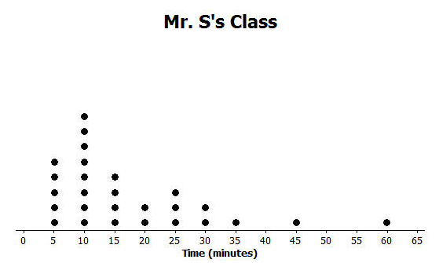
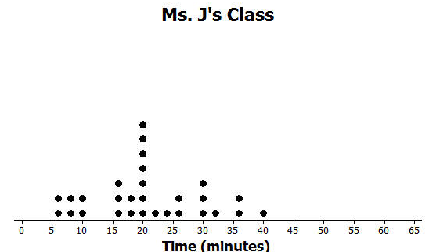
  - Make a box plot of the times for each class.
  - What is one thing you can see in the dot plot that you cannot see in the box plot? What is something that is easier to see in the box plot than in the dot plot?

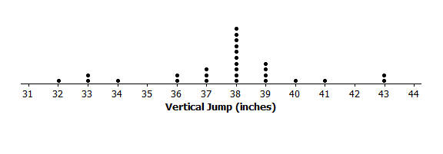
- The dot plot below shows the vertical jump of some NBA players. A vertical jump is how high a player can jump from a standstill. Draw a box plot of the heights for the vertical jumps of the NBA players above the dot plot.

- The mean daily temperatures in °F for the month of February for a certain city are as follows:
$4$, $11$,$14$,$15$,$17$,$20$,$30$,$23$,$20$,$35$,$35$,$31$,$34$,$23$,$15$,$19$,$39$,$22$,$15$,$15$,$19$,$39$,$22$,$23$,$29$,$26$,$29$,$29$
  - Make a box plot of the temperatures.
  - Make a prediction about the part of the United States you think the city might be located. Explain your reasoning.
  - Describe the data distribution of temperature. Include a description of the center and spread.

- The plot below shows the results of a survey of households about the number of dogs they have. Identify the following statements as true or false. Explain your reasoning in each case.
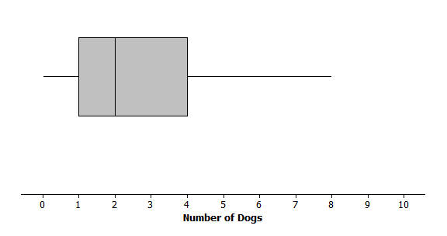
  - The maximum number of dogs per house is $8$.
  - At least $\frac{1}{2}$ of the houses have $2$ or more dogs.
  - All of the houses have dogs.
  - Half of the houses surveyed have between $2$ and $4$ dogs.
  - Most of the houses surveyed have no dogs.

