Lesson 11: Describing Distributions Using the Mean and MAD

Student Outcomes
- Students use the mean and MAD to describe a data distribution in terms of center and variability.
- Students use the mean and MAD to describe similarities and differences between two distributions.

Classwork
Example 1 (5 minutes): Comparing Distributions with the Same Mean

Example 1: Comparing Distributions with the Same Mean
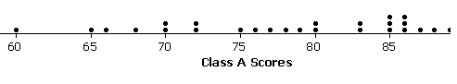
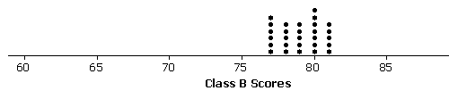
In Lesson 10, a data distribution was characterized mainly by its center (mean) and variability (MAD). How these measures help us make a decision often depends on the context of the situation. For example, suppose that two classes of students took the same test and their grades (based on $100$ points) are shown in the following dot plots. The mean score for each distribution is $79$ points. Would you rather be in Class A or Class B if you had a score of $79$?

In Lesson 10, a data distribution was characterized mainly by its center (mean) and variability (MAD). How these measures help us make a decision often depends on the context of the situation. This example shows two distributions of test scores with the same mean, $79$, but clearly very different variability. Students will need to be able to explain their reasoning for making decisions based not only on the mean but also the variability of the distributions.
MP.6
Introduce the data sets and ask students:
- In which class would you rather be if you scored a $79$?
- How would you describe the shape of the data?

Exercises 1–3 (5–7 minutes)
Let students work independently. Then discuss and confirm answers as a class.

Exercises 1–6
- Looking at the dot plots, which class has the greater MAD? Explain without actually calculating the MAD.
Class A. The data for Class A has a much wider spread. Thus, it has greater variability and a larger MAD.

- If Liz had one of the highest scores in her class, in which class would she rather be? Explain your reasoning.
She would rather be in Class A. This class had higher scores in the $90$s, whereas Class B had a high score of only $81$.

- If Logan scored below average, in which class would he rather be? Explain your reasoning.
Logan would rather be in Class B. The low scores in B were in the $70$s, whereas Class A had low scores in the $60$s.

Exercises 4–6 (10–12 minutes)
Let students work in pairs. Discuss answers to Exercises 5–6 as a class.

Exercises 4–6
Your little brother asks you to replace the battery in his favorite remote control car. The car is constructed so that it is difficult to replace its battery. Your research of the lifetimes (in hours) of two different battery brands (A and B) shows the following data for $20$ batteries from each brand:
A | $$12$$ | $$14$$ | $$14$$ | $$15$$ | $$16$$ | $$17$$ | $$17$$ | $$18$$ | $$19$$ | $$20$$ | $$21$$ | $$21$$ | $$23$$ | $$23$$ | $$24$$ | $$24$$ | $$24$$ | $$25$$ | $$26$$ | $$27$$
B | $$18$$ | $$18$$ | $$19$$ | $$19$$ | $$19$$ | $$19$$ | $$19$$ | $$19$$ | $$20$$ | $$20$$ | $$20$$ | $$20$$ | $$20$$ | $$21$$ | $$21$$ | $$21$$ | $$21$$ | $$22$$ | $$22$$ | $$22$$

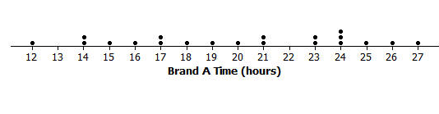
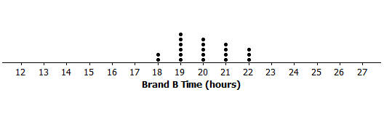
- To help you decide which battery to purchase, start by drawing a dot plot for each brand.

- Find the mean battery life for each brand and compare them.
The mean of Brand A is $20$ hours.
The mean of Brand B is $20$ hours.

- Looking at the variability of each data set shown in its dot plot, give one reason you would choose Brand A. What is one reason you would choose Brand B? Explain your reasoning.
Answers will vary.
Brand A: take a risk and hope the battery lasts longer. You may get a good, long-lasting battery.
Brand B: the battery range is around $20$ hours. Most of the batteries in this brand last that long.

Example 2 (5–7 minutes): Comparing Distributions with Different Means

Example 2: Comparing Distributions with Different Means
You have been comparing distributions that have the same mean, but different variability. As you have seen, deciding whether large variability or small variability is best depends on the context and on what is being asked. For example, in Exercise 2, Liz preferred to be in the distribution with more variability because she had one of the highest scores in the class. Thus, her score would have been higher had she been in Class A than had she been in Class B. Logan, on the other hand, preferred the class with lesser variability (i.e., Class B), since his score was below average.
If two data distributions have different means, how does a measure of variability play a part in making decisions?

Recount the pairs of distributions from Example 1 and Exercises 1–6 that had the same means and how variability played a role in making decisions.
Then answer the question posed in the text: If two data distributions have different means, how does a measure of variability play a part in making decisions?
MP.2
- Comparing the variability in distributions with different means is not really any different, as variability is not concerned with location.
- Note that when the magnitude of the data sets is substantially different, it may not be possible to graph both sets using the same scaling. In such cases, students should be careful in drawing a conclusion concerning variability because what may appear to be differing amounts of spread may not be that different at all. Encourage your students to draw dot plots using a scale that covers the span of both distributions whenever possible.
- If the magnitude of the two distributions is substantially different so that using the same scale is not practical, then advise them to be very careful comparing variability visually. That case requires the use of a measure, such as the MAD.

Exercises 7–9 (10–12 minutes)
Let students continue to work in pairs to complete Exercises 7–9. Then confirm answers to Exercises 8 and 9 as a class. Calculators are needed for this exercise.

Exercises 7–9
Suppose that you wanted to answer the following question: Are field crickets better predictors of atmospheric temperature than katydids are? Both species of insect make chirping sounds by rubbing their front wings together.
The following data are the number of chirps (per minute) for $10$ insects each. All the data were taken on the same evening at the same time.
Insect | $$1$$ | $$2$$ | $$3$$ | $$4$$ | $$5$$ | $$6$$ | $$7$$ | $$8$$ | $$9$$ | $$10$$
Crickets | $$35$$ | $$32$$ | $$35$$ | $$37$$ | $$34$$ | $$34$$ | $$38$$ | $$35$$ | $$36$$ | $$34$$
Katydids | $$66$$ | $$62$$ | $$61$$ | $$64$$ | $$63$$ | $$62$$ | $$68$$ | $$64$$ | $$66$$ | $$64$$

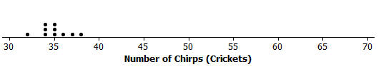
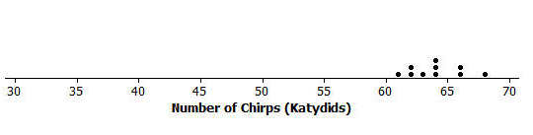
- Draw dot plots for these two data distributions using the same scale, going from $30$ to $70$. Visually, what conclusions can you draw from the dot plots?
Visually you can see a higher value for the mean of the katydids. The variability looks to be similar.

- Calculate the mean and MAD for each distribution.
Crickets: The mean is $35$ chirps per minute.
The MAD is $1.2$ chirps per minute.
Katydids: The mean is $64$ chirps per minute.
The MAD is $1.6$ chirps per minute.

- The outside temperature $T$ can be predicted by counting the number of chirps made by these insects.
  - For crickets, $T$ is found by adding$40$ to its mean number of chirps per minute. What value of $T$ is being predicted by the crickets?
The predicted temperature is $35+40$or $75$ degrees.

  - For katydids, $T$ is found by adding $161$ to its mean number of chirps per minute and then dividing the sum by $3$. What value of $T$ is being predicted by the katydids?
The predicted temperature is $\frac{\left(64+161\right)}{3}$or $75$ degrees.

  - The temperature was $75$ degrees when these data were recorded, so using the mean from each data set gave an accurate prediction of temperature. If you were going to use the number of chirps from a single cricket or a single katydid to predict the temperature, would you use a cricket or a katydid? Explain how variability in the distributions of number of chirps played a role in your decision.
The crickets had a smaller MAD. This indicates that an individual cricket is more likely to have a number of chirps that is close to the mean.
Lesson Summary
This lesson focused on comparing two data distributions based on center and variability. It is important to consider the context when comparing distributions. In decision-making, drawing dot plots and calculating means and MADs can help you make informed decisions.
Exit Ticket (5 minutes)
Name ___________________________________________________ Date____________________
Lesson 11: Describing Distributions Using the Mean and MAD

Exit Ticket

You need to decide which of two brands of chocolate chip cookies to buy. You really love chocolate chip cookies. The numbers of chocolate chips in each of five cookies from each brand are as follows:

Cookie | $$1$$ | $$2$$ | $$3$$ | $$4$$ | $$5$$
ChocFull | $$17$$ | $$19$$ | $$18$$ | $$18$$ | $$18$$
AllChoc | $$22$$ | $$15$$ | $$14$$ | $$21$$ | $$18$$

- Draw a dot plot for each set of data that shows the distribution of number of chips for each brand. Use a scale for your dot plots that covers the same span for both distributions.

- Find the mean number of chocolate chips for each of the two brands. Compare the means.

- Looking at your dot plots and considering variability, which brand do you prefer? Explain your reasoning.

Exit Ticket Sample Solutions

You need to decide which of two brands of chocolate chip cookies to buy. You really love chocolate chip cookies. The numbers of chocolate chips in each of five cookies from each brand are as follows:
Cookie | $$1$$ | $$2$$ | $$3$$ | $$4$$ | $$5$$
ChocFull | $$17$$ | $$19$$ | $$18$$ | $$18$$ | $$18$$
AllChoc | $$22$$ | $$15$$ | $$14$$ | $$21$$ | $$18$$

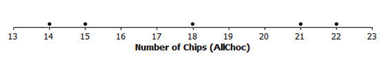
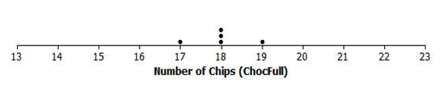
- Draw a dot plot for each set of data that shows the distribution of number of chips for each brand. Use a scale for your dot plots that cover the same span for both distributions.

- Find the mean number of chocolate chips for each of the two brands. Compare the means.
Students should look at both graphs and immediately determine that the means are both $18$ chips, since the distributions are symmetric around $18$.

- Looking at your dot plots and considering variability, which brand do you prefer? Explain your reasoning.
Students could argue either way:
- Students who prefer ChocFull may argue that they are assured of getting $18$ chips most of the time, with no fewer than $17$ chips, and a bonus once in a while of $19$ chips. With AllChoc, they may sometimes get more than $20$ chips, but would sometimes get only $14$ or $15$chips.
- Students who prefer AllChoc are the risk-takers who are willing to tolerate getting only $14$ or $15$ chips for the chance of getting $21$ or $22$ chips.

Problem Set Sample Solutions

- Two classes took the same mathematics test. Summary measures for the two classes are as follows:

 | Mean | MAD
Class A | $$78$$ | $$2$$
Class B | $$78$$ | $$10$$

  - Suppose that you received the highest score in your class. Would your score have been higher if you were in Class A or Class B? Explain your reasoning.
Class B, because the means are the same. And the variability, as measured by the MAD, is higher in that class than it is in Class A.

  - Suppose that your score was below the mean score. In which class would you prefer to have been? Explain your reasoning.
Class A because the variability, as measured by the MAD, indicates a more compact distribution around the mean. Whereas, a score below the mean in Class B could be far lower than in Class A.

- Eight tomato plants each of two varieties, LoveEm and Wonderful, are grown under the same conditions. The numbers of tomatoes produced from each plant of each variety are shown:

Plant | $$1$$ | $$2$$ | $$3$$ | $$4$$ | $$5$$ | $$6$$ | $$7$$ | $$8$$
LoveEm | $$27$$ | $$29$$ | $$27$$ | $$28$$ | $$31$$ | $$27$$ | $$28$$ | $$27$$
Wonderful | $$31$$ | $$20$$ | $$25$$ | $$50$$ | $$32$$ | $$25$$ | $$22$$ | $$51$$

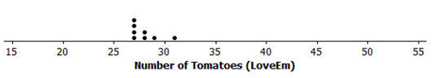
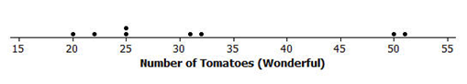
  - Draw dot plots to help you decide which variety is more productive.

  - Calculate the mean number of tomatoes produced for each variety. Which one produces more tomatoes on average?
Guessing a mean, and checking by summing deviations, is not as obvious for these distributions. So, using the formula is probably more efficient. The mean number of LoveEm tomatoes is $28$, and the mean number of Wonderful tomatoes is $32$.

  - If you want to be able to accurately predict the number of tomatoes a plant is going to produce, which variety should you choose – the one with the smaller MAD, or the one with the larger MAD? Explain your reasoning.
LoveEm produces fewer tomatoes on average but is far more consistent. Looking at the dot plots, its variability is far less than that of Wonderful tomatoes. Based on these data sets, choosing LoveEm should yield numbers in the high $20$s consistently, but the number from Wonderful could vary wildly from lower yields in the low $20$s, to huge yields around $50$.

  - Calculate the MAD of each plant variety.
The MAD for LoveEm is $1$ tomato.
The MAD for Wonderful is $9.25$ tomatoes.

