Lesson 7: The Mean as a Balance Point

Student Outcomes
- Students characterize the center of a distribution by its mean in the sense of a balance point.
- Students understand that the mean is a balance point by calculating the distances of the data points from the mean and call the distances, deviations.
- Students understand that the mean is the value such that the sum of the deviations is equal to zero.

Lesson Notes
You may want to introduce this lesson by recalling Lessons 3 and 6. In Lesson 3, Robert gathered data from sixth grade students regarding the amount of sleep they get on school nights. He drew a dot plot of the data and decided informally on a value for the center of the distribution. In Lesson 6, Michelle formalized a center value to be the number of hours that all subjects in the sample would sleep if they all had the same number, called the mean.
MP.4
In this lesson, students will interpret the mean as a “balance point” by using a ruler and pennies to represent data. The objective of this lesson is for students to discover that if they were to draw a dot plot of the original data set that it would balance at the mean. Also, if in the process of moving data, total movement of points to the left equals the total movement of points to the right, then the balance point does not change. Therefore, it remains at the mean of the original data set.
A word of caution before beginning this lesson: Many rulers have holes in them. When data are not symmetric around $6$ inch mark of a $12$ inch ruler, the holes will affect the balancing at the correct value for the mean. Balancing pennies can be problematic. Students will probably have to tape on pennies (or whatever object is used). Also, if balancing on the eraser end of a pencil proves too difficult, try using a paper towel tube cut in half lengthwise (as suggested in Connected Mathematics, Data Distributions, Pearson).
In physics, the underlying principle that pertains to the balance interpretation of mean is called Archimedes’ Law of the Lever. Recall that the Law states that the sum of the products of weights and their distances to the left of the balance point equals the sum of the products of weights and their distances to the right of the balance point. Our use of the Law is a special case since all of our weights (data points) are considered to be equal. Therefore, for us, the sum of the distances from the balance point to points left of the balance point equals the sum of the distances from the balance point to points right of the balance point. Moreover, the mean of the data is the value where the balance point must be to balance the lever. In statistics, deviations are calculated. A deviation is $x-\overline{x}$, where $x$ is a data point and $\overline{x}$ is the mean of the data. Data values to the left of the mean will have negative deviations; data values to the right of the mean will have positive deviations. The sum of all the deviations will be $0$. Further, note that Archimedes’ lever has to be weightless. Clearly, a ruler is not weightless, so when students try to balance various data distributions on a ruler, the balance point may not be the exact value it should be.

Classwork
In Lesson 3, Robert gave us an informal interpretation of the center of a data set. In Lesson 6, Michelle developed a more formal interpretation of the center as a “fair share” mean, a value that every person in the data set would have if they all had the same value. In this lesson, Sabina will show us how to interpret the mean as a “balance point.”
Example 1 (7 minutes): The Mean as a Balance Point

Example 1: The Mean as a Balance Point
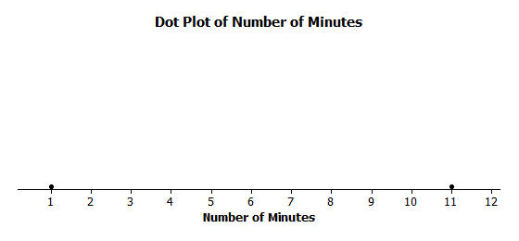
Sabina wants to know how long it takes students to get to school. She asks two students how long it takes them to get to school. It takes one student $1$ minute and the other student $11$ minutes. Sabina represents these data on a ruler putting a penny at $1$ and another at $11$ and shows that the ruler balances on the eraser end of a pencil at $6$. Note that the mean of $1$ and $11$ is also $6$. Sabina thinks that there might be a connection between the mean of two data points and where they balance on a ruler. She thinks the mean may be the balancing point. What do you think? Will Sabina’s ruler balance at $6$? Is the mean of $1$ and $11$ equal to $6$? Sabina shows the result on a dot plot.

Sabina decides to move the penny at $1$ to $4$ and the other penny from $11$ to $8$ on the ruler, noting that the movement for the two pennies is the same distance but in opposite directions. She notices that the ruler still balances at $6$. Sabina decides that if data points move the same distance but in opposite directions, the balancing point on the ruler does not change. Does this make sense? Notice that this implies that the mean of the time to get to school for two students who take $4$ minutes and $8$ minutes to get to school is also $6$ minutes.
Sabina continues by moving the penny at $4$ to $6$. To keep the ruler balanced at $6$, how far should Sabina move the penny at $8$ and in what direction? Since the penny at $4$ moved two to the right, to maintain the balance the penny at $8$ needs to move two to the left. Both pennies are now at $6$, and the ruler clearly balances there. Note that the mean of these two values ($6$ minutes and $6$ minutes) is still $6$ minutes.

Recall the scenarios from Lessons 3 and 6 (i.e., Robert’s informal interpretation of the center value, Michelle’s “fair share” mean). Now Sabina will describe the mean as a “balance point.”
Read through the first paragraph as a class. Ask students the following questions and then display the ruler example.
- Will Sabina’s ruler balance at $6$?
  - Yes. ( Now show the ruler balancing on a pencil.)
- Is $6$ the mean of $1$ and $11$?
  - Yes

Read through the second paragraph as a class. As the scenario is being read, tell students to mark the new positions of the pennies on the dot plot provided in the example. Ask students:
- Do you think the balance point will remain at $6$?
  - Yes. (Now show the ruler balancing on a pencil.)

Read through the last paragraph as a class. Note that Sabina is moving the first penny from $4$ to $6$. Ask students the following:
- How far is she moving the penny?
  - $2$ inches.
- How far should she move the other penny to keep the ruler in balance?
  - $2$ inches. (If needed, remind students it needs to be moved in the opposite direction.)
- If she is moving the penny from $8$, where should it be placed?
  - At $6$ inches. (If students say $10$ inches, again remind them they need to move the pennies in opposite directions.)

Exercises 1–2 (7 minutes)
Let students work in pairs on Exercises 1–2.

Exercises 1–2
Now it is your turn to try balancing two pennies on a ruler.
- Tape one penny at $2.5$ on your ruler.
  - Where should a second penny be taped so that the ruler will balance at $6$?
At $9.5$ inches.

  - How far is the penny at $2.5$ from $6$? How far is the other penny from $6$?
Each is $3.5$ inches away.

  - Is the mean of the two locations of the pennies equal to $6$?
Yes.

- Move the penny that is at $2.5$ two inches to the right.
  - Where will the point be placed?
At $4.5$ inches.

  - What do you have to do with the other data point to keep the balance point at $6$?
Move it $2$ inches to the left.

  - What is the mean of the two new data points? Is it the same value as the balancing point of the ruler?
The mean is $6$; it is the same.

Example 2 (5 minutes): Understanding Deviations

Example 2: Understanding Deviations
In the above example using two pennies, it appears that the balance point of the ruler occurs at the mean location of the two pennies. We computed the distance from the balance point to each penny location and treated the distances as positive numbers. In statistics, we calculate a difference by subtracting the mean from the data point and call it the deviation of a data point from the mean. So, points to the left of the mean are less than the mean and have a negative deviation. Points to the right of the mean are greater than the mean and have a positive deviation.

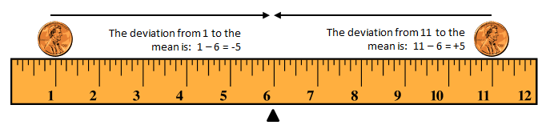
Let’s look at Sabina’s initial placement of pennies at $1$ and $11$ with a mean at $6$ on the graph below. Notice that the deviations are $+5$ and $-5$. What is the sum of the deviations?
Similarly, when Sabina moved the pennies to $4$ and $8$, the deviation of $4$ from $6$ is $4- 6=-2$, and the deviation of $8$ from $6$ is $8-6=+2$. Here again, the sum of the two deviations is $0$, since $-2+2=0.$ It appears that for two data points the mean is the point when the sum of its deviations is equal to $0$.

This example introduces the very important concept of deviation of a data point $x$ from its mean $\overline{x}$, namely the difference $x-\overline{x}$. Explain that a deviation is calculated by subtracting the mean from the data point, i.e., $deviation=data point-mean$. Students need to understand the correct order when subtracting. Be sure that students realize that data to the left of the mean will have negative deviations and those to the right will have positive deviations.
Examine the graphic with students, talk about the deviations and ask:
- What is the sum of the deviations?
  - $0$
Discuss how the deviations change when Sabina moves the pennies again and ask:
- In a data distribution, what is the sum of all of the deviations?
  - $0$
- What does this say about the mean of a data set regarding balance?
  - The mean balances the sum of the positive deviations with the sum of the negative deviations, i.e., the sum of all deviations equals $0$.

Exercises 3–4 (5 minutes)
Let students work in pairs.

Exercises 3–4
Refer back to Exercise 2, where one penny was located at $2.5$ and the mean was at $6$.
- Where was the second penny located?
At $9.5$ inches.

- Calculate the deviations of the two pennies and show that the sum of the deviations is $0$.
The deviation of $2.5$ to $6$: $2.5-6=-3.5$.
The deviation of $9.5$ to $6$: $9.5-6=3.5$.
The sum of $-3.5+3.5$ is $0$.

Example 3 (5 minutes): Balancing the Mean

Example 3: Balancing the Mean
Sabina wants to know what happens if there are more than two data points. Suppose there are three students. One student lives $2$ minutes from school, and another student lives $9$ minutes from school. If the mean time for all three students is $6$ minutes, she wonders how long it takes the third student to get to school. She tapes pennies at $2$ and $9$ and by experimenting finds the ruler balances with a third penny placed at $7$. To check what she found, she calculates deviations.

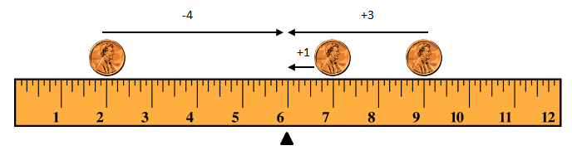
The data point at $2$ has a deviation of $-4$ from the mean. The data point at $7$ has a deviation of $+1$ from the mean. The data point at $9$ has a deviation of $+3$ from the mean. The sum of the three deviations is $0$, since $-4+1+3=0$. So, the mean is indeed $6$ minutes.
Robert says that he found out that the third penny needs to be at $7$ without using his ruler. He put $2$ and $9$ on a dot plot. He says that the sum of the two deviations for the points at $2$ and $9$ is $-1$, since $-4+3=-1.$So, he claims that the third data point would require a deviation of $+1$ to make the sum of all three deviations equal to $0$. That makes the third data point $1$ minute above the mean of $6$ minutes, which is $7$ minutes.

This example extends the data set from containing two data points to three. The main idea is that it does not matter how many data points there are. Whether the data points are represented as pennies on a ruler or as dots on a dot plot, the mean balances the sum of the negative deviations with the sum of the positive deviations.

Read through the example as a class and study the diagram. Note that the sum of the deviations is $0$. Then ask students:
- Can the concept of the mean as the balance point be extended to more than two pennies on a ruler?
  - Yes. (Try it if time permits.)
- Is the concept of the mean as the balance point true if you put multiple pennies on a single location on the ruler?
  - Yes. The balancing process is applicable to stacking pennies or having multiplicity of data points on a dot plot.

Exercises 5–7 (7 minutes)
Students should continue working in pairs. If time is running short, choose just one problem for students to attempt.

Exercises 5–7
Imagine you are balancing pennies on a ruler.
- Suppose you place one penny each at $3$, $7$, and $8$ on your ruler.
  - Sketch a picture of the ruler. At what value do you think the ruler will balance? Mark the balancing point with the symbol ∆.
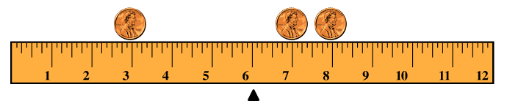
Students should represent the pennies at $3$, $7$, and $8$ on the ruler with a balancing point at $6$.

  - What is the mean of $3$, $7$, and $8$? Does your ruler balance at the mean?
The mean is $6$. Yes, it balances at the mean.

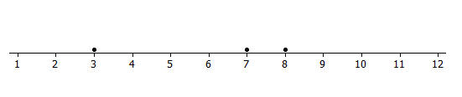
  - Show part (a) on a dot plot. Mark the balancing point with the symbol ∆.

  - What are the deviations from each of the data points to the balancing point? What is the sum of the deviations? What is the value of the mean?
The deviation of $3$ to $6$: $3-6=-3$
The deviation of $7$ to $6$: $7-6=+1$
The deviation of $8$ to $6$: $8-6=+2$
The sum of the deviations $(-3+1+2)$is $0$.
The mean is $6$.
- Now suppose you place a penny each at $7$ and $9$ on your ruler.
  - Draw a dot plot representing these two pennies.
See below.

  - Estimate where to place a third penny on your ruler so that the ruler balances at $6$ and mark the point on the dot plot above. Mark the balancing point with the symbol ∆.
The third penny should be placed at $2$ inches.

  - Explain why your answer in part (b) is true by calculating the deviations of the points from $6$. Is the sum of the deviations equal $0$?
The deviation of $2$ to $6$: $2-6=-4$
The deviation of $7$ to $6$: $7-6=+1$
The deviation of $9$ to $6$: $9-6=+3$
The sum of the deviations $(-4+1+3)$ is $0$.

- Suppose you place two pennies at $7$ and one penny at $9$ on your ruler.
  - Draw a dot plot representing these three pennies.
See below.

  - Estimate where to place a fourth penny on your ruler so that the ruler balances at $6$ and mark the point on the dot plot above. Mark the balancing point with the symbol ∆.
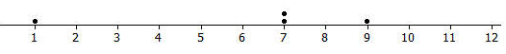
The fourth penny should be placed at $1$ inch.

  - Explain why your answer in part (b) is true by calculating the deviations of the points from $6$. Does the sum of the deviations equal $0$?
The negative deviation is $-5$. The positive deviations are $+1$, $+1$, and $+3$. The sum of the deviations is $0$, so the mean is still $6$.

Example 4 (5 minutes): Finding the Mean

Example 4: Finding the Mean
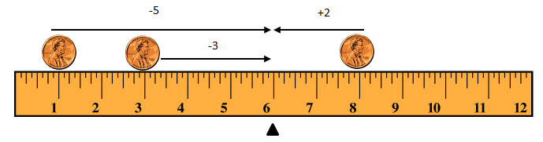
Not all data distributions on a ruler are going to have a “fair share” mean, or “balance point” of $6$. What if the data were $1$, $3$, and $8$? Will your ruler balance at $6$? Why not?
Notice that the deviation of $1$ from $6$ is $-5$. The deviation of $3$ from $6$ is $-3$. The deviation of $8$ from $6$ is $+2$. The sum of the deviations is $-6,$ since $-5+(-3)+2=-6.$The sum should be $0$. Therefore, the mean is not at $6$. Is the mean greater than $6$ or less than $6$? The sum of the deviations is negative. To decrease the negative deviations and increase the positive deviations, the balance point would have to be less than $6$.
Let’s see if the balance point is at $5$. The deviation of $1$ from $5$ is $-4$. The deviation of $3$ from $5$ is $-2$. The deviation of $8$ from $5$ is $+3.$ The sum of the three deviations is $-3$, since $-4+(-2)+3=-3.$ That’s closer to $0$ than before.
Let’s keep going and try $4$ as the balance point. The deviation of $1$ from $4$ is $–3$. The deviation of $3$ from $4$ is $-1$. The deviation of $8$ from $4$ is $+4$. The sum of the deviations is $0$, since $-3+(-1)+4=0.$ The balancing point of the data distribution of $1$, $3$, and $8$ shown on your ruler or on a dot plot is at $4$. The mean of $1$, $3$, and $8$ is $4$.

This example looks at a data set whose mean is not $6$. Read through the example with students. Then ask:
- Is $6$ the balancing point?
  - No
- Why not?
  - The sum of the deviations is not $0$.

If time permits, read through the remainder of the example and explain how to find the mean by using intelligent guessing and checking the guess by calculating the sum of deviations. Then ask:
- If you guess a value for the mean and the sum of the deviations is positive, should your next guess be lower or higher? Since the sum of the deviations is positive, the guess was too low. To decrease the positive sum, the next guess needs to be higher.
If the sum is negative, then the next guess should be lower in order to decrease the negative sum. If the sum is positive, then the next guess should be higher in order to decrease the positive sum.

Exercise 8 (7–10 minutes)
If time permits, let students work in pairs on Exercise 8.

Exercise 8
Use what you have learned about the mean to answer the following questions.
- Recall in Lesson $6$ that Michelle asked ten of her classmates for the number of hours they usually sleep when there is school the next day. Their responses (in hours) were$8$, $10$, $8$, $8$, $11$, $11$, $9$, $8$, $10$, $7$.
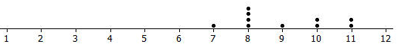
  - It’s hard to balance ten pennies. Instead of actually using pennies and a ruler, draw a dot plot that represents the data set.

  - Use your dot plot to find the balance point. What is the sum of the deviations of the data points from the fair share mean of $9$ hours?
A balance point of $9$ would mean the deviations are $-2, -1, -1, -1, -1, 0, +1, +1, +2, +2$. The sum of these deviations is $0$.
Note to teacher: Demonstrate how crossing out zero pairs (for example, $-1$ and $+1$) is a good strategy when trying to find the sum of a large number of deviations.
Lesson Summary
In this lesson, the “balance” process was developed to provide another way in which the mean characterizes the “center” of a distribution.
- The mean is the balance point of the data set when the data are shown as dots on a dot plot (or pennies on a ruler).
- The difference formed by subtracting the mean from a data point is called its deviation.
- The mean can be defined as the value that makes the sum of all deviations in a distribution equal to zero.
- The mean is the point that balances the sum of the positive deviations with the sum of the negative deviations.

Exit Ticket (5 minutes)

Name ___________________________________________________ Date____________________
Lesson 7: The Mean as a Balance Point

Exit Ticket

- If a class of $27$ students has a mean score of $72$ on a test, what is the sum of the $27$ deviations of the scores from $72$?

- The dot plot below shows the number of goals scored by a school’s soccer team in $7$ games so far this season.

Use the “balancing” process to explain why the mean number of goals scored is $3$. List all of the deviations and calculate the sum of the deviations. Explain your answer.
Exit Ticket Sample Solutions

- If a class of $27$ students has a mean score of $72$ on a test, what is the sum of the $27$ deviations of the scores from $72$?
The sum is $0$.

- The dot plot below shows the number of goals that a school’s soccer team has scored in $7$ games so far this season.

Use the “balancing” process to explain why the mean number of goals scored is $3$. List all of the deviations and calculate the sum of the deviations. Explain your answer.
The deviation from $0$ to $3$ is $-3$; from $2$ to $3$ is $-1;$from $5$ to $3$ is $+2,$ for each of the two data points. The sum of the deviations is $0$, since $-3 + (-1) + 2(+2) = 0.$ The mean is $3$.

Problem Set Sample Solutions

- The number of pockets in the clothes worn by four students to school today is $4$, $1$, $3$,$4$.
  - Perform the “fair share” process to find the mean number of pockets for these four students. Sketch the cube representations for each step of the process.
Each of the $4$’s gives up a pocket to the person with one pocket, yielding three common pockets. The mean is $3$ pockets.

  - Find the sum of the deviations to prove the mean found in part (a) is correct.
The $1$-pocket data point has a deviation of $-2$. Each of the two $4$-pocket data points has a deviation of $+1.$ So, the sum of deviations is $0$.

- The times (rounded to the nearest minute) it took each of six classmates to run a mile are $7$,$9$, $10$,$11$, $11$, and $12$ minutes.
  - Draw a dot plot representation for the times. Suppose that Sabina thinks the mean is $11$ minutes. Use the sum of the deviations to show Sabina that the balance point of $11$ is too high.
$7$ has a deviation of $-4$from $11$; $9$ has a deviation of $-2$; $10$ has a deviation of $-1$; each of the $11$’s has a deviation of $0$; $12$ has a deviation of $+1$. The sum of the deviations is $-6$. That indicates that $11$ is too high.

  - Sabina now thinks the mean is $9$ minutes. Use the sum of the deviations to verify that $9$ is too small to be the mean number of minutes.
$7$ has a deviation of $-2$ from $9$; $9$ has a deviation of $0$; $10$ has a deviation of $+1$; each of the $11$’s has a deviation of $+2$; $13$ has a deviation of $+4$. The sum of the deviations is $+7$; therefore, $9$ is too low for the mean.

  - Sabina asks you to find the mean by using the balancing process. Demonstrate that the mean is $10$ minutes.
As $9$ is too low, and $11$ too high, try $10$. The sum of the deviations is $0$. So, the mean is $10$ minutes.
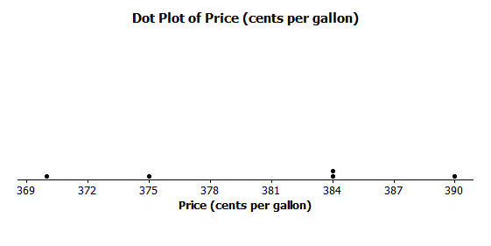
- The prices per gallon of gasoline (in cents) at five stations across town on one day are shown in the following dot plot. The price for a sixth station is missing, but the mean price for all six stations was reported to be $380$ cents per gallon. Use the “balancing” process to determine the price of a gallon of gasoline at the sixth station?

The sum of the negative deviations from $380$ is $(370-380) + (375-380) = -15$cents. The sum of the positive deviations from $380$ is $2(384-380) + (390-380) = +18$. So, the sixth station has to have a deviation that will cause the sum of the negative deviations plus the sum of the positive deviations to be $0$. The deviation from $380$ for the sixth station has to be $-3$. Therefore, the price of gasoline at the sixth station must be $377$ cents.
Note: Try to keep your students from using the mathematical formula for the mean to solve this problem. They could, however, use it to check the answer they get from the balancing process.

- The number of phones (landline and cell) owned by the members of each of nine families is $3$, $5$, $5$, $5$, $6$, $6$,$6$,$6$,$8.$
  - Use the mathematical formula for the mean (sum the data points and divide by the number of data points) to find the mean number of phones owned for these nine families.
The mean is $\frac{50}{9}= 5\frac{5}{9}$phones.

  - Draw a dot plot of the data and verify your answer in part (a) by using the “balancing” process and finding the sum of the deviations.
The sum of the negative deviations from $5\frac{5}{9}$ is: $\left(3-5\frac{5}{9}\right)+ 3\left(5-5\frac{5}{9}\right)= -4\frac{2}{9}.$
The sum of the positive deviations from $5\frac{5}{9}$ is: $4\left(6-5\frac{5}{9}\right)+ \left(8-5\frac{5}{9}\right)= -4\frac{2}{9}$.
The sum of the deviations is $0$, so the mean is $5\frac{5}{9}$ phones.

