Lesson 6: Describing the Center of a Distribution Using the Mean

Classwork
Example 1
Recall that in Lesson 3, Robert, a 6th grader at Roosevelt Middle School, investigated the number of hours of sleep sixth grade students get on school nights. Today, he is to make a short report to the class on his investigation. Here is his report.
“I took a survey of $29$ 6th graders asking them ‘How many hours of sleep per night do you usually get when you have school the next day?’ The first thing I had to do was to organize the data. I did this by drawing a dot plot.
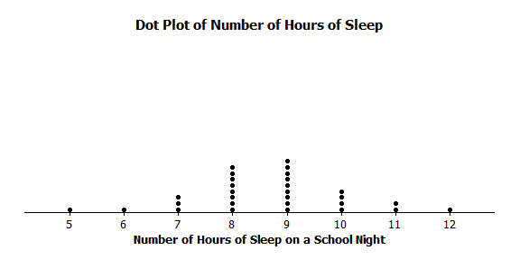

Part of our lessons last week was to identify what we thought was a centering point of the data, the spread of the data, and the shape of the data. So, for my data, looking at the dot plot, I would say that the typical number of hours sixth-grade students sleep get when they have school the next day is around $8$ or $9$ because that is what most students said and the values are kind of in the middle. I also noticed that the data were spread out from the center by about three or four hours in both directions. The shape of the distribution is kind of like a mound.”
Michelle is Robert’s classmate. She liked his report but has a really different thought about determining the center of the number of hours of sleep. Her idea is to even out the data in order to determine a typical or center value.

Exercises 1–6
Suppose that Michelle asks ten of her classmates for the number of hours they usually sleep when there is school the next day.
Suppose they responded (in hours): $8 10 8 8 11 11 9 8 10 7$
- How do you think Robert would organize his data? What do you think Robert would say is the center of these ten data points? Why?

- Do you think his value is a good measure to use for the “center” of Michelle’s data set? Why or why not?

Michelle’s “center” is called the mean. She finds the total number of hours of sleep for each of the ten students. That is $90$ hours. She has $90$ Unifix cubes (Snap cubes). She gives each of the ten students the number of cubes that equals the number of hours of sleep each had reported. She then asks each of the ten students to connect their cubes in a stack and put their stacks on a table to compare them. She then has them share their cubes with each other until they all have the same number of cubes in their stacks when they are done sharing.
- Work in a group. Each group of students gets $90$ cubes. Make ten stacks of cubes representing the number of hours of sleep for each of the ten students. Using Michelle’s Method, how many cubes are in each of the ten stacks when they are done sharing?

- Noting that one cube represents one hour of sleep, interpret your answer to Exercise 3 in terms of “number of hours of sleep.” What does this number of cubes in each stack represent? What is this value called?

- Suppose that the student who told Michelle he slept $7$ hours changes his data entry to $8$ hours. You will need to get one more cube from your teacher. What does Michelle’s procedure now produce for her center of the new set of data? What did you have to do with that extra cube to make Michelle’s procedure work?

- Interpret Michelle’s “fair share” procedure by developing a mathematical formula that results in finding the fair share value without actually using cubes. Be sure that you can explain clearly how the fair share procedure and the mathematical formula relate to each other.

Example 2
Suppose that Robert asked five sixth graders how many pets each had. Their responses were $2$,$6$, $2$,$4$, $1$. Robert showed the data with cubes as follows:

Note that one student has one pet, two students have two pets each, one student has four pets, and one student has six pets. Robert also represented the data set in the following dot plot.
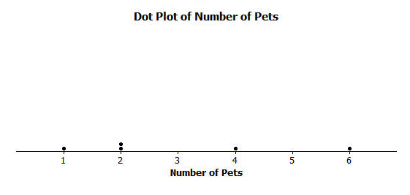

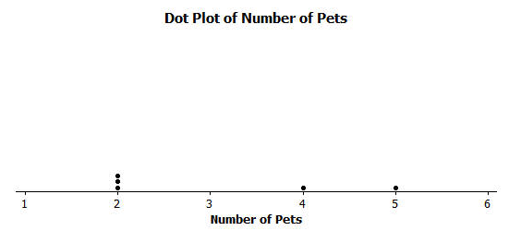
Robert wants to illustrate Michelle’s fair share method by using dot plots. He drew the following dot plot and said that it represents the result of the student with six pets sharing one of her pets with the student who has one pet.
Robert also represented the data with cubes as shown below.

Exercises 7–10
Now continue distributing the pets based on the following steps.
- Robert does a fair share step by having the student with five pets share one of her pets with one of the students with two pets.
  - Draw the cubes representation that shows Robert’s fair share step.

  - Draw the dot plot that shows Robert’s fair share step.

- Robert does another fair share step by having one of the students who has four pets share one pet with one of the students who has two pets.
  - Draw the cubes representation that shows Robert’s fair share step.

  - Draw the dot plot that shows Robert’s fair share step.

- Robert does a final fair share step by having the student who has four pets share one pet with the student who has two pets.
  - Draw the cubes representation that shows Robert’s final fair share step.

  - Draw the dot plot representation that shows Robert’s final fair share step.

- Explain in your own words why the final representations using cubes and a dot plot show that the mean number of pets owned by the five students is $3$ pets.

Lesson Summary
In this lesson, you developed a method to define the center of a data distribution. The method was called the “fair share” method and the center of a data distribution that it produced is called the mean of the data set. The reason it is called the fair share value is that if all the subjects were to have the same data value, it would be the mean value.
Mathematically the “fair share” term comes from finding the total of all of the data values and dividing the total by the number of data points. The arithmetic operation of division divides a total into equal parts.

Problem Set

- A game was played where ten tennis balls are tossed into a basket from a certain distance. The number of successful tosses for six students were: $4$, $1$,$3$,$2$,$1$,$7$.
  - Draw a representation of the data using cubes where one cube represents one successful toss of a tennis ball into the basket.
  - Draw the original data set using a dot plot.

- Find the mean number of successful tosses for this data set by Michelle’s fair share method. For each step, show the cubes representation and the corresponding dot plot. Explain each step in words in the context of the problem. You may move more than one successful toss in a step, but be sure that your explanation is clear. You must show two or more steps.

Step described in words | “Fair Share” cube representation | Dot plot

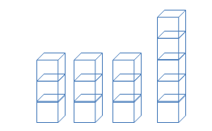
- The number of pockets in the clothes worn by four students to school today is $4$, $1$, $3$,$6$. Paige produces the following cube representation as she does the fair share process. Help her decide how to finish the process of $3$,$3$, $3$, and $5$ cubes.

- Suppose that the mean number of chocolate chips in $30$ cookies is $14$ chocolate chips.
  - Interpret the mean number of chocolate chips in terms of fair share.
  - Describe the dot plot representation of the fair share mean of $14$ chocolate chips in $30$ cookies.

- Suppose that the following are lengths (in millimeters) of radish seedlings grown in identical conditions for three days: $12 11 12 14 13 9 13 11 13 10 10 14 16 13 11$.
  - Find the mean length for these $15$ radish seedlings.
  - Interpret the value from part (a) in terms of the “fair share” center length.

