Lesson 6: Describing the Center of a Distribution Using the Mean

Student Outcomes
- Students define the center of a data distribution by a “fair share” value called the mean.
- Students connect the “fair share” concept with a mathematical formula for finding the mean.

Lesson Notes
In earlier grades, students may have heard the term average (or mean) to describe a measure of center, although it is not part of Common Core Grades K–5. If they have heard the term, typically their understanding of it is the “add up and divide” formula. The goal of Lesson 6 is to bring students an understanding of what mean is, not just how to find it.
For example, if students hear that their class had a mean score of $74$ on a test, we want them to immediately understand that $74$ is the score each student in the class would receive! That’s the “fair share” interpretation of mean. So, when the term mean is mentioned, we want students to think initially of its “fair share” meaning and not of its mathematical formula, although they do go hand-in-hand.
Some students have difficulty understanding what “characterizing a data distribution” means. The idea expressed in this lesson is that single numbers are sought to characterize some feature (e.g., the “center”) of the distribution and that there may be several different ways to characterize a given specific feature. If students suggest the mode and median as measures of center, that’s great, although we are not going to pursue them in this lesson. The term mode is not discussed much at all in the Common Core, and median will be covered in a later lesson.
Teachers should be prepared to distribute some type of manipulative, like Unifix cubes, for group work in Exercise 3. Students use cubes to represent data and manipulate them to develop a measure of center, namely the “fair share” interpretation of the mean. Each group will need to have $90$ units of the manipulative, so teachers should plan accordingly.
MP.4

Classwork
Example 1 (5–7 minutes)

Example 1
Recall that in Lesson 3, Robert, a 6th grader at Roosevelt Middle School, investigated the number of hours of sleep sixth grade students get on school nights. Today, he is to make a short report to the class on his investigation. Here is his report.
“I took a survey of $29$ 6th graders asking them ‘How many hours of sleep per night do you usually get when you have school the next day?’ The first thing I had to do was to organize the data. I did this by drawing a dot plot.

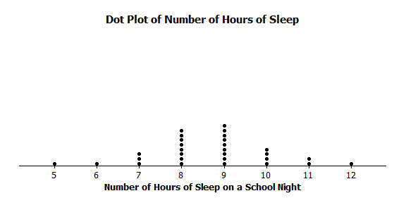

Part of our lessons last week was to identify what we thought was a centering point of the data, the spread of the data, and the shape of the data. So, for my data, looking at the dot plot, I would say that the typical number of hours sixth-grade students sleep get when they have school the next day is around $8$ or $9$ because that is what most students said and the values are kind of in the middle. I also noticed that the data were spread out from the center by about three or four hours in both directions. The shape of the distribution is kind of like a mound.”
Michelle is Robert’s classmate. She liked his report but has a really different thought about determining the center of the number of hours of sleep. Her idea is to even out the data in order to determine a typical or center value.

Read the introductory paragraph to the class. Choose a student to read “Robert’s thought process” out loud. Then ask students:
- How is Robert thinking about the center?
  - When asked to characterize the “center” of the hours of sleep data as represented in a dot plot, many students (including Robert) are drawn to the data point that occurs most often (the mode) or to the middle of the data set (the median).
Read through the last two sentences of the example. Then ask students:
- What do you think Michelle means by evening out the data to determine a typical or center value?
  - Michelle wants to get students thinking a bit more deeply about determining a center. The bottom line is that her view of “center” is an equal sharing of the data (i.e., a “fair share” in which the “fair share” process terminates when all subjects have the same amount of data).
Note: To help explain what Michelle means, it’s easier to use a smaller number of data points. Robert’s data set is too big to work with.

Exercises 1–6 (15 minutes)
Work through Exercises 1–2 as a class. Briefly summarize Michelle’s “fair share method” from the text. Then, split students up into groups to work on Exercises 3–6, with each group getting $90$ cubes.
Exercises 1–6
Suppose that Michelle asks ten of her classmates for the number of hours they usually sleep when there is school the next day.
Suppose they responded (in hours): $8 10 8 8 11 11 9 8 10 7$
- How do you think Robert would organize his data? What do you think Robert would say is the center of these ten data points? Why?
Dot plot; the center is around $8$ hours because it is the most common value.
- Do you think his value is a good measure to use for the “center” of Michelle’s data set? Why or why not?
Answers will vary; it is a good measure as most of the values are described by $8$ hours, or it is not a good measure because half of the values are greater than $8$ hours.

Michelle’s “center” is called the mean. She finds the total number of hours of sleep for each of the ten students. That is $90$ hours. She has $90$ Unifix cubes (Snap cubes). She gives each of the ten students the number of cubes that equals the number of hours of sleep each had reported. She then asks each of the ten students to connect their cubes in a stack and put their stacks on a table to compare them. She then has them share their cubes with each other until they all have the same number of cubes in their stacks when they are done sharing.
- Work in a group. Each group of students gets $90$ cubes. Make ten stacks of cubes representing the number of hours of sleep for each of the ten students. Using Michelle’s Method, how many cubes are in each of the ten stacks when they are done sharing?
There will be $9$ cubes in each of the $10$ stacks.

- Noting that one cube represents one hour of sleep, interpret your answer to Exercise 3 in terms of “number of hours of sleep.” What does this number of cubes in each stack represent? What is this value called?
If all ten students slept the same number of hours, it would be $9$ hours. The $9$ cubes for each stack represent the $9$ hours of sleep for each student if this was a fair share. This value is called the mean.

- Suppose that the student who told Michelle he slept $7$ hours changes his data entry to $8$ hours. You will need to get one more cube from your teacher. What does Michelle’s procedure now produce for her center of the new set of data? What did you have to do with that extra cube to make Michelle’s procedure work?
The extra cube must be split into $10$ equal parts. The mean is now $9\frac{1}{10}$.

- Interpret Michelle’s “fair share” procedure by developing a mathematical formula that results in finding the fair share value without actually using cubes. Be sure that you can explain clearly how the fair share procedure and the mathematical formula relate to each other.
Answers may vary. The “fair share” procedure is the same as adding all of the values and dividing by the number of data points.

Example 2 (5 minutes)

Example 2
Suppose that Robert asked five sixth graders how many pets each had. Their responses were $2$,$6$, $2$,$4$, $1$. Robert showed the data with cubes as follows:

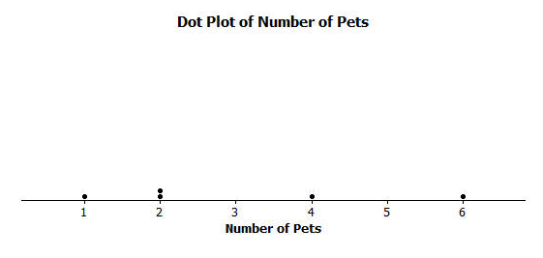
Note that one student has one pet, two students have two pets each, one student has four pets, and one student has six pets. Robert also represented the data set in the following dot plot.
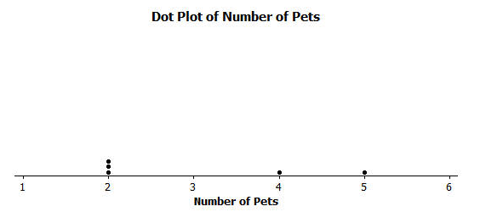
Robert wants to illustrate Michelle’s fair share method by using dot plots. He drew the following dot plot and said that it represents the result of the student with six pets sharing one of her pets with the student who has one pet.

Robert also represented the data with cubes as shown below.

This example gets students to distinguish between the representations of a data set using cubes versus a dot plot. It also reinforces the concept of sharing – one student gives a pet to another that needs one.
Read through the first scenario with students, and then ask:
- Does the original stack of cubes match the dot plot representation? Explain.
  - Yes, the number of cubes in each stack corresponds with a dot on the plot.
Read through the next part of the example with students, where one student shares a pet with another. Demonstrate this step visually on the board or by using an overhead projector. Display the numerical representation next to the dot plot.

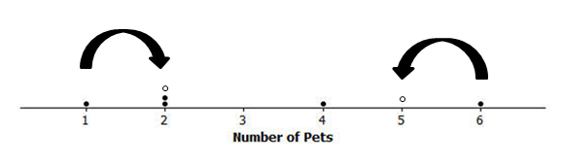
1 |  | 2
2 |  | 2
2 |  | 2
4 |  | 4
+ 6 |  | 5
15 |  | 15

Then ask:
- Is Robert’s new dot plot correct?
  - Yes
- How does the dot plot change?
  - The student who had six pets now has five (new dot), and the student who had one pet now has two (new dot) – the dots are moving towards each other.
- Are the stacks of cubes correct?
  - Yes
- Do the dot plot and stacks represent a “fair share” or mean?
  - No, there is no typical or center value yet.

Exercises 7–10 (12–15 minutes)
Let students work in pairs to complete Exercises 7–10.

Exercises 7–10
Now continue distributing the pets based on the following steps.
- Robert does a fair share step by having the student with five pets share one of her pets with one of the students with two pets.
  - Draw the cubes representation that shows Robert’s fair share step.
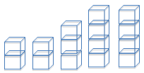

  - Draw the dot plot that shows Robert’s fair share step.

- Robert does another fair share step by having one of the students who has four pets share one pet with one of the students who has two pets.
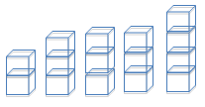
  - Draw the cubes representation that shows Robert’s fair share step.

  - Draw the dot plot that shows Robert’s fair share step.

- Robert does a final fair share step by having the student who has four pets share one pet with the student who has two pets.
  - Draw the cubes representation that shows Robert’s final fair share step.

  - Draw the dot plot representation that shows Robert’s final fair share step.

- Explain in your own words why the final representations using cubes and a dot plot show that the mean number of pets owned by the five students is $3$ pets.
The result of the sharing produces three pets each for the five students. The cube representation shows that after sharing, each student has a “fair share” of three pets. The dot plot representation should have all of the data points at the same point on the scale, the mean. In this problem, the mean number of pets is $3$ for the five students, so there should be five dots above $3$ on the horizontal scale.
Lesson Summary
In this lesson, you developed a method to define the center of a data distribution. The method was called the “fair share” method, and the center of a data distribution that it produced is called the mean of the data set. The reason it is called the fair share value is that if all the subjects were to have the same data value, it would be the mean value.
Mathematically the “fair share” term comes from finding the total of all of the data values and dividing the total by the number of data points. The arithmetic operation of division divides a total into equal parts.

Exit Ticket (5 minutes)
Name ___________________________________________________ Date____________________
Lesson 6: Describing the Center of a Distribution Using the Mean

Exit Ticket

- If a class of $27$ students had a mean of $72$ on a test, interpret the mean of $72$ in the sense of a “fair share” measure of the center of the test scores.

- Suppose that your school’s soccer team has scored a mean of $2$ goals in each of $5$ games.
  - Draw a representation using cubes that displays that your school’s soccer team has scored a mean of $2$ goals in each of $5$ games. Let one cube stand for one goal.

  - Draw a dot plot that displays that your school’s soccer team has scored a mean of $2$ goals in each of $5$ games.
Exit Ticket Sample Solutions

- If a class of $27$ students had a mean of $72$ on a test, interpret the mean of $72$ in the sense of a “fair share” measure of the center of the test scores.
$72$ would be the test score that all $27$ students would have, were all $27$ students to have the same score.

- Suppose that your school’s soccer team has scored a mean of $2$ goals in each of $5$ games.
  - Draw a representation using cubes that displays that your school’s soccer team has scored a mean of $2$ goals in each of $5$ games. Let one cube stand for one goal.

  - Draw a dot plot that displays that your school’s soccer team has scored a mean of $2$ goals in each of $5$ games.

Problem Set Sample Solutions

- A game was played where ten tennis balls are tossed into a basket from a certain distance. The number of successful tosses for six students were: $4$, $1$,$3$,$2$,$1$,$7$.
  - Draw a representation of the data using cubes where one cube represents one successful toss of a tennis ball into the basket.

  - Draw the original data set using a dot plot.

- Find the mean number of successful tosses for this data set by Michelle’s fair share method. For each step, show the cubes representation and the corresponding dot plot. Explain each step in words in the context of the problem. You may move more than one successful toss in a step, but be sure that your explanation is clear. You must show two or more steps.
Clearly, there are several ways of getting to the final cube representation that each of the six stacks will contain three cubes. Ideally, students will move one cube at a time since for many students the leveling is seen more easily in that way. If a student shortcuts the process by moving several cubes at once, that’s okay, as long as the graphic representations are correctly done and the explanation is clear. The table provides one possible representation:

Step described in words | “Fair Share” cube representation | Dot plot
Share two of the cubes in the $7$-cube stack with one of the $1$-cube stacks. The result would be: $5$,$4$, $3$, $3$, $1$,$2$. The $7$-stack went from $7$ successful tosses to $5$ successful tosses, and one of the $1$-stacks went from $1$ successful toss to $3$ successful tosses. | 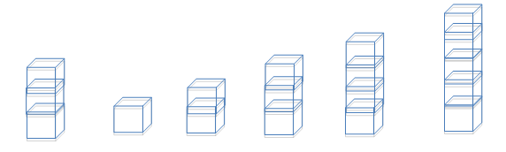 | 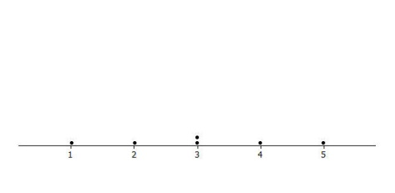
Suppose that the student who has $5$ successful tosses shares two tosses with the student who had one successful toss. The student with $5$ successful tosses went down two tosses to $3$ successful tosses, and the student with one successful toss went up two tosses to $3$ successful tosses. | 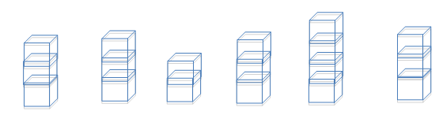 | 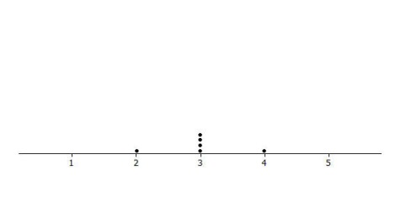
Finally, the student with $4$ successful tosses shares one of them with the student who has $2$ successful tosses. The final step of Michelle’s fair share method shows an even number of tosses for each of the six students. So, the mean number of successful tosses for these six students is $3$ tosses. | 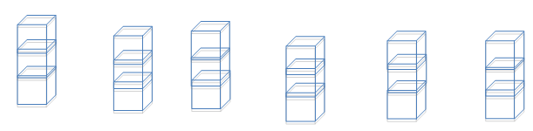 | 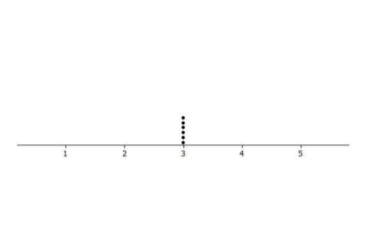

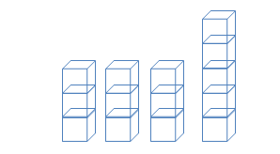
- The number of pockets in the clothes worn by four students to school today is $4$, $1$, $3$,$6$. Paige produces the following cube representation as she does the fair share process. Help her decide how to finish the process of $3$,$3$, $3$, and $5$ cubes.
It should be clear to the student that there are two “extra” cubes in the stack of five cubes. Those two “extras” need to be distributed among the four students. That requires that each of the extra cubes needs to be split in half to produce four halves. Each of the four students gets half of a pocket to have a fair share mean of three and one-half pockets.

- Suppose that the mean number of chocolate chips in $30$ cookies is $14$ chocolate chips.
  - Interpret the mean number of chocolate chips in terms of fair share.
If each of the $30$ cookies were to have the same number of chocolate chips, each would have $14$ chocolate chips.

  - Describe the dot plot representation of the fair share mean of $14$ chocolate chips in $30$ cookies.
The dot plot consists of $30$ dots stacked over the number $14$ on the number line.

- Suppose that the following are lengths (in millimeters) of radish seedlings grown in identical conditions for three days: $12 11 12 14 13 9 13 11 13 10 10 14 16 13 11$.
  - Find the mean length for these $15$ radish seedlings.
The mean length is $12\frac{2}{15}$ mm.

  - Interpret the value from part (a) in terms of the “fair share” center length.
If each of the $15$ radish seedlings were to have the same length, each would have a length of $12\frac{2}{15}$ mm.
Note: Students should realize what the cube representation for these data would look like but also realize that it may be a little cumbersome to move cubes around in the fair share process. Ideally, they would set up the initial cube representation and then use the mathematical approach of summing the lengths to be $182$ mm which, when distributed evenly to $15$ plants, by division would yield $12\frac{2}{15}$ mm as the fair share mean length.

