Lesson 5: Describing a Distribution Displayed in a Histogram

Student Outcomes
- Students construct a relative frequency histogram.
- Students recognize that the shape of a histogram does not change when relative frequency is used compared to when frequency is used to construct the histogram.

Lesson Notes
This lesson may take longer than one class period.

Classwork
Example 1 (10 minutes): Relative Frequency Table

Example 1: Relative Frequency Table
In Lesson 4, we investigated the head circumferences that the boys and girls basketball teams collected. Below is the frequency table of the head circumferences that they measured.

Hat Sizes | Interval of Head Circumferences (mm) | Tally | Frequency
XS | $$510-<530$$ | || | $$2$$
S | $$530-<550$$ | |||| ||| | $$8$$
M | $$550-<570$$ | |||| |||| |||| | $$15$$
L | $$570-<590$$ | |||| |||| | $$9$$
XL | $$590-<610$$ | |||| | $$4$$
XXL | $$610-<630$$ | || | $$2$$
 |  | Total | $$40$$

Isabel, one of the basketball players, indicated that most of the hats were small, medium, or large. To decide if Isabel was correct, the players added a relative frequency column to the table. Relative frequency is the value of the frequency in an interval divided by the total number of data values.

This example begins with the frequency table of head circumferences that students used in Lesson 4. At the start of the lesson, display the frequency table and ask:
- What does the $15$ in the frequency column represent, and how many hats need to be ordered?
- What percent of the total order are medium-size hats?
  - This question leads into the vocabulary of relative frequency as the ratio of the frequency for an interval divided by the total number of data values.
Explain the concept of relative frequency by working through the calculation of the first two rows in the table:
- There are $2$ people in the XS hat size interval (head circumferences from $510-529$). The relative frequency for this interval is $2$ divided by the total number $40$, or $\frac{2}{40}$, which is $0.05$ or $5\%$.
- In the interval from $530–549$ the frequency is $8$. The relative frequency for this interval is $\frac{8}{40}$, which is $0.2$ or $20\%$.

Ask the students:
- How do you find the total number of data values?
- What will the sum of the relative frequency column equal?
- What is the difference between a frequency table and a relative frequency table?
- How are the two types of table similar?

The students should write the relative frequency as a decimal. Converting the decimal to a percent helps to interpret the value. When writing the relative frequency, have the students write their answers to three decimal places. For some exercises they may have to round to the nearest thousandth.

Exercises 1–4 (15 minutes)
In this exercise students are asked to complete the relative frequency table and begin to interpret the values in the table. Let students work in pairs and confirm answers as a class.
Exercises 1–4
- Complete the relative frequency column in the table below.
Hat Sizes | Interval of Head Circumferences (mm) | Tally | Frequency | Relative Frequency
XS | $$510-<530$$ | || | $$2$$ | $$2/40 = 0.05$$
S | $$530-<550$$ | |||| ||| | $$8$$ | $$8/40 = 0.20$$
M | $$550-<570$$ | |||| |||| |||| | $$15$$ | $$0.375$$
L | $$570-<590$$ | |||| |||| | $$9$$ | $$0.225$$
XL | $$590-<610$$ | |||| | $$4$$ | $$0.10$$
XXL | $$610-<630$$ | || | $$2$$ | $$0.05$$
 |  | Total | $$40$$

- What is the total of the relative frequency column?
$$100\%$$

- Which interval has the greatest relative frequency? What is the value?
Medium size hats $550–569$; relative frequency = $0.375$.

- What percent of the head circumferences is between $530$ and $589$? Show how you determined the answer.
$0.20 + 0.375 + 0.225 = 0.80$ or $80\%$
Example 2 (15 minutes): Relative Frequency Histogram

Example 2: Relative Frequency Histogram
The players decided to construct a histogram using the relative frequencies instead of the frequencies.
They noticed that the relative frequencies in the table ranged from close to $0$ to about $0.40$. They drew a number line and marked off the intervals on that line. Then, they drew the vertical line and labeled it relative frequency. They added a scale to this line by starting at $0$ and counting by $0.05$ until they reached $0.40$.
They completed the histogram by drawing the bars so the height of each bar matched the relative frequency for that interval. Here is the completed relative frequency histogram:
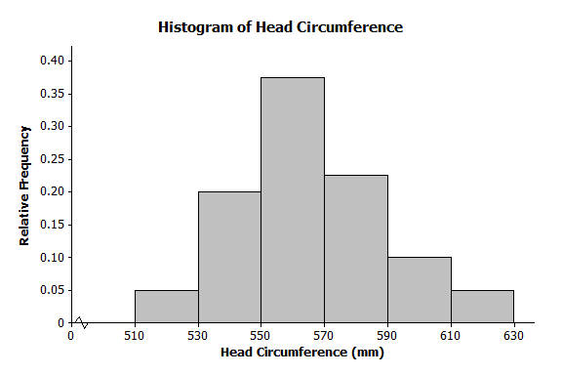
MP.1
In this example students consider the connection between the table and relative frequency histogram. Display the frequency histogram of head circumferences from Lesson 4. Remind students of the importance of the intervals being the same width.
Alongside this frequency histogram, demonstrate how to construct a relative frequency histogram. The labeling of the horizontal axis is the same as for the frequency histogram. The vertical axis scale changes to represent the relative frequency. Students may struggle with the scaling along this vertical axis since you are counting by a decimal rather than by a whole number.
After drawing the relative frequency histogram, ask the students to compare the two histograms. They should notice that the center and shape are the same.
- What do you notice about the shape and center?
  - They are the same.
- What is the greatest number that could be on the vertical axis in a relative frequency histogram?
  - $1.00$
- What is the relative frequency for the large hat sizes? What does this number mean?
  - About $0.24$; approximately $24\%$ of the people measured would wear a large hat.

Exercises 5–6 (15 minutes)
The first exercise asks students to compare the two types of histograms: a frequency histogram and a relative frequency histogram. In the second exercise, students are asked to calculate relative frequencies and to construct a relative frequency histogram. Let students work in small groups. Allow for calculator usage.

Exercises 5–6
- Answer the following questions.
  - Describe the shape of the relative frequency histogram of head circumferences from Example 2.
Slightly skewed to the right.

  - How does the shape of this histogram compare with the frequency histogram you drew in Exercise 5 of Lesson 4?
The shape looks the same.

  - Isabel said that most of the hats that needed to be ordered were small, medium, and large. Was she right? What percent of the hats to be ordered is small, medium, or large?
She was right. The total percentage was $80\%$. (Small $20\%$, Medium $37.5\%$, Large $22.5\%$ for a total of $80\%$.)

- Here is the frequency table of the seating capacity of arenas for the NBA basketball teams.
Number of seats | Tally | Frequency | Relative Frequency
$$17,000-<17,500$$ | || | $$2$$ | $$0.069$$
$$17,500-<18,000$$ | | | $$1$$ | $$0.034$$
$$18,000-<18,500$$ | |||| | | $$6$$ | $$0.207$$
$$18,500-<19,000$$ | |||| | $$5$$ | $$0.172$$
$$19,000-<19,500$$ | |||| | $$5$$ | $$0.172$$
$$19,500-<20,000$$ | |||| | $$5$$ | $$0.172$$
$$20,000-<20,500$$ | || | $$2$$ | $$0.069$$
$$20,500-<21,000$$ | || | $$2$$ | $$0.069$$
$$21,000-<21,500$$ |  | $$0$$ | $$0$$
$$21,500-<22,000$$ |  | $$0$$ | $$0$$
$$22,000-<22,500$$ | | | $$1$$ | $$0.034$$

  - What is the total number of NBA arenas?
$$29$$

  - Complete the relative frequency column. Round to the nearest thousandth.
See table above.

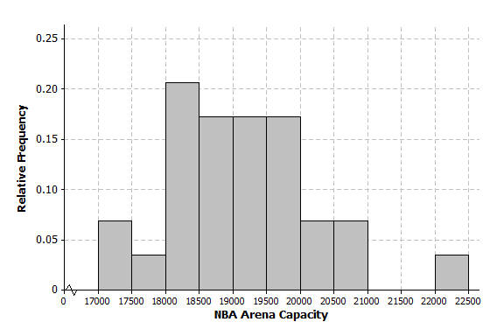
  - Construct a relative frequency histogram. Round to the nearest thousandth.

  - Describe the shape of the relative frequency histogram.
Slightly skewed to the right.

  - What percent of the arenas has a seating capacity between $18,500$ and $19,999$ seats?
$0.516$ or $51.6\%$

  - How does this relative frequency histogram compare to the frequency histogram that you drew in problem 2 of the Problem Set in Lesson 4?
It has the same shape.
Lesson Summary
A relative frequency histogram uses the same data as a frequency histogram but compares the frequencies for each interval frequency to the total number of items. For example, if the first interval contains $8$ out of the total of $32$items, the relative frequency of the first interval $\frac{8}{32}$ or $\frac{1}{4}$ $=0 .25$.
The only difference between a frequency histogram and a relative frequency histogram is that the vertical axis uses relative frequency instead of frequency. The shapes of the histograms are the same as long as the intervals are the same.
.

Exit Ticket (5 minutes)
Name ___________________________________________________ Date____________________
Lesson 5: Describing a Distribution Displayed in a Histogram

Exit Ticket

Calculators are allowed for completing your problems.
Hector’s mom had a rummage sale, and after she sold an item, she tallied for how much money she sold the item. Following is the frequency table Hector’s mom created:

Amount of Money the Item sold for | Tally | Frequency | Relative Frequency
$$\$0-<5$$ | || | $$2$$
$$\$5-<\$10$$ | | | $$1$$
$$\$10-<\$15$$ | |||| | $$4$$
$$\$15-<\$20$$ | |||| |||| | $$10$$
$$\$20-<\$25$$ | |||| | $$5$$
$$\$25-<\$30$$ | ||| | $$3$$
$$\$30-<\$35$$ | || | $$2$$

  - What was the total number of items sold at the rummage sale?

  - Complete the relative frequency column. Round to the nearest thousandth.

  - What percent of the items Hector’s mom sold was sold for $\$15$ or more, but less than $\$20$?

Exit Ticket Sample Solutions

Hector’s mom had a rummage sale, and after she sold an item, she tallied for how much money she sold the item. Following is the frequency table Hector’s mom created:

Amount of Money the Item sold for | Tally | Frequency | Relative Frequency
$$\$0-<\$5$$ | || | $$2$$ | $$0.074$$
$$\$5-<\$10$$ | | | $$1$$ | $$0.037$$
$$\$10-< \$15$$ | |||| | $$4$$ | $$0.148$$
$$\$15-<\$20$$ | |||| |||| | $$10$$ | $$0.370$$
$$\$20-<\$25$$ | |||| | $$5$$ | $$0.185$$
$$\$25-<\$30$$ | ||| | $$3$$ | $$0.111$$
$$\$30-<\$35$$ | || | $$2$$ | $$0.074$$

  - What was the total number of items sold at the rummage sale?
$27$ items

  - Complete the relative frequency column. Round to the nearest thousandth.
See table above.

  - What percent of the items Hector’s mom sold was sold for $\$15$ or more, but less than $\$20$?
$0.37$ or $37\%$

Problem Set Sample Solutions

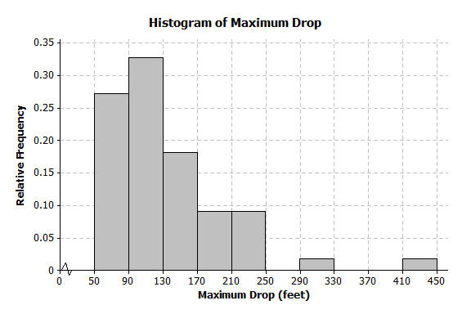
- Below is a relative frequency histogram of the maximum drop (in feet) of a selected group of roller coasters.

  - Describe the shape of the relative frequency histogram.
Skewed to the right.
  - What does the shape tell you about the maximum drop (in feet) of roller coasters?
Most of the roller coasters have a maximum drop that is between $50$ and $170$ feet.

  - Jerome said that more than half of the data is in the interval from $50-130$ feet. Do you agree with Jerome? Why or why not?
Yes, that span has $60\%$ of the data.

- The frequency table below shows the length of selected movies shown in a local theater over the past $6$ months.
Length of Movie (min) | Tally | Frequency | Relative Frequency
$$80-<90$$ | | | $$1$$ | $$0.036$$
$$90-<100$$ | |||| | $$4$$ | $$0.143$$
$$100-<110$$ | |||| || | $$7$$ | $$0.25$$
$$110-<120$$ | |||| | $$5$$ | $$0.179$$
$$120-<130$$ | |||| || | $$7$$ | $$0.25$$
$$130-<140$$ | ||| | $$3$$ | $$0.107$$
$$140-<150$$ | | | $$1$$ | $$0.036$$

  - Complete the relative frequency column. Round to the nearest thousandth.
See table above.

  - What percent of the movie lengths is greater than or equal to $130$ minutes?
$$0.143=14.3\%$$

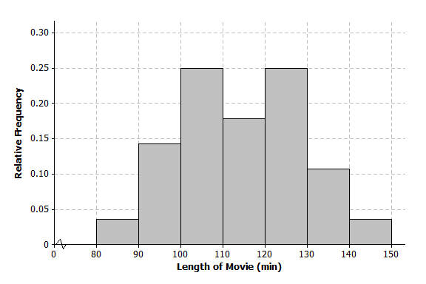
  - Draw a relative frequency histogram.

  - Describe the shape of the relative frequency histogram.
Mound shaped/approximately symmetric.

  - What does the shape tell you about the length of movie times?
The length of most movies is between $100$ and $130$ minutes.
- The table below shows the highway mile per gallon of different compact cars.
Mileage | Tally | Frequency | Relative Frequency
$$128-<31$$ | ||| | $$3$$ | $$0.188$$
$$31-<34$$ | |||| | $$4$$ | $$0.250$$
$$34-<37$$ | |||| | $$5$$ | $$0.313$$
$$37-<40$$ | || | $$2$$ | $$0.125$$
$$40-<43$$ | | | $$1$$ | $$0.063$$
$$43-<46$$ |  | $$0$$ | $$0$$
$$46-<49$$ |  | $$0$$ | $$0$$
$$49-<52$$ | | | $$1$$ | $$0.063$$

  - What is the total number of compact cars?
$$16$$

  - Complete the relative frequency column. Round to the nearest thousandth.
See table above.

  - What percent of the cars gets between $31$ and up to but not including $37$ miles per gallon on the highway?
$$0.563=56.3\%$$
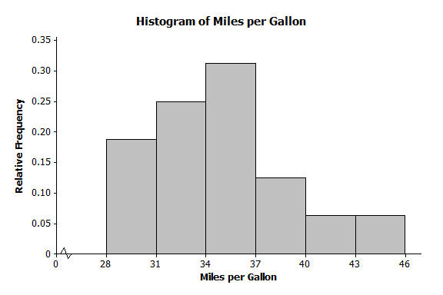
  - Juan drew the relative frequency histogram of the miles per gallon of the compact cars, shown on the right. Do you agree with the way Juan drew the histogram? Explain your answer.
No, Juan skipped the intervals $43-<46$ and $46-<49$.

