Lesson 4: Creating a Histogram

Classwork
Example 1: Frequency Table with Intervals
The boys and girls basketball teams at Roosevelt Middle School wanted to raise money to help buy new uniforms. They decided to sell hats with the school logo on the front to family members and other interested fans. To obtain the correct hat size, the students had to measure the head circumference (distance around the head) of the adults who wanted to order a hat. The following data represents the head circumferences, in millimeters (mm), of the adults:
$$513, 525, 531, 533, 535, 535, 542, 543, 546, 549, 551, 552, 552, 553, 554, 555, 560, 561, 563, 563, 563, 565,$$
$$565, 568, 568, 571,571, 574, 577, 580, 583, 583, 584, 585, 591, 595, 598, 603, 612, 618$$

The hats come in six sizes: XS, S, M, L, XL, and XXL. Each hat size covers a span of head circumferences. The hat manufacturer gave the students the table below that shows the interval of head circumferences for each hat size. The interval $510 - <530$ represents head circumferences from $510$ to $530$, not including $530$.

Hat Sizes | Interval of Head Circumferences (mm) | Tally | Frequency
XS | $$510-<530$$
S | $$530-<550$$
M | $$550-<570$$
L | $$570-<590$$
XL | $$590-<610$$
XXL | $$610-<630$$

Exercises 1–4
- If someone has a head circumference of $570$, what size hat would they need?

- Complete the tally and frequency columns in the table to determine the number of each size hat the students need to order for the adults who wanted to order a hat.

Hat Sizes | Interval of Head Circumferences (mm) | Tally | Frequency
XS | $$510-<530$$
S | $$530-<550$$
M | $$550-<570$$
L | $$570-<590$$
XL | $$590-<610$$
XXL | $$610-<630$$ | || | $$2$$

- What hat size does the data center around?

- Describe any patterns that you observe in the frequency column?

Example 2: Histogram
One student looked at the tally column and said that it looked somewhat like a bar graph turned on its side. A histogram is a graph that is like a bar graph, except that the horizontal axis is a number line that is marked off in equal intervals.
To make a histogram:
- Draw a horizontal line and mark the intervals.
- Draw a vertical line and label it “frequency.”
- Mark the frequency axis with a scale that starts at $0$and goes up to something that is greater than the largest frequency in the frequency table.
- For each interval, draw a bar over that interval that has a height equal to the frequency for that interval.
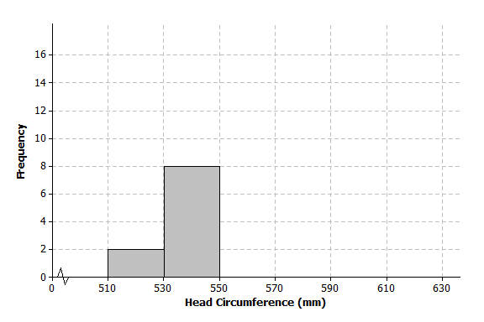
The first two bars of the histogram have been drawn below.

Exercises 5–9
- Complete the histogram by drawing bars whose heights are the frequencies for those intervals.
- Based on the histogram, describe the center of the head circumferences.

- How would the histogram change if you added head circumferences of $551$ and $569$?

- Because the $40$ head circumference values were given, you could have constructed a dot plot to display the head circumference data. What information is lost when a histogram is used to represent a data distribution instead of a dot plot?

- Suppose that there had been $200$ head circumference measurements in the data set. Explain why you might prefer to summarize this data set using a histogram rather than a dot plot.

Example 3: Shape of the Histogram
A histogram is useful to describe the shape of the data distribution. It is important to think about the shape of a data distribution because depending on the shape, there are different ways to describe important features of the distribution, such as center and variability.
A group of students wanted to find out how long a certain brand of AA batteries lasted. The histogram below shows the data distribution for how long (in hours) that some AA batteries lasted. Looking at the shape of the histogram, notice how the data “mounds” up around a center of approximately $105$. We would describe this shape as mound shaped or symmetric. If we were to draw a line down the center, notice how each side of the histogram is approximately the same or mirror images of each other. This means the graph is approximately symmetrical.
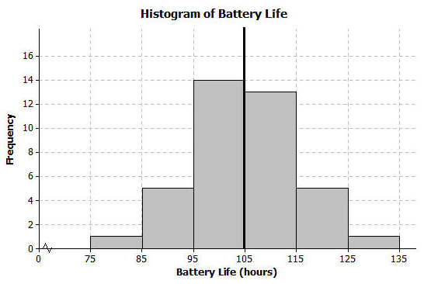
Another group of students wanted to investigate the maximum drop length for roller coasters. The histogram below shows the maximum drop (in feet) of a selected group of roller coasters. This histogram has a skewed shape. Most of the data are in the intervals from $50$ to $170$. But there are two values that are unusual (or not typical) when compared to the rest of the data. These values are much higher than most of the data.
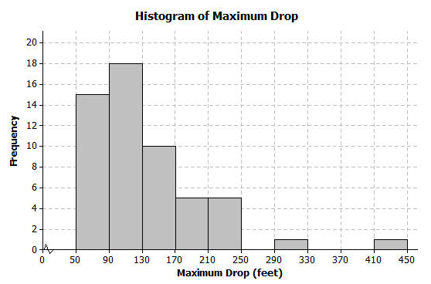
Exercises 10–12
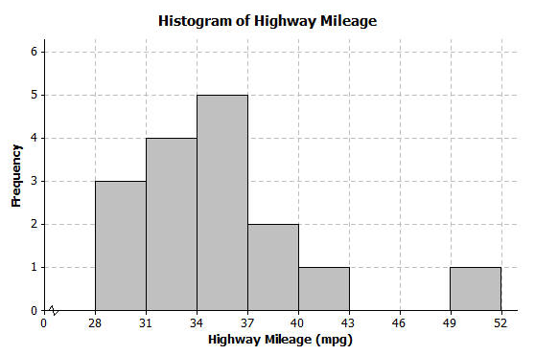
- The histogram below shows the highway miles per gallon of different compact cars.

  - Describe the shape of the histogram as approximately symmetric, skewed left, or skewed right.

  - Draw a vertical line on the histogram to show where the “typical” number of miles per gallon for a compact car would be.

  - What does the shape of the histogram tell you about miles per gallon for compact cars?

- Describe the shape of the head circumference histogram that you completed in Exercise 5 as approximately symmetric, skewed left, or skewed right.

- Another student decided to organize the head circumference data by changing the width of each interval to be $10$ instead of $20$. Below is the histogram that the student made.

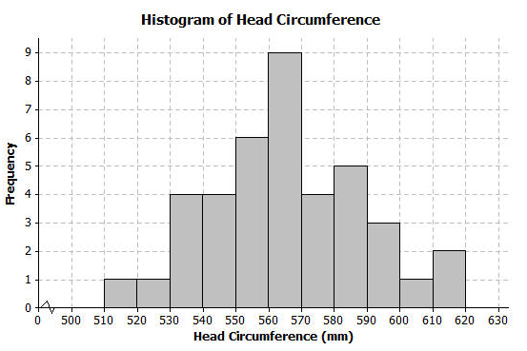
  - How does this histogram compare with the histogram of the head circumferences that you completed in Exercise 5?

  - Describe the shape of this new histogram as approximately symmetric, skewed left, or skewed right.

  - How many head circumferences are in the interval from $570$ to $590$?

  - In what interval would a head circumference of $571$ be included? In what interval would a head circumference of $610$ be included?

Lesson Summary
A histogram is a graph that represents the number of data values falling in an interval with a bar. The horizontal axis shows the intervals and the vertical axis shows the frequencies (how many data values are in the interval). Each interval should be the same width, and the bars should touch each other.

Problem Set

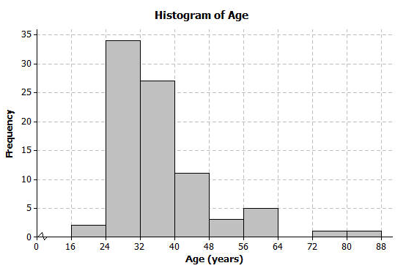
- The following histogram shows ages of the actresses whose performances have won in the Best Leading Actress category at the annual Academy Awards (Oscars).

  - Which age interval contains the most actresses? How many actresses are represented in that interval?
  - Describe the shape of the histogram.
  - What does the shape tell you about the ages of actresses who win the Oscar for best actress award?
  - Which interval describes the center of the ages of the actresses?
  - An age of $72$ would be included in which interval?

- The frequency table below shows the seating capacity of arenas for NBA basketball teams

Number of Seats | Tally | Frequency
$$17000-<17500$$ | || | $$2$$
$$17500-<18000$$ | | | $$1$$
$$18000-<18500$$ | |||| | | $$6$$
$$18500-<19000$$ | |||| | $$5$$
$$19000-<19500$$ | |||| | $$5$$
$$19500-<20000$$ | |||| | $$5$$
$$20000-<20500$$ | || | $$2$$
$$20500-<21000$$ | || | $$2$$
$$21000-<21500$$ |  | $$0$$
$$21500-<22000$$ |  | $$0$$
$$22000-<22500$$ | | | $$1$$

  - Draw a histogram of the number of seats in NBA arenas. Use the histograms you have seen throughout this lesson to help you in the construction of your histogram.
  - What is the width of each interval? How do you know?
  - Describe the shape of the histogram.
  - Which interval describes the center of the number of seats?

- Listed are the grams of carbohydrates in hamburgers at selected fast food restaurants.
$$33 40 66 45 28 30 52 40 26 42 \\ 42 44 33 44 45 32 45 45 52 24$$
  - Complete the frequency table with intervals of width $5$.

Number of Carbohydrates (grams) | Tally | Frequency
$$20-<25$$
$$25-<30$$
$$30-<35$$
$$35-<40$$
$$40-<45$$
$$45-<50$$
$$50-<55$$
$$55-<60$$
$$60-<65$$
$$65-<70$$

  - Draw a histogram of the carbohydrate data.
  - Describe the center and shape of the histogram.

  - In the frequency table below, the intervals are changed. Using the carbohydrate data above, complete the frequency table with intervals of width $10$.

Number of Carbohydrates (grams) | Tally | Frequency
$$20-<30$$
$$30-<40$$
$$40-<50$$
$$50-<60$$
$$60-<70$$

  - Draw a histogram.

- Use the histograms that you constructed in question 3 parts (b) and (e) to answer the following questions.
  - Why are there fewer bars in the histogram in question 3 part (e) than the histogram in part (b)?
  - Did the shape of the histogram in question 3 part (e) change from the shape of the histogram in part (b)?
  - Did your estimate of the center change from the histogram in question 3 part (b) to the histogram in part (e)?

