Lesson 3: Creating a Dot Plot

Classwork
Example 1: Hours of Sleep
Robert, a 6th grader at Roosevelt Middle School, usually goes to bed around 10:00 p.m. and gets up around 6:00 a.m. to get ready for school. That means that he gets about $8$ hours of sleep on a school night. He decided to investigate the statistical question: How many hours per night do 6th graders usually sleep when they have school the next day?
Robert took a survey of $29$ 6th graders and collected the following data to answer the question:
$7 8 5 9 9 9 7 7 10 10 11 9 8 8 8 12 6 11 10 8 8 9 9 9 8 10 9 9 8$
Robert decided to make a dot plot of the data to help him answer his statistical question. Robert first drew a number line and labeled it from $5$ to $12$ to match the lowest and highest number of hours slept.

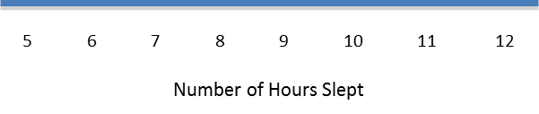
He then placed a dot above $7$ for the first piece of data he collected. He continued to place dots above the numbers until each number was represented by a dot.

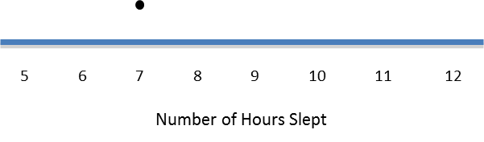

Exercises 1–9
- Complete Robert’s dot plot by placing a dot above the number on the number line for each number of hours slept. If there is already a dot above a number, then add another dot above the dot already there.

- What are the least and the most hours of sleep reported in the survey of 6th graders?

- What is the most common number of hours slept?

- How many hours of sleep describes the center of the data?

- Think about how many hours of sleep you usually get on a school night. How does your number compare with the number of hours of sleep from the survey of 6th graders?

Here are the data for the number of hours 6th graders sleep when they don’t have school the next day:
$$7 8 10 11 5 6 12 13 13 7 9 8 10 12 11 12 8 9 10 11 10 12 11 11 11 12 11 11 10$$

- Make a dot plot of the number of hours slept when there is no school the next day.

- How many hours of sleep with no school the next day describe the center of the data?

- What are the least and most hours slept with no school the next day reported in the survey?

- Do students sleep longer when they don’t have school the next day than they do when they do have school the next day? Explain your answer using the data in both dot plots.

Example 2: Building and Interpreting a Frequency Table
A group of 6th graders investigated the statistical question: “How many hours per week do 6th graders spend playing a sport or outdoor game?”
Here are the data the students collected from a sample of $26$ 6th graders showing the number of hours per week spent playing a sport or a game outdoors:
$$3 2 0 6 3 3 3 1 1 2 2 8 12 4 4 4 3 3 1 1 0 0 6 2 3 2$$
To help organize the data, the students placed the number of hours into a frequency table. A frequency table lists items and how often each item occurs.
To build a frequency table, first draw three columns. Label one column “Number of Hours Playing a Sport/Game,” label the second column “Tally,” and the third column “Frequency.” Since the least number of hours was $0$, and the most was $12$, list the numbers from $0$ to $12$ under the “Number of Hours” column.

Number of Hours Playing a Sport/Game | Tally | Frequency
$$0$$
$$1$$
$$2$$
$$3$$ | |
$$4$$
$$5$$
$$6$$
$$7$$
$$8$$
$$9$$
$$10$$
$$11$$
$$12$$

As you read each number of hours from the survey, place a tally mark opposite that number. The table shows a tally mark for the first number $3$.

Exercises 10–15
- Complete the tally mark column.
Number of hours | Tally | Frequency
$$0$$
$$1$$
$$2$$
$$3$$
$$4$$
$$5$$
$$6$$
$$7$$
$$8$$
$$9$$
$$10$$
$$11$$
$$12$$

- For each number of hours, find the total number of tally marks and place this in the frequency column.

- Make a dot plot of the number of hours playing a sport or playing outdoors.

- What number of hours describes the center of the data?

- How many 6th graders reported that they spend eight or more hours a week playing a sport or playing outdoors?

- The 6th graders wanted to answer the question, “How many hours do 6th graders spend per week playing a sport or playing an outdoor game?” Using the frequency table and the dot plot, how would you answer the 6th graders question?

Lesson Summary
This lesson described how to make a dot plot. This plot starts with a number line labeled from the smallest to the largest value. Then, a dot is placed above the number on the number line for each value in your data.
This lesson also described how to make a frequency table. A frequency table consists of three columns. The first column contains all the values of the data listed in order from smallest to largest. The second column is the tally column, and the third column is the number of tallies for each data value.

Problem Set

- The data below is the number of goals scored by a professional indoor soccer team over their last $23$ games.
$$8 16 10 9 11 11 10 15 16 11 15 13 8 9 11 9 8 11 16 15 10 9 12$$

  - Make a dot plot of the number of goals scored.
  - What number of goals describes the center of the data?
  - What is the least and most number of goals scored by the team?
  - Over the $23$ games played, the team lost $10$ games. Circle the dots on the plot that you think represent the games that the team lost. Explain your answer.

- A 6th grader rolled two number cubes $21$ times. The student found the sum of the two numbers that he rolled each time. The following are the sums of the $21$ rolls of the two number cubes:
$$9 2 4 6 5 7 8 11 9 4 6 5 7 7 8 8 7 5 7 6 6$$

  - Complete the frequency table.
Sum rolled | Tally | Frequency
$$2$$
$$3$$
$$4$$
$$5$$
$$6$$
$$7$$
$$8$$
$$9$$
$$10$$
$$11$$
$$12$$

  - What sum describes the center of the data?
  - What was the most common sum of the number cubes?

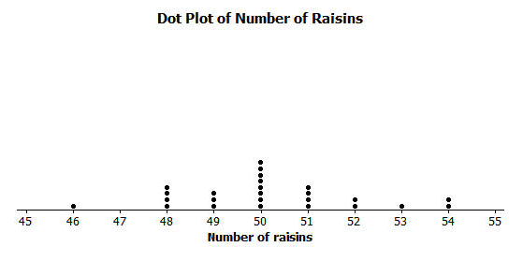
- The dot plot below shows the number of raisins in $25$ selected small boxes of raisins.

  - Complete the frequency table.
Number of Raisins | Tally | Frequency
$$46$$
$$47$$
$$48$$
$$49$$
$$50$$
$$51$$
$$52$$
$$53$$
$$54$$

  - Another student opened up a box of raisins and reported that it had $63$ raisins. Did this student have the same size box of raisins? Why or why not?

