Lesson 3: Creating a Dot Plot

Student Outcomes
- Students create a dot plot of a given data set.
- Students summarize a given data set using equal length intervals and construct a frequency table.
- Based on a frequency table, students describe the distribution.

Classwork
Example 1 (5 minutes): Hours of Sleep

Example 1: Hours of Sleep
Robert, a 6th grader at Roosevelt Middle School, usually goes to bed around 10:00 p.m. and gets up around 6:00 a.m. to get ready for school. That means that he gets about $8$ hours of sleep on a school night. He decided to investigate the statistical question: How many hours per night do 6th graders usually sleep when they have school the next day?
Robert took a survey of $29$ 6th graders and collected the following data to answer the question:
$7 8 5 9 9 9 7 7 10 10 11 9 8 8 8 12 6 11 10 8 8 9 9 9 8 10 9 9 8$
Robert decided to make a dot plot of the data to help him answer his statistical question. Robert first drew a number line and labeled it from $5$ to $12$ to match the lowest and highest number of hours slept.

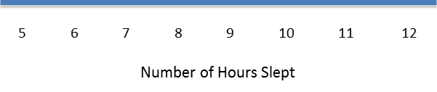
He then placed a dot above $7$ for the first piece of data he collected. He continued to place dots above the numbers until each number was represented by a dot.

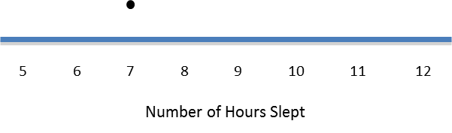

This example begins with the statistical question: How many hours per night do 6th graders usually sleep when they have school the next day? The data shown come from a random sample of 6th graders collected from the Census At School website (http://www.amstat.org/censusatschool/). The beginning steps to make a dot plot are presented and students are asked to complete the plot. It is important to point out to students that as they determine labels for the number line, they must list the numbers sequentially using the same interval. A common mistake is that students may not list a number if there is no data for that value. If there is a large gap between the values, student may also skip numbers. Emphasize that it is important to keep the vertical spacing the same to better understand the distribution that the dot plot summarizes. Lined paper can be useful to students who need help keeping vertical spacing consistent when constructing a dot plot.
MP.1
As you develop this example, pose the following questions to students:
- Why is the number line labeled from $5$ to $12$? Could we have labeled the number line from $8$ to $16$? Could we have labeled the number line from $0$ to $15$?
- If there is no data for a particular value, do you have to show that value on the number line? For example, if your data are $1$,$2$,$3$,$4$,$8$,$9$,$10$. Can you skip $5$,$6,$ and $7$?

Exercises 1–9 (20 minutes)
The first five Exercises are designed to have students complete the dot plot that is started and to answer questions about the most common value and the center of the distribution. Exercise 6 is designed to have students make a dot plot without any prompts. Some students may need help with making the number line. For those students, have them find the lowest and highest value and suggest that they use these values to start and end their number line. Exercise 9 is designed to have students begin to compare two distributions. This comparison of distribution will be a focus of lessons later in this unit.
Allow students about 15 minutes to work independently or in small groups. Bring the groups together to summarize their answers.

Exercises 1–9
- Complete Robert’s dot plot by placing a dot above the number on the number line for each number of hours slept. If there is already a dot above a number, then add another dot above the dot already there.

- What are the least and the most hours of sleep reported in the survey of 6th graders?
The least is $5$, and the most is $12$.

- What is the most common number of hours slept?
$9$ is the most common.

- How many hours of sleep describes the center of the data?
The center is around $8$ or $9$.
- Think about how many hours of sleep you usually get on a school night. How does your number compare with the number of hours of sleep from the survey of 6th graders?
Answers will vary. Analyze answers based on students’ responses.

Here are the data for the number of hours 6th graders sleep when they don’t have school the next day:
$$7 8 10 11 5 6 12 13 13 7 9 8 10 12 11 12 8 9 10 11 10 12 11 11 11 12 11 11 10$$

- Make a dot plot of the number of hours slept when there is no school the next day.
- How many hours of sleep with no school the next day describe the center of the data?
Around $11$ hours.

- What are the least and most hours slept with no school the next day reported in the survey?
The least is $5$, and the most is $13$.

- Do students sleep longer when they don’t have school the next day than they do when they do have school the next day? Explain your answer using the data in both dot plots.
Yes, because more of the data points are in the $10$,$11$,$12$,$13$ categories in the ”no school” dot plot than in the “have school” dot plot.

Example 2 (10 minutes): Building and Interpreting a Frequency Table

Example 2: Building and Interpreting a Frequency Table
A group of 6th graders investigated the statistical question: “How many hours per week do 6th graders spend playing a sport or outdoor game?”
Here are the data the students collected from a sample of $26$ 6th graders showing the number of hours per week spent playing a sport or a game outdoors:
$$3 2 0 6 3 3 3 1 1 2 2 8 12 4 4 4 3 3 1 1 0 0 6 2 3 2$$
To help organize the data, the students placed the number of hours into a frequency table. A frequency table lists items and how often each item occurs.
To build a frequency table, first draw three columns. Label one column “Number of Hours Playing a Sport/Game,” label the second column “Tally,” and the third column “Frequency.” Since the least number of hours was $0$, and the most was $12$, list the numbers from $0$ to $12$ under the “Number of Hours” column.

Number of Hours Playing a Sport/Game | Tally | Frequency
$$0$$
$$1$$
$$2$$
$$3$$ | |
$$4$$
$$5$$
$$6$$
$$7$$
$$8$$
$$9$$
$$10$$
$$11$$
$$12$$

As you read each number of hours from the survey, place a tally mark opposite that number. The table shows a tally mark for the first number $3$.

The data shown come from a random sample of $6$^{th} graders collected from the Census at School website (http://www.amstat.org/censusatschool/). The format for the frequency table is presented, and students are directed on how to complete the table. It is important to point out to students when listing values under the number column that the numbers must be listed sequentially with no missing numbers or gaps in the numbers. Students should be able to draw a dot plot from the frequency table and build a frequency table from the dot plot. After students have completed the frequency table and the dot plot of the data, discuss with them what each representation tells about the data.
MP.4

As you develop this example, pose the following question to students:
- What information is available in the frequency table that is not readily available in the dot plot?

Exercises 10–15 (10 minutes)
In Exercises 10 and 11, students complete the frequency table. In Exercise 12, students are directed to make a dot plot of the data. Encourage students to use the frequency table to help build the dot plot.
Exercise 15 is designed to have students begin to analyze the data as it is presented in two different representations. They should focus on the center and spread of the data as they answer this question.

Exercises 10–15
- Complete the tally mark column.
Number of hours | Tally | Frequency
$$0$$ | | | | | $$3$$
$$1$$ | | | | | | $$4$$
$$2$$ | | | | | | $$5$$
$$3$$ | | | | | | | | $$7$$
$$4$$ | | | | | $$3$$
$$5$$ |  | $$0$$
$$6$$ | | | | $$2$$
$$7$$ |  | $$0$$
$$8$$ | | | $$1$$
$$9$$ |  | $$0$$
$$10$$ |  | $$0$$
$$11$$ |  | $$0$$
$$12$$ | | | $$1$$

- For each number of hours, find the total number of tally marks and place this in the frequency column.
See table above.

- Make a dot plot of the number of hours playing a sport or playing outdoors.

- What number of hours describes the center of the data?
Around $3$.

- How many 6th graders reported that they spend eight or more hours a week playing a sport or playing outdoors?
Only $2$ students.

- The 6th graders wanted to answer the question, “How many hours do 6th graders spend per week playing a sport or playing an outdoor game?” Using the frequency table and the dot plot, how would you answer the 6th graders’ question?
Lesson Summary
This lesson described how to make a dot plot. This plot starts with a number line labeled from the smallest to the largest value. Then, a dot is placed above the number on the number line for each value in your data.
This lesson also described how to make a frequency table. A frequency table consists of three columns. The first column contains all the values of the data listed in order from smallest to largest. The second column is the tally column, and the third column is the number of tallies for each data value.
Most 6th graders spend about $2$ to $4$ hours per week playing a sport or playing outdoors.

Exit Ticket (5 minutes)
Name ___________________________________________________ Date____________________
Lesson 3: Creating a Dot Plot

Exit Ticket

A biologist collected data to answer the question: “How many eggs do robins lay?”
The following is a frequency table of the collected data:

Number of Eggs | Tally | Frequency
$$1$$ | | |
$$2$$ | |||| |||| ||
$$3$$ | |||| |||| |||| |||
$$4$$ | |||| ||||
$$5$$ | |

- Complete the frequency column.

- Draw a dot plot of the number of eggs a robin lays.

- What number of eggs describes the center of the data?
Exit Ticket Sample Solutions
This Exit Ticket is designed to assess if a student can complete a frequency table and draw a dot plot from a given frequency table.
A biologist collected data to answer the question: “How many eggs do robins lay?”
The following is a frequency table of the collected data:
- Complete the frequency column.
Number of Eggs | Tally | Frequency
$$1$$ | | | | $$2$$
$$2$$ | |||| |||| || | $$12$$
$$3$$ | |||| |||| |||| ||| | $$18$$
$$4$$ | |||| |||| | $$9$$
$$5$$ | | | $$1$$
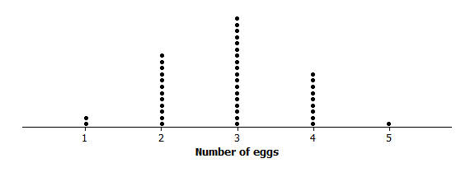
- Draw a dot plot of the number of eggs a robin lays.
- What number of eggs describes the center of the data?
$$3$$

Problem Set Sample Solutions

- The data below is the number of goals scored by a professional indoor soccer team over their last $23$ games.
$$8 16 10 9 11 11 10 15 16 11 15 13 8 9 11 9 8 11 16 15 10 9 12$$

  - Make a dot plot of the number of goals scored.
  - What number of goals describes the center of the data?
Around $11$ or $12$

  - What is the least and most number of goals scored by the team?
$8$ is the least, and $16$ is the most.

  - Over the $23$ games played, the team lost $10$ games. Circle the dots on the plot that you think represent the games that the team lost. Explain your answer.
Students should circle the lowest $10$ scores.
- A 6th grader rolled two number cubes $21$ times. The student found the sum of the two numbers that he rolled each time. The following are the sums of the $21$ rolls of the two number cubes:
$$9 2 4 6 5 7 8 11 9 4 6 5 7 7 8 8 7 5 7 6 6$$

  - Complete the frequency table.
Sum rolled | Tally | Frequency
$$2$$ | | | $$1$$
$$3$$ |  | $$0$$
$$4$$ | | | | $$2$$
$$5$$ | | | | | $$3$$
$$6$$ | | | | | | $$4$$
$$7$$ | | | | | | $$5$$
$$8$$ | | | | | $$3$$
$$9$$ | | | | $$2$$
$$10$$ |  | $$0$$
$$11$$ | | | $$1$$
$$12$$ |  | $$0$$

  - What sum describes the center of the data?
$$7$$

  - What was the most common sum of the number cubes?
$$7$$

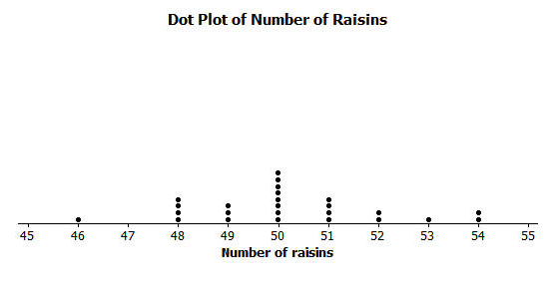
- The dot plot below shows the number of raisins in $25$ selected small boxes of raisins.
  - Complete the frequency table.
Number of Raisins | Tally | Frequency
$$46$$ | | | $$1$$
$$47$$ |  | $$0$$
$$48$$ | | | | | | $$4$$
$$49$$ | | | | | $$3$$
$$50$$ | | | | | | | | | $$8$$
$$51$$ | | | | | | $$4$$
$$52$$ | | | | $$2$$
$$53$$ | | | $$1$$
$$54$$ | | | | $$2$$

  - Another student opened up a box of raisins and reported that it had $63$ raisins. Did this student have the same size box of raisins? Why or why not?
No, the boxes opened had at most $54$ raisins, and $63$ is too high.

