Lesson 2: Displaying a Data Distribution

Student Outcomes
- Given a dot plot, students begin describing the distribution of the points on the dot plot in terms of center and variability.

Classwork
Example 1 (10 minutes): Heart Rate

Example 1: Heart Rate
Mia, a 6th grader at Roosevelt Middle School, was thinking about joining the middle school track team. She read that Olympic athletes have lower resting heart rates than most people. She wondered about her own heart rate and how it would compare to other students. Mia was interested in investigating the statistical question: “What are the heart rates of the students in my 6th grade class?”
Heart rates are expressed as bpm (or beats per minute). Mia knew her resting heart rate was $80$ beats per minute. She asked her teacher if she could collect the heart rates of the other students in her class. With the teacher’s help, the other 6th graders in her class found their heart rates and reported them to Mia. Following are the heart rates (in beats per minute) for the $22$ other students in Mia’s class:
$$89 87 85 84 90 79 83 85 86 88 84 81 88 85 83 83 86 82 83 86 82 84$$
To learn about the heart rates, a good place to start is to make a graph of the data. There are several different graphs that could be used, including the three types of graphs that you will learn in this module: dot plots, histograms, and box plots. In this lesson, you will learn about dot plots.
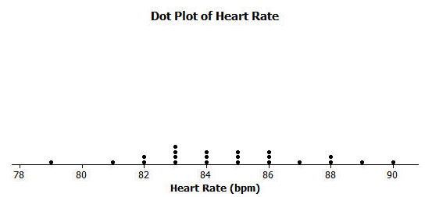
Mia noticed that there were many different heart rates. She decided to make a dot plot to show the different heart rates. She drew a number line and started numbering from $78$ to $92$. She then placed a dot above the number on the number line for each heart rate. If there was already a dot above a number she added another dot above the one already there. She continued until she had added one dot for each heart rate.

This example uses the scenario of students’ resting heart rate. As you discuss the scenario with students, you may want to demonstrate how a pulse is taken, and (if time permits) have your students find their resting heart rate and use that data to make a dot plot. Note: This lesson is not intended to teach students how to construct a dot plot, but rather to show them a dot plot as a graph of the distribution of the data collected to answer a statistical question. Emphasize thinking about the center of the data and the spread of the data.
MP.1
At this point, students may differ on what “center” of the data means. Write down students’ suggestions of what “center” means so that you can refer back to their initial ideas throughout the module. Exercise 6 asks students to describe the center. Some students may choose a number that occurs most often while others may pick a number that is in the “middle” (i.e., halfway between the highest and lowest data values). Some students may say it’s the “average.” The intent is not to calculate any specific value, but to gauge your students’ thinking about center. Formal measures of center will be developed starting in Lesson 6.
Exercise 8 asks students to think about what a “typical” heart rate is for 6th graders. Similar to the idea of center, students will vary to what they think is typical. The idea is to have students begin to discuss where there are clusters of data and where the data centers.
Ask students the following questions as you develop this example:
- What can you tell me about the heart rates of the 6th grade students?
- Where do the heart rates tend to center? Why did you choose that number?
- How much spread do you see in the heart rates?

Exercises 1–10 (15 minutes)
These ten questions are designed to have students recognize the details that can be observed in a dot plot. They should be able to find the lowest heart rate, the highest heart rate, and the most common heart rate, and describe the approximate location of the center.
Allow the students about 5–8 minutes to work independently or in small groups. Then, bring the groups together to summarize their answers.

Exercises 1–10
- What was the heart rate for the student with the lowest heart rate?
$79$

- What was the heart rate for the student with the highest heart rate?
$$90$$

- How many students had a heart rate greater than $86$?
$$5$$

- What fraction of the students had a heart rate less than $82$?
$\frac{2}{22}$ or $\frac{1}{11}$

- What is the most common heart rate?
$$83$$

- What heart rate describes the center of the data?
$85$ (Answers may vary, but students’ responses should be around the center.)
- What heart rates are the most unusual heart rates?
$79$ and $90$

- If Mia’s teacher asked what the typical heart rate is for 6th graders in the class, what would you tell Mia’s teacher?
Most students had a heart rate between $82$ and $86$. The most common was $83$.

- On the dot plot add a dot for Mia’s heart rate.
Add a dot above $80$.

- How does Mia’s heart rate compare with the heart rates of the other students in the class?
Her heart rate is lower than all but one of the students.

Example 2 (10 minutes): Seeing the Spread in Dot Plots

Example 2: Seeing the Spread in Dot Plots
Mia’s class collected data to answer several other questions about her class. After they collected data, they drew dot plots of their findings.
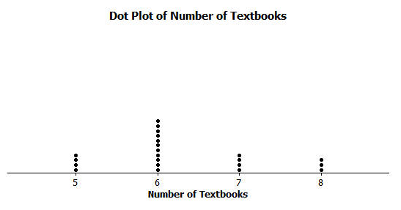
Here is a dot plot showing the data collected to answer the question: “How many textbooks are in the desks of 6th graders?”
When the students thought about this question, many said that they all had about the same number of books in their desk since they all take the same subjects in school.
The class noticed that the graph was not very spread out since there were only four different answers that students gave, with most of the students answering that they had $6$ books in their desk.
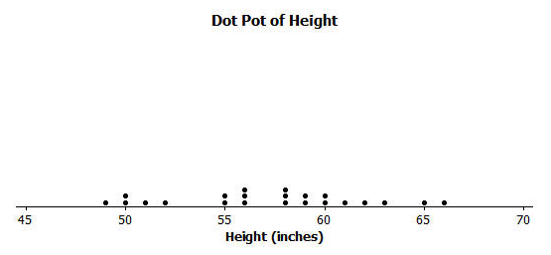
Another student wanted to ask the question: “How tall are the 6th graders in our class?” When students thought about this question, they thought that the heights would be spread out since there were some shorter students and some very tall students in class. Here is a dot plot of the students’ heights:
Dot Plot of Height

In this example, the focus is on the spread of the data. Display the two dot plots (one of the number of textbooks in their desks and the other for the heights of 6th graders). Discuss with students the values shown on the number line. For the number of textbooks, the data span from $5$ to $8$, while the heights go from $49$ to $66$.
Ask students the following question as you develop this example:
- Why do you think the data for the number of textbooks go from $4$ to $8$, while the heights span from $49$” to $66$”?

Exercises 11–14 (10 minutes)
This exercise is a matching problem where students are given statistical questions to which they should match a dot plot. Stress to students that they need to explain why they matched the questions and the dot plots as they did.
Allow the students about 3–5 minutes to work independently or in small groups. Bring the groups together to summarize their answers.

Exercises 11–14
Listed are four statistical questions and four different dot plots of data collected to answer these questions. Match each statistical question with the appropriate dot plot. Explain each of your choices.
Statistical Question:
- What are the ages of 4th graders in our school?
A - Many 4th graders are around $9$ or $10$ years old.

- What are the heights of the players on the 8th grade boys’ basketball team?
D – The guys on an 8th grade basketball team can vary in height. Generally, there is a tall player ($73$ inches), while most others are around $5$ feet, or $60$ inches.

- How many hours do 6th graders in our class watch TV on a school night?
B - Answers vary. I think a few of the students may watch a lot of TV. Most students watch two hours or less.

- How many different languages do students in our class speak?
C - Most students know one language – English. Many of the students in our class also study another language, or live in an environment where their family speaks another language.
Dot plot A  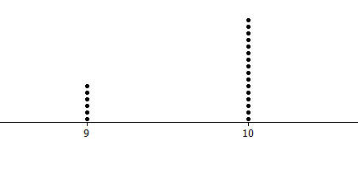 | 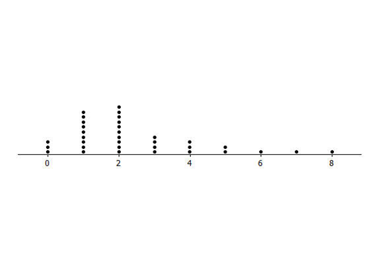  Dot plot B
Dot plot C  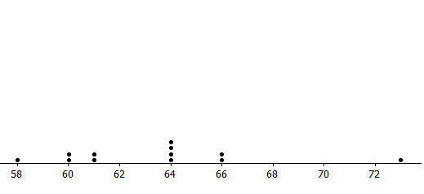  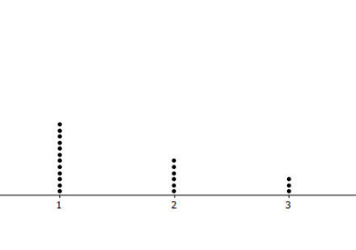 | Dot plot D
Lesson Summary
In this lesson, numerical data collected to answer a statistical question were shown in a dot plot. In a dot plot, a data value is represented by a dot over a number line. The number of dots over the number line at a particular value tells how many of the data points have that value. A dot plot can help you find the smallest and largest values, see how spread out the data are, and see where the center of the data is.

Exit Ticket (5 minutes)

Name __________________________________________________ Date____________________
Lesson 2: Displaying a Data Distribution

Exit Ticket

A 6th grade class collected data on the number of letters in the first names of all the students in class. Here is the dot plot of the data they collected:

- How many students are in the class?

- What is the shortest name length?

- What is the longest name length?

- What is the most common name length?

- What name length describes the center of the data?
Exit Ticket Sample Solutions

A 6th grade class collected data on the number of letters in the first names of all the students in class. Here is the dot plot of the data they collected:
- How many students are in the class?
$$25$$

- What is the shortest name length?
$3$ letters

- What is the longest name length?
$9$ letters

- What is the most common name length?
$6$ letters

- What name length describes the center of the data?
$6$ letters

Problem Set Sample Solutions

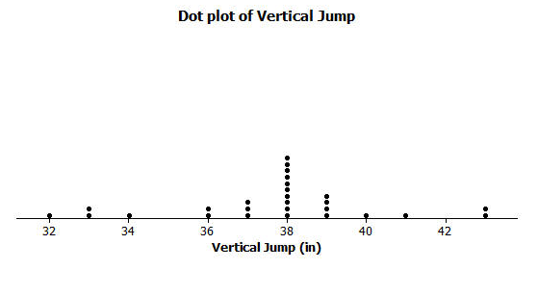
- The dot plot below shows the vertical jump of some NBA players. A vertical jump is how high a player can jump from a standstill.
Dot Plot of Vertical Jump

  - What statistical question do you think could be answered using these data?
What is the vertical jump of NBA players?

  - What was the highest vertical jump by a player?
$43$ inches

  - What was the lowest vertical jump by a player?
$32$ inches

  - What is the most common vertical jump?
$38$ inches

  - How many players jumped that high?
$$10$$

  - How many players jumped higher than $40$ inches?
$$3$$

  - Another NBA player jumped $33$ inches. Add a dot for this player on the dot plot. How does this player compare with the other players?
This player jumped the same as two other players and jumped higher than only one player.

- Listed are two statistical questions and two different dot plots of data collected to answer these questions. Match each statistical question with its dot plot. Explain each of your choices.
Statistical questions:
  - What is the number of fish (if any) that students in class have in an aquarium at their home?
A; some students may not have any fish ($0$ from the dot plot) while another student has $10$ fish.

  - How many pockets do the 6th graders have in the pants that they are wearing at school on a particular day?
B; the dot plot displays the values $2$, $3$, $4$, $5$, $6$, which are all reasonable within the context of the question. Pants generally have at least $2$ pockets.
Dot Plot A
Dot Plot B
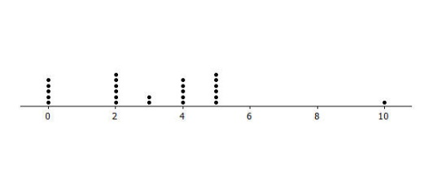
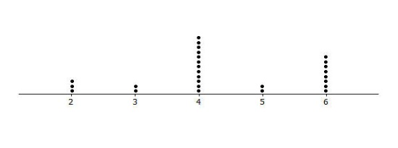
- Read each of the following statistical questions. Write a description of what the dot plot of the data collected to answer the question might look like. Your description should include a description of the spread of the data and the center of the data.
  - What is the number of hours 6th grade students are in school during a typical school day?
Most students are in school for the same number of hours. Differences may exist for those students who travel or participate in a club or afterschool activity. Students’ responses vary based on their estimate of the number of hours students spend in school.

  - What is the number of video games owned by the 6th graders in our class?
These data would have a very big spread. Some students might have no video games, while others could have a large number of games. A typical value of $5$ (or something similar) would identify a center. In this case, the center is based on the number most commonly reported by students.

