Lesson 2: Displaying a Data Distribution

Classwork
Example 1: Heart Rate
Mia, a 6th grader at Roosevelt Middle School, was thinking about joining the middle school track team. She read that Olympic athletes have lower resting heart rates than most people. She wondered about her own heart rate and how it would compare to other students. Mia was interested in investigating the statistical question: “What are the heart rates of the students in my 6th grade class?”
Heart rates are expressed as bpm (or beats per minute). Mia knew her resting heart rate was $80$ beats per minute. She asked her teacher if she could collect the heart rates of the other students in her class. With the teacher’s help, the other 6th graders in her class found their heart rates and reported them to Mia. Following are the heart rates (in beats per minute) for the $22$ other students in Mia’s class:
$$89 87 85 84 90 79 83 85 86 88 84 81 88 85 83 83 86 82 83 86 82 84$$
To learn about the heart rates, a good place to start is to make a graph of the data. There are several different graphs that could be used, including the three types of graphs that you will learn in this module: dot plots, histograms, and box plots. In this lesson, you will learn about dot plots.
Mia noticed that there were many different heart rates. She decided to make a dot plot to show the different heart rates. She drew a number line and started numbering from $78$ to $92$. She then placed a dot above the number on the number line for each heart rate. If there was already a dot above a number she added another dot above the one already there. She continued until she had added one dot for each heart rate.

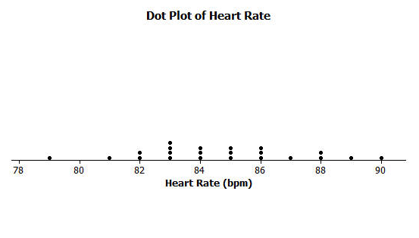

Exercises 1–10
- What was the heart rate for the student with the lowest heart rate?

- What was the heart rate for the student with the highest heart rate?

- How many students had a heart rate greater than $86$?

- What fraction of the students had a heart rate less than $82$?

- What is the most common heart rate?

- What heart rate describes the center of the data?

- What heart rates are the most unusual heart rates?

- If Mia’s teacher asked what the typical heart rate is for 6th graders in the class, what would you tell Mia’s teacher?

- On the dot plot add a dot for Mia’s heart rate.

- How does Mia’s heart rate compare with the heart rates of the other students in the class?

Example 2: Seeing the Spread in Dot Plots
Mia’s class collected data to answer several other questions about her class. After they collected data, they drew dot plots of their findings.
Here is a dot plot showing the data collected to answer the question: “How many textbooks are in the desks of 6th graders?”
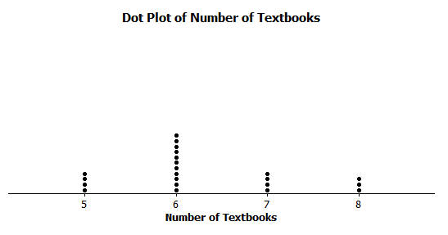
When the students thought about this question, many said that they all had about the same number of books in their desk since they all take the same subjects in school.
The class noticed that the graph was not very spread out since there were only four different answers that students gave, with most of the students answering that they had $6$ books in their desk.
Another student wanted to ask the question: “How tall are the 6th graders in our class?” When students thought about this question, they thought that the heights would be spread out since there were some shorter students and some very tall students in class. Here is a dot plot of the students’ heights:
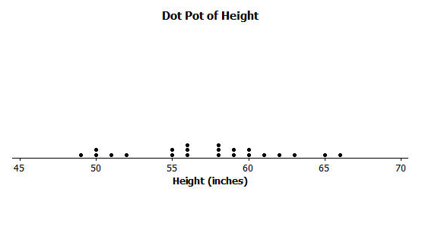
Dot Plot of Height
Exercises 11–14
Listed are four statistical questions and four different dot plots of data collected to answer these questions. Match each statistical question with the appropriate dot plot. Explain each of your choices.
Statistical Question:
- What are the ages of 4th graders in our school?

- What are the heights of the players on the 8th grade boys’ basketball team?

- How many hours do 6th graders in our class watch TV on a school night?

- How many different languages do students in our class speak?

Dot plot A  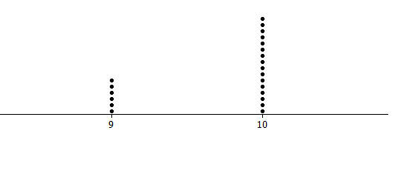 | Dot plot B  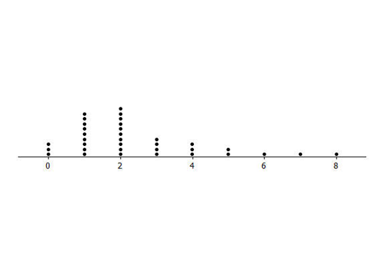
Dot plot C  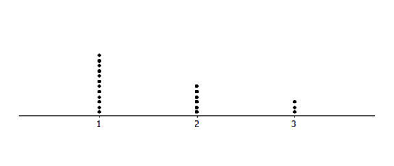 | Dot plot D  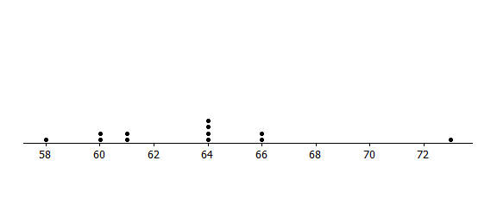
Lesson Summary
In this lesson, numerical data collected to answer a statistical question were shown in a dot plot. In a dot plot, a data value is represented by a dot over a number line. The number of dots over the number line at a particular value tells how many of the data points have that value. A dot plot can help you find the smallest and largest values, see how spread out the data are, and see where the center of the data is.

Problem Set

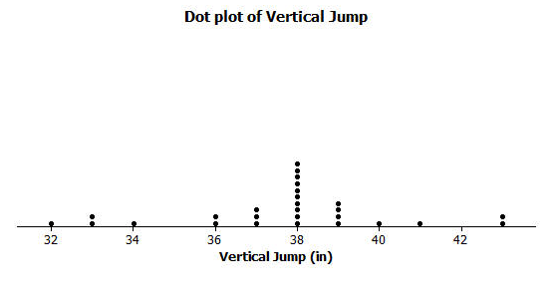
- The dot plot below shows the vertical jump of some NBA players. A vertical jump is how high a player can jump from a standstill.
Dot Plot of Vertical Jump
  - What statistical question do you think could be answered using these data?
  - What was the highest vertical jump by a player?
  - What was the lowest vertical jump by a player?
  - What is the most common vertical jump?
  - How many players jumped that high?
  - How many players jumped higher than $40$ inches?
  - Another NBA player jumped $33$ inches. Add a dot for this player on the dot plot. How does this player compare with the other players?

- Listed are two statistical questions and two different dot plots of data collected to answer these questions. Match each statistical question with its dot plot. Explain each of your choices.
Statistical questions:
  - What is the number fish (if any) that students in class have in an aquarium at their home?
  - How many pockets do the 6th graders have in the pants that they are wearing at school on a particular day?

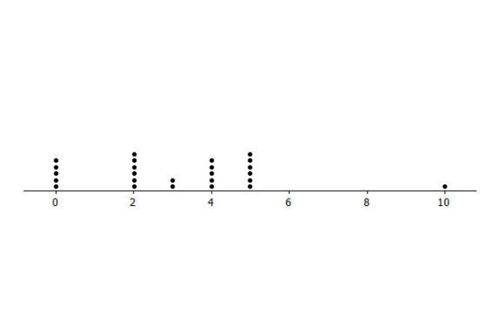
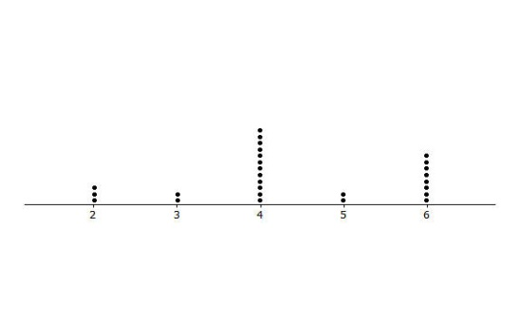
Dot Plot A
Dot Plot B

- Read each of the following statistical questions. Write a description of what the dot plot of the data collected to answer the question might look like. Your description should include a description of the spread of the data and the center of the data.
  - What is the number of hours 6th grade students are in school during a typical school day?
  - What is the number of video games owned by the 6th graders in our class?

