Lesson 19a: Applying Surface Area and Volume to Aquariums

Classwork
Opening Exercise
Determine the volume of this aquarium.
$20 in$.
$10 in$.
$12 in$.

Mathematical Modeling Exercise: Using Ratios and Unit Rate to Determine Volume
For his environmental science project, Jamie is creating habitats for various wildlife including fish, aquatic turtles, and aquatic frogs. For each of these habitats, he will use a standard aquarium with length, width, and height dimensions measured in inches, identical to the aquarium mentioned in the Opening Exercise. To begin his project, Jamie will need to determine the volume, or cubic inches, of water that will fill the aquarium.
Use the table below to determine the unit rate of gallons/cubic inches.
Gallons | Cubic Inches
$$1$$
$$2$$ | $$462$$
$$3$$ | $$693$$
$$4$$ | $$924$$
$$5$$ | $$1,155$$
Determine the volume of the aquarium.

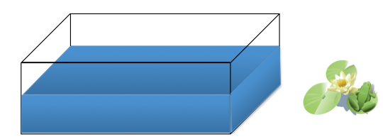
Exercise 1

- Determine the volume of the tank when filled with $7$ gallons of water.

- Work with your group to determine the height of the water when Jamie places $7$ gallons of water in the aquarium.

Exercise 2
- Use the table from Example 1 to determine the volume of the aquarium when Jamie pours $3$ gallons of water into the tank.

- Use the volume formula to determine the missing height dimension.

Exercise 3
  - Using the table of values below, determine the unit rate of liters to gallon.
Gallons | Liters
$$1$$
$$2$$ | $$7.57$$
$$4$$ | $$15.14$$

  - Using this conversion, determine the number of liters you will need to fill the $10$-gallon tank.

  - The ratio of the number of centimeters to the number of inches is $2.54: 1$. What is the unit rate?

  - Using this information, complete the table to convert the heights of the water in inches to the heights of the water in centimeters Jamie will need for his project at home.
Height in Inches | Convert to Centimeters | Height in Centimeters
$$1$$ | $$2.54 \frac{centimeters}{inch}×1 inch$$ | $$2.54$$
$$3.465$$
$$8.085$$
$$11.55$$

Exercise 4
  - Determine the amount of plastic film the manufacturer uses to cover the aquarium faces. Draw a sketch of the aquarium to assist in your calculations. Remember that the actual height of the aquarium is $12$ inches.

  - We do not include the measurement of the top of the aquarium since it is open without glass and does not need to be covered with film. Determine the area of the top of the aquarium, and find the amount of film the manufacturer will use to cover only the sides, front, back, and bottom.

  - Since Jamie will need three aquariums, determine the total surface area of the three aquariums.

Problem Set

This Problem Set is a culmination of skills learned in this module. Note that the figures are not drawn to scale.
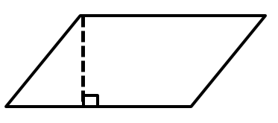
- Calculate the area of the figure below.
$$40 ft.$$
$$20 ft.$$
$$24 ft.$$

- Calculate the area of the figure below.
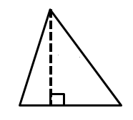
$$1.2 m$$
$0.5 m$ $0.8 m$
$$1.3 m$$

- Calculate the area of the figure below.
$$12 in.$$
$$18 in.$$
$$7 in.$$
$$32 in.$$

- Complete the table using the diagram on the coordinate plane.
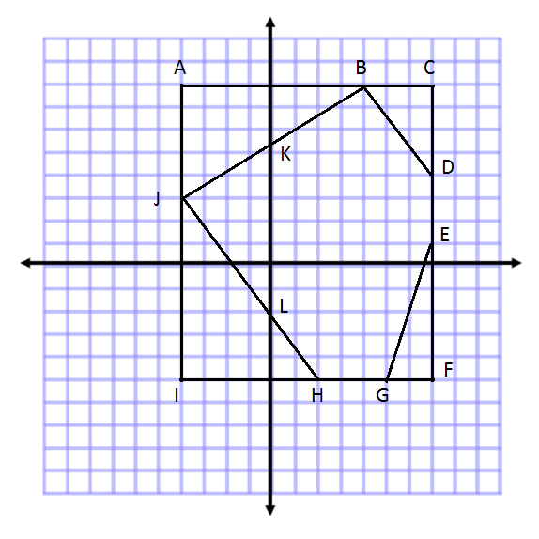

Line Segment | Point | Point | Distance | Proof
$$\overline{AB}$$
$$\overline{CE}$$
$$\overline{GI}$$
$$\overline{HI}$$
$$\overline{IJ}$$
$$\overline{AI}$$
$$\overline{AJ}$$

- Plot the points below, and draw the shape. Then, determine the area of the polygon.
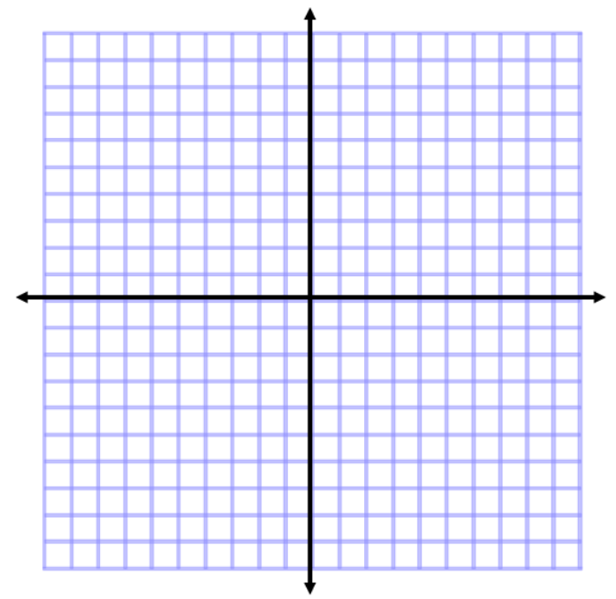
$A(-3, 5)$, $B(4, 3)$,$C(0, -5)$

- Determine the volume of the figure.
$$3\frac{1}{2} m$$
$$\frac{7}{8} m$$
$$1\frac{1}{4} m$$

- Give at least three more expressions that could be used to determine the volume of the figure in Problem 6.

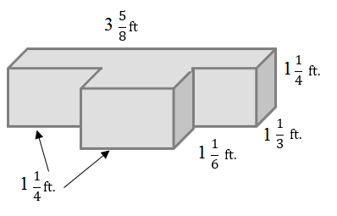
- Determine the volume of the irregular figure.
- Draw and label a net for the following figure. Then, use the net to determine the surface area of the figure.
$12$ cm
$7$ cm
$10$ cm

- Determine the surface area of the figure in Problem 9 using the formula $SA=2lw+2lh+2wh$. Then, compare your answer to the solution in Problem 9.

- A parallelogram has a base of $4.5 cm$ and an area of $9.495 {cm}^{2}$. Tania wrote the equation $4.5x=9.495$ to represent this situation.
  - Explain what $x$ represents in the equation.
  - Solve the equation for $x$.

- Triangle A has an area equal to one-third the area of Triangle B. Triangle A has an area of $3\frac{1}{2}$ square meters.
  - Gerard wrote the equation $\frac{B}{3}=3\frac{1}{2}$. Explain what$B$ represents in the equation.
  - Determine the area of Triangle B.

