|  |
| --- |
|  |

Lesson 19a: Applying Surface Area and Volume to Aquariums

Student Outcomes

* Students apply the formulas for surface area and volume to determine missing dimensions of aquariums and water level.

Lesson Notes

The purpose of this lesson is to demonstrate an abridged version of the modeling cycle in preparation for shortened modeling cycles in Grades 7 and 8 and, finally, in preparation for the complete modeling cycle in Grade 9. The modeling cycle is described and detailed in the New York State P–12 Common Core Standards for Mathematics, pages 61 and 62. Although the modeling cycle is addressed in detail in high school, the goal of instruction in Grades 6–8 is to prepare students for this kind of thinking. The graphic below is a brief summation of the modeling cycle in which students:

* Identify variables in a situation and select those that represent essential figures.
* Formulate a model by creating and selecting geometric, graphical, tabular, algebraic, or statistical representations between variables.
* Analyze and perform operations on these relationships to draw conclusions.
* Interpret results of the mathematics in terms of the original situation.
* Validate conclusions by comparing them with the situation, and then either improve the model or determine if it is acceptable.
* Report on the conclusions and the reasoning behind them.



This lesson affords students the opportunity to apply their knowledge of surface area and volume in the real-life context of aquariums. Students will also utilize their knowledge of rates and ratios, as well as apply arithmetic operations and their knowledge of expressions and equations from Module 4 to determine missing aquarium dimensions. Below is an outline of the CCSS addressed in this lesson.

|  |  |  |
| --- | --- | --- |
| Module | Other Related Modules | Standards |
| G6-M5: Area, Surface Area, and Volume Problems  6.EE.A.2c, 6.EE.B.5, 6.EE.B.6, 6.EE.B.7, 6.G.A.2, 6.G.A.4 | M1: Ratios and Rates  M2: Arithmetic Operations Including Dividing by a Fraction  M4: Expressions and Equations | 6.RP.A.1, 6.RP.A.2, 6.RP.A.3a, 6.RP.A.3b  6.NS.B.2, 6.NS.B.3, 6.NS.C.5  6.EE.A.2c, 6.EE.B.7, 6.EE.B.8 |

Students will model with mathematics, demonstrating CCSS Mathematical Practice 4 throughout this lesson. They will use proportional reasoning to plan, approximate, and execute problem solving and calculations in this contextual platform.

The activities in this lesson are based on the standard dimensions of a -gallon aquarium. Because real-life materials may not be accessible in all classrooms, problems are presented in two ways. Students will either use proportional reasoning to determine a course of action to calculate volume, surface area, and missing dimensions, and/or students will experience a hands-on, tangible experience through optional exercises that are offered for those classrooms that have access to real-life materials. Teacher preparation will include finding aquariums with the dimensions noted in the lesson or adjusting the measurements throughout the lesson to match the aquariums actually used in the lesson. Teachers will need to prepare stations with liter measuring tools, gallon measuring tools, water, aquariums, and rulers. The exercises found in this teacher lesson are reproduced for the students in their student materials.

Classwork

Opening Exercise (2 minutes)

Display the following figure.

Most standard tanks and aquariums have a length of , a width of , and a height of .

* Using the formula for volume, determine the volume of this aquarium in cubic inches.

Opening Exercise

Determine the volume of this aquarium.

.

**Mathematical Modeling Exercise (10 minutes): Using Ratios and Unit Rate to Determine Volume**

* Below is a table of values that indicates the relationship between gallons of water and cubic inches.
* Use the table below to determine how many cubic inches are in one gallon of water, or more specifically, the unit rate of gallons/cubic inches.

Mathematical Modeling Exercise: Using Ratios and Unit Rate to Determine Volume

For his environmental science project, Jamie is creating habitats for various wildlife including fish, aquatic turtles, and aquatic frogs. For each of these habitats, he will use a standard aquarium with length, width, and height dimensions measured in inches, identical to the aquarium mentioned in the Opening Exercise. To begin his project, Jamie will need to determine the volume, or cubic inches, of water that will fill the aquarium.

Use the table below to determine the unit rate of gallons/cubic inches.

|  |  |
| --- | --- |
| Gallons | Cubic Inches |
|  |  |
|  |  |
|  |  |
|  |  |
|  |  |

*There are for every of water. So, the unit rate is .*

* Since we determined that for every gallon of water, there are , determine how many cubic inches are in the of water that Jamie needs for the fish.
* How can we determine how many cubic inches are in of water?
  + *We could use a tape diagram or a double number line, or we could find equivalent ratios.*
* Using either of these representations, determine the volume of the aquarium.

Determine the volume of the aquarium.

Answers will vary depending on student choice. An example of a tape diagram is below.



* We determined the volume of this tank is . This is not the same volume we calculated earlier in the opening exercise. Why do you think the volumes are different?
  + *Answers will vary but should include discussion that there needs to be room for a lid; also, the water level cannot go all the way to the top so that there is room for heaters, filters, and fish, etc., without the water spilling over.*
* Generally, it is suggested that the highest level of water in this tank should be approximately . Calculate the volume of the aquarium using this new dimension.
* What do you notice about this volume?
  + *This volume is the same as the volume we determined when we found the volume using ratio and unit rates.*
* Let’s use the dimensions for our exploration.

Optional Exercise 1

* We have determined that the volume for the 10-gallon aquarium with dimensions is
* Suppose Jamie needs to fill the aquarium to the top in order to prepare the tank for fish. According to our calculations, if Jamie pours of water into the tank, the height of the water will be approximately .
* 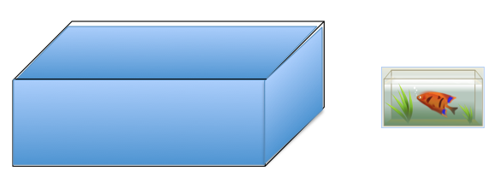Let’s test it. Begin pouring water into the aquarium at a time. Be sure to keep track of the number of gallons. Use a tally system.

|  |  |
| --- | --- |
| Tally the Number of Gallons | Number of Gallons |
|  |  |

* Measure the height of the water with your ruler.
* What did you find about our height estimation?
  + *Our estimation was correct. The height is approximately .*

Exercise 1 **(10 minutes)**

* Next, suppose Jamie needs to prepare another aquarium for aquatic frogs. He contacted the local pet store, and the employee recommended that Jamie only partially fill the tank in order for the frogs to have room to jump from the water to a lily pad or designated resting place. The employee suggested that the tank hold of water. Considering that the length and the width of the tank remain the same (), use what you know about volume to determine the height of the water that is appropriate for the frogs in the tank.
* To determine the missing dimension of height, we need the volume formula

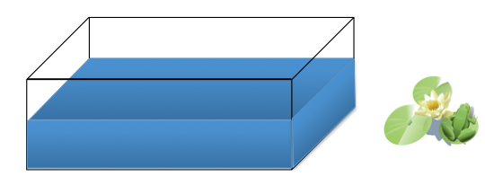  
Exercise 1

* 1. Determine the volume of the tank when filled with of water.

*The volume for of water is* .

* 1. Work with your group to determine the height of the water when Jamie places of water in the aquarium.

The tank should have a water height ofinches.

Optional Exercise 2

* Let’s test it. Begin by pouring water into the aquarium at a time.
* Be sure to keep track of the number of gallons poured. Use a tally system.

Or, have students mark the height of the water using a wax marker or a dry erase marker on the outside of the tank after each gallon is poured in. Then, students measure the intervals (distance between the marks). Students will notice that the intervals are equal.

* Test the height at , and record the height measurement.

|  |  |
| --- | --- |
| Tally the Number of Gallons | Number of Gallons |
|  |  |

* What did you find about our estimation?
  + *Our estimation was correct. The height is about .*

Exercise 2 (5 minutes)

* According to the local pet store, turtles need very little water in an aquarium. The suggested amount of gallons of water in the aquarium for a turtle is . Determine the height of the water in another aquarium of the same size that is housing a turtle when the amount of water Jamie pours into the tank is .
* Describe how you would estimate the height level?
  + *First, determine the volume of the water. Then, to determine the missing dimension of height, we need the volume formula .*

Exercise 2

* 1. Use the table from Example 1 to determine the volume of the aquarium when Jamie pours of water into the tank.

*The volume of the tank is .*

* 1. Use the volume formula to determine the missing height dimension.

*The tank should have a water height of .*

Optional Exercise 3

* Let’s test it. Begin by pouring water into the aquarium n at a time.
* Be sure to keep track of the number of gallons poured. Use a tally system.
* Test the height at , and record the height measurement.

|  |  |
| --- | --- |
| Tally the Number of Gallons | Number of Gallons |
|  |  |

* What did you find about our estimation?
  + *Our estimation was correct. The height is about .*

Exercise 3 (5 minutes)

* Let’s say that when Jamie sets up these aquariums of the same size at home, he does not have any tools that measure gallons. What he does have at home is a few leftover one-liter soft drink bottles. How could Jamie calculate the volume of the aquarium?
  + *Answers will vary but should include that gallons need to be converted to liters.*
* Using the table of values, determine the unit rate for liters to gallons.
* What is the unit rate?
  + *The unit rate is* .
* What does this mean?
  + *Answers will vary. For every gallon of water, there are liters of water.*
* If this conversion is accurate, determine the number of liters Jamie will need to fill a -gallon tank.
* It is not advantageous to combine liters and inches. Liters and centimeters are both in the metric system of measurement. The ratio of the number of centimeters to the number of inches is . What does this mean?
  + *Answers will vary. For every inch, there are centimeters.*
* What is the unit rate?
  + *The unit rate is .*
* Use the conversion to determine the length, the width, and the height of the aquariums in centimeters.

Exercise 3

* 1. Using the table of values below, determine the unit rate of liters to gallon.

|  |  |
| --- | --- |
| Gallons | Liters |
|  |  |
|  |  |
|  |  |

The unit rate is .

* 1. Using this conversion, determine the number of liters you will need to fill the -gallon tank.
  2. The ratio of the number of centimeters to the number of inches is . What is the unit rate?
  3. Using this information, complete the table to convert the heights of the water in inches to the heights of the water in centimeters Jamie will need for his project at home.

|  |  |  |
| --- | --- | --- |
| Height in Inches | Convert to Centimeters | Height in Centimeters |
|  |  |  |
|  |  |  |
|  |  |  |
|  |  |  |

Exercise 4 (5 minutes)

* Jamie had the tanks he used at home shipped from the manufacturer. Typically, the manufacturer sends aquariums already assembled; however, they use plastic film to cover the glass in order to protect it during shipping.
* Determine the amount of plastic film the manufacturer uses to cover the aquarium faces. Draw a sketch of the aquarium to assist in your calculations. Remember that the actual height of the aquarium is inches.

Exercise 4

* 1. Determine the amount of plastic film the manufacturer uses to cover the aquarium faces. Draw a sketch of the aquarium to assist in your calculations. Remember that the actual height of the aquarium is .
* We do not include the measurement of the top of the aquarium since it is open without glass. It does not need to be covered with film.
  1. We do not include the measurement of the top of the aquarium since it is open without glass and does not need to be covered with film. Determine the area of the top of the aquarium, and find the amount of film the manufacturer will use to cover only the sides, front, back, and bottom.

Side

Side

* 1. Since Jamie will need three aquariums, determine the total surface area of the three aquariums.

*or*

Closing/Challenge Exercises (5 minutes)

1. An internet company that sells aquariums charges per aquarium. Jamie is considering building the aquariums at home and buying the parts from a different company that sells glass for per square inch. Which option, buying the aquariums already built from the first company or buying the glass and building at home, is a better deal?

*Sample Solution:*

*or . It would be a better deal for Jamie to purchase the aquariums from the company that ships the aquariums because for one aquarium . For three aquariums, the comparison is .*

1. If Jamie wanted to increase the length of the aquarium by , how would that affect the surface area? How would it affect the volume of water the tank could contain?

*Sample Solution:*

*Since the length is inches, additional inches The new length would be*

*The surface area without the top is , or .*

*The new surface area of is more than the original surface area of .*

*; , which is more than the original volume of .*

Exit Ticket (3 minutes)

Name ___________________________________________________ Date____________________

Lesson 19a: Applying Surface Area and Volume to Aquariums

Exit Ticket

What did you learn today? Describe at least one situation in real life that would draw on the skills you used today.

Exit Ticket Sample Solution

What did you learn today? Describe at least one situation in real life that would draw on the skills you used today.

Answers will vary.

Problem Set Sample Solutions

This Problem Set is a culmination of skills learned in this module. Note that the figures are not drawn to scale.

1. Calculate the area of the figure below.

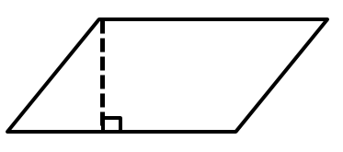

1. Calculate the area of the figure below.

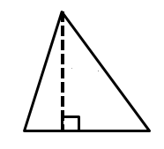

1. Calculate the area of the figure below.

*Area of top rectangle:*

*Area of bottom rectangle*:

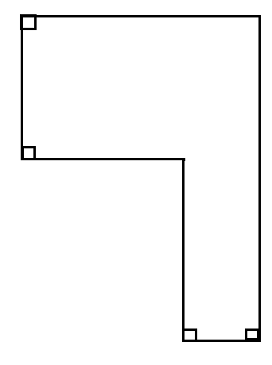

1. Complete the table using the diagram on the coordinate plane.

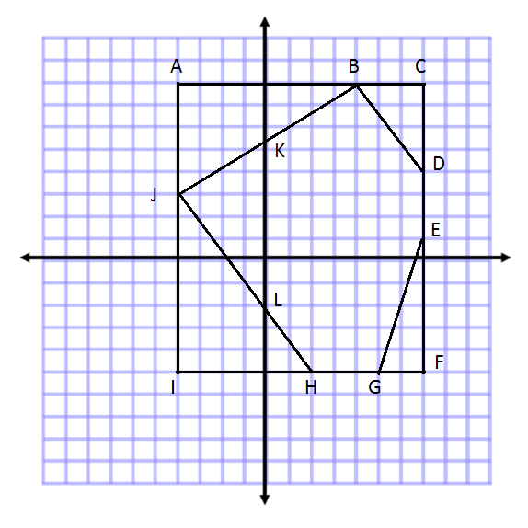

|  |  |  |  |  |
| --- | --- | --- | --- | --- |
| Line Segment | Point | Point | Distance | Proof |
|  |  |  |  |  |
|  |  |  |  |  |
|  |  |  |  |  |
|  |  |  |  |  |
|  |  |  |  |  |
|  |  |  |  |  |
|  |  |  |  |  |

1. Plot the points below, and draw the shape. Then, determine the area of the polygon.

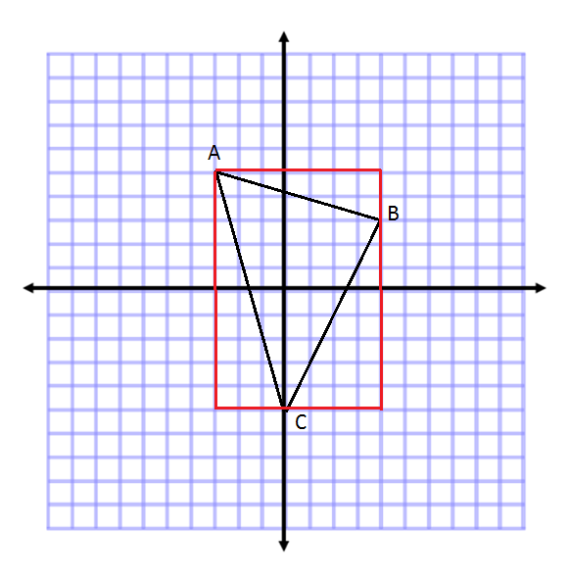,,

1. Determine the volume of the figure.
2. Give at least three more expressions that could be used to determine the volume of the figure in Problem 6.

Answers will vary. Some examples include the following:

1. 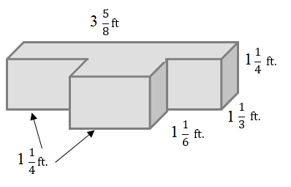Determine the volume of the irregular figure.

*Volume of the back Rectangular Prism:*

*Volume of the front Rectangular Prism:*

1. 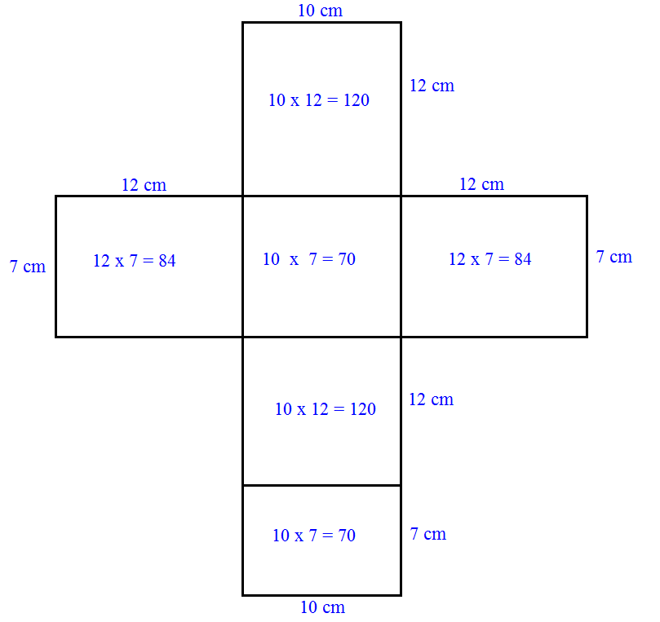Draw and label a net for the following figure. Then, use the net to determine the surface area of the figure.
2. Determine the surface area of the figure in Problem 9 using the formula . Then, compare your answer to the solution in Problem 9.

The answer in Problem 10 is the same as in Problem 9. The formula finds the areas of each face and adds them together, like we did with the net.

1. A parallelogram has a base of and an area of . Tania wrote the equation to represent this situation.
   1. Explain what represents in the equation.

represents the height of the parallelogram.

* 1. Solve the equation for .

1. Triangle A has an area equal to one-third the area of Triangle B. Triangle A has an area of square meters.
   1. Gerard wrote the equation . Explain what represents in the equation.

represents the area of Triangle B in square meters.

* 1. Determine the area of Triangle B.