Lesson 17: From Nets to Surface Area

Classwork
Opening Exercise
  - Write a numerical equation for the area of the figure below. Explain and identify different parts of the figure.
$$9 cm$$
$$13 cm$$
$$12 cm$$
$$5 cm$$
$$15 cm$$

    - How would you write an equation that shows the area of a triangle with base $b$ and height $h$?

  - Write a numerical equation for the area of the figure below. Explain and identify different parts of the figure.
$$28 ft.$$
$$18 ft.$$

    - How would you write an equation that shows the area of a rectangle with base $b$ and height $h$?

Example 1
Use the net to calculate the surface area of the figure.

Example 2
Use the net to write an expression for surface area.

Exercises
Name the solid the net would create, and then write an expression for the surface area. Use the expression to determine the surface area. Assume that each box on the grid paper represents a $1 cm×1 cm$ square. Explain how the expression represents the figure.

Problem Set

Name the shape, and write an expression for surface area. Calculate the surface area of the figure. Assume each box on the grid paper represents a $1 ft\text{.}×1 ft.$ square.
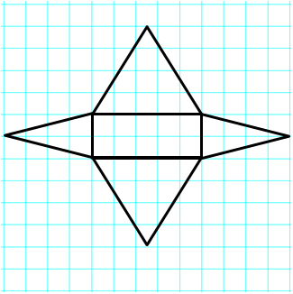
- 2. .

Explain the error in each problem below. Assume each box on the grid paper represents a $1 m×1 m$ square.
Name of Shape: Rectangular Pyramid, but more specifically a Square Pyramid
Area of Base: $3 m×3 m=9 m^{2}$
Area of Triangles: $3 m×4 m=12 m^{2}$
Surface Area: $9 m^{2}+12 m^{2}+12 m^{2}+12 m^{2}+12 m^{2}=57 m^{2}$

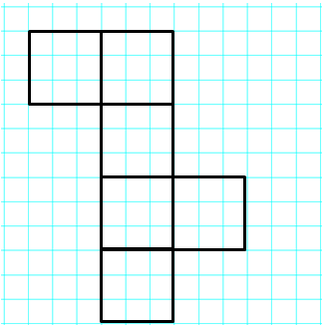
Name of Shape: Rectangular Prism or, more specifically, a Cube
Area of Faces: $3 m×3 m=9 m^{2}$
Surface Area: $9 m^{2}+9 m^{2}+9 m^{2}+9 m^{2}+9 m^{2}=45 m^{2}$

- Sofia and Ella are both writing expressions to calculate the surface area of a rectangular prism. However, they wrote different expressions.
  - Examine the expressions below, and determine if they represent the same value. Explain why or why not.

Sofia’s Expression:
$$\left(3 cm×4 cm\right)+\left(3 cm×4 cm\right)+\left(3 cm×5 cm\right)+\left(3 cm×5 cm\right)+\left(4 cm×5 cm\right)+(4 cm×5 cm)$$

Ella’s Expression:
$$2\left(3 cm×4 cm\right)+2\left(3 cm×5 cm\right)+2(4 cm×5 cm)$$

  - What fact about the surface area of a rectangular prism does Ella’s expression show that Sofia’s does not?

