Lesson 17: From Nets to Surface Area

Student Outcomes
- Students use nets to determine the surface area of three-dimensional figures.

Classwork
Fluency Exercise (5 minutes): Addition and Subtraction Equations
Sprint: Refer to the Sprints and the Sprint Delivery Script sections of the Module Overview for directions to administer a Sprint.

Opening Exercise (4 minutes)
Students work independently to calculate the area of the shapes below.
Opening Exercise
  - Write a numerical equation for the area of the figure below. Explain and identify different parts of the figure.
$$9 cm$$
$$13 cm$$
$$12 cm$$
$$5 cm$$
$$15 cm$$
$A=\frac{1}{2}(14 cm)(12 cm)=84 cm^{2}$
$14 cm$ represents the base of the figure because
$5 cm+9 cm=14 cm$, and $12 cm$ represents the altitude of the figure because it forms a right angle with the base.

    - How would you write an equation that shows the area of a triangle with base $b$ and height $h$?
$$A=\frac{1}{2}bh$$

  - Write a numerical equation for the area of the figure below. Explain and identify different parts of the figure.
$$28 ft.$$
$$18 ft.$$

$$A=(28 ft.)(18 ft.)=504 ft^{2}$$
$28 ft.$ represents the base of the rectangle, and $18 ft.$ represents the height of the rectangle.

    - How would you write an equation that shows the area of a rectangle with base $b$ and height $h$?
$$A=bh$$
Discussion (5 minutes)
English language learners may not recognize the word surface; take this time to explain what surface area means. Demonstrate that surface is the upper or outer part of something, like the top of a desk. Therefore, surface area is the area of all the faces, including the bases of a three-dimensional figure.
Use the diagram below to discuss nets and surface area.
- Examine the net on the left and the three-dimensional figure on the right. What do you notice about the two diagrams?
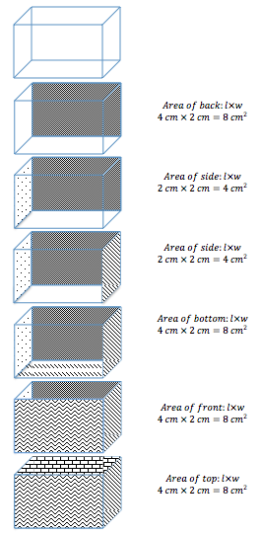
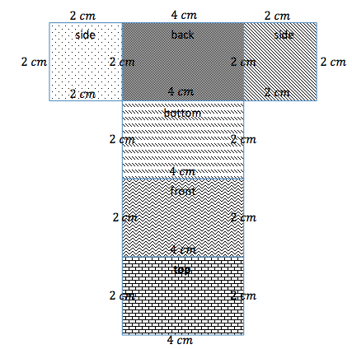
  - The two diagrams represent the same rectangular prism.
$$Surface Area=Area of back+Area of side+Area of side+Area of bottom+Area of front+Area of top$$

$$Surface Area= 8 {cm}^{2}+4 {cm}^{2}+ 4 {cm}^{2}+ 8 {cm}^{2}+ 8 {cm}^{2}+ 8 {cm}^{2}=40 {cm}^{2}$$

- Examine the second rectangular prism in the center column. The one shaded face is the back of the figure, which matches the face labeled back on the net. What do you notice about those two faces?
  - The faces are identical and will have the same area.
Continue the discussion by talking about one rectangular prism pictured at a time, connecting the newly shaded face with the identical face on the net.
- Will the surface area of the net be the same as the surface area of the rectangular prism? Why or why not?
  - The surface area for the net and the rectangular prism will be the same because all the matching faces are identical, which means their areas are also the same.

Example 1 (4 minutes)
Lead students through the problem.
Example 1
Use the net to calculate the surface area of the figure.

- When you are calculating the area of a figure, what are you finding?
  - The area of a figure is the amount of space inside a two-dimensional figure.
- Surface area is similar to area, but surface area is used to describe three-dimensional figures. What do you think is meant by the surface area of a solid?
  - The surface area of a three-dimensional figure is the area of each face added together.
- What type of figure does the net create? How do you know?
  - It creates a rectangular prism because there are six rectangular faces.
- If the boxes on the grid paper represent a $1 cm×1 cm$ box, label the dimensions of the net.
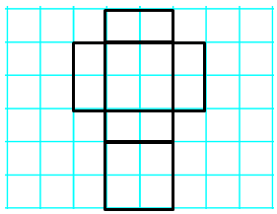
$$2 cm$$
$$2 cm$$
$$2 cm$$
$$2 cm$$
$$1 cm$$
$$1 cm$$
$$1 cm$$
$$1 cm$$

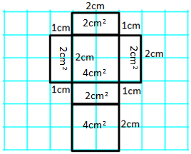
- The surface area of a figure is the sum of the areas of all faces. Calculate the area of each face, and record this value inside the corresponding rectangle.

- In order to calculate the surface area, we will have to find the sum of the areas we calculated since they represent the area of each face. There are two faces that have an area of$4 {cm}^{2}$ and four faces that have an area of $2 {cm}^{2}$. How can we use these areas to write a numerical expression to show how to calculate the surface area of the net?
MP.2
&
MP.7
  - The numerical expression to calculate the surface area of the net would be
$$\left(1 cm×2 cm\right)+\left(1 cm×2 cm\right)+\left(1 cm×2 cm\right)+\left(1 cm×2 cm\right)+\left(2 cm×2 cm\right)+$$$(2 cm×2 cm)$.
- Write the expression more compactly, and explain what each part represents on the net.
  - $4(1 cm×2 cm)+2(2 cm×2 cm)$
  - The expression means there are $4$ rectangles that have dimensions $1 cm×2 cm$ on the net and $2$ rectangles that have dimensions $2 cm×2 cm$ on the net.
- What is the surface area of the net?
  - The surface area of the net is $16 {cm}^{2}$.

Example 2 (4 minutes)
Lead students through the problem.
Example 2
Use the net to write an expression for surface area.

- What type of figure does the net create? How do you know?
  - It creates a square pyramid because one face is a square and the other four faces are triangles.
- If the boxes on the grid paper represent a $1 ft\text{.}×1 ft.$ square, label the dimensions of the net.
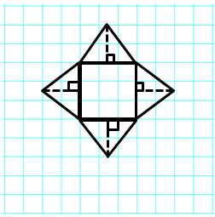
$$3 ft$$
$$3 ft$$
$$2 ft$$
$2$ $ft$
$2$ $ft$
$2$ $ft$

- How many faces does the rectangular pyramid have?
  - $5$
- Knowing the figure has$5$ faces, use the knowledge you gained in Example 1 to calculate the surface area of the rectangular pyramid.
  - Area of Base: $3 ft\text{.}×3 ft\text{.}=9 {ft}^{2}$
Area of Triangles: $\frac{1}{2}×3 ft\text{.}×2 ft\text{.}=3 {ft}^{2}$
Surface Area: $9 {ft}^{2}+3 {ft}^{2}+3 {ft}^{2}+3 {ft}^{2}+3 {ft}^{2}=21 {ft}^{2}$

Exercises (13 minutes)
Students work individually to calculate the surface area of the figures below.
Exercises
Name the solid the net would create, and then write an expression for the surface area. Use the expression to determine the surface area. Assume that each box on the grid paper represents a $1 cm×1 cm$ square. Explain how the expression represents the figure.

Name of Shape: Rectangular Pyramid, but more specifically a Square Pyramid
MP.1
Surface Area: $4 cm×4 cm+4\left(\frac{1}{2}×4 cm×3 cm\right)=16{ cm}^{2}+4\left(6{ cm}^{2}\right)=40 {cm}^{2}$
The figure is made up of a square base that is $4 cm×4 cm$ and four triangles with a base of $4 cm$ and a height of $3 cm$.

Name of Shape: Rectangular Prism
Surface Area: $2\left(5 cm×5 cm\right)+4\left(5 cm×2 cm\right)=2\left(25 cm^{2} \right)+4\left(10 cm^{2}\right)=90 cm^{2}$
The figure has $2$ square faces that are
$5 cm×5 cm$ and $4$ rectangular faces that are
$5 cm×2 cm$.

Name of Shape: Rectangular Pyramid
Surface Area: $3 cm×4 cm+2\left(\frac{1}{2}×4 cm×4 cm\right)+2\left(\frac{1}{2}×4 cm×3 cm\right)=12{ cm}^{2}+2\left(8 {cm}^{2}\right)+2\left(6 {cm}^{2}\right)=40{cm}^{2}=40 {cm}^{2}$
MP.1

The figure has$1$ rectangular base that is $3 cm×4 cm$, $2$triangular faces that have a base of $4 cm$ and a height of $4 cm$, and $2$other triangular faces with a base of $3 cm$ and a height of $4 cm$.

Name of Shape: Rectangular Prism
Surface Area: $2(6 cm×5 cm)+2(5 cm×1 cm)+2(6 cm×1 cm)=2(30 cm^{2})+2(5 cm^{2})+2(6 cm^{2} )$$$=82 cm2$$

The figure has $2$ rectangular faces that are$6 cm×5 cm$, $2$ rectangular faces that are $5 cm×1 cm$, and the final $2$ faces that are $6 cm×1 cm$.

Closing (5 minutes)
- Why is a net helpful when calculating the surface area of pyramids and prisms?
  - Answers will vary. The nets are helpful when calculating surface area because it is easier to find the areas of all the faces.
- What type of pyramids and/or prisms requires the fewest calculations when finding surface area?
  - Regular pyramids or prisms require the fewest calculations because the lateral faces are identical, so the faces have equal areas.

Exit Ticket (5 minutes)
Name Date
Lesson 17: From Nets to Surface Area

Exit Ticket

Name the shape, and then calculate the surface area of the figure. Assume each box on the grid paper represents a
$1 in\text{.}×1 in.$ square.
1.23

Exit Ticket Sample Solutions

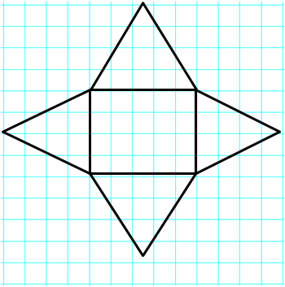
Name the shape, and then calculate the surface area of the figure. Assume each box on the grid paper represents a
$1 in\text{.}×1 in\text{.}$ square.
Name of Shape: Rectangular Pyramid
Area of Base: $5 in\text{.}×4 in\text{.}=20 in^{2}$
Area of Triangles: $\frac{1}{2}×4 in\text{.}×4 in\text{.}=8 in^{2}$, $\frac{1}{2}×5 in\text{.}×4 in\text{.}=10 in^{2}$
Surface Area: $20 in^{2}+8 in^{2}+8 in^{2}+10 in^{2}+10 in^{2}=56 in^{2}$

Problem Set Sample Solutions

Name the shape, and write an expression for surface area. Calculate the surface area of the figure. Assume each box on the grid paper represents a $1 ft\text{.}×1 ft\text{.}$ square.
Name of Shape: Rectangular Prism
Surface Area: $(2 ft\text{.}×4 ft\text{.})+(2 ft\text{.}×4 ft\text{.})+(4 ft\text{.}×7 ft\text{.})+(4 ft\text{.}×7 ft\text{.})+(7 ft\text{.}×2 ft\text{.})+(7 ft\text{.}×2 ft\text{.})$
$$2(2 ft\text{.}×4 ft\text{.})+2(4 ft\text{.}×7 ft\text{.})+2(7 ft\text{.}×2 ft\text{.})$$
$$16 ft^{2}+56 ft^{2}+28 ft^{2}=100 ft^{2}$$

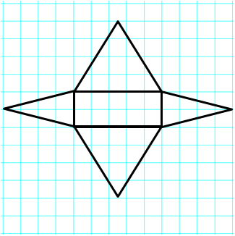
Name of Shape: Rectangular Pyramid
Surface Area: $\left(2 ft\text{.}×5 ft\text{.}\right)+\left(\frac{1}{2}×2 ft\text{.}×4 ft\text{.}\right)+\left(\frac{1}{2}×2 ft\text{.}×4 ft\text{.}\right)+\left(\frac{1}{2}×5 ft\text{.}×4 ft\text{.}\right)+\left(\frac{1}{2}×5 ft\text{.}×4 ft\text{.}\right)$
$$2 ft\text{.}×5 ft\text{.}+2\left(\frac{1}{2}×2 ft\text{.}×4 ft\text{.}\right)+2\left(\frac{1}{2}×5 ft\text{.}×4 ft\text{.}\right)$$
$$10 {ft}^{2}+8{ft}^{2}+20 {ft}^{2}=38 {ft}^{2}$$

Explain the error in each problem below. Assume each box on the grid paper represents a $1 m×1 m$ square.
Name of Shape: Rectangular Pyramid, but more specifically a Square Pyramid
Area of Base: $3 m×3 m=9 m^{2}$
Area of Triangles: $3 m×4 m=12 m^{2}$
Surface Area: $9 m^{2}+12 m^{2}+12 m^{2} +12 m^{2}+12 m^{2}=57 m^{2}$

The error in the solution is the area of the triangles. In order to calculate the correct area of the triangles, you must use the correct formula $A=\frac{1}{2}bh$. Therefore, the area of each triangle would be $6 m^{2}$ and not $12 m^{2}$.

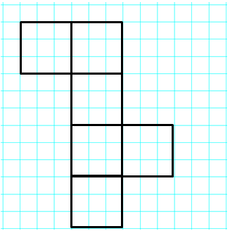
Name of Shape: Rectangular Prism or, more specifically, a Cube
Area of Faces: $3 m×3 m=9 m^{2}$
Surface Area: $9 m^{2}+9 m^{2}+9 m^{2}+9 m^{2}+9 m^{2}=45 m^{2}$

The surface area is incorrect because the student did not find the sum of all $6$ faces. The solution shown above only calculates the sum of $5$ faces. Therefore, the correct surface area should be $9 m^{2}+9{ m}^{2}+9 m^{2}+9 m^{2}+9 m^{2}+9 m^{2}=54 m^{2}$ and not$45 m^{2}$.

- Sofia and Ella are both writing expressions to calculate the surface area of a rectangular prism. However, they wrote different expressions.
  - Examine the expressions below, and determine if they represent the same value. Explain why or why not.

Sofia’s Expression:
$$\left(3 cm×4 cm\right)+\left(3 cm×4 cm\right)+\left(3 cm×5 cm\right)+\left(3 cm×5 cm\right)+\left(4 cm×5 cm\right)+(4 cm×5 cm)$$

Ella’s Expression:
$$2\left(3 cm×4 cm\right)+2\left(3 cm×5 cm\right)+2(4 cm×5 cm)$$
Sofia and Ella’s expressions are the same, but Ella used the distributive property to make her expression more compact than Sofia’s.

  - What fact about the surface area of a rectangular prism does Ella’s expression show that Sofia’s does not?
A rectangular prism is composed of three pairs of sides with identical areas.

Addition and Subtraction Equations—Round 1
Directions: Find the value of $m$ in each equation.
Number Correct: ______

 | $$m+4=11$$ |  |  |  | $$m-54=37$$
 | $$m+2=5$$ |  |  |  | $$4+m=9$$
 | $$m+5=8$$ |  |  |  | $$6+m=13$$
 | $$m-7=10$$ |  |  |  | $$2+m=31$$
 | $$m-8=1$$ |  |  |  | $$15=m+11$$
 | $$m-4=2$$ |  |  |  | $$24=m+13$$
 | $$m+12=34$$ |  |  |  | $$32=m+28$$
 | $$m+25=45$$ |  |  |  | $$4=m-7$$
 | $$m+43=89$$ |  |  |  | $$3=m-5$$
 | $$m-20=31$$ |  |  |  | $$12=m-14$$
 | $$m-13=34$$ |  |  |  | $$23.6=m-7.1$$
 | $$m-45=68$$ |  |  |  | $$14.2=m-33.8$$
 | $$m+34=41$$ |  |  |  | $$2.5=m-41.8$$
 | $$m+29=52$$ |  |  |  | $$64.9=m+23.4$$
 | $$m+37=61$$ |  |  |  | $$72.2=m+38.7$$
 | $$m-43=63$$ |  |  |  | $$1.81=m-15.13$$
 | $$m-21=40$$ |  |  |  | $$24.68=m-56.82$$

Addition and Subtraction Equations—Round 1 [KEY]
Directions: Find the value of $m$ in each equation.
 | $$m+4=11$$ | $$m= 7$$ |  |  | $$m-54=37$$ | $$m=91$$
 | $$m+2=5$$ | $$m=3$$ |  |  | $$4+m=9$$ | $$m=5$$
 | $$m+5=8$$ | $$m=3$$ |  |  | $$6+m=13$$ | $$m=7$$
 | $$m-7=10$$ | $$m=17$$ |  |  | $$2+m=31$$ | $$m=29$$
 | $$m-8=1$$ | $$m = 9$$ |  |  | $$15=m+11$$ | $$m=4$$
 | $$m-4=2$$ | $$m=6$$ |  |  | $$24=m+13$$ | $$m=11$$
 | $$m+12=34$$ | $$m=22$$ |  |  | $$32=m+28$$ | $$m=4$$
 | $$m+25=45$$ | $$m=20$$ |  |  | $$4=m-7$$ | $$m=11$$
 | $$m+43=89$$ | $$m=46$$ |  |  | $$3=m-5$$ | $$m=8$$
 | $$m-20=31$$ | $$m=51$$ |  |  | $$12=m-14$$ | $$m=26$$
 | $$m-13=34$$ | $$m=47$$ |  |  | $$23.6=m-7.1$$ | $$m=30.7$$
 | $$m-45=68$$ | $$m=113$$ |  |  | $$14.2=m-33.8$$ | $$m=48$$
 | $$m+34=41$$ | $$m=7$$ |  |  | $$2.5=m-41.8$$ | $$m=44.3$$
 | $$m+29=52$$ | $$m=23$$ |  |  | $$64.9=m+23.4$$ | $$m=41.5$$
 | $$m+37=61$$ | $$m=24$$ |  |  | $$72.2=m+38.7$$ | $$m=33.5$$
 | $$m-43=63$$ | $$m=106$$ |  |  | $$1.81=m-15.13$$ | $$m=16.94$$
 | $$m-21=40$$ | $$m=61$$ |  |  | $$24.68=m-56.82$$ | $$m=81.5$$

Addition and Subtraction Equations—Round 2
Number Correct: ______
Improvement: ______
Directions: Find the value of $m$ in each equation.
 | $$m+2=7$$ |  |  |  | $$6=m+3$$
 | $$m+4=10$$ |  |  |  | $$12=m+7$$
 | $$m+8=15$$ |  |  |  | $$24=m+16$$
 | $$m+7=23$$ |  |  |  | $$13=m+9$$
 | $$m+12=16$$ |  |  |  | $$32=m-3$$
 | $$m-5=2$$ |  |  |  | $$22=m-12$$
 | $$m-3=8$$ |  |  |  | $$34=m-10$$
 | $$m-4=12$$ |  |  |  | $$48=m+29$$
 | $$m-14=45$$ |  |  |  | $$21=m+17$$
 | $$m+23=40$$ |  |  |  | $$52=m+37$$
 | $$m+13=31$$ |  |  |  | $$\frac{6}{7}=m+\frac{4}{7}$$
 | $$m+23=48$$ |  |  |  | $$\frac{2}{3}=m-\frac{5}{3}$$
 | $$m+38=52$$ |  |  |  | $$\frac{1}{4}=m-\frac{8}{3}$$
 | $$m-14=27$$ |  |  |  | $$\frac{5}{6}=m-\frac{7}{12}$$
 | $$m-23=35$$ |  |  |  | $$\frac{7}{8}=m-\frac{5}{12}$$
 | $$m-17=18$$ |  |  |  | $$\frac{7}{6}+m=\frac{16}{3}$$
 | $$m-64=1$$ |  |  |  | $$\frac{1}{3}+m=\frac{13}{15}$$

Addition and Subtraction Equations—Round 2 [KEY]
Directions: Find the value of $m$ in each equation.
 | $$m+2=7$$ | $$m=5$$ |  |  | $$6=m+3$$ | $$m=3$$
 | $$m+4=10$$ | $$m=6$$ |  |  | $$12=m+7$$ | $$m=5$$
 | $$m+8=15$$ | $$m=7$$ |  |  | $$24=m+16$$ | $$m=8$$
 | $$m+7=23$$ | $$m=16$$ |  |  | $$13=m+9$$ | $$m=4$$
 | $$m+12=16$$ | $$m=4$$ |  |  | $$32=m-3$$ | $$m=35$$
 | $$m-5=2$$ | $$m=7$$ |  |  | $$22=m-12$$ | $$m=34$$
 | $$m-3=8$$ | $$m=11$$ |  |  | $$34=m-10$$ | $$m=44$$
 | $$m-4=12$$ | $$m=16$$ |  |  | $$48=m+29$$ | $$m=19$$
 | $$m-14=45$$ | $$m=59$$ |  |  | $$21=m+17$$ | $$m=4$$
 | $$m+23=40$$ | $$m=17$$ |  |  | $$52=m+37$$ | $$m=15$$
 | $$m+13=31$$ | $$m=18$$ |  |  | $$\frac{6}{7}=m+ \frac{4}{7}$$ | $$m=\frac{2}{7}$$
 | $$m+23=48$$ | $$m=25$$ |  |  | $$\frac{2}{3}=m-\frac{5}{3}$$ | $$m=\frac{7}{3}$$
 | $$m+38=52$$ | $$m=14$$ |  |  | $$\frac{1}{4}=m-\frac{8}{3}$$ | $$m=\frac{35}{12}$$
 | $$m-14=27$$ | $$m=41$$ |  |  | $$\frac{5}{6}=m-\frac{7}{12}$$ | $$m=\frac{17}{12}$$
 | $$m-23=35$$ | $$m=58$$ |  |  | $$\frac{7}{8}=m-\frac{5}{12}$$ | $$m=\frac{31}{24}$$
 | $$m-17=18$$ | $$m=35$$ |  |  | $$\frac{7}{6}+m=\frac{16}{3}$$ | $$m=\frac{25}{6}$$
 | $$m-64=1$$ | $$m=65$$ |  |  | $$\frac{1}{3}+m=\frac{13}{15}$$ | $$m=\frac{8}{15}$$

