Lesson 16: Constructing Nets

Classwork

Opening Exercise

Sketch the faces in the area below. Label the dimensions.

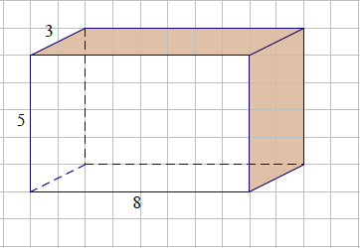

Exploratory Challenge 1: Rectangular Prisms

* 1. Use the measurements from the solid figures to cut and arrange the faces into a net.

3

6

7

* 1. A juice box measures inches high, inches long, and inches wide. Cut and arrange all faces into a net.

C:\Users\glenn.gebhard\AppData\Local\Microsoft\Windows\Temporary Internet Files\Content.IE5\V8N0GMCL\MC900232682[1].wmf

* 1. Challenge: Write a numerical expression for the total area of the net for part (b). Explain each term in your expression.

Exploratory Challenge 2: Triangular Prism

Use the measurements from the triangular prism to cut and arrange the faces into a net.

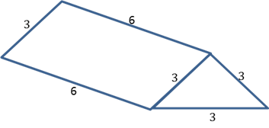

Exploratory Challenge 3: Pyramids

Pyramids are named for the shape of the base.

* 1. Use the measurements from this square pyramid to cut and arrange the faces into a net. Test your net to be sure it folds into a square pyramid.

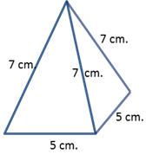

* 1. A triangular pyramid that has equilateral triangles for faces is called a tetrahedron. Use the measurements from this tetrahedron to cut and arrange the faces into a net.

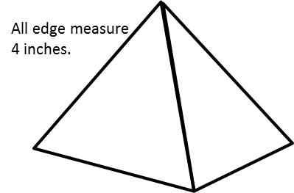

Problem Set

1. Sketch and label the net of the following solid figures, and label the edge lengths.
   1. A cereal box that measures inches high, inches long, and inches wide
   2. A cubic gift box that measures on each edge
   3. Challenge: Write a numerical expression for the total area of the net in part (b). Tell what each of the terms in your expression means.
2. This tent is shaped like a triangular prism. It has equilateral bases that measure feet on each side. The tent is feet long. Sketch the net of the tent, and label the edge lengths.

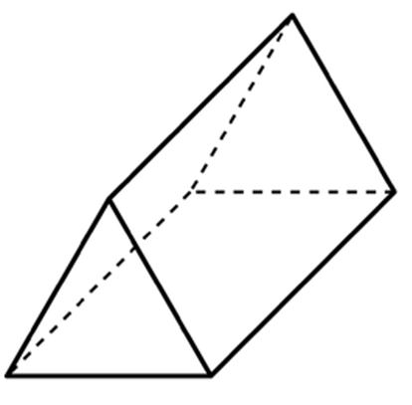

1. The base of a table is shaped like a square pyramid. The pyramid has equilateral faces that measure inches on each side. The base is inches long. Sketch the net of the table base, and label the edge lengths.
2. The roof of a shed is in the shape of a triangular prism. It has equilateral bases that measure feet on each side. The length of the roof is feet. Sketch the net of the roof, and label the edge lengths.