|  |
| --- |
|  |

Lesson 16: Constructing Nets

Student Outcomes

* Students construct nets of three-dimensional objects using the measurements of a solid’s edges.

Lesson Notes

In the previous lesson, a cereal box was cut down to one of its nets. On the unprinted side, the fold lines should be highlighted with a thick marker to make all six faces easily seen. These rectangles should be labeled Front, Back, Top, Bottom, Left Side, and Right Side. Measure each rectangle to the nearest inch, and record the dimensions on each.

During this lesson, students are given the length, width, and height of a right rectangular solid. They cut out six rectangles (three pairs), arrange them into a net, tape them, and fold them up to check the arrangement to ensure the net makes the solid. Triangular pieces are also used in constructing the nets of pyramids and triangular prisms.

When students construct the nets of rectangular prisms, if no two dimensions, length, width, or height, are equal, then no two adjacent rectangular faces will be identical.

The nets that were used in Lesson 15 should be available so that students have the general pattern layout of the nets.

Two-centimeter graph paper works well with this lesson. Prior to the lesson, cut enough polygons for Example 1. Cutting all the nets used in this lesson will save time as well but removes the opportunity for students to do the work.

Classwork

Opening (2 minutes)

Display the cereal box net from the previous lesson. Fold and unfold it so students will recall the outcome of the lesson.

*Scaffolding:*

Some students will need more opportunities than others to manipulate the nets in this lesson.

* How has this net changed since the previous lesson?
  + *It now has labels and dimensions.*
* What can you say about the angles in each rectangle?
  + *They are degrees, or right angles.*
* What can you say about the angles between the faces when it is folded up?
  + *The two faces also form a right angle.*
* What can you say about the vertices where faces come together?
  + *Again, they form right angles.*
* This refolded box is an example of a right rectangular prism. It is named for the angles formed at each vertex.

Opening Exercise (3 minutes)

Opening Exercise

Sketch the faces in the area below. Label the dimensions.

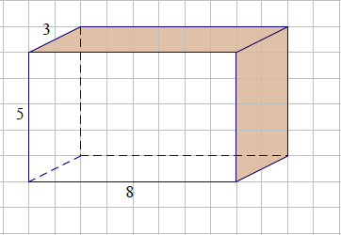

Display this graphic using a document camera or other device.



* How could you create a net for this solid? Discuss this with a partner.

MP.1

Allow a short time for discussion with a partner about this before having a whole-class discussion.

Example 1 (10 minutes): Right Rectangular Prism

* How can we use the dimensions of a rectangular solid to figure out the dimensions of the polygons that make up its net?
  + *The length, width, and height measurements of the solid will be paired to become the length and width of the rectangles.*
* How many faces does the rectangular prism have?
* What are the dimensions of the top of this prism?
* What are the dimensions of the bottom?
* What are the dimensions of the right side?
* What are the dimensions of the left side?
* What are the dimensions of the front?
* What are the dimensions of the back?
* The faces of this rectangular solid are all rectangles that make up the net. Are there any faces that are identical to any others?
  + *There are three different rectangles, but two copies of each will be needed to make the solid. The top is identical to the bottom, the left and right sides are identical, and the front and back faces are also identical.*

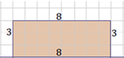 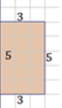 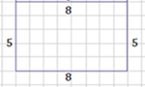

Make sure each student can visualize the rectangles depicted on the graphic of the solid and can make three different pairs of rectangle dimensions (, , and ).

Display the previously cut six rectangles from this example on either an interactive whiteboard or on a magnetic surface. Discuss the arrangement of these rectangles. Identical sides must match.

Working in pairs, ask students to rearrange the rectangles into the shape below and use tape to attach them. Having a second copy of these already taped will save time during the lesson.

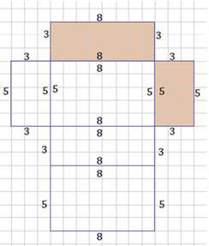

*Scaffolding:*

* Some students will benefit from using precut rectangles and triangles. Using cardstock or lamination will make more durable polygons.
* Other students benefit from tracing the faces of actual solids onto paper and then cutting and arranging them.
* If this is truly a net of the solid, it will fold up into a box. In mathematical language, it is known as a right rectangular prism.

Students should fold the net into the solid to prove that it was indeed a net. Be prepared for questions about other arrangements of these rectangles that are also nets of the right rectangular prism. There are many possible arrangements.

Exploratory Challenge 1 (9 minutes): Rectangular Prisms

Students will make nets from given measurements. Rectangles should be cut from graph paper and taped. Ask students to have their rectangle arrangements checked before taping. After taping, it can be folded to check its fidelity.

Exploratory Challenge 1: Rectangular Prisms

* 1. Use the measurements from the solid figures to cut and arrange the faces into a net.

|  |  |
| --- | --- |
|  | ***One possible configuration of rectangles is shown here:*** |

* 1. A juice box measures inches high, incheslong, and inches wide. Cut and arrange all faces into a net.

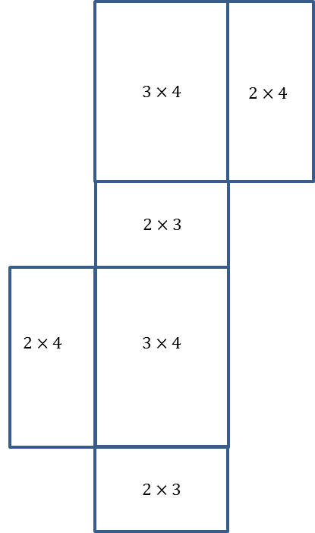C:\Users\glenn.gebhard\AppData\Local\Microsoft\Windows\Temporary Internet Files\Content.IE5\V8N0GMCL\MC900232682[1].wmf***One possible configuration of faces is shown here:***

* 1. Challenge: Write a numerical expression for the total area of the net for part (b). Explain each term in your expression.

*Possible answer: . There are two sides that have dimensions by , two sides that are by , and two sides that are by .*

Exploratory Challenge 2 (7 minutes): Triangular Prisms

Cutting these prior to the lesson will save time during the lesson.

Exploratory Challenge 2: Triangular Prisms

Use the measurements from the triangular prism to cut and arrange the faces into a net.

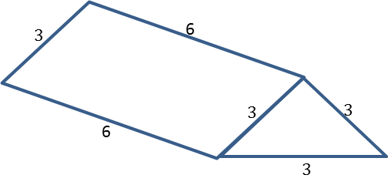

***One possible configuration of rectangles and triangles is shown here:***

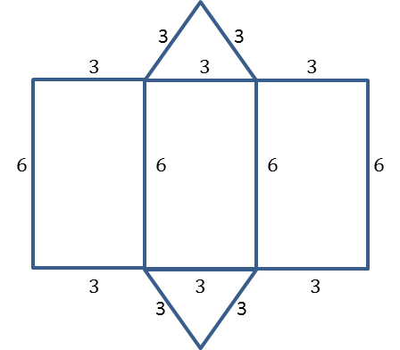

Exploratory Challenge 3 (9 minutes): Pyramids

Exploratory Challenge 3: Pyramids

Pyramids are named for the shape of the base.

* 1. 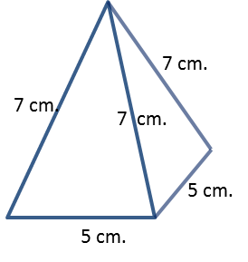Use the measurements from this square pyramid to cut and arrange the faces into a net. Test your net to be sure it folds into a square pyramid.

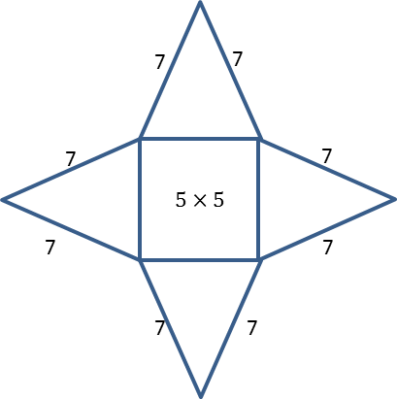***One possible configuration of rectangles and triangles is shown here:***

* 1. A triangular pyramid that has equilateral triangles for faces is called a tetrahedron. Use the measurements from this tetrahedron to cut and arrange the faces into a net.

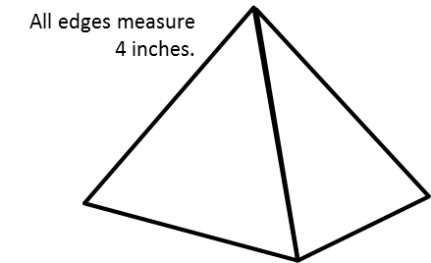

***One possible configuration of triangles is shown here:***

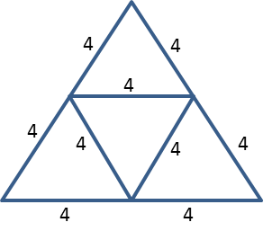

Closing (2 minutes)

* What are the most important considerations when making nets of solid figures?
  + *Each face must be taken into account.*
* After all faces are made into polygons (either real or drawings), what can you say about the arrangement of those polygons?
  + *Edges must match like on the solid.*
* Describe the similarities between the nets of right rectangular prisms.
  + *All faces are rectangles. Opposite faces are identical rectangles. If the base is a square, the lateral faces are identical rectangles. If the prism is a cube, all of the faces are identical.*
* Describe the similarities between the nets of pyramids.
  + *All of the faces that are not the base are triangles. The number of these faces is equal to the number of sides the base contains. If the base is a regular polygon, the faces are identical triangles. If all of the faces of a triangular pyramid are identical, then the solid is a tetrahedron.*
* How can you test your net to be sure that it is really a true net of the solid?
  + *Make a physical model and fold it up.*

Exit Ticket (3 minutes)

Name Date

Lesson 16: Constructing Nets

Exit Ticket

Sketch and label a net of this pizza box. It has a square top that measures inches on a side, and the height isinches. Treat the box as a prism, without counting the interior flaps that a pizza box usually has.



Exit Ticket Sample Solutions

Sketch and label a net of this pizza box. It has a square top that measures inches on a side, and the height is inches. Treat the box as a prism, without counting the interior flaps that a pizza box usually has.

**One possible configuration of faces is shown here:**

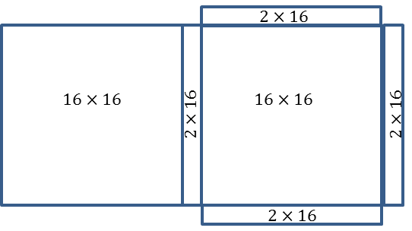

Problem Set Sample Solutions

1. Sketch and label the net of the following solid figures, and label the edge lengths.
   1. A cereal box that measures inches high, inches long, and inches wide

***One possible configuration of faces is shown here:***

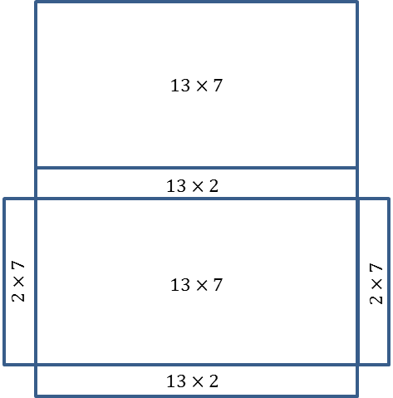

.

.

* 1. A cubic gift box that measures on each edge

**One possible configuration of faces is shown here:**

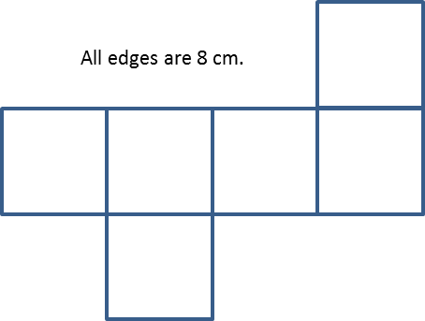

* 1. Challenge: Write a numerical expression for the total area of the net in part (b). Tell what each of the terms in your expression means.

*or*

*There are faces in the cube, and each has dimensions by .*

1. This tent is shaped like a triangular prism. It has equilateral bases that measure feet on each side. The tent is   
   feet long. Sketch the net of the tent, and label the edge lengths.

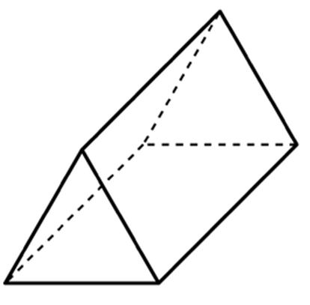Possible net:

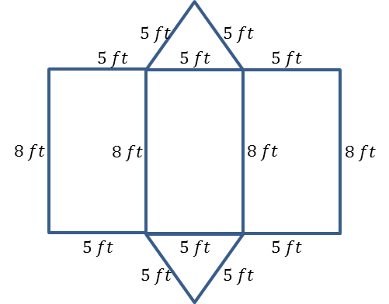

1. The base of a table is shaped like a square pyramid. The pyramid has equilateral faces that measure inches on each side. The base is inches long. Sketch the net of the table base, and label the edge lengths.

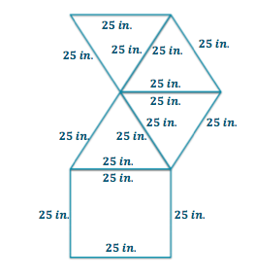Possible net:

1. The roof of a shed is in the shape of a triangular prism. It has equilateral bases that measure feet on each side. The length of the roof is feet. Sketch the net of the roof, and label the edge lengths.

Possible net:

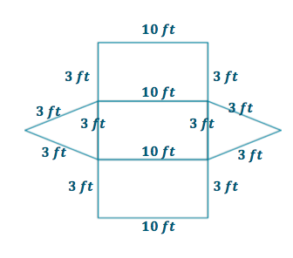

Rectangles for Opening Exercise

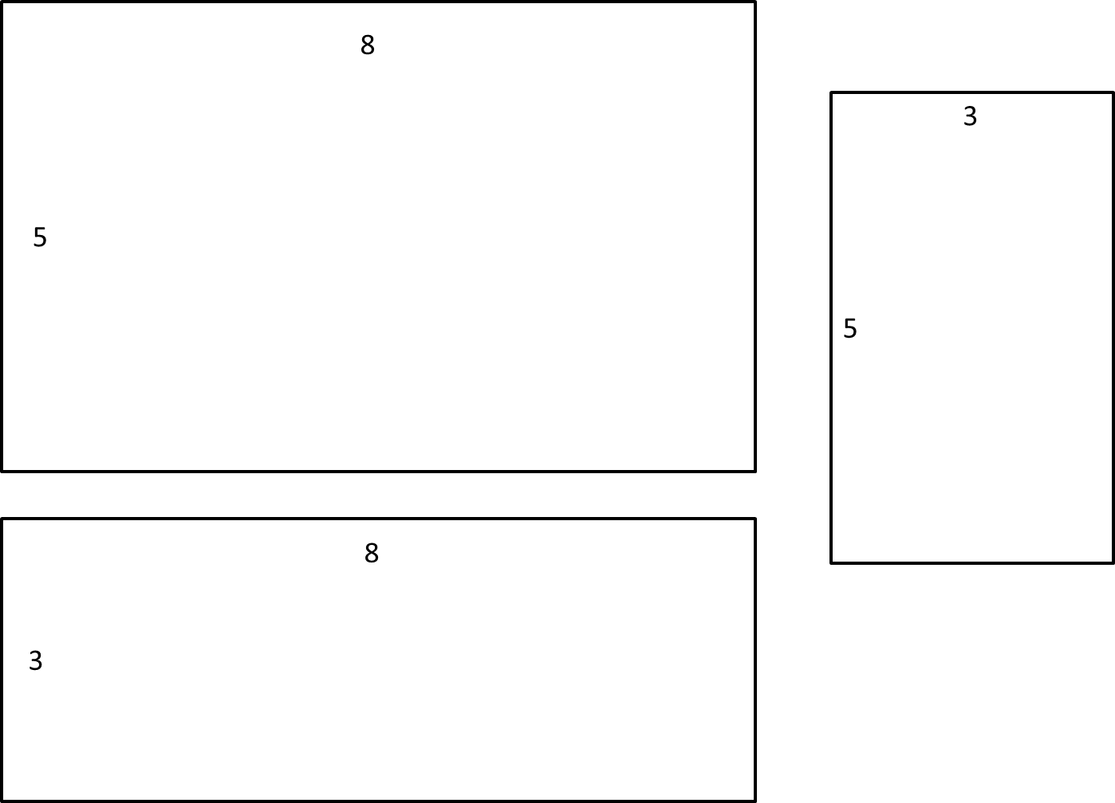

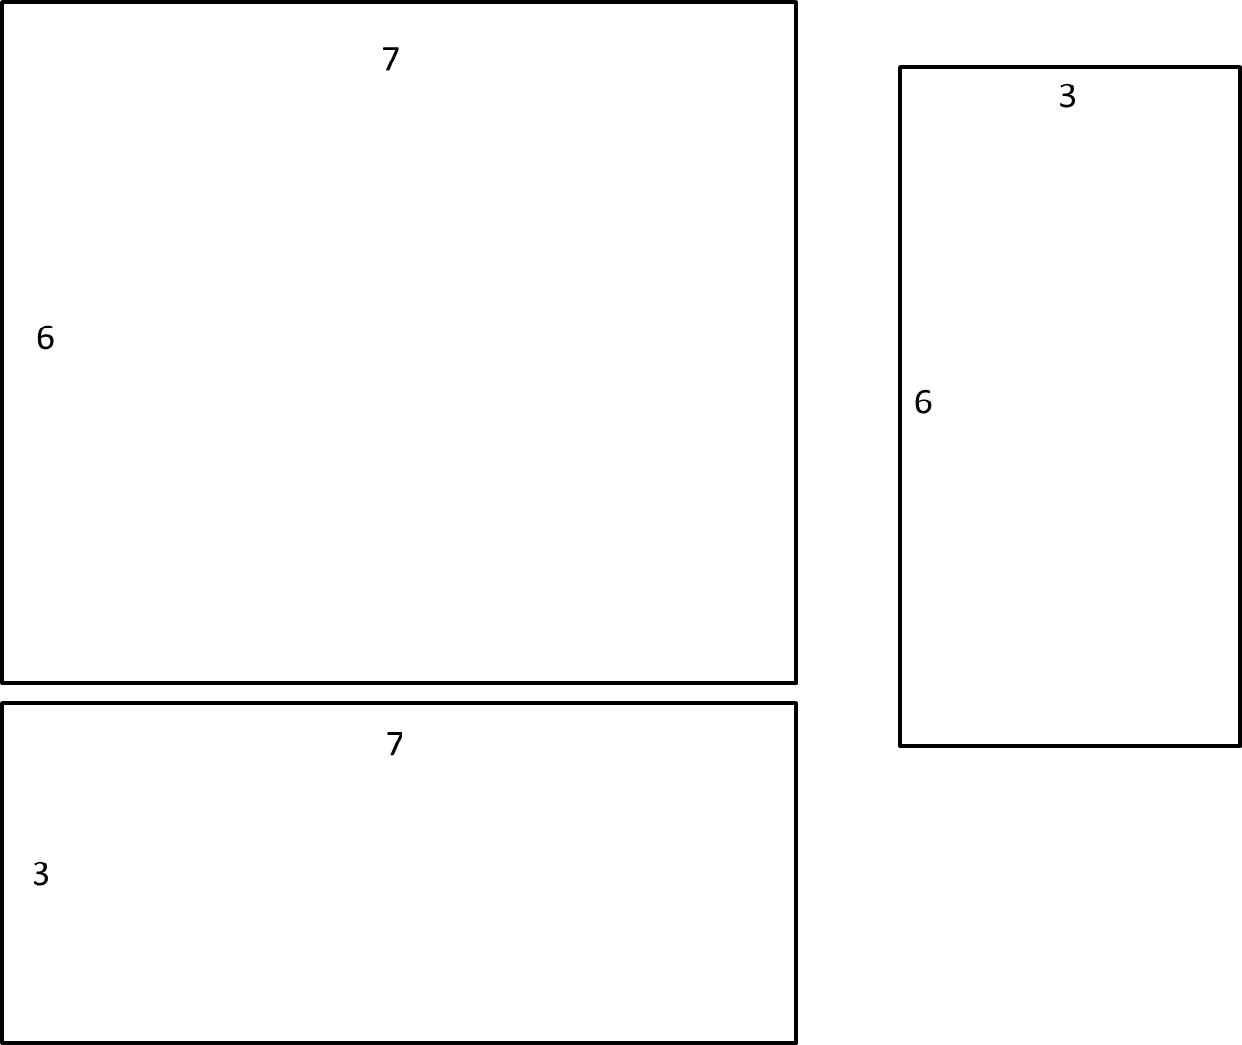Rectangles for Exercise 1, part (a)

Rectangles for Exercise 1, part (b)

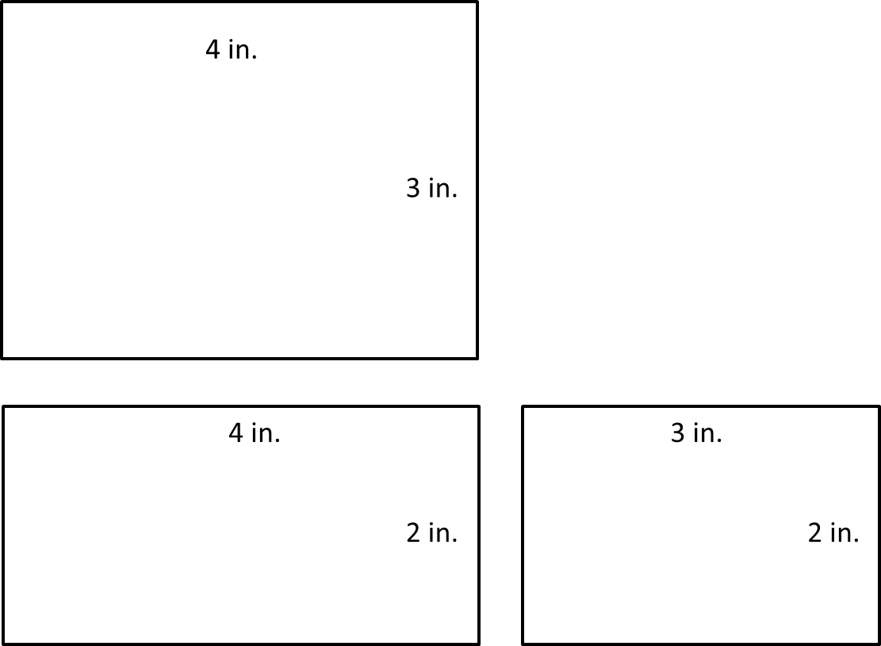

Polygons for Exercise 2

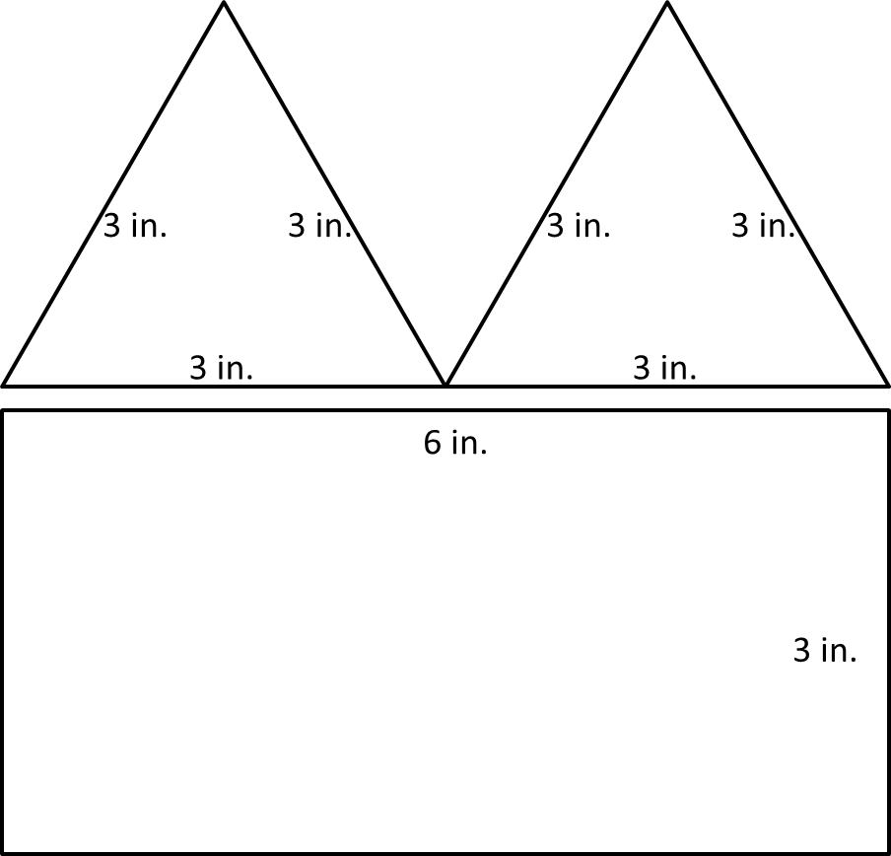

Polygons for Exercise 3, part (a)

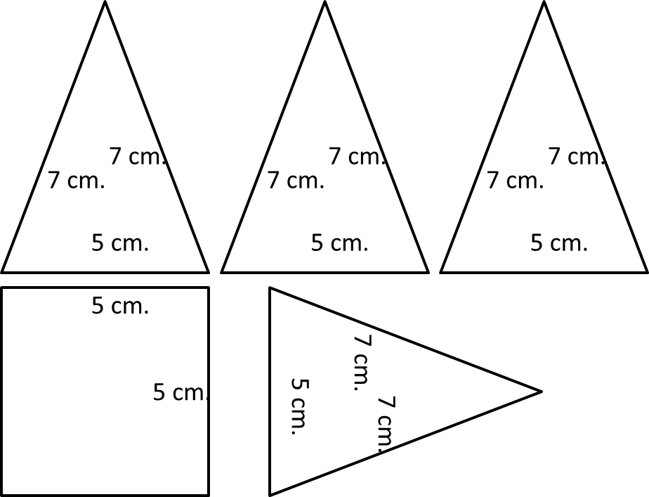

Triangles for Exercise 3, part (b)

