Lesson 14: Volume in the Real World

Classwork
Example 1
  - The area of the base of a sandbox is $9\frac{1}{2} {ft}^{2}$. The volume of the sandbox is $7\frac{1}{8}{ ft}^{3}$. Determine the height of the sandbox.

  - The sandbox was filled with sand, but after kids played, some of the sand spilled out. Now, the sand is at a height of $\frac{1}{2} ft$. Determine the volume of the sand.

Example 2
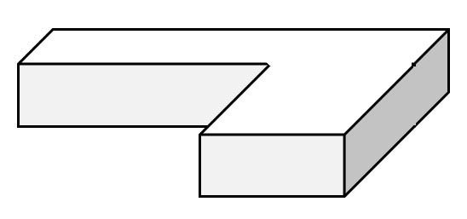
A special order sandbox has been created for children to use as an archeological digging area at the zoo. Determine the volume of the sandbox.
$$4\frac{1}{3} m$$
$$\frac{1}{5} m$$
$$5 m$$
$$2\frac{1}{4}m$$
$$2\frac{3}{4}m$$
$$2 m$$
$$2\frac{1}{3} m$$

Exercises

  - The volume of the rectangular prism is given. Determine the missing measurement using a one-step equation.
$$V=\frac{36}{15} {yd}^{3}$$
$$Area=\frac{4}{5} {yd}^{2}$$
$$h= ?$$

  - The volume of the box is $\frac{45}{6} m^{3}$. Determine the area of the base using a one-step equation.

$$\frac{9}{2} m$$

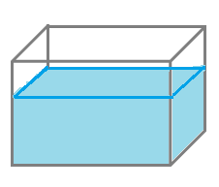
- Marissa’s fish tank needs to be filled with more water.
$$\frac{3}{4} m$$
$$\frac{3}{5} m$$
$$\frac{1}{4} m$$
$$\frac{3}{8} m$$
  - Determine how much water the tank can hold.

  - Determine how much water is already in the tank.

  - How much more water is needed to fill the tank?

- Determine the volume of the composite figures.
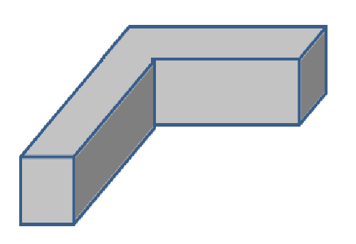
$$3\frac{1}{4} m$$
$$2\frac{1}{3} m$$
$$2 m$$
$$9\frac{1}{2} m$$
$$12 m$$

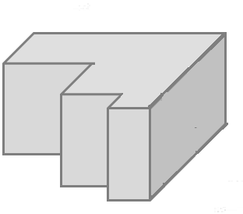
$$\frac{3}{4} ft.$$
$$1\frac{1}{2} ft.$$
$$\frac{1}{2} ft.$$
$$\frac{1}{2} ft.$$
$$\frac{1}{4} ft.$$
$$1\frac{1}{2} ft.$$

Problem Set

- The volume of a rectangular prism is $\frac{21}{12}{ ft}^{3}$, and the height of the prism is $\frac{3}{4} ft$. Determine the area of the base.

- The volume of a rectangular prism is $\frac{10}{21} {ft}^{3}$. The area of the base is $\frac{2}{3} {ft}^{2}$. Determine the height of the rectangular prism.

- Determine the volume of the space in the tank that still needs to be filled with water if the water is $\frac{1}{3} f$t. deep.
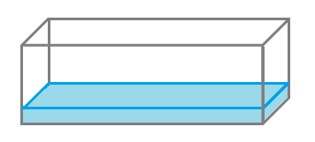
$$5 ft.$$
$$1\frac{2}{3} ft.$$
$$2 ft.$$

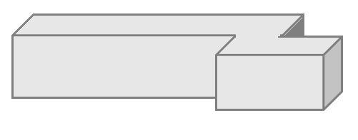
- Determine the volume of the composite figure.
$$\frac{3}{4} m$$
$$\frac{1}{8} m$$
$$\frac{1}{3} m$$
$$\frac{1}{4} m$$
$$\frac{1}{3} m$$

- Determine the volume of the composite figure.
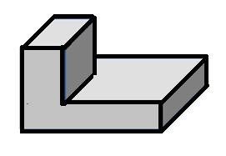
$$1 in.$$
$$3 in.$$
$$2\frac{1}{2} in.$$
$$\frac{1}{4} in.$$
$$1\frac{1}{2} in.$$
$$1\frac{1}{4}in.$$

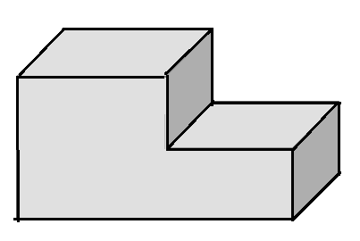
$$7\frac{1}{4} m$$
$$2 m$$
$$3\frac{1}{2} m$$
$$1\frac{1}{4} m$$
$$1 m$$

  - Write an equation to represent the volume of the composite figure.
  - Use your equation to calculate the volume of the composite figure.

