Lesson 14: Volume in the Real World

Student Outcomes
- Students understand that volume is additive and apply volume formulas to determine the volume of composite solid figures in real-world contexts.
- Students apply volume formulas to find missing volumes and missing dimensions.

Lesson Notes
This lesson is a continuation of the three previous lessons, Lessons 11–13, in this module and Grade 5, Module 5, Topics A and B.

Classwork
Example 1 (6 minutes)
Example 1
  - The area of the base of a sandbox is $9\frac{1}{2} ft^{2}$. The volume of the sandbox is $7\frac{1}{8} ft^{3}$. Determine the height of the sandbox.

Students make sense of this problem on their own before discussing.
- What information are we given in this problem?
MP.1
Note to Teacher:
In these examples, it might be easier for students to use common denominators when dividing and working with dimensions. Students can use the invert and multiply rule, but it may cause more work and make it harder to see the relationships.

  - We have been given the area of the base and the volume.
- How can we use the information to determine the height?
  - We know that the area of the base times the height will give the volume. Since we already have the volume, we can do the opposite and divide to get the height.
- Notice that the number for the volume is less than the number for the area. What does that tell us about the height?
- If the product of the area of the base and the height is less than the area, we know that the height must be less than $1$.
- Calculate the height.
  - $Volume=Area of the base×height$
MP.1
$$V=bh \\ 7\frac{1}{8}{ ft}^{3}=\left(9\frac{1}{2}{ ft}^{2}\right)h \\ \frac{57}{8}{ ft}^{3}=\left(\frac{19}{2}{ ft}^{2}\right)h \\ \frac{57}{8}{ ft}^{3}×\frac{2}{19}=\frac{19}{2}×\left(\frac{2}{19}{ ft}^{2}\right)h \\ \frac{114}{152} ft\text{.}=h \text{or} \frac{3}{4} ft\text{.}=h$$

  - The sandbox was filled with sand, but after kids played, some of the sand spilled out. Now, the sand is at a height of$\frac{1}{2} ft$. Determine the volume of the sand.

- What new information have we been given in this problem?
  - This means that the sandbox is not totally filled. Therefore, the volume of sand used is not the same as the volume of the sandbox.
- How will we determine the volume of the sand?
  - To determine the volume of the sand, I will use the area of the base of the sand box, but I will use the height of $\frac{1}{2} ft.$ instead of the height of the sandbox.
$$Volume=Area of the base×height \\ Volume=9\frac{1}{2} ft^{2}×\frac{1}{2} ft. \\ Volume=\frac{19}{2} ft^{2}×\frac{1}{2} ft. \\ Volume=\frac{19}{4} ft^{3} \\ Volume=4\frac{3}{4} ft^{3}$$
The volume of the sand is $4\frac{3}{4} {ft}^{3}$.

Example 2 (6 minutes)
Example 2
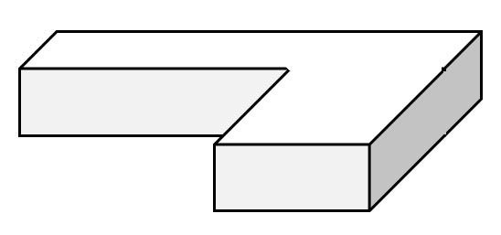
A special order sandbox has been created for children to use as an archeological digging area at the zoo. Determine the volume of the sandbox.
$$4\frac{1}{3} m$$
$$\frac{1}{5} m$$
$$5 m$$
$$2\frac{1}{4}m$$
$$2\frac{3}{4}m$$
$$2 m$$
$$2\frac{1}{3} m$$

- Describe this three-dimensional figure.
MP.7
  - This figure looks like two rectangular prisms that have been placed together to form one large prism.
  - I could think of it as a piece on the left and a piece on the right.
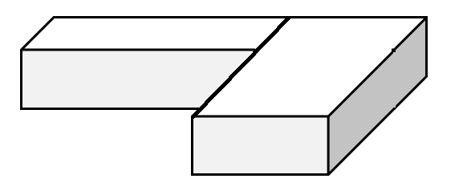
  - Or, I could think of it as a piece in front and a piece behind.
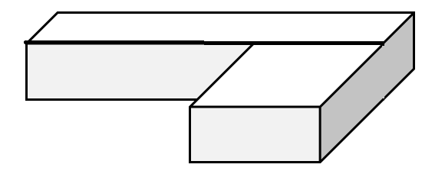
- How can we determine the volume of this figure?
  - We can find the volume of each piece and then add the volumes together to get the volume of the entire figure.
- Does it matter which way we divide the shape when we calculate the volume?
  - Answers will vary.
- At this point, you can divide the class in half and have each half determine the volume using one of the described methods.
  - If the shape is divided into a figure on the left and a figure on the right, we would have the following:
$Volume of prism on the left=l w h$.
$$V=2\frac{3}{4} m×2 m×\frac{1}{5} m$$
$$V=\frac{11}{4} m×2 m×\frac{1}{5} m$$
$V=\frac{22}{20} m^{3}$
$Volume of the prism on the right=l w h$.
$$V=2\frac{1}{4} m×4\frac{1}{3} m×\frac{1}{5} m \\ V=\frac{9}{4} m×\frac{13}{3} m×\frac{1}{5} m \\ V=\frac{117}{60} m^{3} \\ V=\frac{39}{20} m^{3}$$
$$Total volume=volume of left+volume of right$$
$Total volume=\frac{22}{20} m^{3}+\frac{39}{20} m^{3}$
$Total volume=\frac{61}{20} m^{3}=3\frac{1}{20} m^{3}$
  - If the shape is divided into a figure with a piece in front and piece behind, we have the following:
$$Volume of the back piece=l w h$$
$$V=5 m×2 m×\frac{1}{5}m$$
$$V=2 m^{3}$$
$$Volume of the front piece=l w h$$
$$V=2\frac{1}{4} m×2\frac{1}{3} m×\frac{1}{5} m \\ V=\frac{9}{4} m×\frac{7}{3} m×\frac{1}{5} m \\ V=\frac{63}{60} m^{3}=1\frac{3}{60} m^{3}=1\frac{1}{20} m^{3}$$
$$Total volume=volume of back+volume of front$$
$$Total volume=2 m^{3}+1\frac{1}{20} m^{3}$$
$$Total volume=3\frac{1}{20} m^{3}$$
- What do you notice about the volumes determined in each method?
  - The volume calculated with each method is the same. It does not matter how we break up the shape. We will still get the same volume.

Exercises (20 minutes)
Students work in pairs. When working with composite figures, have one student solve using one method and the other solve the problem another way so they can compare answers.
Exercises

  - The volume of the rectangular prism is given. Determine the missing measurement using a one-step equation.
$$V=\frac{36}{15} {yd}^{3}$$
$$Area=\frac{4}{5} {yd}^{2}$$
$$h= ?$$
$$V = Bh \\ \frac{36}{15} =\left(\frac{4}{5}\right)h \\ \frac{36}{15} ×\frac{5}{4}=\left(\frac{4}{5}\right)\left(\frac{5}{4 }\right)h \\ \frac{180}{60}=h \\ 3=h$$
The height is $3 yd.$

  - The volume of the box is$\frac{45}{6} m^{3}$. Determine the area of the base using a one-step equation.
$$\frac{9}{2} m$$
$$V=Bh \\ \frac{45}{6}=B\left(\frac{9}{2} \right) \\ \left(\frac{45}{6}\right)\left(\frac{2}{9 }\right)=B\left(\frac{9}{2}\right)\left(\frac{2}{9 }\right) \\ \frac{90}{54}=B \\ \frac{5}{3}=B$$
The area is $\frac{5}{3} m^{2}$.

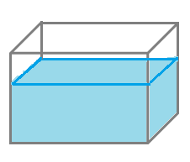
- Marissa’s fish tank needs to be filled with more water.
$$\frac{3}{4} m$$
$$\frac{3}{5} m$$
$$\frac{1}{4} m$$
$$\frac{3}{8} m$$
  - Determine how much water the tank can hold.
$$Volume of entire tank=l w h$$
$$V=\left(\frac{3}{4} m\right)\left(\frac{1}{4} m\right)\left(\frac{3}{5} m\right) \\ V=\frac{9}{80}{ m}^{3}$$

  - Determine how much water is already in the tank.
$$Volume of water in the tank=l w h$$
$$V=\left(\frac{3}{4} m\right)\left(\frac{1}{4} m\right)\left(\frac{3}{8} m\right) \\ V=\frac{9}{128}{ m}^{2}$$

  - How much more water is needed to fill the tank?
Height of empty part of tank:
$$h=\frac{3}{5} m-\frac{3}{8} m=\frac{24}{40} m-\frac{15}{40} m=\frac{9}{40} m$$

$$Volume needed to fill=l w h$$
$$V=\left(\frac{3}{4} m\right)\left(\frac{1}{4} m\right)\left(\frac{9}{40} m\right) \\ V=\frac{27}{640} m^{3}$$

- Determine the volume of the composite figures.
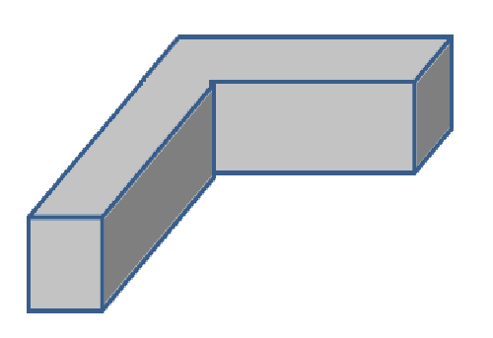
$$3\frac{1}{4} m$$
$$2\frac{1}{3} m$$
$$2 m$$
$$9\frac{1}{2} m$$
$$12 m$$

$Volume of left piece=l w h$ $Volume of back right=l w h$
$V=\left(2 m\right)\left(12 m\right)\left(3\frac{1}{4} m\right)$ $V=\left(9\frac{1}{2} m\right)\left(2\frac{1}{3} m\right)\left(3\frac{1}{4} m\right)$
$V=\left(2 m\right)\left(12 m\right)\left(\frac{13}{4} m\right)$ $V=\left(\frac{19}{2} m\right)\left(\frac{7}{3} m\right)\left(\frac{13}{4} m\right)$
$V=78 m^{3}$ $V=\frac{1729}{24} m^{3}=72\frac{1}{24} m^{3}$
$$Total volume=78 m^{3}+72\frac{1}{24} m^{3}=150\frac{1}{24}{ m}^{3}$$

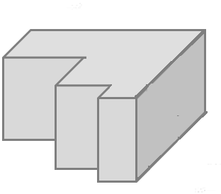
$$1\frac{1}{2} ft.$$
$$\frac{3}{4} ft.$$
$$1\frac{1}{2} ft.$$
$$\frac{1}{2} ft.$$
$$\frac{1}{2} ft.$$
$$\frac{1}{4} ft.$$

$Volume of long back piece=l w h$ $Volume of middle piece=l w h$
$V=\left(1\frac{1}{2} ft\text{.}\right)\left(\frac{1}{2} ft\text{.}\right)\left(\frac{3}{4} ft\text{.} \right)$ $V=\left(\frac{3}{4} ft\text{.}\right)\left(\frac{1}{2} ft\text{.}\right)\left(\frac{3}{4} ft\text{.}\right)$
$V=\left(\frac{3}{2} ft\text{.}\right)\left(\frac{1}{2} ft\text{.}\right)\left(\frac{3}{4} ft\text{.}\right)$ $V=\frac{9}{32} {ft}^{3}$
$V=\frac{9}{16} {ft}^{3}$

$Volume of front piece=l w h$ $Total volume = sum of the three volumes$
$V=\left(\frac{1}{4} ft\text{.}\right)\left(\frac{1}{4} ft\text{.}\right)\left(\frac{3}{4} ft\text{.}\right)$ $Total volume=\frac{9}{16} {ft}^{3}+\frac{9}{32}{ ft}^{3}+\frac{3}{64} {ft}^{3}$
$V=\frac{3}{64} {ft}^{3}$ $Total volume=\frac{36}{64} {ft}^{3}+\frac{18}{64} {ft}^{3}+\frac{3}{64} {ft}^{3}$
$Total volume=\frac{57}{64} {ft}^{3}$
Another possible solution:
$$V=\left(1\frac{1}{2} ft\text{.}\right)\left(\frac{1}{2} ft\text{.}\right)\left(\frac{3}{4} ft\text{.}\right)+\left(\frac{3}{4} ft\text{.}\right)\left(\frac{1}{2} ft\text{.}\right)\left(\frac{3}{4} ft\text{.}\right)+\left(\frac{1}{4} ft\text{.}\right)\left(\frac{1}{4} ft\text{.}\right)\left(\frac{3}{4} ft\text{.}\right)$$
$$V=\frac{9}{16} {ft}^{3}+\frac{9}{32} {ft}^{3}+\frac{3}{64} {ft}^{3}$$
$$V= \frac{36}{64} {ft}^{3}+\frac{18}{64} {ft}^{3}+\frac{3}{64} {ft}^{3}$$
$$V= \frac{57}{64} {ft}^{3}$$

Closing (5 minutes)
Students take time to share their solutions with the class. Discuss the differences between the types of problems and how working with volume and the many formulas or methods for solving can help in determining how to get to a solution.

Exit Ticket (8 minutes)
Name Date
Lesson 14: Volume in the Real World

Exit Ticket

- Determine the volume of the water that would be needed to fill the rest of the tank.
$$\frac{1}{2} m$$
$$\frac{3}{4} m$$
$$\frac{1}{2} m$$
$$1\frac{1}{4}m$$

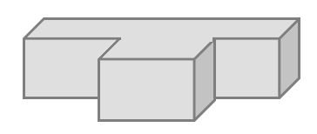
- Determine the volume of the composite figure.
$$\frac{5}{8} ft.$$
$$\frac{1}{4} ft.$$
$$\frac{1}{3} ft.$$
$$\frac{1}{4} ft.$$
$$\frac{1}{6} ft.$$

Exit Ticket Sample Solutions

- Determine the volume of the water that would be needed to fill the rest of the tank.
$$\frac{1}{2} m$$
$$\frac{3}{4} m$$
$$\frac{1}{2} m$$
$$1\frac{1}{4}m$$
$$Volume of tank=l w h \\ Volume of tank=\left(1\frac{1}{4} m\right)\left(\frac{1}{2} m\right)\left(\frac{3}{4} m\right) \\ Volume of tank=\frac{15}{32}{ m}^{3}$$
$$Volume of water=l w h \\ Volume of water=\left(1\frac{1}{4} m\right)\left(\frac{1}{2} m\right)\left(\frac{1}{2} m\right) \\ Volume of water=\frac{5}{16} m^{3}=\frac{10}{32}m^{3}$$
$$Remaining water needed=\frac{15}{32} m^{3}- \frac{10}{32} m^{3}=\frac{5}{32}{ m}^{3}$$
$$\frac{5}{8}ft.$$
$$\frac{1}{4} ft.$$
$$\frac{1}{3} ft.$$
$$\frac{1}{4}ft.$$
$$\frac{1}{6} ft.$$
- Determine the volume of the composite figure.
$$Volume of back piece=l w h \\ Volume of back piece=\left(\frac{5}{8} ft\text{.}\right)\left(\frac{1}{3} ft\text{.}\right)\left(\frac{1}{4} ft\text{.}\right) \\ Volume of back piece=\frac{5}{96}{ ft}^{3}$$
$$Volume of front piece=l w h \\ Volume of front piece=\left(\frac{1}{4} ft\text{.}\right)\left(\frac{1}{6} ft\text{.}\right)\left(\frac{1}{4}ft\text{.}\right) \\ Volume of front piece=\frac{1}{96} {ft}^{3}$$
$$Total volume=\frac{5}{96} {ft}^{3}+\frac{1}{96}{ ft}^{3}=\frac{6}{96} {ft}^{3}$$

Problem Set Sample Solutions

- The volume of a rectangular prism is $\frac{21}{12} ft^{3}$, and the height of the prism is $\frac{3}{4}ft$. Determine the area of the base.
$$Area of base=volume÷height$$
$$Area of base= \frac{21}{12} ft^{3}÷\frac{3}{4} ft.$$
$$Area of base=\frac{21}{12} ft^{3}÷\frac{9}{12} ft.$$
$$Area of base=21 ft^{3}÷ 9 ft.$$
$$Area of base=\frac{7}{3} ft^{2}$$

- The volume of a rectangular prism is $\frac{10}{21} ft^{3}$. The area of the base is $\frac{2}{3} ft^{2}$. Determine the height of the rectangular prism.
$$Height=volume÷area of the base$$
$$Height=\frac{10}{21} ft^{3}÷\frac{2}{3} ft^{2}$$
$$Height=\frac{10}{21} ft^{3}÷\frac{14}{21} ft^{2}$$
$$Height = \frac{10}{14} ft. \text{OR} \frac{5}{7} ft.$$
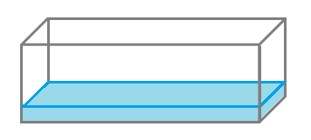
$$5 ft.$$
$$1\frac{2}{3} ft.$$
- Determine the volume of the space in the tank that still needs to be filled with water if the water is $\frac{1}{3} ft.$ deep.
$$2 ft.$$

$Volume of tank=l w h$ $Volume of water=l w h$
$Volume of tank=\left(5 ft\text{.}\right)\left(1\frac{2}{3} ft\text{.}\right)\left(2 ft\text{.}\right)$ $Volume of water=\left(5 ft\text{.}\right)\left(1\frac{2}{3} ft\text{.}\right)\left(\frac{1}{3} ft\text{.}\right)$
$Volume of tank=\frac{50}{3} {ft}^{3}$ $Volume of water=\frac{25}{9} {ft}^{3}$
$Volume to be filled=\frac{50}{3} {ft}^{3}-\frac{25}{9} {ft}^{3}$
$Volume to be filled=\frac{150}{9} {ft}^{3}-\frac{25}{9} {ft}^{3}$
$Volume to be filled=\frac{125}{9} {ft}^{3}$

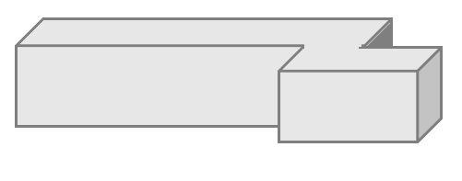
- Determine the volume of the composite figure.
$$\frac{3}{4} m$$
$$\frac{1}{8} m$$
$$\frac{1}{3} m$$
$$\frac{1}{4} m$$
$$\frac{1}{3} m$$
$Volume of back piece=l w h$ $Volume of front piece=l w h$
$Volume of back piece=\left(\frac{3}{4} m\right)\left(\frac{1}{8} m\right)\left(\frac{1}{3} m\right)$ $Volume of front piece=\left(\frac{1}{4} m\right)\left(\frac{1}{8} m\right)\left(\frac{1}{3} m\right)$
$Volume of back piece=\frac{3}{96} m^{3}$ $Volume of front piece=\frac{1}{96} m^{3}$
$Total volume=\frac{3}{96} m^{3}+ \frac{1}{96} m^{3}=\frac{4}{96} m^{3}$ OR $\frac{1}{24} m^{3}$
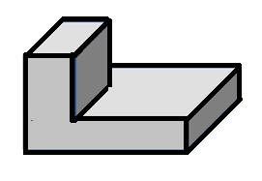
- Determine the volume of the composite figure.
$$1 in.$$
$$3 in.$$
$$2\frac{1}{2} in.$$
$$\frac{1}{4} in.$$
$$1\frac{1}{2} in.$$
$$1\frac{1}{4} in.$$
$$V=\left(1 in\text{.}\right)\left(1\frac{1}{2} in\text{.}\right)\left(1\frac{1}{4} in\text{.}\right)+\left(3 in\text{.}\right)\left(2\frac{1}{2} in\text{.}\right)\left(\frac{1}{4} in\text{.}\right)$$
$$V=\left(1 in\text{.}\right)\left(\frac{3}{2} in\text{.}\right)\left(\frac{5}{4} in\text{.}\right)+\left(3 in\text{.}\right)\left(\frac{5}{2} in\text{.}\right)\left(\frac{1}{4} in\text{.}\right)$$
$$V=\frac{15}{8} {in}^{3}+\frac{15}{8}{ in}^{3}$$
$$V=\frac{30}{8} {in}^{3}=3\frac{6}{8} {in}^{3} \text{OR} 3\frac{3}{4} in^{3}$$

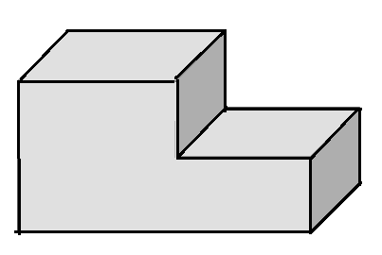
$$7\frac{1}{4} m$$
$$2 m$$
$$3\frac{1}{2} m$$
$$1\frac{1}{4} m$$
$$1 m$$

  - Write an equation to represent the volume of the composite figure.
$$V =\left(3\frac{1}{2} m×2 m×1\frac{1}{4} m\right)+\left(3\frac{3}{4} m×2 m×2\frac{1}{4} m\right)$$

  - Use your equation to calculate the volume of the composite figure.
$$V=\left(3\frac{1}{2} m×2 m×1\frac{1}{4} m\right)+\left(3\frac{3}{4} m×2 m×2\frac{1}{4} m\right) \\ V=\left(\frac{7}{2} m×\frac{2}{1} m×\frac{5}{4} m\right)+\left(\frac{15}{4} m×\frac{2}{1} m×\frac{9}{4} m\right) \\ V=\frac{70}{8} m^{3}+\frac{270}{16} m^{3} \\ V=\frac{70}{8} m^{3}+\frac{135}{8}{ m}^{3} \\ V=\frac{205}{8} m^{3} \\ V=25\frac{5}{8} m^{3}$$

