Lesson 12: From Unit Cubes to the Formulas for Volume

Classwork
Example 1
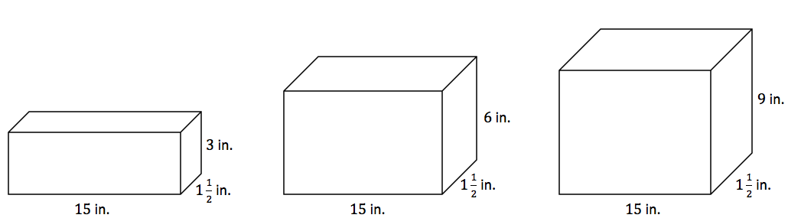

  - Write a numerical expression for the volume of each of the rectangular prisms above.

  - What do all of these expressions have in common? What do they represent?

  - Rewrite the numerical expressions to show what they have in common.

  - If we know volume for a rectangular prism as length times width times height, what is another formula for volume that we could use based on these examples?

  - What is the area of the base for all of the rectangular prisms?

  - Determine the volume of each rectangular prism using either method.

  - How do the volumes of the first and second rectangular prisms compare? The volumes of the first and third?

Example 2
The base of a rectangular prism has an area of $3\frac{1}{4} {in}^{2}$. The height of the prism is $2\frac{1}{2} in$. Determine the volume of the rectangular prism.

Extension
A company is creating a rectangular prism that must have a volume of $6 {ft}^{3}$. The company also knows that the area of the base must be $2\frac{1}{2} ft^{2}$. How can you use what you learned today about volume to determine the height of the rectangular prism?

Problem Set

- Determine the volume of the rectangular prism.
$$\frac{7}{8} m$$
$$\frac{1}{2} m$$
$$1\frac{1}{2} m$$

- The area of the base of a rectangular prism is $4\frac{3}{4} {ft}^{2}$, and the height is $2\frac{1}{3} ft$. Determine the volume of the rectangular prism.

- The length of a rectangular prism is $3\frac{1}{2}$times as long as the width. The height is $\frac{1}{4}$ of the width. The width is $3 cm$. Determine the volume.

$$1\frac{2}{3}in.$$
$$10\frac{1}{2}in.$$
$$6 in.$$

  - Write numerical expressions to represent the volume in two different ways, and explain what each reveals.
  - Determine the volume of the rectangular prism.

- An aquarium in the shape of a rectangular prism has the following dimensions: length $=50 cm$, width $=25\frac{1}{2} cm$, and height$=30\frac{1}{2} cm$.
  - Write numerical expressions to represent the volume in two different ways, and explain what each reveals.
  - Determine the volume of the rectangular prism.

- The area of the base in this rectangular prism is fixed at $36 {cm}^{2}$. This means that for the varying heights, there will be various volumes.
  - Complete the table of values to determine the various heights and volumes.
$$12 cm$$
$$3 cm$$
Height in Centimeters | Volume in Cubic Centimeters
$$2$$ | $$72$$
$$3$$ | $$108$$
 | $$144$$
 | $$180$$
$$6$$
$$7$$
 | $$288$$
  - Write an equation to represent the relationship in the table. Be sure to define the variables used in the equation.
  - What is the unit rate for this proportional relationship? What does it mean in this situation?

- The volume of a rectangular prism is $16.328 {cm}^{3}$. The height is $3.14 cm$.
  - Let $B$ represent the area of the base of the rectangular prism. Write an equation that relates the volume, the area of the base, and the height.
  - Solve the equation for $B$.

