Lesson 10: Distance, Perimeter, and Area in the Real World

Classwork
Opening Exercises
- Find the area and perimeter of this rectangle:
$$5 cm$$
$$9 cm$$

- Find the width of this rectangle. The area is $1.2 m^{2}$, and the length is $1.5 m$.
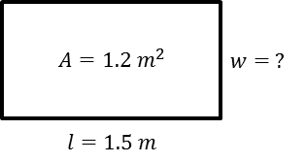

Example 1: Student Desks or Tables
- Measure the dimensions of the top of your desk.

- How do you find the area of the top of your desk?

- How do you find the perimeter?

- Record these on your paper in the appropriate column.

Exploratory Challenge
Estimate and predict the area and perimeter of each object. Then measure each object, and calculate both the area and perimeter of each.
Object or Item to be Measured | Measure-ment Units | Precision  (Measure to the Nearest) | Area Prediction  (Square Units) | Area (Square Units)  Write the expression and evaluate it. | Perimeter Prediction  (Linear Units) | Perimeter  (Linear Units)
Ex: door | feet | half foot |  | $$6\frac{1}{2} ft\text{.}×3\frac{1}{2} ft\text{.}$$  $$=22\frac{3}{4}{ ft}^{2}$$ |  | $$2\left(3\frac{1}{2} ft\text{.}+6\frac{1}{2} ft\text{.}\right)$$  $$=20 ft.$$
Desktop

Optional Challenge
Object or Item to be Measured | Measurement Units | Precision  (Measure to the Nearest) | Area (Square Units) | Perimeter  (Linear Units)
Ex: door | feet | half foot | $$6\frac{1}{2}ft\text{.}×3\frac{1}{2}ft\text{.}$$  $$=22\frac{3}{4}{ft}^{2}$$ | $$2\left(3\frac{1}{2}ft\text{.}+6\frac{1}{2}ft\text{.}\right)$$  $$=20 ft.$$

Problem Set

- How is the length of the side of a square related to its area and perimeter? The diagram below shows the first four squares stacked on top of each other with their upper left-hand corners lined up.
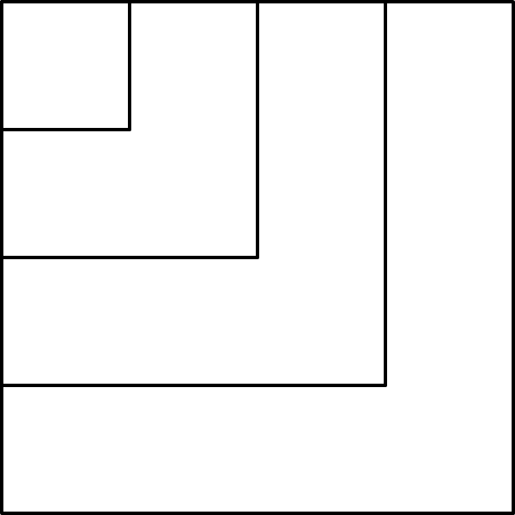

  - Complete this chart calculating area and perimeter for each square.
Side Length in Feet | Expression Showing the Area | Area in Square Feet | Expression Showing the Perimeter | Perimeter in Feet
$$1$$ | $$1×1$$ | $$1$$ | $$1×4$$ | $$4$$
$$2$$
$$3$$
$$4$$
$$5$$
$$6$$
$$7$$
$$8$$
$$9$$
$$10$$
$$n$$
  - In a square, which numerical value is greater, the area or the perimeter?
  - When is the numerical value of a square’s area (in square units) equal to its perimeter (in units)?
  - Why is this true?

- This drawing shows a school pool. The walkway around the pool needs special non-skid strips installed but only at the edge of the pool and the outer edges of the walkway.
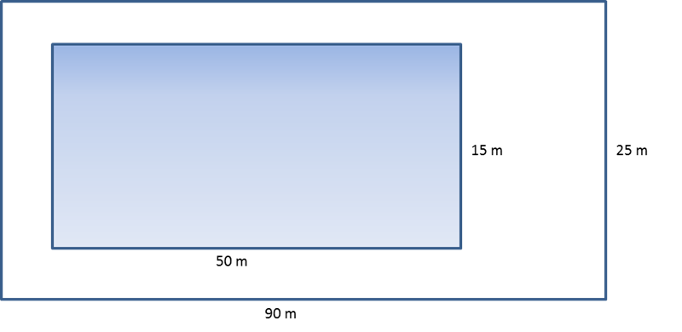
  - Find the length of non-skid strips that is needed for the job.
  - The non-skid strips are sold only in rolls of $50 m$. How many rolls need to be purchased for the job?

- A homeowner called in a painter to paint the walls and ceiling of one bedroom. His bedroom is $18 ft.$ long, $12 ft.$ wide, and $8 ft.$ high. The room has two doors, each $3 ft.$ by $7 ft.$ and three windows each $3 ft.$ by$5 ft$. The doors and windows do not have to be painted. A gallon of paint can cover$300 ft^{2}$. A hired painter claims he will need $4$gallons. Show that his estimate is too high.

- Theresa won a gardening contest and was awarded a roll of deer-proof fencing. The fence is $36$yards long. She and her husband, John, discuss how to best use the fencing to make a rectangular garden. They agree that they should only use whole numbers of feet for the length and width of the garden.
  - What are all of the possible dimensions of the garden?
  - Which plan yields the maximum area for the garden? Which plan yields the minimum area?

- Write and then solve the equation to find the missing value below.
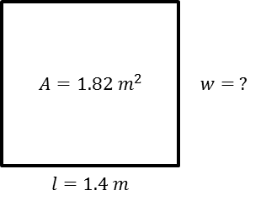

- Challenge: This is a drawing of the flag of the Republic of the Congo. The area of this flag is $3\frac{3}{4} {ft}^{2}$.
  - Using the area formula, tell how you would determine the value of the base.
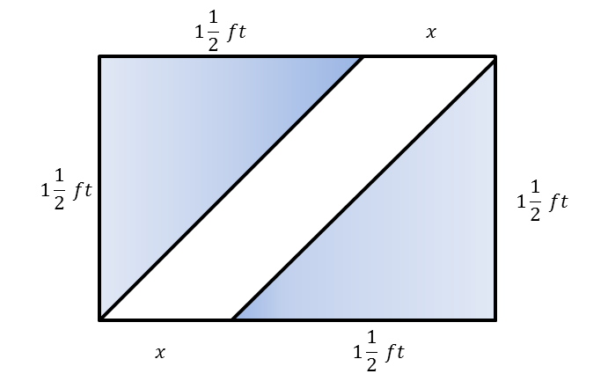

  - Using what you found in part (a), determine the missing value of the base.

