Lesson 10: Distance, Perimeter, and Area in the Real World

Student Outcomes
- Students determine distance, perimeter, and area in real-world contexts.

Lesson Notes
This lesson is similar to Lesson 6 from this module. The teacher can determine ahead of time whether to do the exploration in the classroom or venture out into hallways or some other location. The measuring tools, units, and degree of precision to be used in this activity should be chosen in a manner that best meets the needs of the students. For large distances, a long measuring tape or trundle wheel can be used. For very small objects, a millimeter ruler would be more appropriate.
The critical understanding for students is that area involves covering, while perimeter involves surrounding. Since plane objects have both area and perimeter, the distinction between the two concepts must be made.
When choosing objects to be measured, look for composite objects that require more than just measuring length and width. Avoid curved edges, as students will not be able to find area. When possible, choose objects that explicitly lend themselves to both area and perimeter. Such objects could include a frame or mat around a picture, wood trim around the top of a table, piping around a dinner napkin, or baseboard molding along walls. Some of the objects that were chosen for Lesson 6 of this Module can also be used.
It is appropriate for students to use a calculator for this lesson.

Classwork
Opening Exercises 1–2 (6 minutes)
Scaffolding:
There is a great deal of flexibility in this lesson, so it can be tailored to the needs of the class and can be easily individualized for both struggling and advanced learners.

Opening Exercises 1–2
- Find the area and perimeter of this rectangle:
$$5 cm$$
$$9 cm$$
$A=bh=9 cm×5 cm=45 {cm}^{2}$
$P=9 cm+9 cm+5 cm+5 cm=28 cm$

- Find the width of this rectangle. The area is $1.2 m^{2}$, and the length is $1.5 m$.
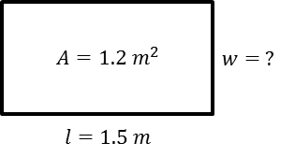
$$A=l×w \\ 1.2 m^{2}=1.5 m×w \\ \frac{ 1.2 m^{2}}{1.5 m}=\frac{1.5 m×w}{1.5 m} \\ 0.8 m=w$$

Discussion (5 minutes)
Scaffolding:
The term dimensions may be new to ELL students and as such, may need to be taught and rehearsed. Similarly, the word superscript may be new for ELL students and should be taught or reviewed.
- How many dimensions does the rectangle have, and what are they?
  - Two dimensions: length and width
- What units are used to express area?
  - Square units, such as square centimeters as we had in the first Opening Exercise.
- What superscript is used to denote square units?
  - The number $2$, for two dimensions
- What does the prefix peri- mean?
  - Around
- Are there any other words that use this prefix?
  - Periscope (seeing around), periodontal (surrounding a tooth), pericardium (the sac around the heart), period (a portion of time that is limited and determined by some recurring phenomenon, as by the completion of a revolution of the earth or moon), etc.
- How can focusing on the meaning of the word help you remember the difference between area and perimeter?
  - Peri- means around; -meter means measure. Perimeter is the measure of the distance around an object. Area is the measure of the surface of an object and has two dimensions.
- How many dimensions do the line segments around the rectangle have?
  - The line segments around the rectangle have one dimension; line segments only have length.
- What units are used to express perimeter?
  - Linear units
- We do not typically write linear units with an exponent because the exponent is $1$.

Example 1 (6 minutes): Student Desks or Tables
Distribute measuring tools. Explain the units that will be used and level of precision expected.
Example 1: Student Desks or Tables
Scaffolding:
Consider asking some students to measure to the nearest inch, others to the nearest half inch, and others to the nearest quarter inch, depending on ability. Compare these.

- Measure the dimensions of the top of your desk.
- How do you find the area of the top of your desk?
- How do you find the perimeter?
- Record these on your paper in the appropriate column.

- Let’s do an example before starting out on this investigation. Measure the dimensions of the top of your desk (or tabletop, etc.).
  - Dimensions will vary.
- How do you find the area of the surface?
  - Multiply the length by the width.
- How do you find the perimeter?
  - Any of three ways: Add the length and width (to find the semi-perimeter), and then double the sum; double the length, double the width, and add those two products; or add the length, length, width, and width.
- Record these on your paper in the appropriate column.

Exploratory Challenge (17 minutes)
Exploratory Challenge
Estimate and predict the area and perimeter of each object. Then measure each object, and calculate both the area and perimeter of each.
Answers are determined by the teacher when objects are chosen. Consider using examples like decorating a bulletin board: bulletin board trim (perimeter), paper for bulletin board (area).
Object or Item to be Measured | Measure-ment Units | Precision  (Measure to the Nearest) | Area Prediction  (Square Units) | Area (Square Units)  Write the expression and evaluate it. | Perimeter Prediction  (Linear Units) | Perimeter  (Linear Units)
Ex: door | feet | half foot |  | $$6\frac{1}{2} ft\text{.}×3\frac{1}{2} ft\text{.}=22\frac{3}{4}{ ft}^{2}$$ |  | $$2\left(3\frac{1}{2} ft\text{.}+6\frac{1}{2} ft\text{.}\right)=20 ft.$$
Desktop
Optional Challenge (10 minutes)
If desired, send some students to measure other real-world objects found around the school. Set measurement units and precision parameters in advance. The teacher should measure these objects in advance of the activity and calculate the corresponding perimeters and areas. Measuring the school building from the outside could be a whole group activity or could be assigned as an extra credit opportunity.
Optional Challenge
Object or Item to be Measured | Measurement Units | Precision  (Measure to the Nearest) | Area  (Square Units) | Perimeter  (Linear Units)
Ex: door | feet | half foot | $$6\frac{1}{2} ft\text{.}×3\frac{1}{2} ft\text{.}=22\frac{3}{4}{ ft}^{2}$$ | $$2\left(3\frac{1}{2} ft\text{.}+6\frac{1}{2} ft\text{.}\right)=20 ft.$$

Closing (4 minutes)
- What are some professions that use area and perimeter regularly?
  - Surveyors, garment manufacturers, packaging engineers, cabinetmakers, carpenters
- Can you think of any circumstances where you or someone you know has or might have to calculate perimeter and area?
  - Answers will vary. Encourage a large quantity of responses.
- Would you like to work in an occupation that requires measuring and calculating as part of the duties?
  - Answers will vary.

Exit Ticket (7 minutes)
Name Date
Lesson 10: Distance, Perimeter, and Area in the Real World

Exit Ticket

- The local school is building a new playground. This plan shows the part of the playground that needs to be framed with wood for the swing set. The unit of measure is feet. Determine the number of feet of wood that will be needed to frame the area.

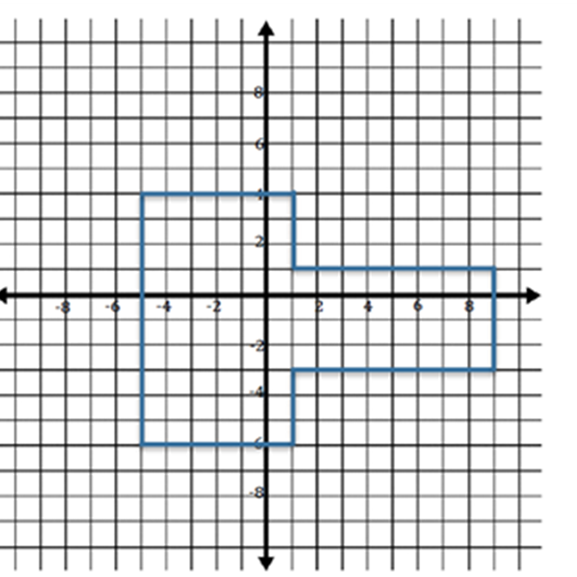

- The school will fill the area with wood mulch for safety. Determine the number of square feet that need to be covered by the mulch.

Exit Ticket Sample Solutions

- The local school is building a new playground. This plan shows the part of the playground that needs to be framed with wood for the swing set. The unit of measure is feet. Determine the number of feet of wood that will be needed to frame the area.
Perimeter: $10 ft. + 6 ft. + 6 ft. + 3 ft. + 3 ft. + 8 ft. + 8 ft. + 4 ft. =48 ft.$

- The school will fill the area with wood mulch for safety. Determine the number of square feet that need to be covered by the mulch.
$$A=bh=\left(6 ft\text{.}×10 ft\text{.}\right)=60 ft^{2} \\ A=bh=\left(8 ft\text{.}×4 ft\text{.}\right)=32 ft^{2} \\ A=60 ft^{2}+32 ft^{2}=92 ft^{2}$$

Problem Set Sample Solutions
Note: When columns in a table are labeled with units, students need only enter numerical data in the cells of the table and not include the units each time.

- How is the length of the side of a square related to its area and perimeter? The diagram below shows the first four squares stacked on top of each other with their upper left-hand corners lined up.
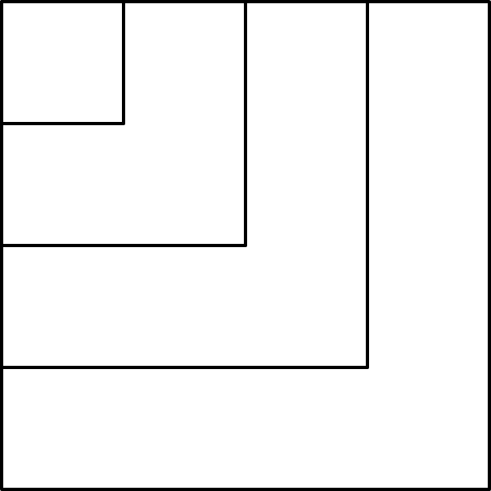

  - Complete this chart calculating area and perimeter for each square.
Side Length in Feet | Expression Showing the Area | Area in Square Feet | Expression Showing the Perimeter | Perimeter in Feet
$$1$$ | $$1×1$$ | $$1$$ | $$1×4$$ | $$4$$
$$2$$ | $$2×2$$ | $$4$$ | $$2×4$$ | $$8$$
$$3$$ | $$3×3$$ | $$9$$ | $$3×4$$ | $$12$$
$$4$$ | $$4×4$$ | $$16$$ | $$4×4$$ | $$16$$
$$5$$ | $$5×5$$ | $$25$$ | $$5×4$$ | $$20$$
$$6$$ | $$6×6$$ | $$36$$ | $$6×4$$ | $$24$$
$$7$$ | $$7×7$$ | $$49$$ | $$7×4$$ | $$28$$
$$8$$ | $$8×8$$ | $$64$$ | $$8×4$$ | $$32$$
$$9$$ | $$9×9$$ | $$81$$ | $$9×4$$ | $$36$$
$$10$$ | $$10×10$$ | $$100$$ | $$10×4$$ | $$40$$
$$n$$ | $$n×n$$ | $$n^{2}$$ | $$4×n$$ | $$4n$$

  - In a square, which numerical value is greater, the area or the perimeter?
It depends. For side length $<4$, perimeter is greater; however, for side length $>4$, area is greater.

  - When is the numerical value of a square’s area (in square units) equal to its perimeter (in units)?
When the side length is exactly $4$.

  - Why is this true?
$n^{2}=4n$is only true when $n=4$.

- This drawing shows a school pool. The walkway around the pool needs special non-skid strips installed but only at the edge of the pool and the outer edges of the walkway.
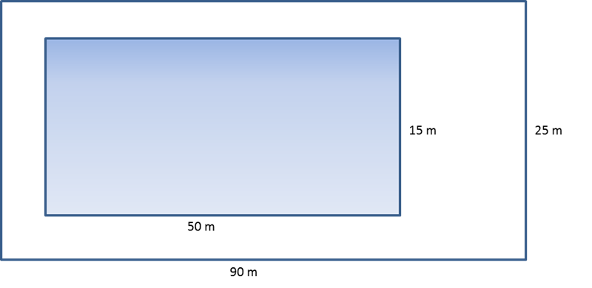
  - Find the length of non-skid strips that is needed for the job.
$50 m+50 m+15 m+15 m+90 m+90 m+25 m+25 m=360 m$

  - The non-skid strips are sold only in rolls of $50 m$. How many rolls need to be purchased for the job?
$$360 m÷50 \frac{m}{roll}=7.2 rolls$$
Therefore, $8$ rolls will need to be purchased.
- A homeowner called in a painter to paint the walls and ceiling of one bedroom. His bedroom is $18 ft.$ long, $12 ft.$ wide, and $8 ft.$ high. The room has two doors, each $3 ft.$ by $7 ft.$ and three windows each $3 ft.$ by$5 ft$. The doors and windows do not have to be painted. A gallon of paint can cover$300 ft^{2}$. A hired painter claims he will need $4$gallons. Show that his estimate is too high.
Area of $2$ long walls: $2\left(18 ft\text{.}×8 ft\text{.}\right)=288 ft^{2}$
Area of $2$ short walls: $2\left(12 ft\text{.}×8 ft\text{.}\right)=192 ft^{2}$
Area of ceiling: $18 ft\text{.}×12 ft\text{.}=216 ft^{2}$
Area of $2$ doors: $2\left(3 ft\text{.}×7 ft\text{.}\right)=42 ft^{2}$
Area of $3$ windows $3\left(3 ft\text{.}×5 ft\text{.}\right)=45 ft^{2}$
Area to be painted: $\left(288 ft^{2}+192 ft^{2}+216 ft^{2}\right)-\left(42 ft^{2}+45 ft^{2}\right)=609 ft^{2}$
Gallons of paint needed: $609÷300=2.03$
The painter will need a little more than$2$ gallons. The painter’s estimate for how much paint is necessary was too high.

- Theresa won a gardening contest and was awarded a roll of deer-proof fencing. The fence is $36$yards long. She and her husband, John, discuss how to best use the fencing to make a rectangular garden. They agree that they should only use whole numbers of feet for the length and width of the garden.
  - What are all of the possible dimensions of the garden?
Length in Feet | Width in Feet
$$17$$ | $$1$$
$$16$$ | $$2$$
$$15$$ | $$3$$
$$14$$ | $$4$$
$$13$$ | $$5$$
$$12$$ | $$6$$
$$11$$ | $$7$$
$$10$$ | $$8$$
$$9$$ | $$9$$

  - Which plan yields the maximum area for the garden? Which plan yields the minimum area?
Length in feet | Width in feet | Area in square feet
$$17$$ | $$1$$ | $$17$$
$$16$$ | $$2$$ | $$32$$
$$15$$ | $$3$$ | $$45$$
$$14$$ | $$4$$ | $$56$$
$$13$$ | $$5$$ | $$65$$
$$12$$ | $$6$$ | $$72$$
$$11$$ | $$7$$ | $$77$$
$$10$$ | $$8$$ | $$80$$
$$9$$ | $$9$$ | $$81$$
The $9 ft.$ by $9 ft.$garden would have the maximum area ($81 ft^{2}$), while the $17 ft.$ by $1 ft.$ garden would have only$17 ft^{2}$ of garden space.

- Write and then solve the equation to find the missing value below.
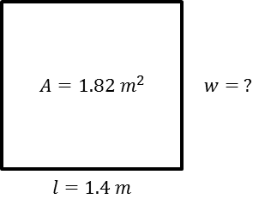
$$A=l×w \\ 1.82 m^{2}=1.4 m×w \\ \frac{1.82 m^{2}}{1.4 m}=w \\ 1.3 m=w$$

- Challenge: This is a drawing of the flag of the Republic of the Congo. The area of this flag is $3\frac{3}{4} ft^{2}$.
  - Using the area formula, tell how you would determine the value of the base.
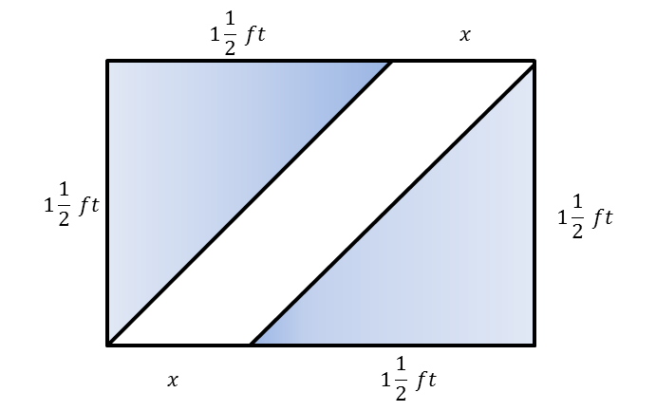
$$A=bh \\ A÷h=b \\ 3\frac{3}{4}{ft}^{2}÷1\frac{1}{2}ft\text{.}=b \\ 2\frac{1}{2} ft\text{.}=b$$

  - Using what you found in part (a), determine the missing value of the base.
$$2\frac{1}{2} ft\text{.}=1\frac{1}{2} ft\text{.}+x \\ 1 ft\text{.}=x$$

