Lesson 9: Determining Area and Perimeter of Polygons on the Coordinate Plane

Classwork
Example 1
Jasjeet has made a scale drawing of a vegetable garden she plans to make in her backyard. She needs to determine the perimeter and area to know how much fencing and dirt to purchase. Determine both the perimeter and area.
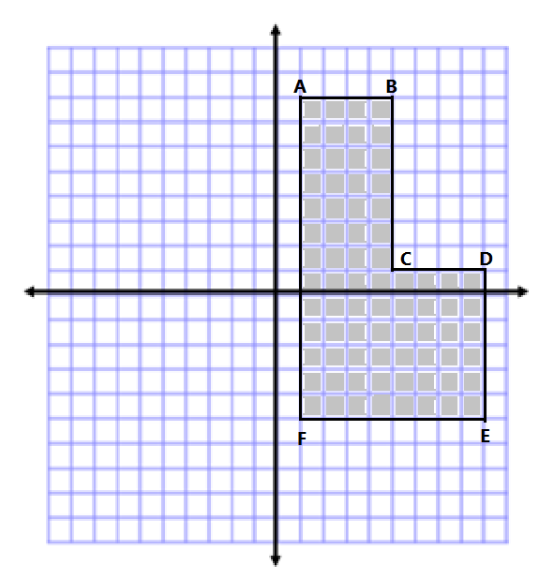
Example 2
Calculate the area of the polygon using two different methods. Write two expressions to represent the two methods, and compare the structure of the expressions.
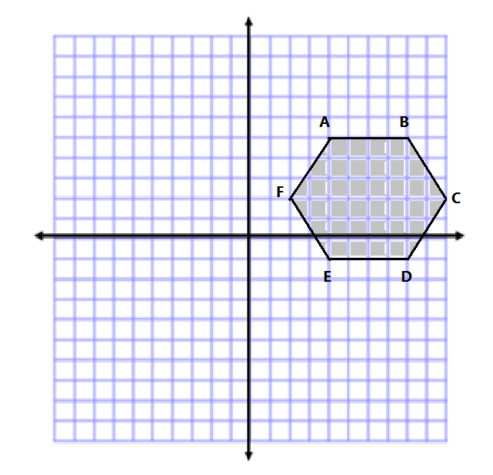
Exercises 1–2
- Determine the area of the following shapes.

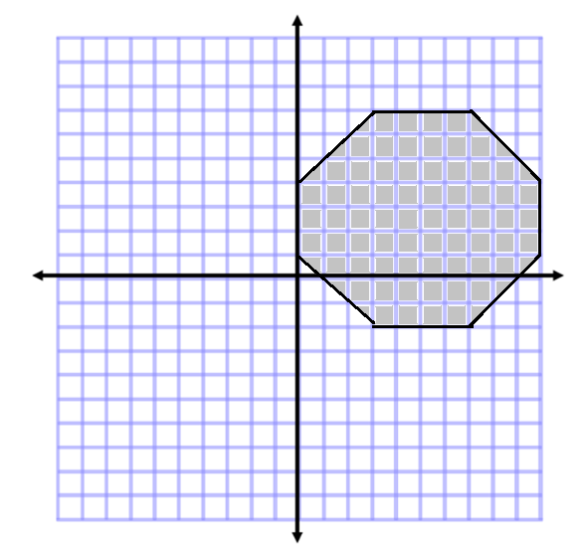

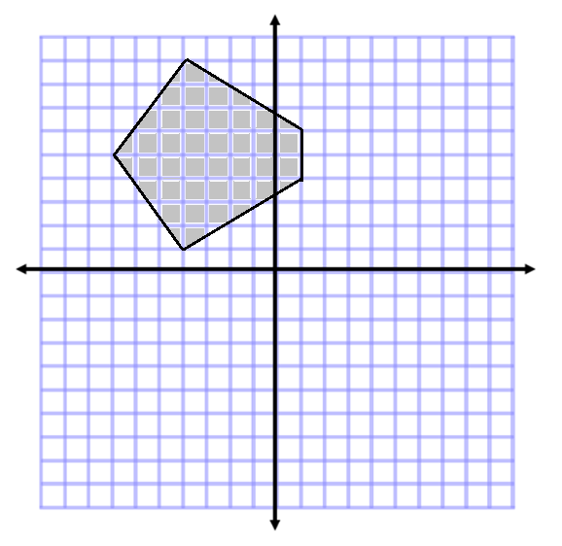

- Determine the area and perimeter of the following shapes.

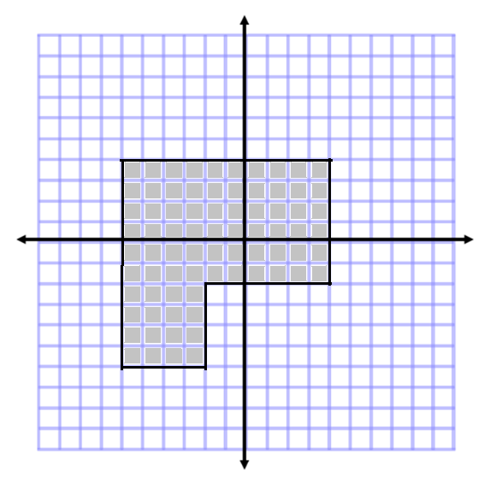

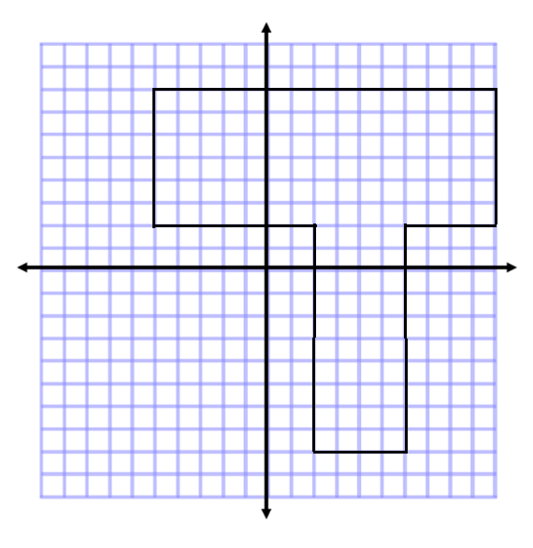

Problem Set

- Determine the area of the polygon.
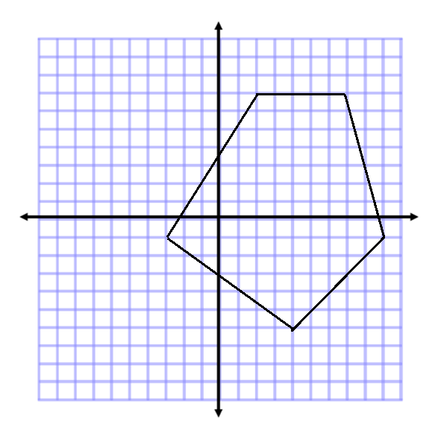

- Determine the area and perimeter of the polygon.
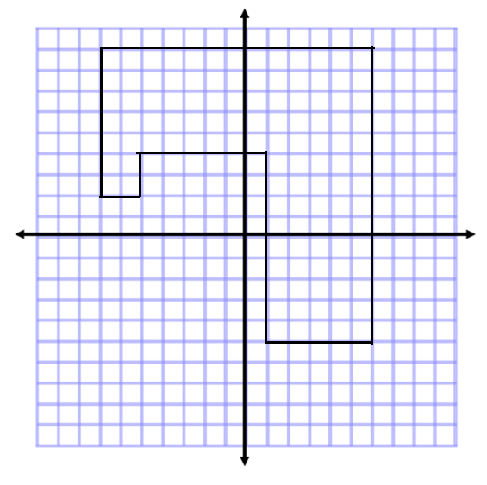

- Determine the area of the polygon. Then, write an expression that could be used to determine the area.
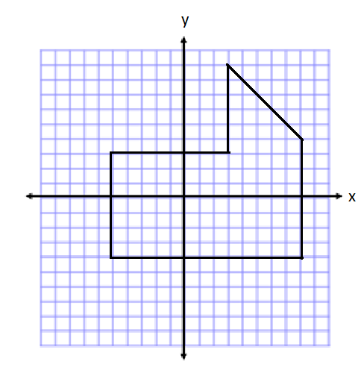

- If the length of each square was worth $2$ instead of $1$, how would the area in Problem 3 change? How would your expression change to represent this area?

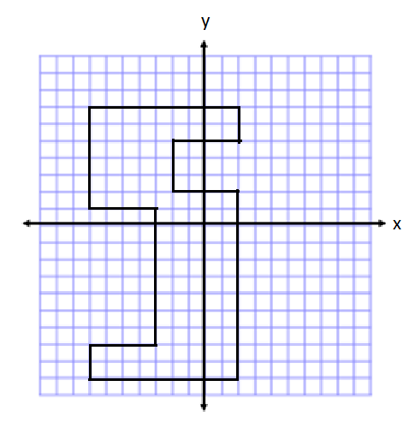
- Determine the area of the polygon. Then, write an expression that represents the area.

- Describe another method you could use to find the area of the polygon in Problem 5. Then, state how the expression for the area would be different than the expression you wrote.
- Write one of the letters from your name using rectangles on the coordinate plane. Then, determine the area and perimeter. (For help see Exercise 2(b). This irregular polygon looks sort of like a T.)

