Lesson 9: Determining Area and Perimeter of Polygons on the Coordinate Plane

Student Outcomes
- Students find the perimeter of irregular figures using coordinates to find the length of a side joining points with the same first coordinate or the same second coordinate.
- Students find the area enclosed by a polygon on the coordinate plane by composing or decomposing using polygons with known area formulas.

Lesson Notes
The solutions given throughout the lesson only represent some of the correct answers to the problems. Discussion throughout the lesson about other possible solutions should be welcomed.
Please note that in each coordinate plane, each square unit is one unit in length.
The formulas $A=lw$ and $A=bh$ are used intermittently. Both are correct strategies for determining the area of a rectangle and should be accepted.
Please also note that some of the formulas are solved in a different order depending on the problem. For example, when using the formula for the area of triangles, students could multiply the base and the height and then multiply by $\frac{1}{2}$ or they could take $\frac{1}{2}$ of either the base or the height before multiplying by the other. Because multiplication is commutative, multiplying in different orders is mathematically sound. Students should be comfortable with using either order and may see opportunities when it is more advantageous to use one order over another.

Classwork
Fluency Exercise (5 minutes): Addition and Subtraction Equations
Sprint: Refer to the Sprints and the Sprint Delivery Script sections in the Module Overview for directions to administer a Sprint.

Example 1 (8 minutes)
Example 1
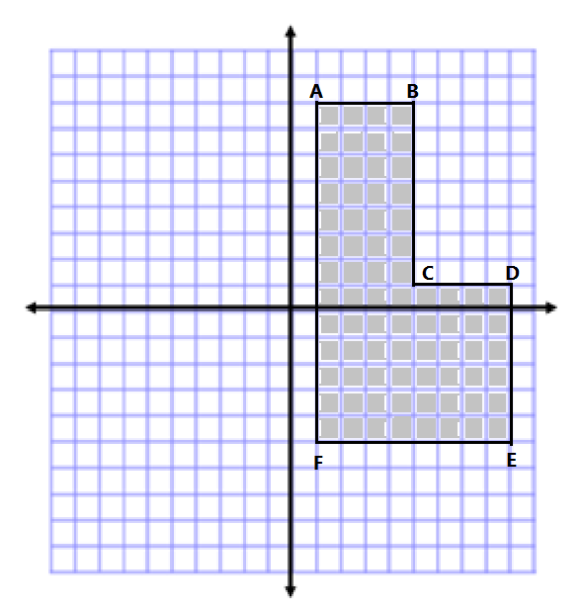
Jasjeet has made a scale drawing of a vegetable garden she plans to make in her backyard. She needs to determine the perimeter and area to know how much fencing and dirt to purchase. Determine both the perimeter and area.
$AB=4 units$ $BC=7 units$ $CD=4 units$
$DE=6 units$ $EF=8 units$ $AF=13 units$
Perimeter $=4 units+7 units+4 units+6 units+8 units+13 units$
Perimeter $=42 units$
The area is determined by making a horizontal cut from $(1, 1)$ to point $C$.
Area of Top Area of Bottom
$A=lw$ $A=lw$
$A=(4 units)(7 units)$ $A=(8 units)(6 units)$
$A=28 {units}^{2}$ $A=48 {units}^{2}$
Total Area $=28 {units}^{2}+48 {units}^{2}$
Total Area $=76 {units}^{2}$

- How can we use what we worked on in Lessons 7 and 8 to help us calculate the perimeter and area?
  - We can determine the lengths of each side first. Then, we will add the lengths together to get the perimeter.
  - Next, we can break the shape into two rectangles, find the area of each rectangle using the side lengths, and add the areas together to get the total area of the polygon.

Example 2 (8 minutes)
Example 2
Calculate the area of the polygon using two different methods. Write two expressions to represent the two methods, and compare the structure of the expressions.
Answers will vary. The following are two possible methods. However, students could also break the shape into two triangles and a rectangle or another correct method.
Method One: Method Two:
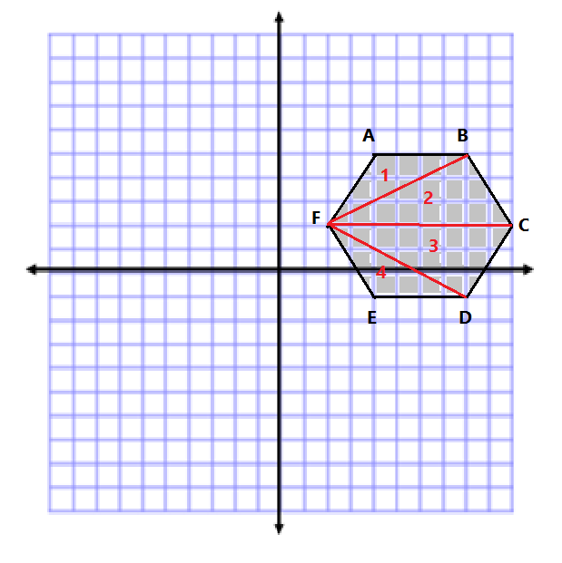
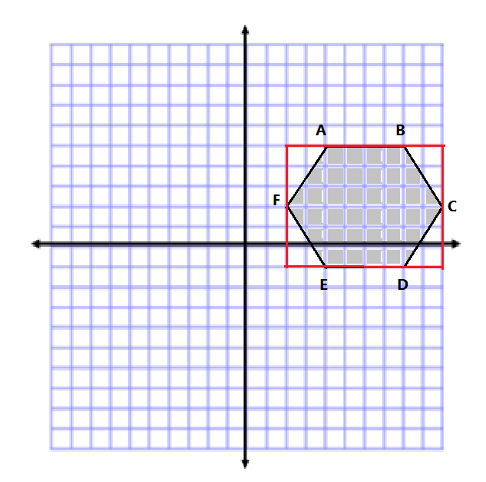
$$A=lw$$
$$A=(8 units)(6 units)$$
$$A=48 {units}^{2}$$
$$A=\frac{1}{2}bh$$
$$A=\frac{1}{2}(2 units)(3 units)$$
$$A=3 {units}^{2}$$
There are $4$ triangles of equivalent base and height.
$$4(3 {units}^{2})=12 {units}^{2}$$
Total Area $=48 {units}^{2}-12 {units}^{2}$
Total area $= 36 {units}^{2}$
Area of Triangle 1 and 4
$$A=\frac{1}{2}bh$$
$$A=\frac{1}{2}(4 units)(3 units)$$
$$A=\frac{1}{2}(12 units^{2})$$
$$A=6 {units}^{2}$$
Since there are $2$, we have a
total area of $12 units^{2}$.

Total Area $=12 {units}^{2}+24 units^{2}=36 {units}^{2}$
Area of Triangle 2 and 3
$$A=\frac{1}{2}bh$$
$$A=\frac{1}{2}(8 units)(3 units)$$
$$A=\frac{1}{2}(24 units^{2})$$
$$A=12 {units}^{2}$$
Since there are $2$, we have a total area of $24 units^{2}$.

Expressions
$$2\left[\frac{1}{2}\left(4\right)\left(3\right)\right]+2\left[\frac{1}{2}\left(8\right)\left(3\right)\right] \text{or } \left(8\right)\left(6\right)-4\left[\frac{1}{2}\left(2\right)\left(3\right)\right]$$
The first expression shows terms being added together because I separated the hexagon into smaller pieces and had to add their areas back together.
The second expression shows terms being subtracted because I made a larger outside shape, and then had to take away the extra pieces.
Allow time for students to share and explain one of their methods.
Scaffolding:
As ELL students discuss their thinking, it may be useful to provide support for their conversations. Sentence starters may include, “My favorite method is ...” or
“First, I ...”

MP.1
&
MP.3
- What were the strengths and weaknesses of the methods that you tried?
  - Responses will vary. Some students may prefer methods that require fewer steps while others may prefer methods that only include rectangles and triangles.

Exercises 1–2 (16 minutes)
Students work on the practice problems in pairs, so they can discuss different methods for calculating the areas. Discussions should include explaining the method they chose and why they chose it. Students should also be looking to see if both partners got the same answer.
Consider asking students to write explanations of their thinking in terms of decomposition and composition as they solve each problem.
Exercises 1–2
- Determine the area of the following shapes.
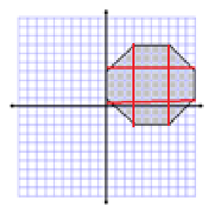
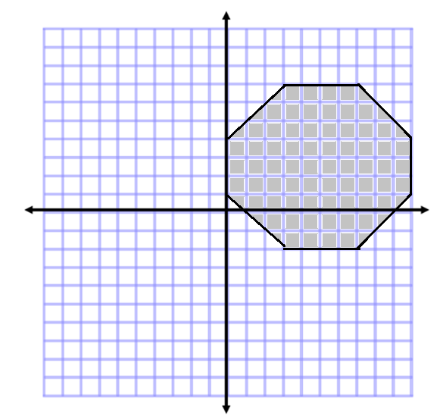
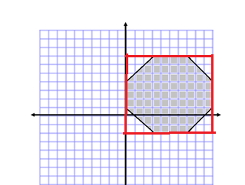
Teachers please note that students may also choose to solve by decomposing. Here is another option:
Area of Rectangle
$$A=lw$$
$$A=(10 units)(9 units)$$
$$A=90 {units}^{2}$$
Area of Triangle
$$A=\frac{1}{2}bh$$
$$A=\frac{1}{2}(3 units)(3 units)$$
$$A=4.5 {units}^{2}$$
$$4$$ triangles with equivalent base and height
$$4\left(4.5 {units}^{2}\right)=18 {units}^{2}$$
Area $=90 {units}^{2}-18 {units}^{2}$
Area $=72 {units}^{2}$
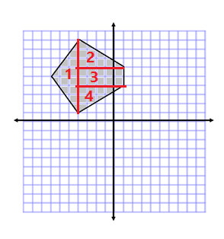
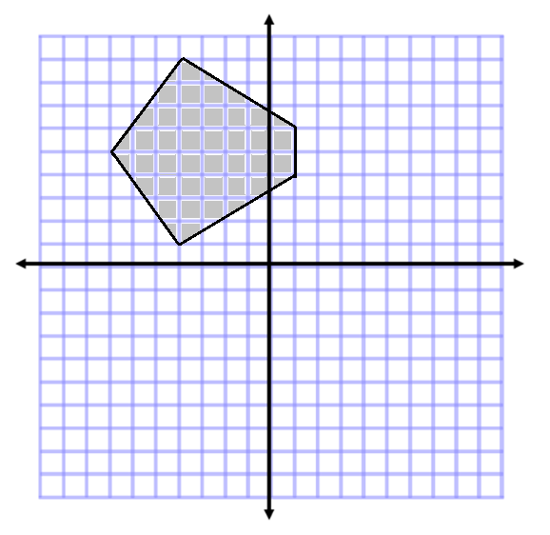
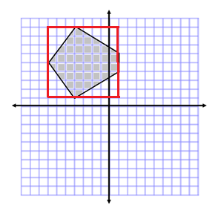
Area of Triangle 1
$$A=\frac{1}{2}bh$$
$$A=\frac{1}{2}(8 units)(3 units)$$
$$A=(4 units)(3 units)$$
$$A=12 {units}^{2}$$

Area of Triangles 2 and 4
$$A=\frac{1}{2}bh$$
$$A=\frac{1}{2}\left(5 units\right)\left(3 units\right)$$
$$A=\frac{1}{2}(15 units^{2})$$
$$A=7.5 {units}^{2}$$

Since triangles 2 and 4 are congruent, the combined area is $15 {units}^{2}$.

Area of Rectangle 3
$$A=bh$$
$$A=(5 units)(2 units)$$
$$A=10 units^{2}$$

Total Area $=12 {units}^{2} +15 units^{2}+10 units^{2}$
Total Area $=37 {units}^{2}$
Another correct solution might start with the following diagram:

- Determine the area and perimeter of the following shapes.
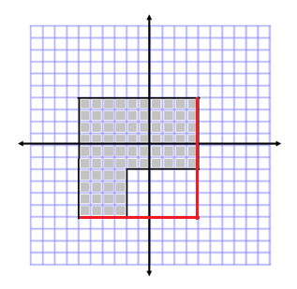
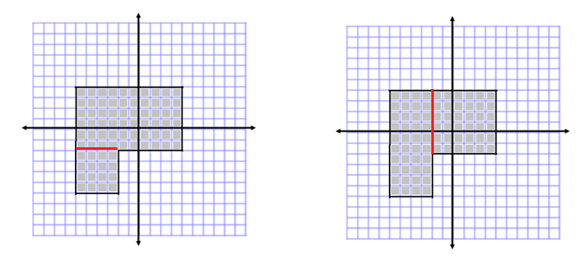
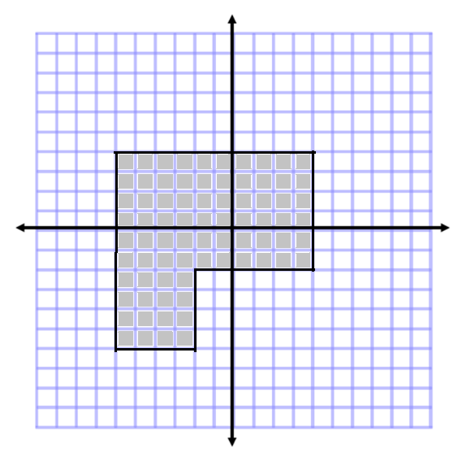
Area

Large Square
$$A=s^{2}$$
$$A={(10 units)}^{2}$$
$$A=100 {units}^{2}$$

Removed Piece
$$A=bh$$
$$A=(6 units)(4 units)$$
$$A=24 {units}^{2}$$

Area $=100 {units}^{2}-24 {units}^{2}$
Area $=76 {units}^{2}$

Perimeter $=10 units+6 units+6 units+4 units+4 units+10 units$
Perimeter $=40 units$
Other correct solutions might start with the following diagrams:

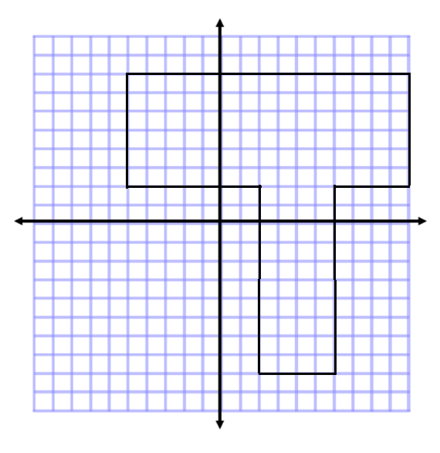
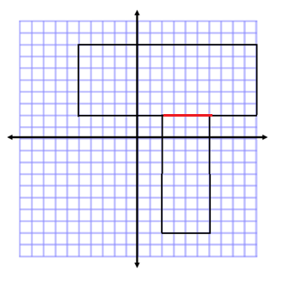
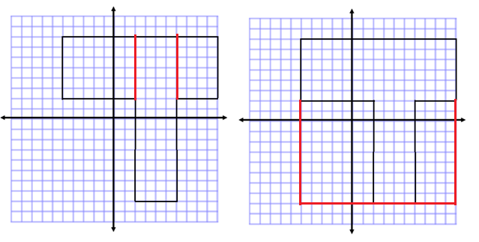
Area

Horizontal Area
$$A=bh$$
$$A=(15 units)(6 units)$$
$$A=90 {units}^{2}$$

Vertical Area
$$A=bh$$
$$A=(10 units)(4 units)$$
$$A=40 {units}^{2}$$

Total Area $=90 {units}^{2}+40 {units}^{2}$
Total Area $=130 {units}^{2}$

Perimeter $=15 units+6 units+4 units+10 units+4 units+10 units+7 units+6 units$
Perimeter $=62 units$
Other correct solutions might start with the following diagrams:

Closing (4 minutes)
- Share with the class some of the discussions made between partners about the methods for determining area of irregular polygons.
Ask questions to review the key ideas:
- There appear to be multiple ways to determine the area of a polygon. What do all of these methods have in common?
  - Answers will vary.
  - The areas cannot overlap.
  - When you decompose the figure, you cannot leave any parts out.
  - When drawing a rectangle around the outside of the shape, the vertices of the original shape should be touching the perimeter of the newly formed rectangle.
- Why did we determine the area and perimeter of some figures and only the area of others?
  - In problems similar to Exercise 1 (parts (a) and (b)), the sides were not horizontal or vertical, so we were not able to use the methods for determining length like we did in other problems.

Exit Ticket (4 minutes)
Name Date
Lesson 9: Determining Area and Perimeter of Polygons on the Coordinate Plane

Exit Ticket

Determine the area and perimeter of the figure below. Note that each square unit is $1 unit$ in length.
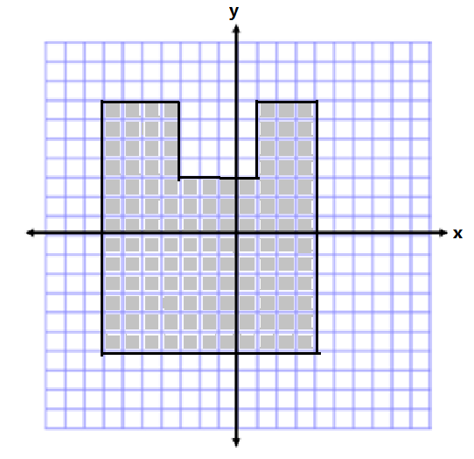

Exit Ticket Sample Solutions
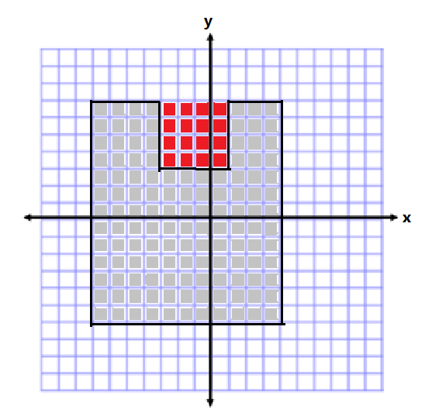
Determine the area and perimeter of the figure below. Note that each square unit is $1 unit$ in length.
Area

Area of Large Rectangle
$$A=bh$$
$$A=(11 units)(13 units)$$
$$A=143 {units}^{2}$$

Area of Small Square
$$A=s^{2}$$
$$A={(4 units)}^{2}$$
$$A=16 {units}^{2}$$

Area of Irregular Shape
$$A=143 {units}^{2}-16 {units}^{2}$$
$$A=127 {units}^{2}$$

Perimeter $=13 units+4 units+4 units+4 units+4 units+3 units+13 units+11 units$
Perimeter $=56 units$
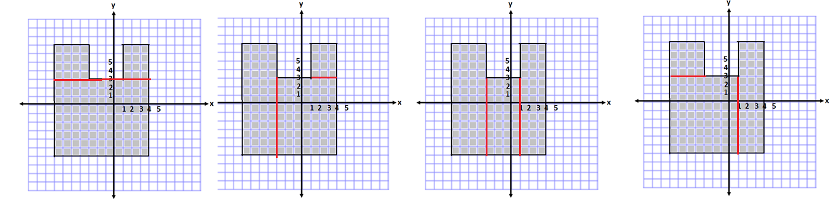
Other correct solutions might start with the following diagrams:

Problem Set Sample Solutions

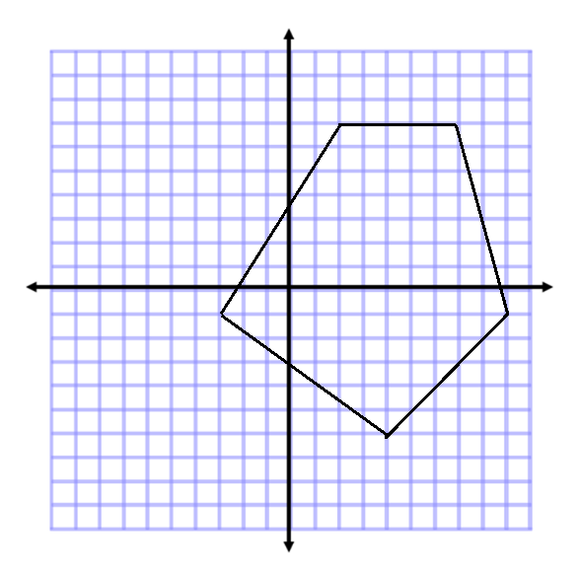
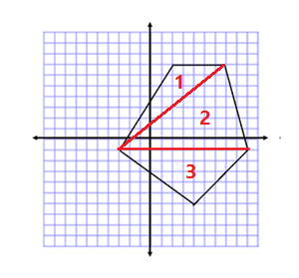
- Determine the area of the polygon.
Area of Triangle 1
$$A=\frac{1}{2}bh$$
$$A=\frac{1}{2}(5 units)(8 units)$$
$$A=\frac{1}{2}(40 units^{2})$$
$$A=20 {units}^{2}$$

Area of Triangle 2
$$A=\frac{1}{2}bh$$
$$A=\frac{1}{2}(12 units)(8 units)$$
$$A=\frac{1}{2}(96 units^{2})$$
$$A=48 {units}^{2}$$

Area of Triangle 3
$$A=\frac{1}{2}bh$$
$$A=\frac{1}{2}(12 units)(5 units)$$
$$A=\frac{1}{2}(60 units^{2})$$
$$A=30 {units}^{2}$$

Total Area $=20 units^{2}+48 {units}^{2}+30 {units}^{2}$
Total Area $=98 {units}^{2}$

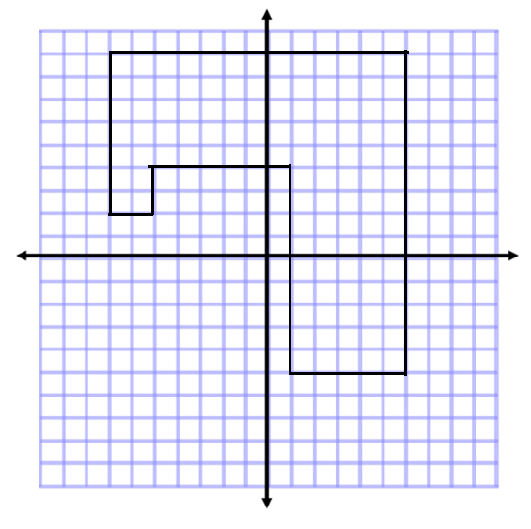
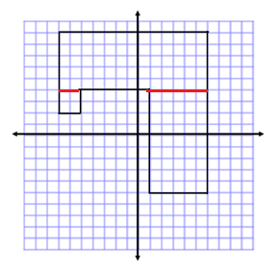
- Determine the area and perimeter of the polygon.
Area
Horizontal Rectangle
$$A=bh$$
$$A=(13 units)(5 units)$$
$$A=65 {units}^{2}$$

Vertical Rectangle
$$A=bh$$
$$A=(5 units)(9 units)$$
$$A=45 {units}^{2}$$

Square
$$A=s^{2}$$
$$A={(2 units)}^{2}$$
$$A=4 {units}^{2}$$

Total Area $=65 {units}^{2}+45 {units}^{2}+4 {units}^{2}$
Total Area $=114 {units}^{2}$

Perimeter
Perimeter $=2 units+2 units+7 units+13 units+14 units+5 units+9 units+6 units$
Perimeter $=58 units$

- Determine the area of the polygon. Then, write an expression that could be used to determine the area.
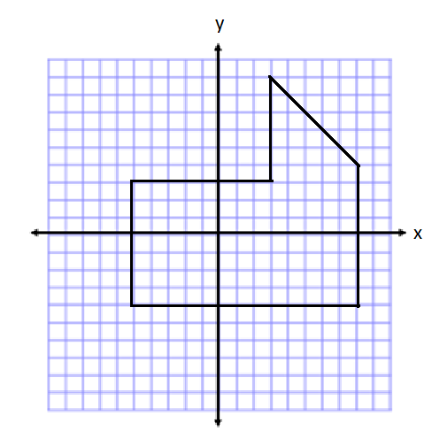
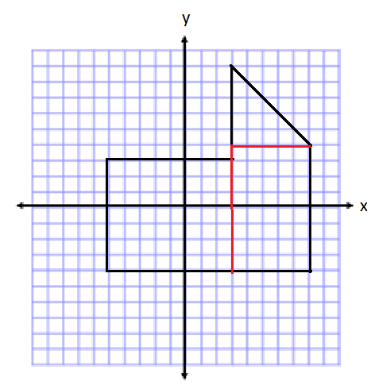

Area of Rectangle on Left  $$A=lw \\ A=\left(8 units\right)\left(7 units\right) \\ A=56 {units}^{2}$$ | Area of Rectangle on Right  $$A=lw \\ A=\left(5 units\right)\left(8 units\right) \\ A=40 {units}^{2}$$ | Area of Triangle on Top  $$A=\frac{1}{2}bh \\ A=\frac{1}{2}(5 units)(5 units) \\ A=12.5 {units}^{2}$$
Total Area $=56 {units}^{2}+40{ units}^{2}+12.5 {units}^{2}=108.5 {units}^{2}$
Expression $\left(8\right)\left(7\right)+\left(5\right)\left(8\right)+\frac{1}{2}(5)(5)$

- If the length of each square was worth $2$ instead of $1$, how would the area in Problem 3 change? How would your expression change to represent this area?
If each length is twice as long, when they are multiplied, $2l×2w=4lw$. Therefore, the area will be four times larger when the side lengths are doubled.
I could multiply my entire expression by $4$ to make it $4$ times as big. $4\left[\left(8\right)\left(7\right)+\left(5\right)\left(8\right)+\frac{1}{2}\left(5\right)\left(5\right)\right]$

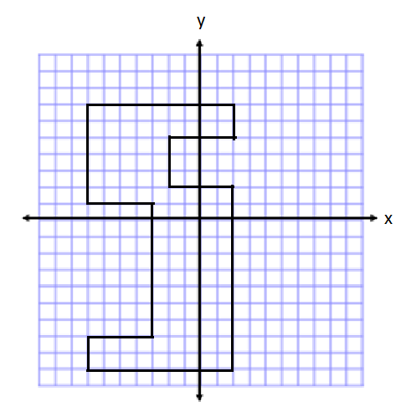
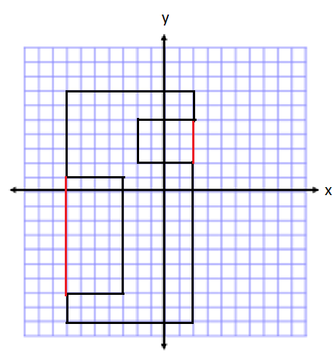
- Determine the area of the polygon. Then, write an expression that represents the area.

Area of Outside Rectangle  $$A=lw \\ A=\left(9 units\right)\left(16 units\right) \\ A=144 {units}^{2}$$ | Area of Rectangle on Left  $$A=lw \\ A=\left(4 units\right)\left(8 units\right) \\ A=32 {units}^{2}$$ | Area of Rectangle on Right  $$A=lw \\ A=\left(4 units\right)\left(3 units\right) \\ A=12 {units}^{2}$$
Total Area $=144 {units}^{2}-32{units}^{2}-12{units}^{2}$
Total Area$=100 {units}^{2}$
Expression $\left(9\right)\left(16\right)-\left(4\right)\left(8\right)-(4)(3)$
- Describe another method you could use to find the area of the polygon in Problem 5. Then, state how the expression for the area would be different than the expression you wrote.
I could have broken up the large shape into many smaller rectangles. Then I would need to add all the areas of these rectangles together to determine the total area.
My expression showed subtraction because I created a rectangle that was larger than the original polygon, and then I had to subtract the extra areas. If I break the shape into pieces, I would need to add the terms together instead of subtracting them to get the total area.

- Write one of the letters from your name using rectangles on the coordinate plane. Then, determine the area and perimeter. (For help see Exercise 2(b). This irregular polygon looks sort of like a T.)
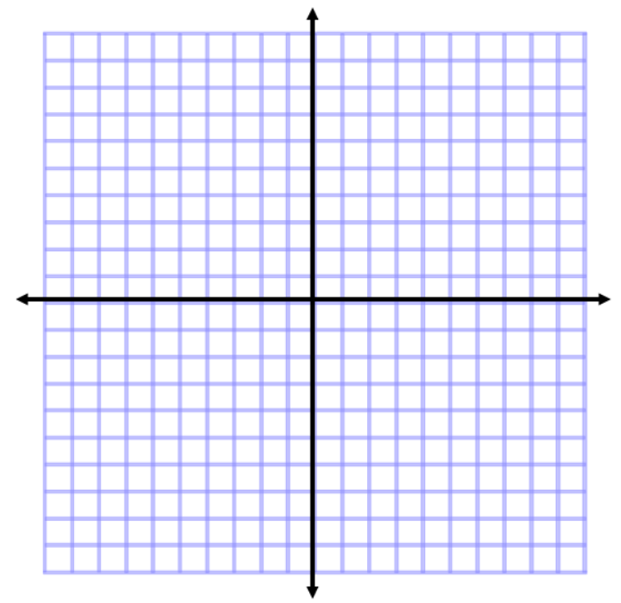
Answers will vary.

Addition and Subtraction Equations—Round 1
Directions: Find the value of $m$ in each equation.
Number Correct: ______

 | $$m+4=11$$ |  |  |  | $$m-54=37$$
 | $$m+2=5$$ |  |  |  | $$4+m=9$$
 | $$m+5=8$$ |  |  |  | $$6+m=13$$
 | $$m-7=10$$ |  |  |  | $$2+m=31$$
 | $$m-8=1$$ |  |  |  | $$15=m+11$$
 | $$m-4=2$$ |  |  |  | $$24=m+13$$
 | $$m+12=34$$ |  |  |  | $$32=m+28$$
 | $$m+25=45$$ |  |  |  | $$4=m-7$$
 | $$m+43=89$$ |  |  |  | $$3=m-5$$
 | $$m-20=31$$ |  |  |  | $$12=m-14$$
 | $$m-13=34$$ |  |  |  | $$23.6=m-7.1$$
 | $$m-45=68$$ |  |  |  | $$14.2=m-33.8$$
 | $$m+34=41$$ |  |  |  | $$2.5=m-41.8$$
 | $$m+29=52$$ |  |  |  | $$64.9=m+23.4$$
 | $$m+37=61$$ |  |  |  | $$72.2=m+38.7$$
 | $$m-43=63$$ |  |  |  | $$1.81=m-15.13$$
 | $$m-21=40$$ |  |  |  | $$24.68=m-56.82$$

Addition and Subtraction Equations—Round 1 [KEY]
Directions: Find the value of $m$ in each equation.
 | $$m+4=11$$ | $$m= 7$$ |  |  | $$m-54=37$$ | $$m=91$$
 | $$m+2=5$$ | $$m=3$$ |  |  | $$4+m=9$$ | $$m=5$$
 | $$m+5=8$$ | $$m=3$$ |  |  | $$6+m=13$$ | $$m=7$$
 | $$m-7=10$$ | $$m=17$$ |  |  | $$2+m=31$$ | $$m=29$$
 | $$m-8=1$$ | $$m = 9$$ |  |  | $$15=m+11$$ | $$m=4$$
 | $$m-4=2$$ | $$m=6$$ |  |  | $$24=m+13$$ | $$m=11$$
 | $$m+12=34$$ | $$m=22$$ |  |  | $$32=m+28$$ | $$m=4$$
 | $$m+25=45$$ | $$m=20$$ |  |  | $$4=m-7$$ | $$m=11$$
 | $$m+43=89$$ | $$m=46$$ |  |  | $$3=m-5$$ | $$m=8$$
 | $$m-20=31$$ | $$m=51$$ |  |  | $$12=m-14$$ | $$m=26$$
 | $$m-13=34$$ | $$m=47$$ |  |  | $$23.6=m-7.1$$ | $$m=30.7$$
 | $$m-45=68$$ | $$m=113$$ |  |  | $$14.2=m-33.8$$ | $$m=48$$
 | $$m+34=41$$ | $$m=7$$ |  |  | $$2.5=m-41.8$$ | $$m=44.3$$
 | $$m+29=52$$ | $$m=23$$ |  |  | $$64.9=m+23.4$$ | $$m=41.5$$
 | $$m+37=61$$ | $$m=24$$ |  |  | $$72.2=m+38.7$$ | $$m=33.5$$
 | $$m-43=63$$ | $$m=106$$ |  |  | $$1.81=m-15.13$$ | $$m=16.94$$
 | $$m-21=40$$ | $$m=61$$ |  |  | $$24.68=m-56.82$$ | $$m=81.5$$

Addition and Subtraction Equations—Round 2
Number Correct: ______
Improvement: ______
Directions: Find the value of $m$ in each equation.
 | $$m+2=7$$ |  |  |  | $$6=m+3$$
 | $$m+4=10$$ |  |  |  | $$12=m+7$$
 | $$m+8=15$$ |  |  |  | $$24=m+16$$
 | $$m+7=23$$ |  |  |  | $$13=m+9$$
 | $$m+12=16$$ |  |  |  | $$32=m-3$$
 | $$m-5=2$$ |  |  |  | $$22=m-12$$
 | $$m-3=8$$ |  |  |  | $$34=m-10$$
 | $$m-4=12$$ |  |  |  | $$48=m+29$$
 | $$m-14=45$$ |  |  |  | $$21=m+17$$
 | $$m+23=40$$ |  |  |  | $$52=m+37$$
 | $$m+13=31$$ |  |  |  | $$\frac{6}{7}=m+\frac{4}{7}$$
 | $$m+23=48$$ |  |  |  | $$\frac{2}{3}=m-\frac{5}{3}$$
 | $$m+38=52$$ |  |  |  | $$\frac{1}{4}=m-\frac{8}{3}$$
 | $$m-14=27$$ |  |  |  | $$\frac{5}{6}=m-\frac{7}{12}$$
 | $$m-23=35$$ |  |  |  | $$\frac{7}{8}=m-\frac{5}{12}$$
 | $$m-17=18$$ |  |  |  | $$\frac{7}{6}+m=\frac{16}{3}$$
 | $$m-64=1$$ |  |  |  | $$\frac{1}{3}+m=\frac{13}{15}$$

Addition and Subtraction Equations—Round 2 [KEY]
Directions: Find the value of $m$ in each equation.
 | $$m+2=7$$ | $$m=5$$ |  |  | $$6=m+3$$ | $$m=3$$
 | $$m+4=10$$ | $$m=6$$ |  |  | $$12=m+7$$ | $$m=5$$
 | $$m+8=15$$ | $$m=7$$ |  |  | $$24=m+16$$ | $$m=8$$
 | $$m+7=23$$ | $$m=16$$ |  |  | $$13=m+9$$ | $$m=4$$
 | $$m+12=16$$ | $$m=4$$ |  |  | $$32=m-3$$ | $$m=35$$
 | $$m-5=2$$ | $$m=7$$ |  |  | $$22=m-12$$ | $$m=34$$
 | $$m-3=8$$ | $$m=11$$ |  |  | $$34=m-10$$ | $$m=44$$
 | $$m-4=12$$ | $$m=16$$ |  |  | $$48=m+29$$ | $$m=19$$
 | $$m-14=45$$ | $$m=59$$ |  |  | $$21=m+17$$ | $$m=4$$
 | $$m+23=40$$ | $$m=17$$ |  |  | $$52=m+37$$ | $$m=15$$
 | $$m+13=31$$ | $$m=18$$ |  |  | $$\frac{6}{7}=m+\frac{4}{7}$$ | $$m=\frac{2}{7}$$
 | $$m+23=48$$ | $$m=25$$ |  |  | $$\frac{2}{3}=m-\frac{5}{3}$$ | $$m=\frac{7}{3}$$
 | $$m+38=52$$ | $$m=14$$ |  |  | $$\frac{1}{4}=m-\frac{8}{3}$$ | $$m=\frac{35}{12}$$
 | $$m-14=27$$ | $$m=41$$ |  |  | $$\frac{5}{6}=m-\frac{7}{12}$$ | $$m=\frac{17}{12}$$
 | $$m-23=35$$ | $$m=58$$ |  |  | $$\frac{7}{8}=m-\frac{5}{12}$$ | $$m=\frac{31}{24}$$
 | $$m-17=18$$ | $$m=35$$ |  |  | $$\frac{7}{6}+m=\frac{16}{3}$$ | $$m=\frac{25}{6}$$
 | $$m-64=1$$ | $$m=65$$ |  |  | $$\frac{1}{3}+m=\frac{13}{15}$$ | $$m=\frac{8}{15}$$

