Lesson 8: Drawing Polygons on the Coordinate Plane

Classwork
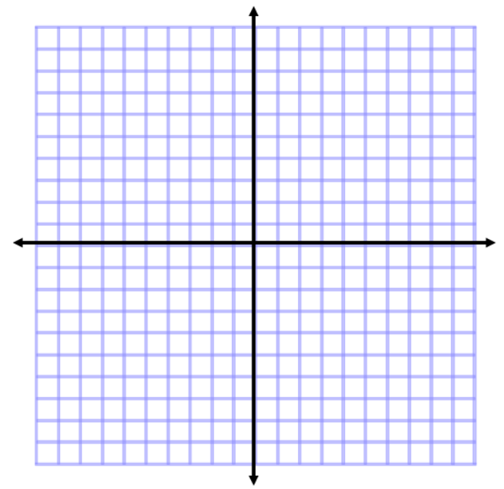
Examples

- Plot and connect the points $A(3, 2)$, $B(3, 7)$, and $C(8, 2)$. Name the shape, and determine the area of the polygon.

- Plot and connect the points $E(-8, 8)$, $F(-2, 5)$, and $G(-7, 2)$. Then give the best name for the polygon, and determine the area.

- Plot and connect the following points: $K(-9, -7)$, $L(-4, -2)$, $M(-1, -5)$, and $N(-5, -5)$. Give the best name for the polygon, and determine the area.

- Plot and connect the following points: $P(1, -4)$, $Q(5, -2)$, $R(9, -4)$,$S(7, -8)$, and $T(3, -8)$. Give the best name for the polygon, and determine the area.

- Two of the coordinates of a rectangle are $A(3, 7)$ and $B(3, 2)$. The rectangle has an area of $30$ square units. Give the possible locations of the other two vertices by identifying their coordinates. (Use the coordinate plane to draw and check your answer.)

Exercises
For Exercises 1 and 2, plot the points, name the shape, and determine the area of the shape. Then write an expression that could be used to determine the area of the figure. Explain how each part of the expression corresponds to the situation.

- $A(4, 6)$, $B(8, 6)$, $C(10, 2)$,$D(8, -3)$, $E(5, -3)$, and $F(2, 2)$

- $X(-9, 6)$,$Y(-2, -1)$, and $Z(-8, -7)$

- A rectangle with vertices located at $(-3, 4)$ and $(5, 4)$ has an area of $32$ square units. Determine the location of the other two vertices.

- Challenge: A triangle with vertices located at $(-2, -3)$ and $(3, -3)$ has an area of $20$square units. Determine one possible location of the other vertex.

Problem Set

Plot the points for each shape, determine the area of the polygon, and then write an expression that could be used to determine the area of the figure. Explain how each part of the expression corresponds to the situation.
- $A(1, 3)$, $B(2, 8)$, $C(8, 8)$,$D(10, 3)$, and $E(5, -2)$

- $X(-10, 2)$, $Y(-3, 6),$ and $Z(-6, -5)$

- $E(5, 7)$, $F(9, -5)$, and $G(1, -3)$

- Find the area of the triangle in Problem 3 using a different method. Then, compare the expressions that can be used for both solutions in Problems 3 and 4.

- Two vertices of a rectangle are $(8, -5)$ and $(8, 7)$. If the area of the rectangle is $72$ square units, name the possible location of the other two vertices.

- A triangle with two vertices located at $(5, -8)$ and $(5, 4)$ has an area of $48$ square units. Determine one possible location of the other vertex.

