Lesson 8: Drawing Polygons on the Coordinate Plane

Student Outcomes
- Given coordinates for the vertices, students draw polygons in the coordinate plane. Students find the area enclosed by a polygon by composing or decomposing using polygons with known area formulas.
- Students name coordinates that define a polygon with specific properties.

Lesson Notes
Helping students understand the contextual pronunciation of the word coordinate may be useful. Compare it to the verb coordinate, which has a slightly different pronunciation and a different stress. In addition, it may be useful to revisit the singular and plural forms of this word vertex (vertices).

Classwork
Examples 1–4 (20 minutes)
Students graph all four examples on the same coordinate plane.
Examples
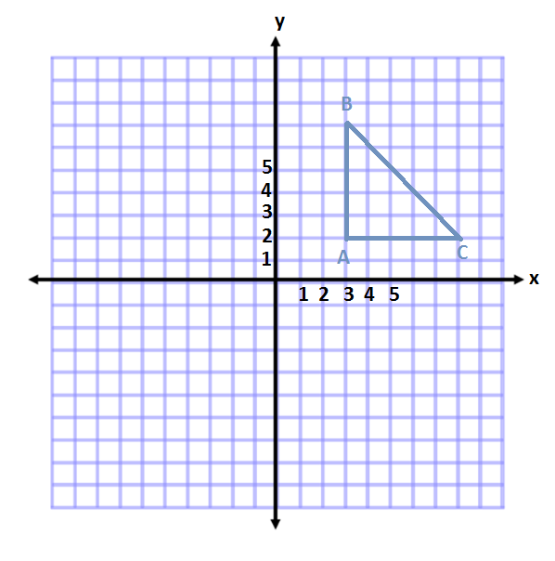
- Plot and connect the points $A(3, 2)$, $B(3, 7)$, and $C(8, 2)$. Name the shape, and determine the area of the polygon.
Right Triangle
$$A=\frac{1}{2}bh \\ A=\frac{1}{2}(5 units)(5 units) \\ A=\frac{1}{2}(25 units^{2}) \\ A=12.5 {units}^{2}$$

- How did you determine the length of the base and height?
  - In this example, I subtracted the values of the coordinates. For $AB$, I subtracted the absolute value of the $y$-coordinates. For $AC$, I subtracted the absolute value of the$x$-coordinates.

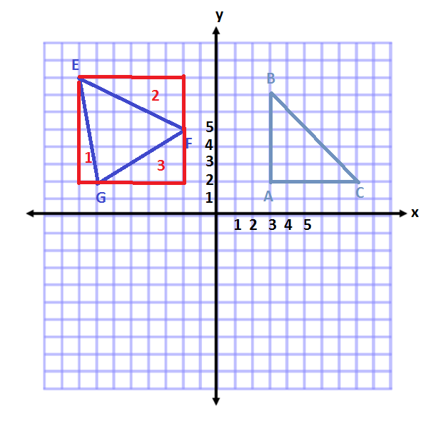
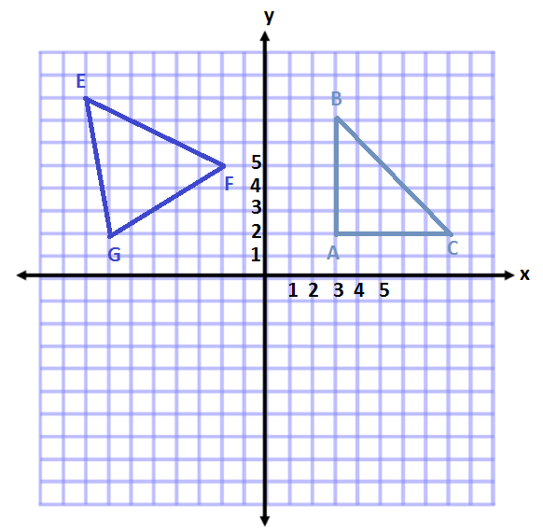
- Plot and connect the points $E(-8, 8)$, $F(-2, 5)$, and $G(-7, 2)$. Then give the best name for the polygon, and determine the area.
The shape is a triangle.
Area of Square
$$A=s^{2}$$
$$A={(6 units)}^{2}$$
$$A=36 {units}^{2}$$

Area of Triangle 2
$$A=\frac{1}{2}bh$$
$$A=\frac{1}{2}(6 units)(3 units)$$
$$A=\frac{1}{2}(18 units^{2})$$
$$A=9 {units}^{2}$$

Area of Triangle 1
$$A=\frac{1}{2}bh$$
$$A=\frac{1}{2}(1 unit)(6 units)$$
$$A=\frac{1}{2}(6 units^{2})$$
$$A=3 {units}^{2}$$

Area of Triangle 3
$$A=\frac{1}{2}bh$$
$$A=\frac{1}{2}\left(5 units\right)\left(3 units\right)$$
$$A=\frac{1}{2}(15 units^{2})$$
$$A=7.5 {units}^{2}$$
Total Area of Triangle
$$A=36 {units}^{2}-3 {units}^{2}-9{ units}^{2}-7.5 {units}^{2}$$
$$A=16.5 {units}^{2}$$

- How is this example different than the first?
MP.1
  - The base and height are not on vertical and horizontal lines. This makes it difficult to determine the measurements and calculate the area.

- What other methods might we try?
MP.1
Students may not come up with the correct method in discussion and may need to be led to the idea. If this is the case, ask students if the shape can be divided into smaller pieces. Try drawing lines on the figure to show this method will not work. Then draw one of the outside triangles to show a triangle whose area could be determined, and help lead students to determine that the areas of the surrounding triangles can be found.
  - Answers will vary. We can draw a square around the outside of the shape. Using these vertical and horizontal lines, we can find the area of the triangles that would be formed around the original triangle. These areas would be subtracted from the area of the square leaving us with the area of the triangle in the center.
- What expression could we write to represent the area of the triangle?
  - $6^{2}-\frac{1}{2}\left(1\right)\left(6\right)-\frac{1}{2}\left(6\right)\left(3\right)-\frac{1}{2}\left(5\right)\left(3\right)$
- Explain what each part of the expression corresponds to in this situation.
  - The $6^{2}$ represents the area of the square surrounding the triangle.
MP.2
  - The $\frac{1}{2}\left(1\right)\left(6\right)$represents the area of triangle $1$ that needs to be subtracted from the square.
  - The $\frac{1}{2}\left(6\right)\left(3\right)$represents the area of triangle $2$ that needs to be subtracted from the square.
  - The $\frac{1}{2}(5)(3)$ represents the area of triangle $3$ that needs to be subtracted from the square.

- Plot and connect the following points: $K(-9, -7)$, $L(-4, -2)$,$M(-1, -5)$, and $N(-5, -5)$. Give the best name for the polygon, and determine the area.
Area of Triangle 1
$$A=\frac{1}{2}bh$$
$$A=\frac{1}{2}(6 units)(3 units)$$
$$A=\frac{1}{2}(18 units^{2})$$
$$A=9 {units}^{2}$$

Area of Triangle 2
$$A=\frac{1}{2}bh$$
$$A=\frac{1}{2}(2 units)(2 units)$$
$$A=\frac{1}{2}(4 units^{2})$$
$$A=2 {units}^{2}$$

Total Area $=9 {units}^{2}+2 {units}^{2}$
Total Area $=11 {units}^{2}$
MP.1
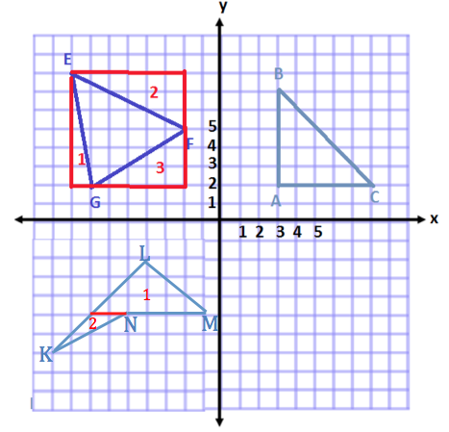
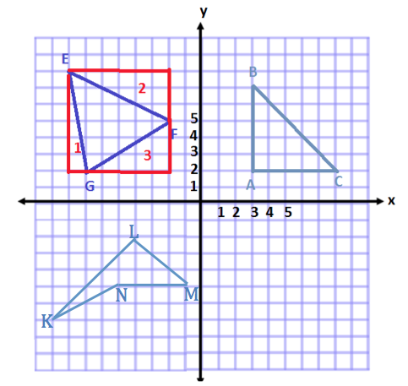
This polygon has $4$ sides and has no pairs of parallel sides. Therefore, the best name for this shape is a quadrilateral.
To determine the area I will separate the shape into two triangles.
- What method(s) could be used to determine the area of this shape?
  - We could decompose the shape, or break the shape, into two triangles using a horizontal line segment to separate the two pieces.
  - We could also have used a similar method to Example 2, where we draw a rectangle around the outside of the shape, find the area of the pieces surrounding the quadrilateral, and then subtract these areas from the area of the rectangle.
MP.1
- In this case, which method is more efficient?
  - It would be more efficient to only have to find the area of the two triangles, and then add them together.
- What expression could we write to represent the area of the triangle?
  - $\frac{1}{2}\left(6\right)\left(3\right)+\frac{1}{2}\left(2\right)\left(2\right)$
- Explain what each part of the expression corresponds to in this situation.
MP.2
  - The $\frac{1}{2}\left(6\right)\left(3\right)$represents the area of triangle $1$ that needs to be added to the rest of the shape.
  - The $\frac{1}{2}\left(2\right)\left(2\right)$represents the area of triangle $2$ that needs to be added to the rest of the shape.

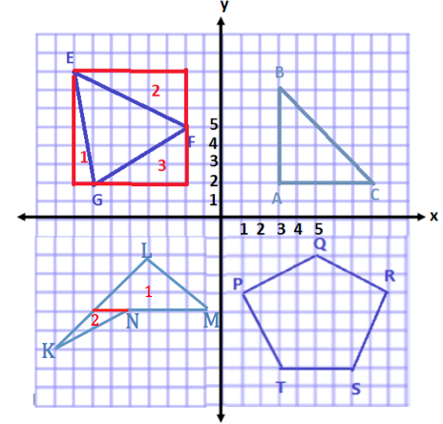
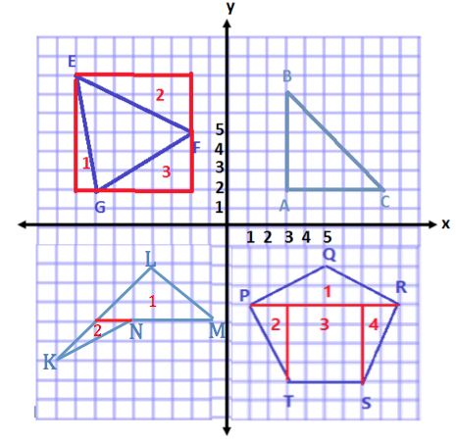
- Plot and connect the following points: $P(1, -4)$, $Q(5, -2)$, $R(9, -4)$,$S(7, -8)$, and $T(3, -8)$. Give the best name for the polygon, and determine the area.
MP.1
This shape is a pentagon.
Area of Shape 1
$$A=\frac{1}{2}bh$$
$$A=\frac{1}{2}\left(8 units\right)(2 units)$$
$$A=\frac{1}{2}(16 units^{2})$$
$$A=8 {units}^{2}$$

Area of Shape 2 and Shape 4
$$A=\frac{1}{2}bh$$
$$A=\frac{1}{2}(4 units)(2 units)$$
$$A=\frac{1}{2}(8 units^{2})$$
$$A=4 {units}^{2}$$
Because there are two of the same triangle, that makes a total of $8 units^{2}$.

Area of Shape 3
$$A=bh$$
$$A=(4 units)(4 units)$$
$$A=16 units^{2}$$

Total Area $=8 {units}^{2} + 8 units^{2}+ 16 {units}^{2}$
Total Area $=32 {units}^{2}$
- What is the best name for this polygon?
  - This shape has $5$ sides. Therefore, the best name is pentagon.
- Do we have a formula that we typically use to calculate the area of a pentagon?
MP.1
  - No, we have formulas for different types of triangles and quadrilaterals.
- How could we use what we know to determine the area of the pentagon?
  - Answers will vary. We can break up the shape into triangles and rectangles, find the areas of these pieces, and then add them together to get the total area.
- What expression could we write to represent the area of the pentagon?
  - $\frac{1}{2}\left(8\right)\left(2\right)+2\left[\frac{1}{2}\left(4\right)\left(2\right)\right]+\left(4\right)\left(4\right)$
- Explain what each part of the expression corresponds to in this situation.
  - The $\frac{1}{2}\left(8\right)\left(2\right)$ represents the area of triangle 1 that needs to be added to the rest of the areas.
MP.2
  - The $\frac{1}{2}\left(4\right)\left(2\right)$represents the area of triangles 2 and 4 that needs to be added to the rest of the areas. It is multiplied by $2$ because there are two triangles with the same area.
  - The $(4)(4)$ represents the area of rectangle 3 that needs to also be added to the rest of the areas.

Example 5 (5 minutes)

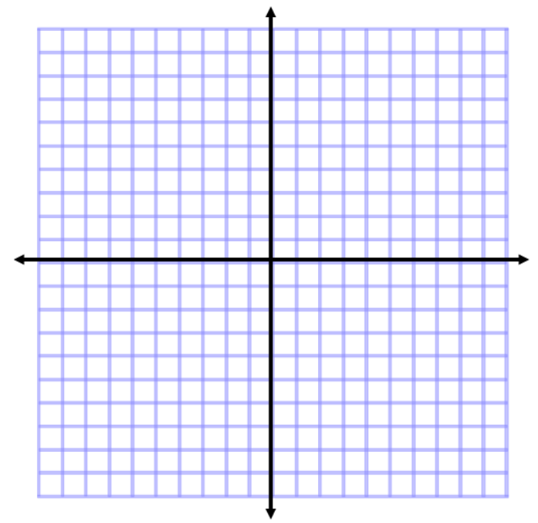
- Two of the coordinates of a rectangle are $A(3, 7)$ and $B(3, 2)$. The rectangle has an area of $30$square units. Give the possible locations of the other two vertices by identifying their coordinates. (Use the coordinate plane to draw and check your answer.)
One possible location of the other two vertices is$\left(9,2\right)$ and $\left(9,7\right)$. Using these coordinates will result in a distance, or side length, of $6 units$.
Since the height is $5 units$, $5 units×6 units=30 units^{2}$.
Another possible location of the other two vertices is $(-3,2)$ and $(-3,7)$. Using these coordinates will result in a distance, or side length, of$6 units$.
Since the height is $5 units$, $5 units×6 units=30 units^{2}$.
A

B

Allow students a chance to try this question on their own first, and then compare solutions with a partner.
- What is the length of $\overline{AB}$?
  - $\left|7\right|-\left|2\right|=7-2=5$; therefore, $AB=5 units$.
- If one side of the rectangle is $5$ units, what must be the length of the other side?
  - Since the area is $30$ square units, the other length must be $6$ units so that $5×6$ will make $30$.
- How many different rectangles can be created with segment $AB$ as one side and the two sides adjacent to segment $AB$ having a length of $6$units?
  - There are two different solutions. I could make a rectangle with two new points at $(9, 7)$ and $(9, 2)$, or I could make a rectangle with two new points at $(-3, 7)$and $(-3, 2)$.
- How are the $x$-coordinates in the two new points related to the $x$-coordinates in point $A$ and point $B$?
  - They are $6$ units apart.

Exercises 1–4 (10 minutes)
Students will work independently.
Exercises
For Exercises 1 and 2, plot the points, name the shape, and determine the area of the shape. Then write an expression that could be used to determine the area of the figure. Explain how each part of the expression corresponds to the situation.
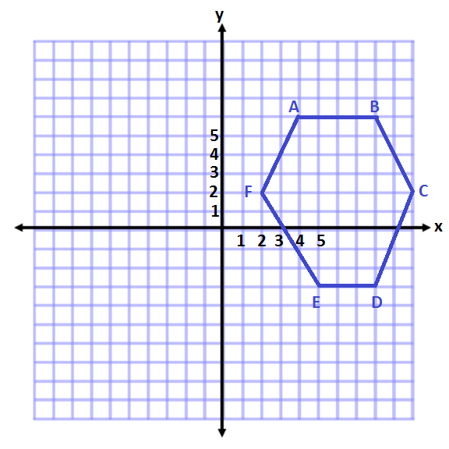
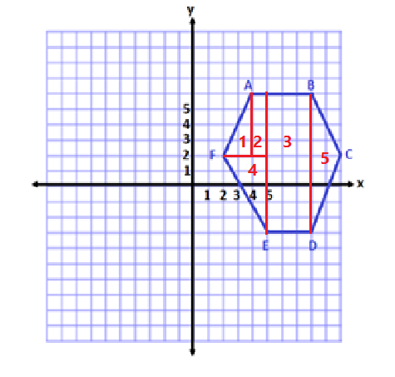
- $A(4, 6)$, $B(8, 6)$, $C(10, 2)$,$D(8, -3)$, $E(5, -3)$, and $F(2, 2)$
Area of 4
$$A=\frac{1}{2}bh$$
$$A=\frac{1}{2}(3 units)(5 units)$$
$$A=\frac{1}{2}(15 units^{2})$$
$$A=7.5 {units}^{2}$$
Area of 5
$$A=\frac{1}{2}bh$$
$$A=\frac{1}{2}(2 units)(9 units)$$
$$A=\frac{1}{2}(18 units^{2})$$
$$A=9 {units}^{2}$$
This shape is a hexagon.
Area of 1
$$A=\frac{1}{2}bh$$
$$A=\frac{1}{2}(2 units)(4 units)$$
$$A=\frac{1}{2}(8 units^{2})$$
$$A=4 {units}^{2}$$
Area of 2
$$A=bh$$
$$A=(1 unit)(4 units)$$
$$A=4 {units}^{2}$$
Area of 3
$$A=bh$$
$$A=(3 units)(9 units)$$
$$A=27 units^{2}$$
Total Area$=4 {units}^{2}+4 {units}^{2}+27 {units}^{2}+7.5 {units}^{2}+9 {units}^{2}$
Total Area $=51.5 {units}^{2}$
Expression
$$\frac{1}{2}\left(2\right)\left(4\right)+\left(1\right)\left(4\right)+\left(3\right)\left(9\right)+\frac{1}{2}\left(3\right)\left(5\right)+\frac{1}{2}(2)(9)$$
Each term represents the area of a section of the hexagon. They must be added together to get the total.
The first term is the area of triangle 1 on the left.
The second term is the area of rectangle 2.
The third term is the area of the large rectangle 3.
The fourth term is the area of triangle 4 on the left.
The fifth term is the area of triangle 5 on the right.
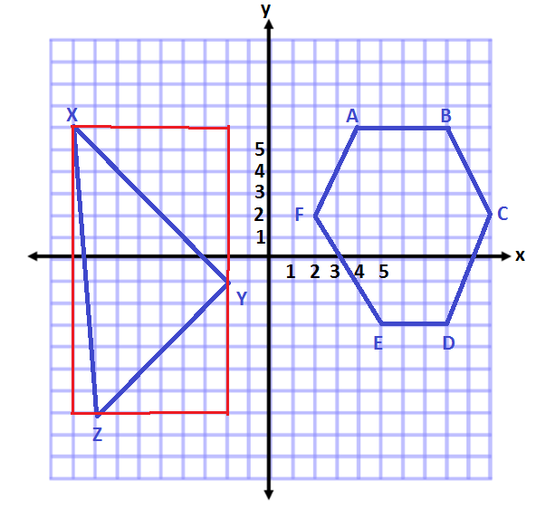
- $X\left(-9, 6\right)$,$Y(-2, -1)$, and $Z(-8, -7)$
3
2
1
Area of Triangle 2
$$A=\frac{1}{2}bh$$
$$A=\frac{1}{2}(6 units)(6 units)$$
$$A=\frac{1}{2}(36 units^{2})$$
$$A=18 {units}^{2}$$
Area of Triangle 3
$$A=\frac{1}{2}bh$$
$$A=\frac{1}{2}(13 units)(1 unit)$$
$$A=\frac{1}{2}(13 units^{2})$$
$$A=6.5 {units}^{2}$$
This shape is a triangle.
Area of Outside Rectangle
$$A=lw$$
$$A=(7 units) (13 units)$$
$$A=91 {units}^{2}$$
Area of Triangle 1
$$A=\frac{1}{2} bh$$
$$A=\frac{1}{2}(7 units)(7 units)$$
$$A=\frac{1}{2}(49 units^{2})$$
$$A=24.5 {units}^{2}$$

Total Area $=91 {units}^{2}-24.5 {units}^{2}-18 {units}^{2}-6.5 {units}^{2}$
Total Area $=42 {units}^{2}$

Expression
$$\left(7\right)\left(13\right)-\frac{1}{2}\left(7\right)\left(7\right)-\frac{1}{2}\left(6\right)\left(6\right)-\frac{1}{2} \left(13\right)\left(1\right)$$
The first term in the expression represents the area of the rectangle that goes around the outside of the triangle.
The next three terms represent the areas that need to be subtracted from the rectangle so that we are only left with the given triangle.
The second term is the area of the top right triangle.
The third term is the area of the bottom right triangle.
The fourth term is the area of the triangle on the left.

- A rectangle with vertices located at $(-3, 4)$ and $(5, 4)$ has an area of $32$ square units. Determine the location of the other two vertices.
The other two points could be located at $(-3, 8)$ and $(5, 8)$ or $(-3, 0)$ and $(5, 0)$.

- Challenge: A triangle with vertices located at $(-2, -3)$ and $(3, -3)$ has an area of $20$ square units. Determine one possible location of the other vertex.
Answers will vary. Possible solutions include points that are $8$ $units$from the base. $(-2, 5)$ or $(3, -11)$.

Closing (5 minutes)
- What different methods could you use to determine the area of a polygon plotted on the coordinate plane?
  - In order to find the area of a polygon on a coordinate plane, it is important to have vertical and horizontal lines. Therefore, the polygon can be decomposed to triangles and rectangles or a large rectangle can be drawn around the polygon.

- How did the shape of the polygon influence the method you used to determine the area?
  - If the shape is easily decomposed with horizontal and vertical lines, then this is the method that I would use to calculate the area. If this is not the case, then it would be easier to draw a rectangle around the outside of the shape.

Exit Ticket (5 minutes)
Name Date
Lesson 8: Drawing Polygons on the Coordinate Plane

Exit Ticket

Determine the area of both polygons on the coordinate plane, and explain why you chose the methods you used. Then write an expression that could be used to determine the area of the figure. Explain how each part of the expression corresponds to the situation.
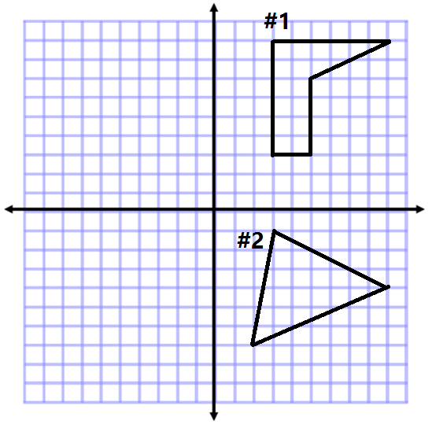

Exit Ticket Sample Solutions

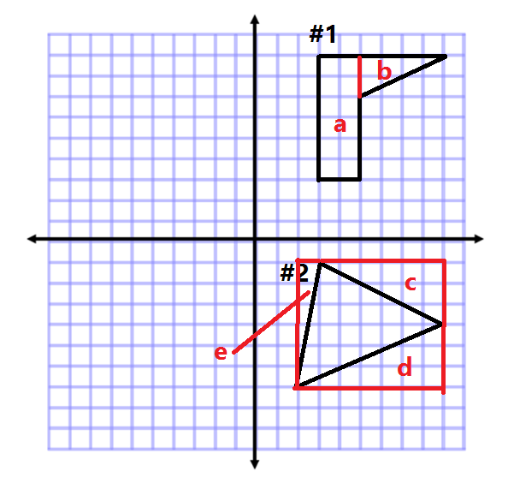
Determine the area of both polygons on the coordinate plane, and explain why you chose the methods you used. Then write an expression that could be used to determine the area of the figure. Explain how each part of the expression corresponds to the situation.
Methods to calculate the answer will vary.
#1 Area of shape a Area of shape b
$A=lw$ $A=\frac{1}{2}bh$
$A=(2 units)(6 units)$ $A=\frac{1}{2}(4 units)(2 units)$
$A=12 {units}^{2}$ $A=\frac{1}{2}(8 units^{2})$
$A=4 {units}^{2}$
Total Area $=12 {units}^{2}+4 {units}^{2}=16 {units}^{2}$
Explanations will vary depending on method chosen.
Expression $\left(2\right)\left(6\right)+\frac{1}{2}(4)(2)$
The first term represents the area of the rectangle on the left, which makes up part of the figure.
The second term represents the area of the triangle on the right that completes the figure.
#2 Area of outside rectangle Area of shape c Area of shape d Area of shape e
$A=lw$ $A=\frac{1}{2}bh$ $A=\frac{1}{2}bh$ $A=\frac{1}{2}bh$
$A=(7 units)(6 units)$ $A=\frac{1}{2}(6 units)(3 units)$ $A=\frac{1}{2}(7 units)(3 units)$ $A=\frac{1}{2}(1 units)(6 units)$
$A=42 {units}^{2}$ $A=\frac{1}{2}(18 units^{2})$ $A=\frac{1}{2}(21 units^{2})$ $A=\frac{1}{2}(6 units^{2})$
$A=9 {units}^{2}$ $A=10.5 {units}^{2}$ $A=3 {units}^{2}$
Total Area $=42 {units}^{2}-9 {units}^{2}-10.5 {units}^{2}-3 {units}^{2}$
Total Area $=19.5 {units}^{2}$
Explanations will vary depending on method chosen.
Expression $\left(7\right)(6) -\frac{1}{2}\left(6\right)\left(3\right)-\frac{1}{2}\left(7\right)\left(3\right)-\frac{1}{2}(1)(6)$
The first term in the expression is the area of a rectangle that goes around the triangle.
Each of the other terms represents the triangles that need to be subtracted from the rectangle so that we are left with just the figure in the center.

Problem Set Sample Solutions

Plot the points for each shape, determine the area of the polygon, and then write an expression that could be used to determine the area of the figure. Explain how each part of the expression corresponds to the situation.
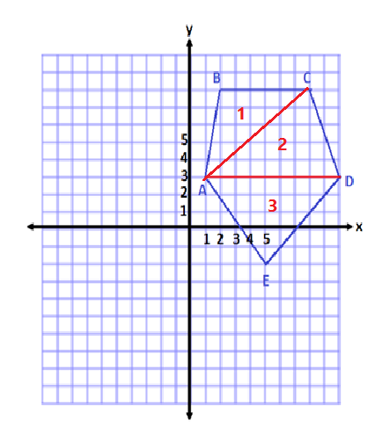
- $A(1, 3)$, $B(2, 8)$, $C(8, 8)$, $D(10, 3)$, and $E(5, -2)$
Area of Triangle 1
$$A=\frac{1}{2}bh$$
$$A=\frac{1}{2}(6 units)(5 units)$$
$$A=\frac{1}{2}(30 units^{2})$$
$$A=15 {units}^{2}$$

Area of Triangle 2
$$A=\frac{1}{2}bh$$
$$A=\frac{1}{2}(9 units)(5 units)$$
$$A=\frac{1}{2}(45 units^{2})$$
$$A = 22.5 {units}^{2}$$

Pentagon total area $=15 {units}^{2}+22.5 {units}^{2}+ 22.5 {units}^{2 }$
Total Area $=60 {units}^{2}$
Area of Triangle 3
$$A=\frac{1}{2}bh$$
$$A=\frac{1}{2}(9 units)(5 units)$$
$$A=\frac{1}{2}(45 units^{2})$$
$$A=22.5 {units}^{2}$$
Expression
$$\frac{1}{2}\left(6\right)\left(5\right)+\frac{1}{2}\left(9\right)\left(5\right)+\frac{1}{2}\left(9\right)\left(5\right)$$
Each term in the expression represents the area of one of the triangular pieces that fits inside the pentagon. They are all added together to form the complete figure.

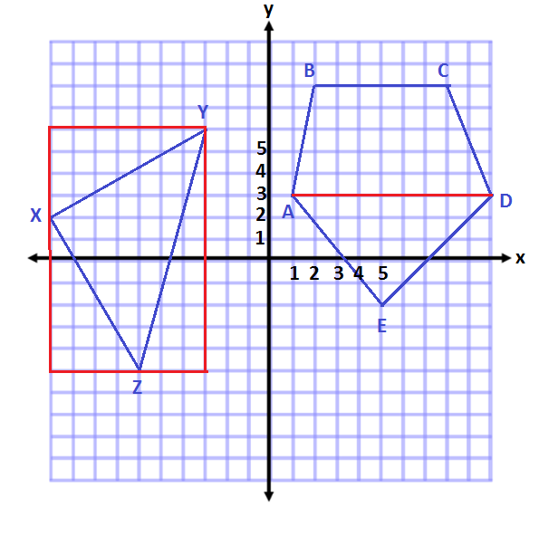
- $X(-10, 2)$, $Y(-3, 6)$, and $Z(-6, -5)$
Area of Outside Rectangle
$$A=lw$$
$$A=(11 units)(7 units)$$
$$A=77 {units}^{2}$$

Area of Top Triangle
$$A=\frac{1}{2}bh$$
$$A=\frac{1}{2}(7 units)(4 units)$$
$$A=\frac{1}{2}(28 units^{2})$$
$$A=14 {units}^{2}$$

Area of center triangle $=77 units^{2}-14 units^{2}-14 units^{2}-16.5 units^{2}$
Area of center triangle $=32.5 units^{2}$

Area of Bottom Left Triangle
$$A=\frac{1}{2}bh$$
$$A=\frac{1}{2}(4 units)(7 units)$$
$$A= \frac{1}{2}(28 units^{2})$$
$$A=14 {units}^{2}$$

Area of Bottom Right Triangle
$$A= \frac{1}{2}bh$$
$$A=\frac{1}{2}(3 units)(11 units)$$
$$A=\frac{1}{2}(33 units^{2})$$
$$A=16.5 {units}^{2}$$

Expression
$$\left(11\right)\left(7\right)-\frac{1}{2}\left(7\right)\left(4\right)-\frac{1}{2}\left(4\right)\left(7\right)-\frac{1}{2}(3)(11)$$
The first term in the expression represents the area of the rectangle that would enclose the triangle. Then the three terms after represent the triangles that need to be removed from the rectangle so that the given triangle is the only shape left.

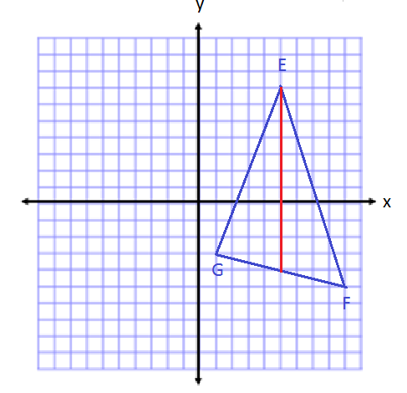
- $E(5, 7)$,$F(9, -5)$, and $G(1, -3)$
Area of Triangle on the Left
$$A=\frac{1}{2}bh \\ A=\frac{1}{2}\left(11\right)\left(4\right) \\ A=22 units^{2}$$
Area of Triangle on the Right
$$A=\frac{1}{2}bh \\ A=\frac{1}{2}(11)(4) \\ A=22 units^{2}$$
Total Area $=22 units^{2}+22 units^{2}=44 units^{2}$

Expression
$$\frac{1}{2}\left(11\right)\left(4\right)+\frac{1}{2}\left(11\right)\left(4\right)$$
Each term in the expression represents the area of a triangle that makes up the total area. The first term is the area of the triangle on the left, and the second term is the area of a triangle on the right.
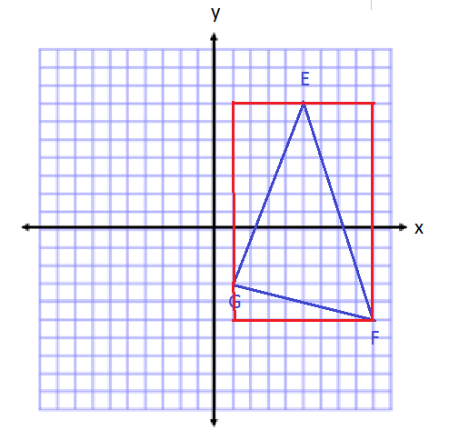
- Find the area of the triangle in Problem 3 using a different method. Then, compare the expressions that can be used for both solutions in Problems 3 and 4.
Area of Rectangle
$$A=lw$$
$$A=\left(12 units\right)\left(8 units\right)$$
$$A=96 units^{2}$$

Area of Triangle on Top Left
$$A=\frac{1}{2}bh$$
$$A=\frac{1}{2}\left(4 units\right)\left(10 units\right)$$
$$A=20 units^{2}$$

Total Area$=96 units^{2}-20 units^{2}-8 units^{2}-24units^{2}$
Total Area $=44 units^{2}$
Area of Triangle on Bottom Left
$$A=\frac{1}{2}bh$$
$$A=\frac{1}{2}\left(8 units\right)\left(2 units\right)$$
$$A=8 units^{2}$$

Area of Triangle on Right
$$A=\frac{1}{2}bh$$
$$A=\frac{1}{2}\left(4 units\right)\left(12 units\right)$$
$$A=24 units^{2}$$
Expression $\left(12\right)\left(8\right)-\frac{1}{2}\left(4\right)\left(10\right)-\frac{1}{2}\left(8\right)\left(2\right)-\frac{1}{2}\left(4\right)\left(12\right)$
The first term in the expression is the area of a rectangle around the outside of the figure. Then we subtracted all of the extra areas with the next three terms.
The two expressions are different because of the way we divided up the figure. In the first expression, we split the shape into two triangles that had to be added together to get the whole. In the second expression, we enclosed the triangle inside a new figure, and then had to subtract the extra area.

- Two vertices of a rectangle are $(8, -5)$ and $(8, 7)$. If the area of the rectangle is $72$ square units, name the possible location of the other two vertices.
$(2, -5)$ and $(2, 7)$ or $(14, -5)$ and$(14, 7)$

- A triangle with two vertices located at $(5, -8)$ and $(5, 4)$ has an area of $48$ square units. Determine one possible location of the other vertex.
Answers will vary. Possible solutions include points that are $8 units$ from the base. $(13, -2)$ or $(-3, -2)$.

